I am 100 meters from your location and rapidly approaching, start running
so I recently discovered the meme “I am 100 meters from your location and rapidly approaching” and I found a really fitting use for it today:

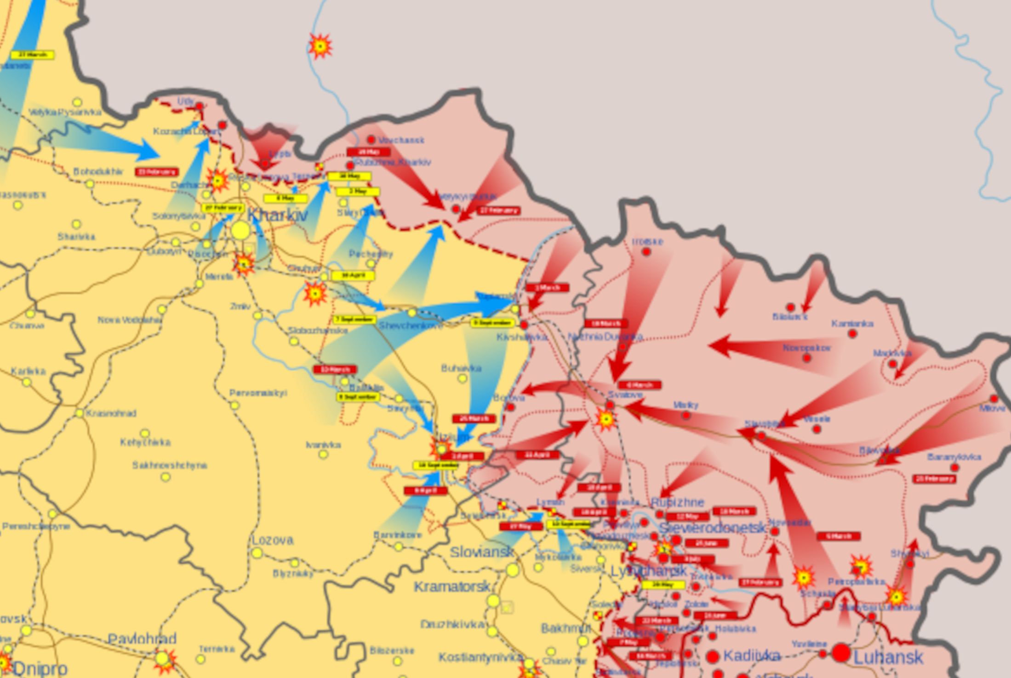
🇺🇦️: Я перебуваю в 100 метрах від вашого місця розташування і стрімко наближаюся. Почніть бігати
English: I am 100 meters from your location and rapidly approaching. Start running
Context: this occupation map picture comes directly before Ukraine came in and made the Russians surrender a claimed 6000 square miles of land back to Ukraine. I find it really fitting, as the Russians really did run here. I would insert the horizontal rectangular after photo, but it was more work than it should have been to crop the SVG file in this way, so instead, here is the vertical rectangular after photo:

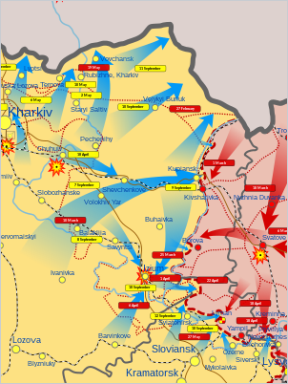

This was less than 2 weeks later. The advance to where it is now was made mostly in 5 days.

Erratum
So I need to make some next day corrections here: I knew I got something wrong when I picked out the first picture. I was 5 days off with the picture, the counteroffensive officially began on September 6th, not September 11th, and no, I didn’t pick this date because of the September 11th terrorist attacks, they didn’t even cross my mind when I wrote the date. It seems that it isn’t as traumatizing to me anymore. Second correction: I wrote 6000 square miles, when I meant 6000 square kilometers. It is still a lot of land to take back in just 5 days. Please forgive my errors, and accept this erratum.

TL;DR of Erratum
1: The claim was for 6000 square kilometers, NOT 6000 square miles
2: The first picture dates from 2022 September 11th, when the counteroffensive actually began on 2022 September 6th. I was 5 days off

What is an Erratum?
If you haven’t made a web search yet, an Erratum is basically a summary of mistakes that were made in a document, and corrections to stated mistakes.

Why not fix the mistakes before publishing?
I wanted to preserve the original document as much as possible. The fixed version is separate from the original version. You are currently reading the original document.

