Send a tip
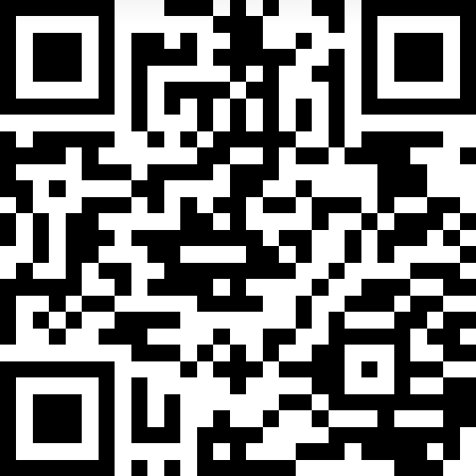
Minimum: 0.00000001₿
Secured by ProtonWallet
Alternatively (ProtonMail users) send to seanpm2001-cryptocurrency@proton.me
This page to not be printed

Font usage
Fonts used:
Chilanka (title)
FreeMono: Minimum + value
ProtonWallet: Dhurjati
Alternate method text: Chandas
Page 2+ print notice: Chandas
Other: Ubuntu, FreeMono

QR Code
Points to: bc1qm3c3qsm5e0ym9t085qttdrps4rjz49wpwsmvv7

File info
File version: 3 (2024, Wednesday, October 9th at 5:49 pm PST)
Word count: 81
Page count: 2 (only 1 to print)
Character count: 545
This page to not be printed

