Summer 2013 Mr. McGowan
AP Calculus AB Minuteman Tech
Quiz 5 – Differentiation Techniques

Find 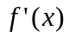
1) 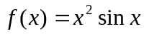 2) 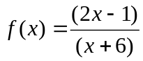 3) 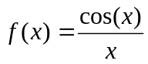
4) 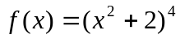 5) 