Summer 2013 Mr. McGowan
AP Calculus AB Minuteman Tech
Test 1 Chapters 1-3.2
1) 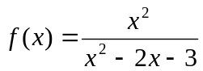 Use your graphing calculator and/or you crazy algebra skills to find the Domain and Range of f(x)

2) You are building a rectangular enclosure with 1000 sq ft of fence. You will use one side of your building as one side of the enclosure. Let x and y be the dimensions of the enclosure and let L be the length of fencing required. Note: xy=1000.

a) find a formula for L in terms of x and y and use the area formula to express L in terms of only x. (remember that one side of the enclosure does not need fencing)

b) State any restrictions on x.

c) Graph L versus x and use the graph to estimate the value of x that results in the smallest value of L.

d) Estimate the smallest value of L.

3) A camera is positioned 3000 ft from the base of a launching pad. As the rocket rises vertically, the camera elevation angle changes to follow the bottom of the rocket.

a) Draw and label a sketch and then express the height of the rocket as a function of the
elevation angle of the camera.

b) Find the natural domain and range of your function.

c) Specify any physical restrictions on your domain and range.

d) Graph the height v. elevation angle and use the graph to approximate the height of the rocket when the elevation angle is π/4. Your calculator should be in radian mode.

4) 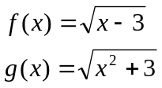 Find 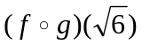 and find 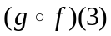

5) 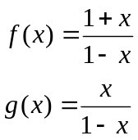 Find 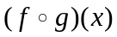 and find 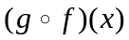 and give domain, range for each.
6) 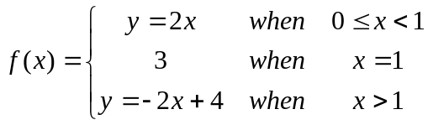
Find: 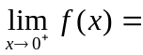 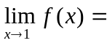 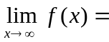

7) Find 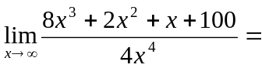

8) Given the function below, use a ruler to approximate f ‘(2).
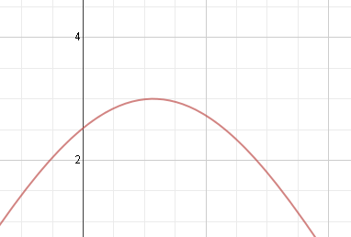

9) Use the definition of the derivative to find f ‘(x), given f(x)=-x²+2

10) Given f(x)=x³-2x+1 and f ’(x)=3x²-2 , Find the equation of the line that is tangent to f(x) at x=1.

