AP Calculus AB - Minuteman Tech Mr. McGowan
Test 2 Chapters 3.3-6 Summer 2013
1) Find 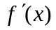
a) 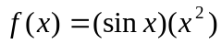 b) 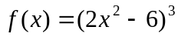 c) 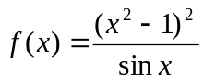
d) 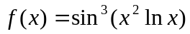 e) 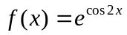

2) Solve for x (no calculator, show your work)
a) 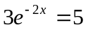 b) 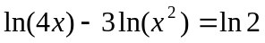

3) Find  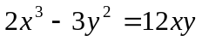
4) A camera is mounted 3000 ft from the launch pad for a rocket and trained on the base of the rocket. At what rate is the camera-to-rocket distance changing when the rocket is 4000 ft up and rising vertically at 880 ft/s?

5) Make a sketch (on graph paper) of a continuous curve with f(2)=4, f '(2)=0, f ''(x)>0 for x<2, f ''(x)<0 for x>2.

6) Find all relative extrema for 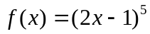 (do not use your calculator, and show all your work.

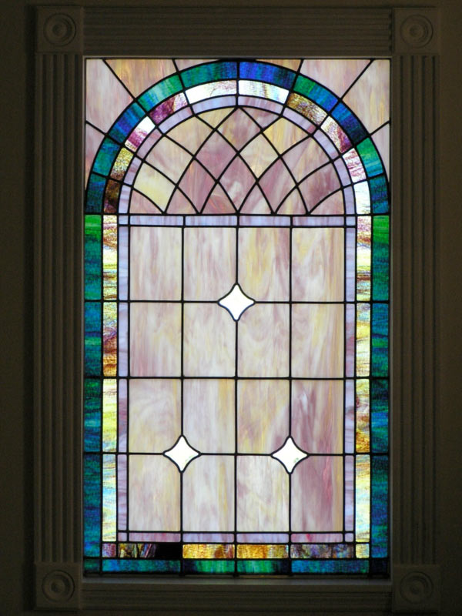
7) Find the absolute max and min values for 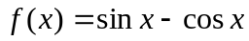 on the interval [0,π] and state where those values occur.

8) A church window consisting of a rectangle topped by a semicircle is to have a perimeter p. Find the radius of the semicircle if the area of the window is to be maximum.

9) The position v time function for an object moving in a straight line is 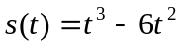 for 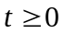.
a) At what time t is the object stopped?
b) what total distance does the object cover during the interval [0,5]?

10) Approximate 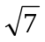by applying Newton's method to the equation 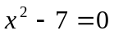
Remember 