AP Calculus AB - Minuteman Tech Mr. McGowan
Test 3 Chapter 7 Summer 2013

1) a) 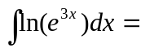 b)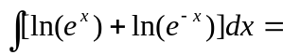

2) a) 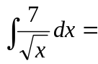 b) 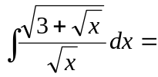

3) a) 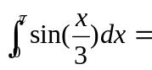 b) 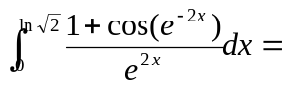

4) Use your graphing calculator to help you approximate the largest and smallest values for 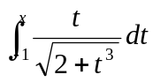 for 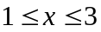

5) Use the midpoint method with n=4 to approximate the area under the curve 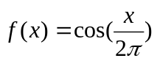on the interval [0,8]

6) a) 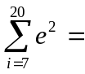 b) 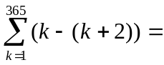

7) Given that 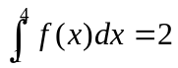 and 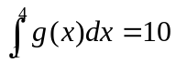
Find 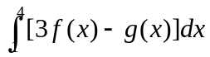

8) Find the average value of f(x) on the given interval
a) 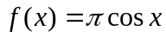 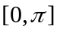 b) 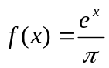 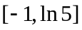

9) A particle moving along a straight line is accelerating at a constant rate of 3m/s². Find the initial velocity if the particle moves 40m in the first 4s.

10) 