AP Calculus AB - Minuteman Tech Mr. McGowan
Test 4 Chapters 8,9 Summer 2013

Directions: draw stuff for points.
1) Find the area between y=x³-4x, y=0, x=0, and x=2.

2) Find the area between y=sinx and the segment joining (0,0) and 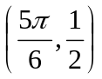. Note that both the points are on the curve y=sinx.

3) Find the volume of the solid generated when the region between
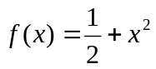 and 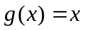 on the interval [0,2] is revolved about the x-axis.

4) Find the volume of the solid generated when the region bounded by
y=x³, x=0, and y=1 is revolved about the y-axis.

5) Use the shell method, 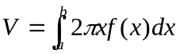, to find the volume of the solid generated when the area between y=x² and the x-axis on [1,2] is revolved about the y-axis.

6) Use the formula 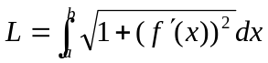 to find the length of the curve y=3x-2 from x=0 to x=3.

7) Use the formula 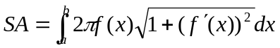 to find the area of the surface generated when the curve y=2x-6 from x=0 to x=3 is rotated about the x-axis.

8) a) 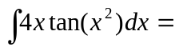 b) 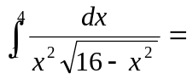

9) Use integration by parts to integrate 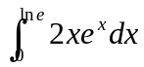

10) Use Partial fractions to integrate 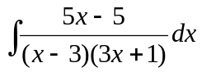

EC) Use Partial fractions to integrate 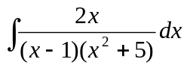 (you will end with 1 integral that you can’t solve… just leave it in the solution)

