public class Question1 {

public static void main(String[] args) {

System.out.println("*_*_*_*_*_*_*_*");

System.out.println(" *_*_*_*_*_*_*");

System.out.println(" *_*_*_*_*_*");

System.out.println(" *_*_*_*_*");

System.out.println(" *_*_*_*");

System.out.println(" *_*_*");

System.out.println(" *_*");

System.out.println(" *");

System.out.println("Welcome to Java");

System.out.println("Welcome to Computer Science");

System.out.println("Programming is fun");

System.out.println("*_*_*_*_*_*_*_*");

System.out.println("*_*_*_*_*_*_*");

System.out.println("*_*_*_*_*_*");

System.out.println("*_*_*_*_*");

System.out.println("*_*_*_*");

System.out.println("*_*_*");

System.out.println("*_*");

System.out.println("*");

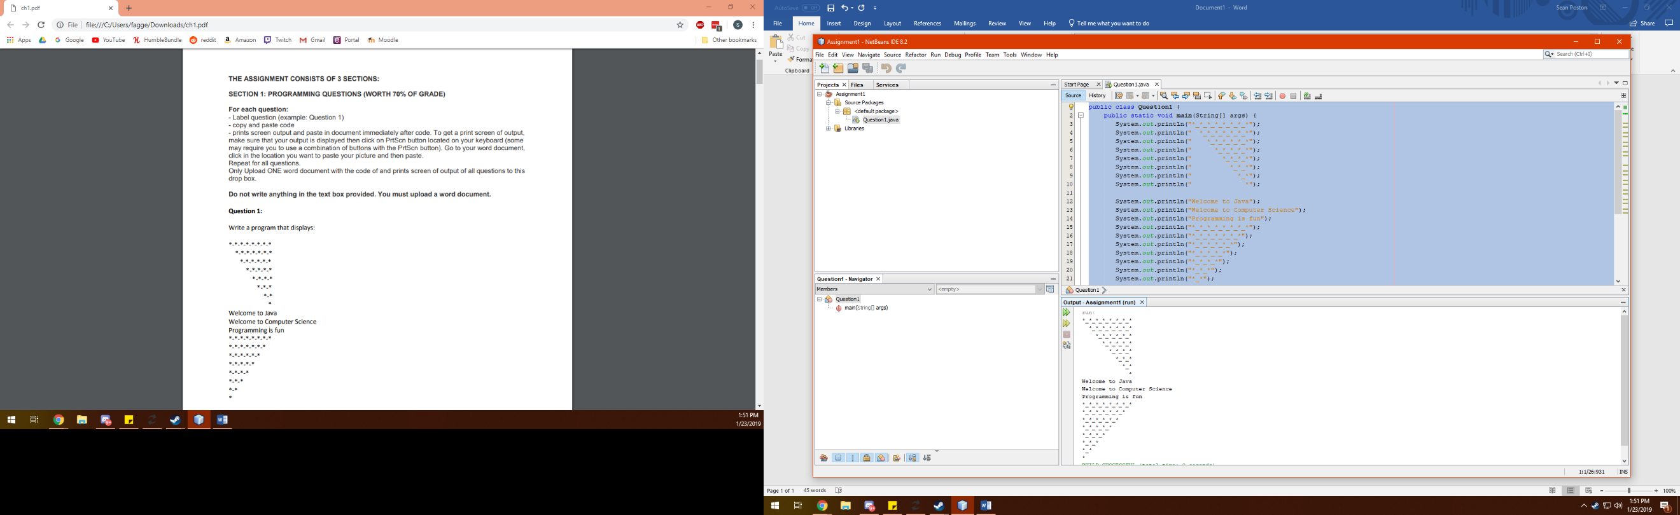 }

}

public class Question2 {

public static void main(String[] args) {

System.out.println("((10.5 x 3 x 4.6)(9.5 x 4.5 - 2.5 x 3)) / (45.5 - 3.5) = " + ((10.5 * 3 * 4.6)*(9.5 * 4.5 - 2.5 * 3)) / (45.5 - 3.5));

}

}

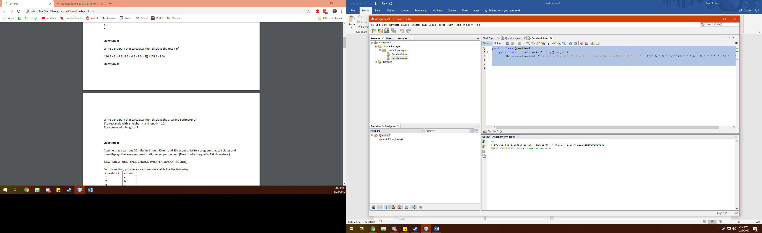

public class Question3 {

public static void main(String[] args) {

System.out.println("A rectangle with a width of 4 and a length of 10 has an area of " + 4*10 + " and a perimeter of " + (2*4)+(2*10) + ".");

System.out.println("A square with a length of 5 has an area of " + 5*5 + " and a perimeter of " + (4*5) + ".");

}

}

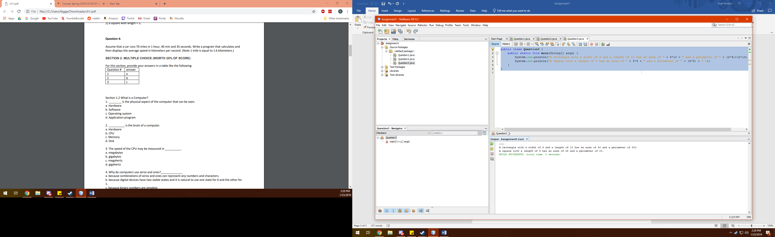

public class Question4 {

public static void main(String[] args) {

System.out.print("A car that goes 70 miles in 1 hour, 40 minutes, and 35 seconds is going ");

System.out.print((70*1.6)/(1*60*60)+(40*60)+35);

System.out.println(" kilometers per second.");

}

}

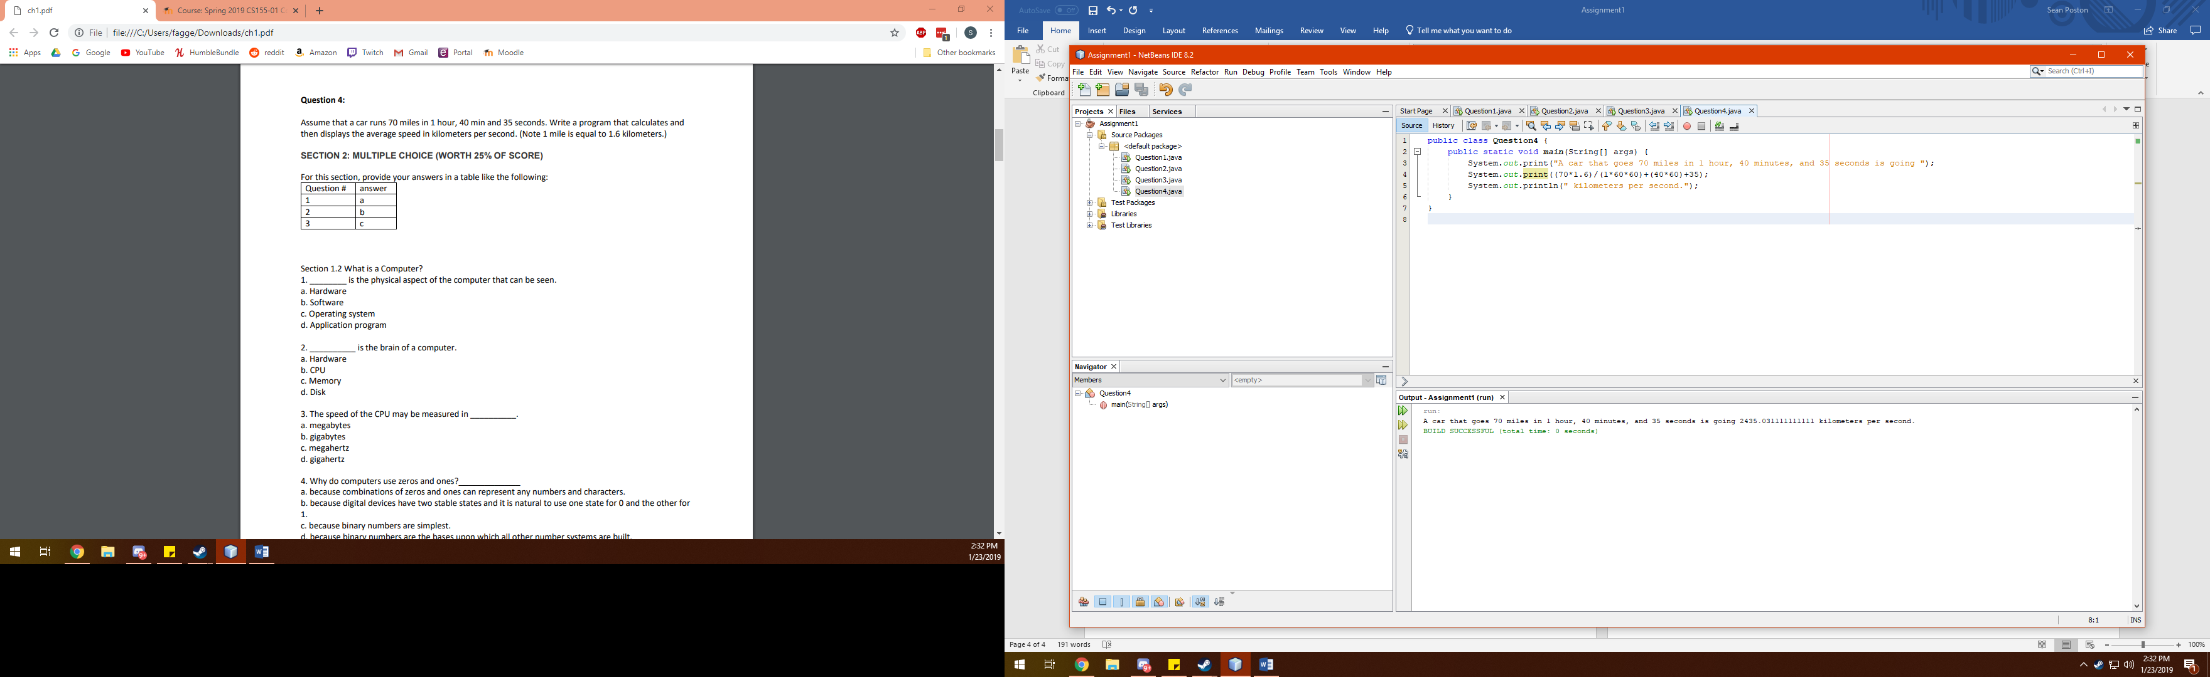

**Section 2**

|  |  |
| --- | --- |
| 1 | A |
| 2 | B |
| 3 | C, D |
| 4 | B |
| 5 | B |
| 6 | E |
| 7 | D |
| 8 | B, C |
| 9 | A |
| 10 | B |
| 11 | C |
| 12 | A |
| 13 | A |
| 14 | B |
| 15 | E |
| 16 | E |
| 17 | A |
| 18 | A |
| 19 | B |
| 20 | C |
| 21 | D |
| 22 | C |
| 23 | B |
| 24 | B |
| 25 | C |
| 26 | A |
| 27 | A |
| 28 | A |
| 29 | D |
| 30 | C |
| 31 | A |
| 32 | A, C, E |
| 33 | A, B, C, D |
| 34 | A |
| 35 | B |
| 36 | C, D |
| 37 | D |
| 38 | D |
| 39 | C |
| 40 | A |

**Section 3**

1. The JDK isn’t installed or configured properly.
2. The file name isn’t correctly input, so it’s not found.
3. The class Welcome is named something different from the source code’s filename.
4. The code doesn’t contain a main method block.
5. (string[] args) should be capitalized to (String[] args).