Sean Poston

1/25/19

**Question 1**

public class Quiz11 {

public static void main(String[] args) {

System.out.println("Welcome to CS155");

System.out.println("Programming");

System.out.println("in");

System.out.println("Java");

System.out.println("is");

System.out.println("fun");

}

}

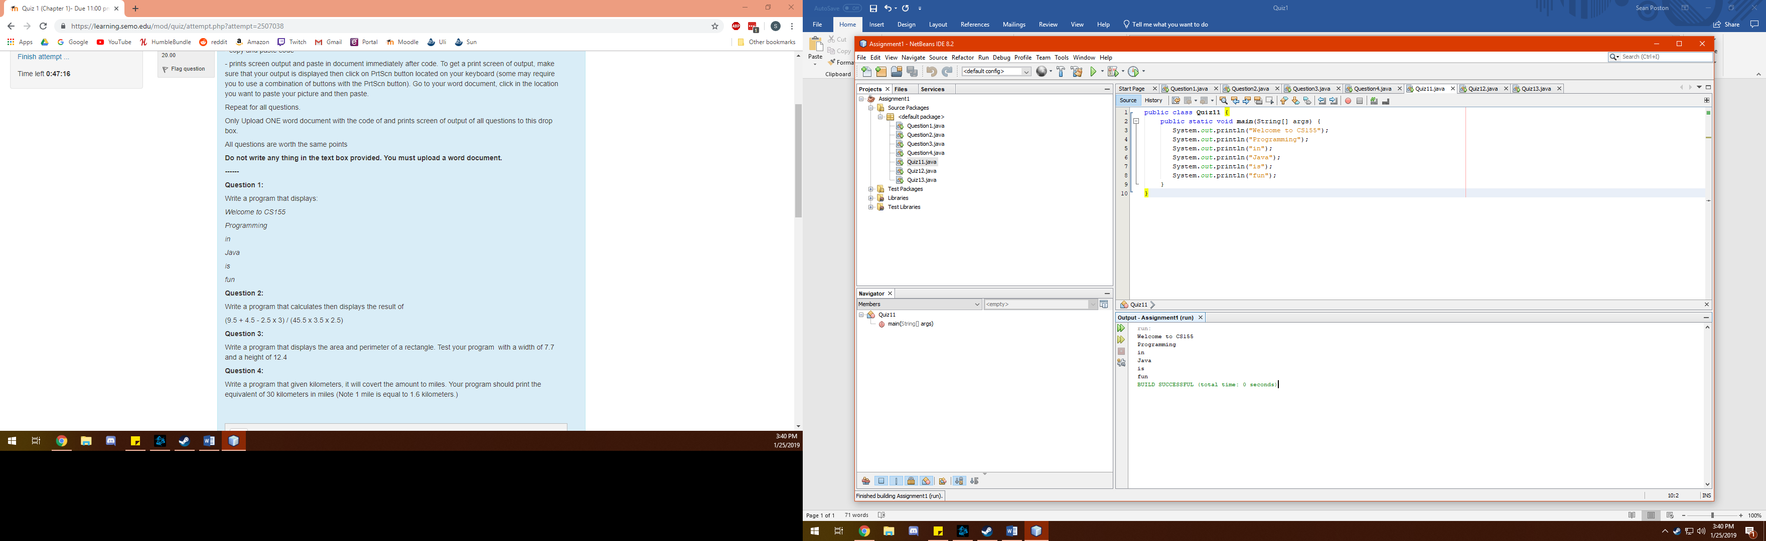

**Question 2**

public class Quiz12 {

public static void main(String[] args) {

System.out.print("(9.5 + 4.5 - 2.5 x 3) / (45.5 x 3.5 x 2.5) is equal to ");

System.out.println((9.5 + 4.5 - (2.5 * 3.0)) / (45.5 * 3.5 * 2.5));

}

}

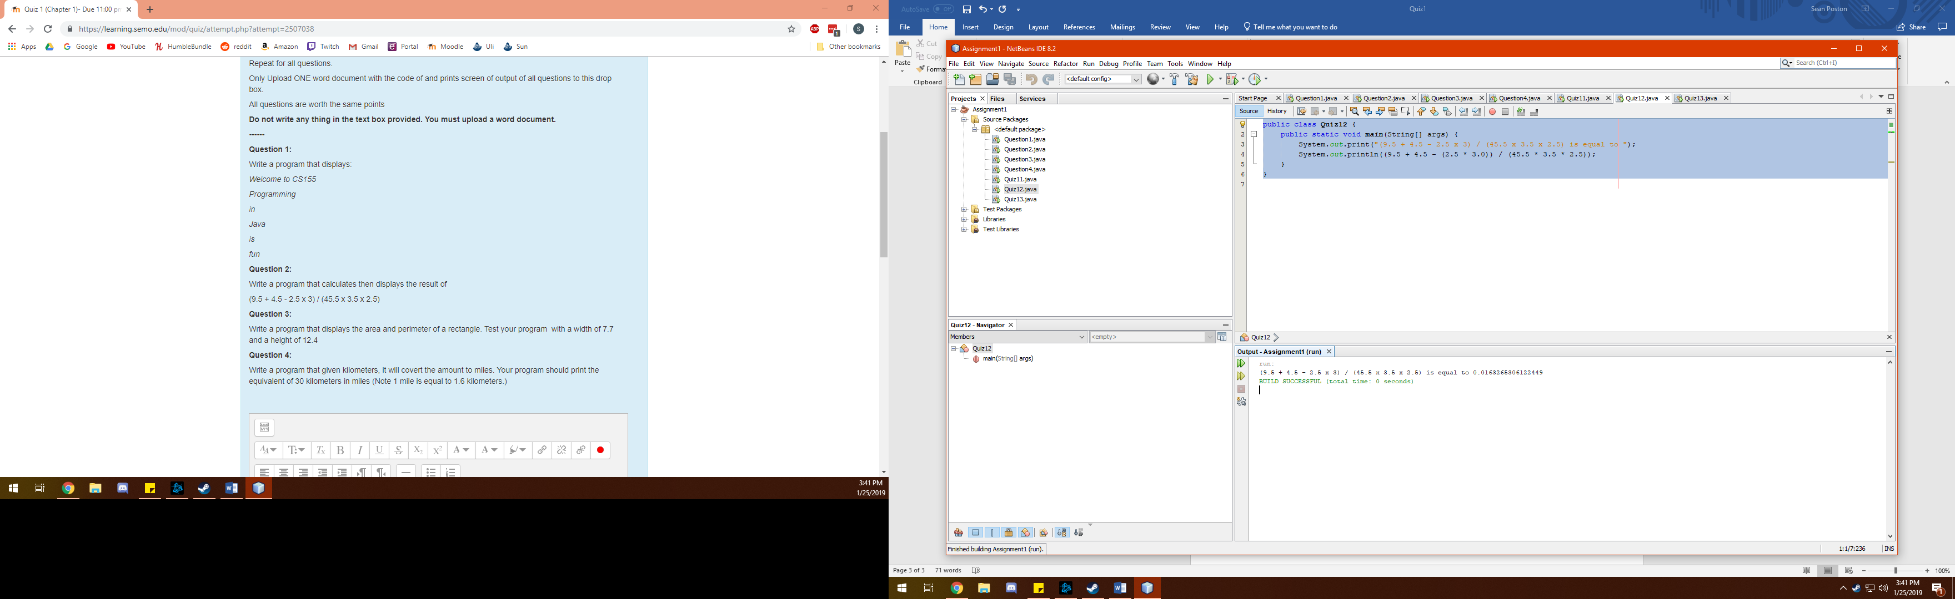

**Question 3**

import java.util.Scanner;

public class Quiz13 {

public static void main(String[] args) {

Scanner input = new Scanner(System.in);

System.out.println("This program will calculate the area and perimeter of a rectangle.");

System.out.print("Enter the length: ");

double length = input.nextDouble();

System.out.print("Enter the width: ");

double width = input.nextDouble();

System.out.println("The area of the rectangle is: " + length * width);

System.out.println("The perimeter of the rectangle is: " + ((2.0 * length) + (2.0 * width)));

}

}

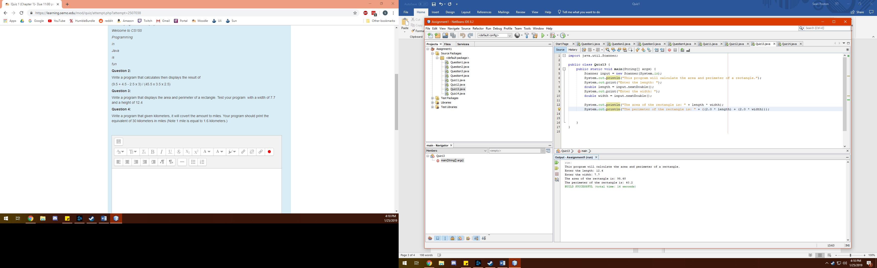

**Question 4**

import java.util.Scanner;

public class Quiz14 {

public static void main(String[] args){

Scanner input = new Scanner(System.in);

System.out.println("This program will convert kilometers to miles.");

System.out.print("Please enter the distance in kilometers: ");

double km = input.nextDouble();

double miles = + (km * 0.6214);

System.out.println("The converted distance is " + (miles) + " miles.");

}

}

