1. **Assume that we are comparing implementations of insertion sort and merge sort on the same machine. For inputs of size k, insertion sort runs in 16k2 steps, while merge sort runs in 64k*lg(k) steps. For which values of k does insertion sort beat merge sort?**

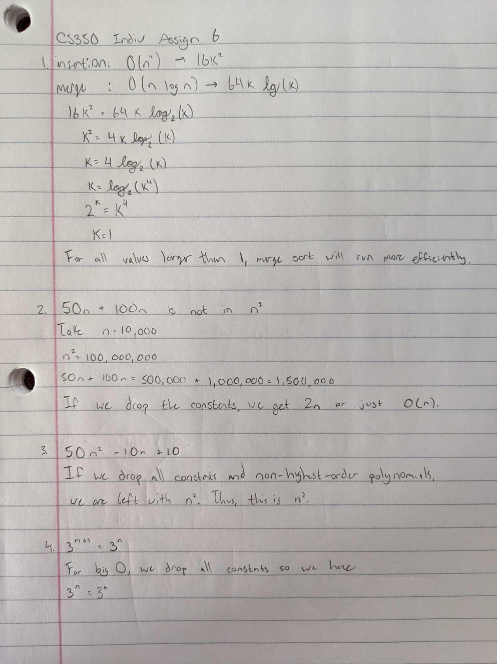

1. **Prove that 50n + 100n is in O(n2).**



1. **Prove that 50 n2 -10n + 10 is in O(n2) .**

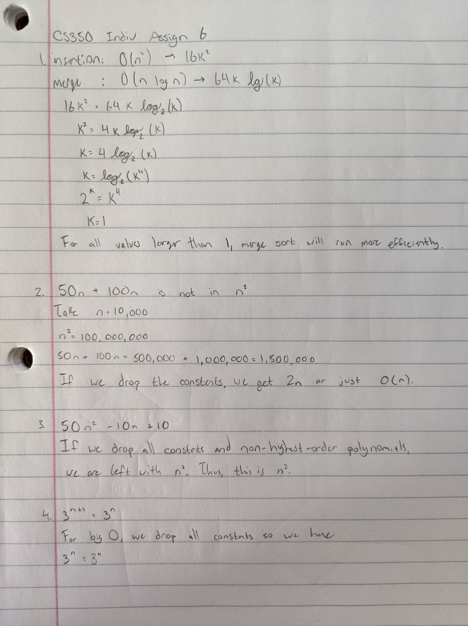

1. **Is = O() ? please write down your answers with detailed steps.**



1. **Write Java functions to implement Big-O notations below.**

**[3] O() [4] O**

public static void main(String[] args) {

    int n = 1000;

    // log n

    for (int i = 0; i < n; i *= 2) {

    }

    // n log n

    for (int i = 0; i < n; i++) {

      for (int j = n; j > 0; j /= 2) {

      }

    }

    // cube root

    for (int i = 0; i < Math.pow(n, 1/3); i++) {

    }

    // sqrt

    for (int i = 0; i < Math.sqrt(n); i++) {

    }

    // cubed

    for (int i = 0; i < n; i++) {

      for (int j = 0; j < n; j++) {

        for (int k = 0; k < n; k++) {

        }

      }

    }

  }

1. **Consider the graph in Figure 1 below. Unless otherwise indicated, always visit adjacent nodes in alphabetical order. (20% points, 10% each)**
2. **DFS algorithm traverses all nodes starting at node D**

**D -> E -> G -> J -> B -> A -> C -> F -> K -> H -> I**

1. **BFS algorithm traverses all nodes starting at node G**

**J -> K -> F -> C -> A -> B -> D -> E -> G -> I -> H**

**2. Consider the graph in Figure 1 below. Please fill in Questions 1-7.**

1. READY
2. RUNNING
3. WAITING
4. SLEEPING
5. BLOCKED
6. SUSPENDED
7. DEAD