**Sean Poston**

CS-351

1/31/2020

Homework 1A: <https://repl.it/@seanposton4/CS351-Homework-1A>

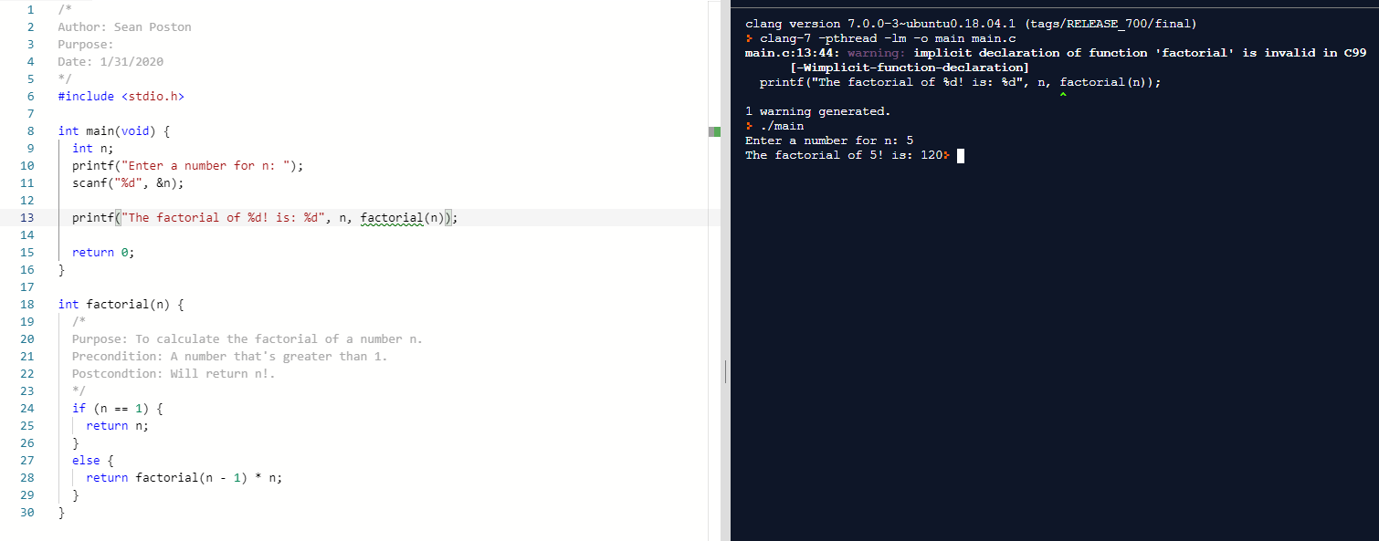

Homework 1B: <https://repl.it/@seanposton4/CS351-Homework-1B>

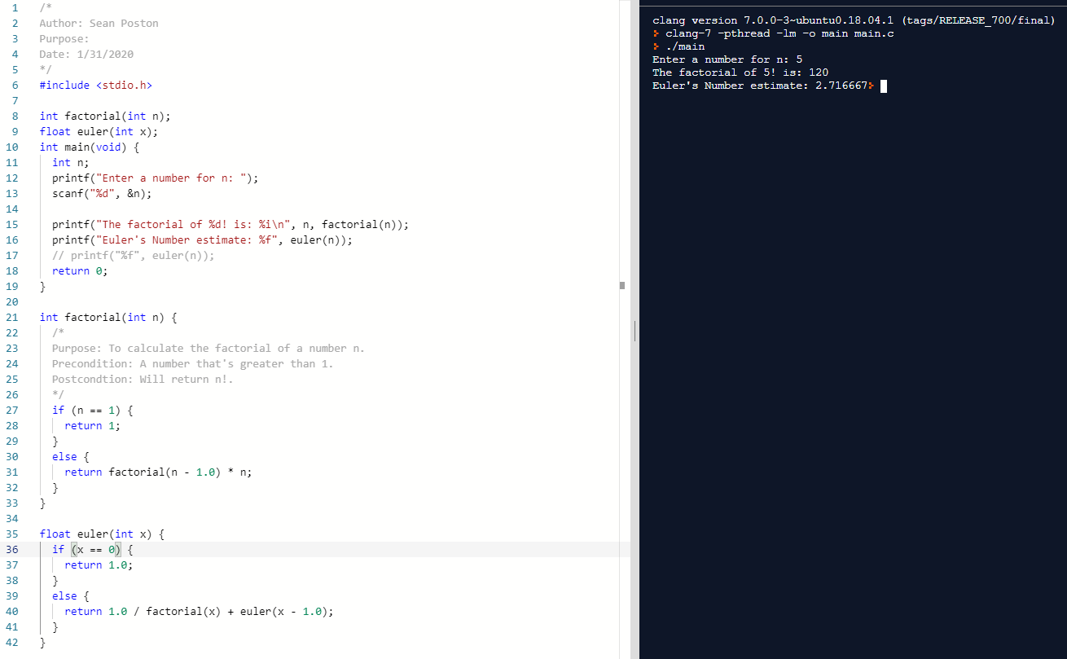

Homework 1C: <https://repl.it/@seanposton4/CS351-Homework-1C>

