**Sean Poston**

**4.5:**

a) “For” is capitalized. X isn’t declared with a type. It’s an infinite loop.

b) Value isn’t initialized, no “break;” on the cases.

c) Type is never specified on char Val.

d) Computers don’t evaluate floats exactly, and the program will only run when x = 0.0001 which will be never.

e) It’s an infinite loop (needs to be x -= 2 to be fixed).

f) It’s redundant to put the if statement with += 2. The counter doesn’t have a type when initialized. Do and While shouldn’t be capitalized.

g) Should be x++ for proper execution.

**4.7:** <https://repl.it/@seanposton4/Homework-2-47>

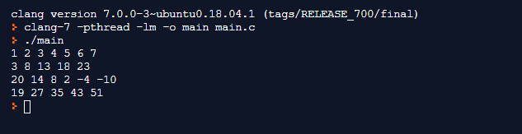

**5.8:** <https://repl.it/@seanposton4/Homework-2-58>

