**Instructions:**

**In a word document, answer the following questions.**

**Keep question in the exact order they are listed in.**

**Questions should be in bold font.**

**Answers should be in non-bold font.**

**All questions are worth the same points**

**Question 1 (Chapter 10): consider the following database and its schema. Write a program segment to read a student’s name and print his or her grade point average, assuming that A=4, B=3, C=2 and D=1 points.**

1. **Use SQLJ with Java as the host language**

1- stuName = readEntry("Enter Student's Name: ");

1. #sql iterator Grades (
2. char grade
3. );
4. Grades grades;
5. try {
6. grades = #sql(
7. SELECT gr.Grade
8. INTO grade
9. FROM GRADE_REPORT gr, STUDENT stu
10. WHERE stu.Name = stuName AND gr.Student_number = stu.Student_number
11. );
12. while (grades.hasNext()) {
13. grades.next();
14. switch (grades.grade) {
15. case 'A':
16. gpa += 4.0;
17. break;
18. case 'B':
19. gpa += 3.0;
20. break;
21. case 'C':
22. gpa += 2.0;
23. break;
24. case 'D':
25. gpa += 1.0;
26. break
27. }
28. numGrades++;
29. }
30. System.out.println(stuName + " GPA: " + gpa / numGrades)
31. }
32. catch (Exception e) {
33. System.out.println("Error: " + e);
34. }
35. **Use JDBC with Java as the host language**
36. import java.sql.*;
37. class Homework10 Q2.java {
38. public static void main (String args[]) throws SQLException, IOException {
39. try { Class.forName("oracle.jdbc.driver.OracleDriver")}
40. catch (ClassNotFoundException e) {
41. System.out.println("Driver not located");
42. }
43. String user, password;
44. Connection conn = DriverManager.getConnection("jdbc:oracle:oci8:" + user + "/" + password);
45. String stuName = readentry("Enter Student's Name: ");
47. String stmt = "SELECT Grade FROM GRADE_REPORT gr, STUDENT stu WHERE stu.Name = name AND gr.Student_number = stu.Student_number";
48. PreparedStatement p = conn.prepareStatement(stmt);
49. ResultSet r = p.executeQuery();
50. int numGrades;
51. float gpa;
52. while (r.next()) {
53. switch (grades.grade) {
54. case 'A':
55. gpa += 4.0;
56. break;
57. case 'B':
58. gpa += 3.0;
59. break;
60. case 'C':
61. gpa += 2.0;
62. break;
63. case 'D':
64. gpa += 1.0;
65. break
66. }
67. numGrades++;
69. }
70. System.out.println("GPA: " + gpa / numGrades)
71. }
72. }

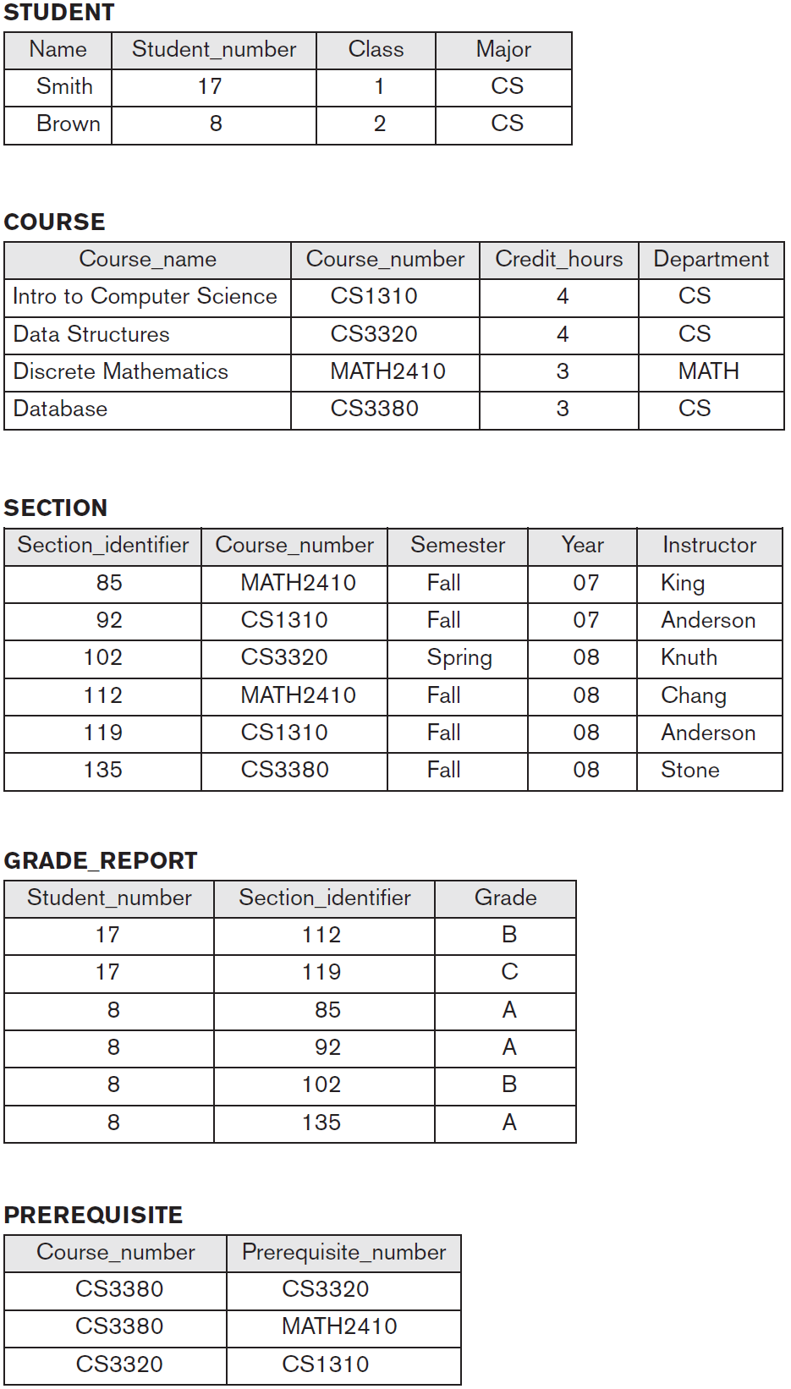

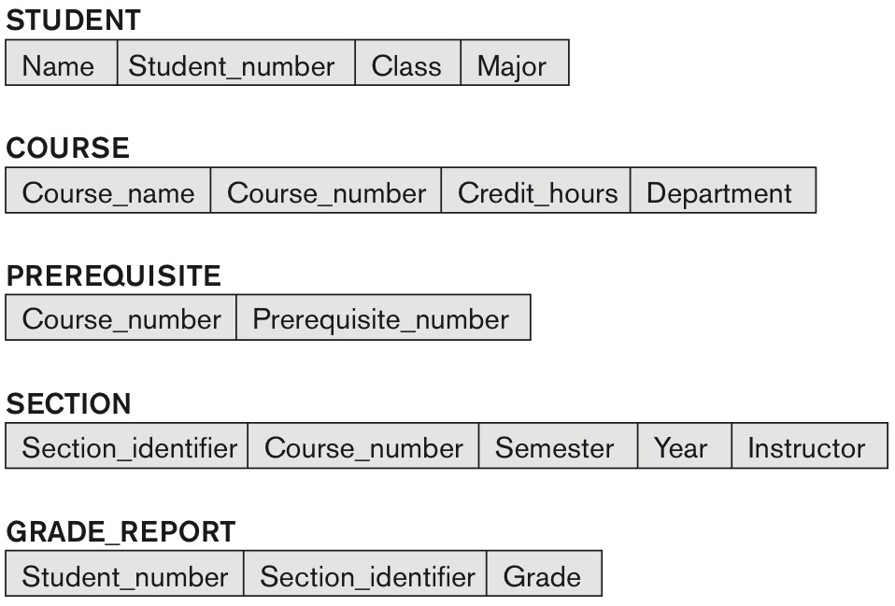

**Question 2 (chapter 10): consider the following library relational database schema Write a program segment to retrieves the list of books that became overdue yesterday and that prints the book title and borrower name for each .**

1. **Use SQLJ with Java as the host language**

1-

1. class Homework10 Q2.java {
2. public static void main (String args[]) {
3. #sql iterator borrowerInfo (
4. String borrower;
5. String title;
6. );
7. borrowerInfo bInfo;
8. try {
9. bInfo = #sql(
10. SELECT b.Title, bor.Name FROM BOOK_LOANS bl, BOOK b, BORROWER bor WHERE bl.Card_no = bor.Card_no AND b.Book_id = bl.Book_id AND bl.Due_date < SYSDATE
11. );
13. while (bInfo.next()) {
14. System.out.printf("Borrower: %s -> Title: %s\n", bInfo.borrower, bInfo.title);
15. }
16. catch (Exception e) {
17. System.out.println("Exception: ", e);
18. }
19. }
20. }
21. **Use JDBC with Java as the host language**
22. import java.sql.*;
23. class Homework10 Q2.java {
24. public static void main (String args[]) throws SQLException, IOException {
25. try { Class.forName("oracle.jdbc.driver.OracleDriver")}
26. catch (ClassNotFoundException e) {
27. System.out.println("Driver not located");
28. }
29. String user, password;
30. Connection conn = DriverManager.getConnection("jdbc:oracle:oci8:" + user + "/" + password);
31. String stmt = "SELECT b.Title, bor.Name FROM BOOK_LOANS bl, BOOK b, BORROWER bor WHERE bl.Card_no = bor.Card_no AND b.Book_id = bl.Book_id AND bl.Due_date < SYSDATE";
32. PreparedStatement p = conn.prepareStatement(stmt);
33. ResultSet r = p.executeQuery();
35. while (r.next()) {
36. System.out.printf("Borrower: %s -> Title: %s\n", r.getString(1), r.getString(2));
37. }
38. }
39. }

