**Instructions:**

**In a word document, answer the following questions.**

**Keep question in the exact order they are listed in.**

**Questions should be in bold font.**

**Answers should be in non-bold font.**

**All questions are worth the same points**

**Question 1 (chapter 11): consider the following LIBRARY database schema. Write PHP code to create the tables of this schema.**

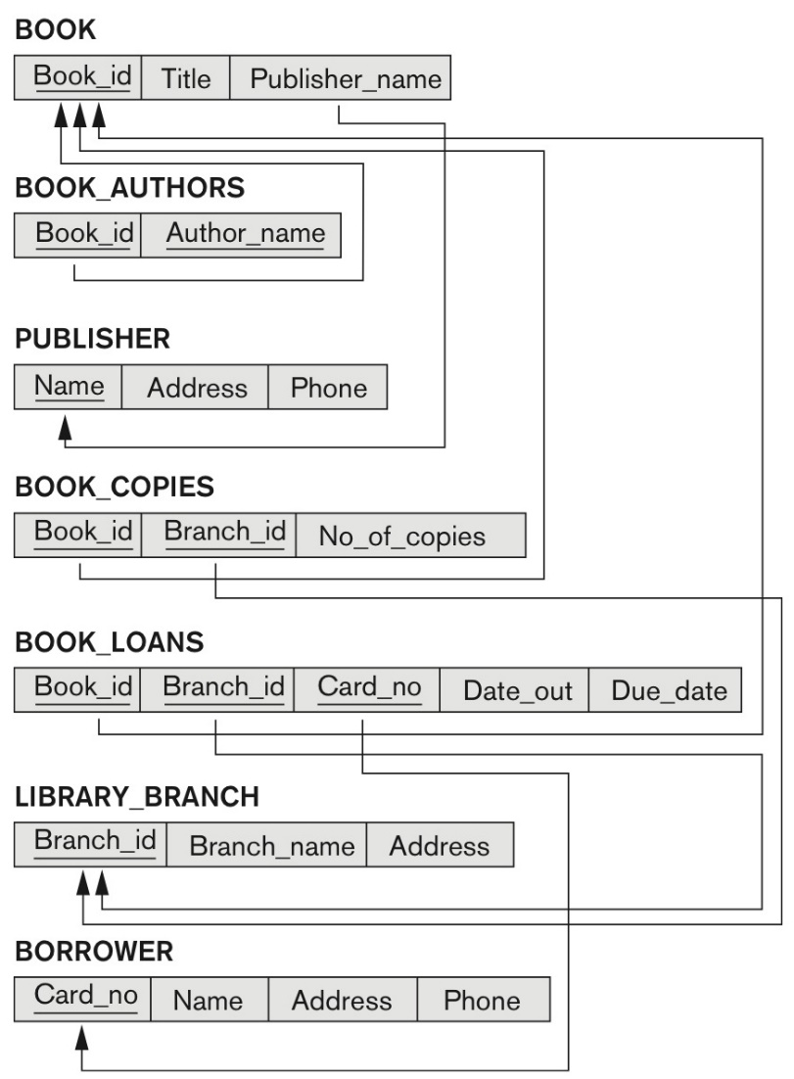

<?php

?>

**Question 2 (chapter 11): Write a PHP program that creates Web forms for entering the information about a new BORROWER entity. Repeat for a new BOOK entity.**

<?php

<FORM method=”post” action=””>

<p>Enter Card Number: <input type = “text” name=”Card_no”></p>

<p>Enter Name: <input type=”text” name=”Name”></p>

<p>Enter Address: <input type=”text” name=”Address”></p>

<p>Enter Phone: <input type=”text” name=”Phone”></p>

<input type =”submit” value=”Submit Borrower”>

</FORM>

?>

<?php

<FORM method=”post” action=””>

<p>Enter Book ID: <input type = “text” name=”Book_id”></p>

<p>Enter Title: <input type=”text” name=”Title”></p>

<p>Enter Publisher Name: <input type=”text” name=”Publisher_name”></p>

<input type =”submit” value=”Submit Book”>

</FORM>

?>