**Instructions:**

**In a word document, answer the following questions.**

**Keep question in the exact order they are listed in.**

**Questions should be in bold font.**

**Answers should be in non-bold font.**

**All questions are worth the same points**

**Question 1 (CHAPTER 6) Consider the database and schema shown next.**

**What are the referential integrity constraints that should hold on the schema?**

**Write appropriate SQL DDL statements to define the database.**

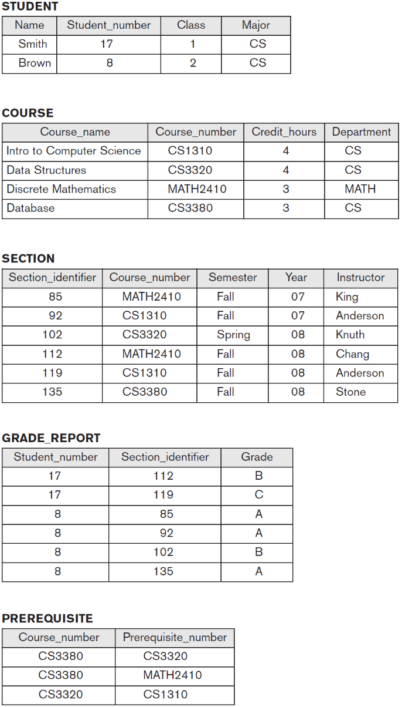

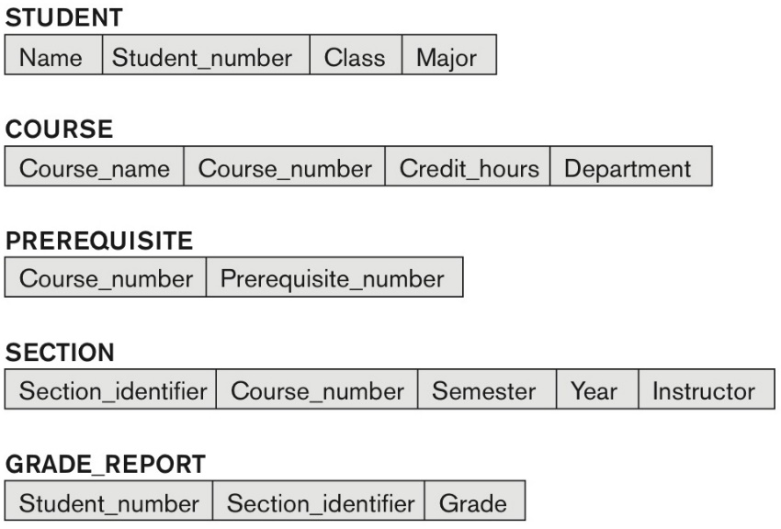

CREATE TABLE STUDENT (

Name VARCHAR(30) NOT NULL,

Student_number INTEGER NOT NULL,

Class INTEGER NOT NULL,

Major CHAR(2),

PRIMARY KEY(Student_number)

);

CREATE TABLE COURSE (

Course_number CHAR(8) NOT NULL,

Credit_hours INTEGER NOT NULL,

Department CHAR(4),

PRIMARY KEY (CourseNumber),

UNIQUE (CourseName);

);

CREATE TABLE PREREQUISITE (

Course_number CHAR(8) NOT NULL,

Prerequisite_number CHAR(8),

FOREIGN KEY(Course_number) REFERENCES COURSE(Course_number),

FOREIGN KEY(Prerequisite_number) REFERENCES COURSE(Course_number)

);

CREATE TABLE SECTION (

Section_identifier INTEGER NOT NULL,

Course_number CHAR(8) NOT NULL,

Semester CHAR(6) NOT NULL,

Year CHAR(4),

Instructor CHAR(30),

PRIMARY KEY(Section_identifier),

FOREIGN KEY (Course_number) REFERENCES COURSE (Course_number)

);

CREATE TABLE GRADE_REPORT (

Student_number INTEGER NOT NULL,

Section_identifier INTEGER NOT NULL,

Grade CHAR,

PRIMARY KEY(Student_number)

FOREIGN KEY (Student_number) REFERENCES STUDENT (Student_number),

FOREIGN KEY (Section_identifier) REFERENCES SECTION (SectionIdentifier)

);

**Question 2 (CHAPTER 6) Write appropriate SQL DDL statements for declaring the LIBRARY relational database schema of following figure Specify the keys and referential triggered actions.**

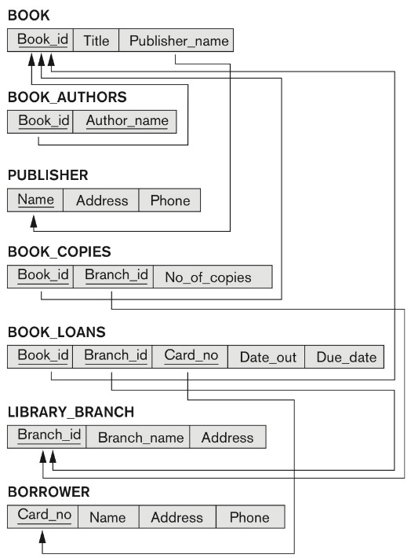

CREATE TABLE BOOK (

Book_id VARCHAR(30) NOT NULL,

Title VARCHAR(100) NOT NULL,

Publisher_name VARCHAR(30),

PRIMARY KEY(Book_id)

FOREIGN KEY (Publisher_name) REFERENCES PUBLISHER(Name)

);

CREATE TABLE BOOK_AUTHORS (

Book_id VARCHAR(30) NOT NULL,

Author_name VARCHAR(30) NOT NULL,

PRIMARY KEY (Book_id, Author_name),

FOREIGN KEY (Book_id) REFERENCES BOOK (Book_id)

);

CREATE TABLE PUBLISHER (

Name VARCHAR(30) NOT NULL,

Address VARCHAR(50) NOT NULL,

Phone VARCHAR(10),

PRIMARY KEY (Name)

);

CREATE TABLE BOOK_COPIES(

Book_id VARCHAR(30) NOT NULL,

Branch_id VARCHAR(30) NOT NULL,

No_of_copies INTEGER,

PRIMARY KEY (Book_id, Branch_id),

FOREIGN KEY (Book_id) REFERENCES BOOK (Book_id)

FOREIGN KEY (Branch_id) REFERENCES LIBRARY_BRANCH (Branch_id),

);

CREATE TABLE BOOK_LOANS(

Book_id VARCHAR(30) NOT NULL,

Branch_id VARCHAR(30) NOT NULL,

Card_no INTEGER NOT NULL,

Date_out DATETIME,

Due_date DATETIME,

PRIMARY KEY (Book_id, Branch_id, Card_no),

FOREIGN KEY (Book_id) REFERENCES BOOK (Book_id)

FOREIGN KEY (Branch_id) REFERENCES LIBRARY_BRANCH (Branch_id),

FOREIGN KEY (Card_no) REFERENCES BORROWER (Card_no)

);

CREATE TABLE LIBRARY_BRANCH(

Branch_id VARCHAR(30) NOT NULL,

Branch_name VARCHAR (30) NOT NULL,

Address VARCHAR(50) NOT NULL,

PRIMARY KEY (Branch_id)

);

CREATE TABLE BORROWER(

Card_no INTEGER NOT NULL,

Name CHAR(30) NOT NULL,

Address VARCHAR(50) NOT NULL,

Phone VARCHAR(10) NOT NULL,

PRIMARY KEY(Card_no)

);