**Instructions:**

**In a word document, answer the following questions.**

**Keep question in the exact order they are listed in.**

**Questions should be in bold font.**

**Answers should be in non-bold font.**

**All questions are worth the same points**

**Question 1(chapter 7) Specify the following additional queries on the following database in SQL. Show the query results if applied to the following database.**

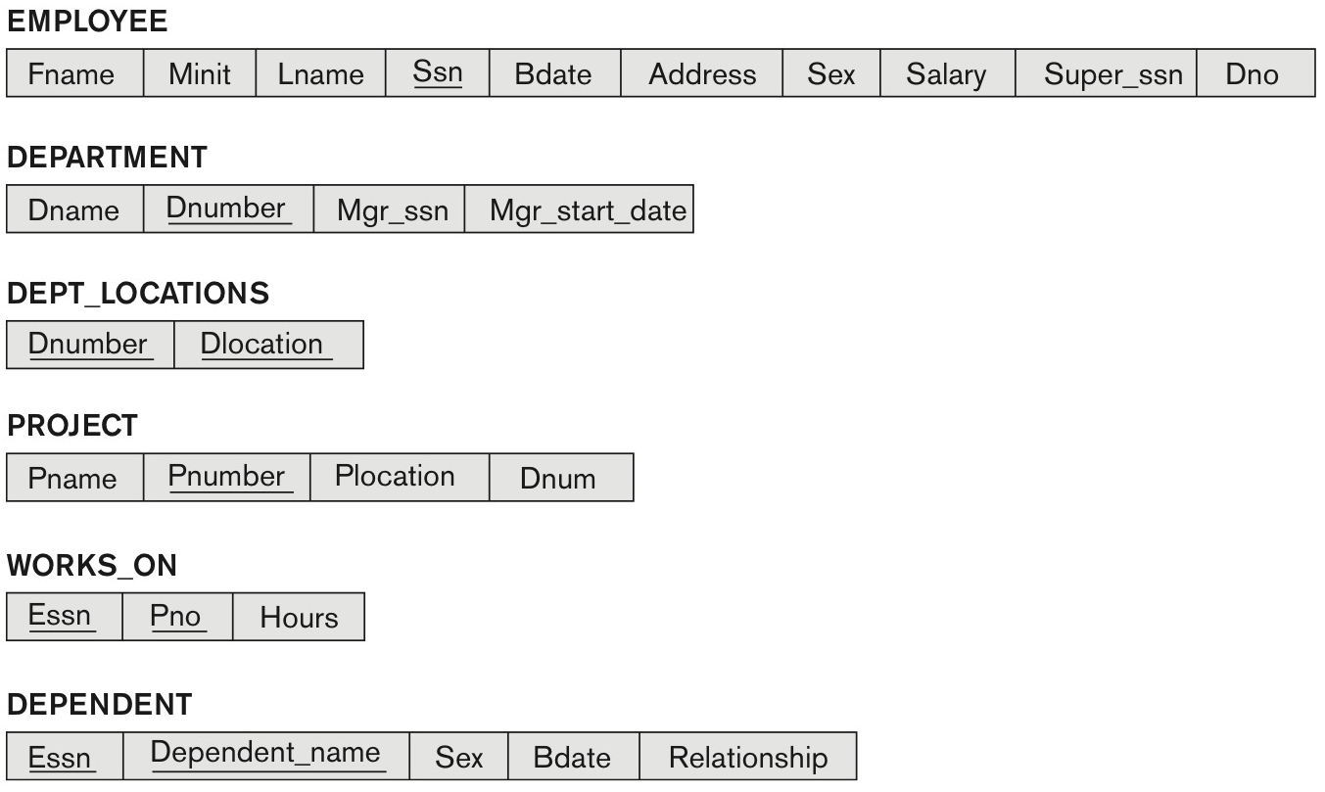

**3 tables list tuples under Employee, Department and Department locations.
Table 1 titled, employee has 8 rows and 9 columns. The columns have the following headings from left to right. F name, M i n i t, L name, S s n, B date, Address, Sex, Salary, Super s s n, D n o. The row entries are as follows. Row 1. F name, John. M i n i t, B. L name, Smith. S s n, 123 45 6789. B date, 19 65 01 09. Address, 731 Fondren, Houston, T X. Sex, M. Salary, 30,000. Super s s n, 333 44 5555. D n o, 5. Row 2. F name, Franklin. M i n i t, T. L name, Wong. S s n, 333 44 5555. B date, 19 55 12 08. Address, 638 Voss, Houston, T X. Sex, M. Salary, 40,000. Super s s n, 888 66 5555. D n o, 5. Row 3. F name, Alicia. M i n i t, J. L name, Zelaya. S s n, 999 88 7777. B date, 19 68 01 19. Address, 3321 Castle, Spring, T X. Sex, F. Salary, 25,000. Super s s n, 987 65 4321. D n o, 4. Row 4. F name, Jennifer. M i n i t, S. L name, Wallace. S s n, 987 65 4321. B date, 19 41 06 20. Address, 291 Berry, Bellaire, TX. Sex, F. Salary, 43,000. Super s s n, 888 66 5555. D n o, 4. Row 5. F name, Ramesh. M i n i t, K. L name, Narayan. S s n, 666 88 4444. B date, 19 62 09 15. Address, 975 Fire Oak, Humble, TX. Sex, M. Salary, 38,000. Super s s n, 333 44 5555. D n o, 5. Row 6. F name, Joyce. M i n i t, A. L name, English. S s n, 453 45 3453. B date, 19 72 07 31. Address, 5631 Rice, Houston, TX. Sex, F. Salary, 25,000. Super s s n, 333 44 5555. D n o, 5. Row 7. F name, Ahmad. M i n i t, V. L name, Jabbar. S s n, 888 66 5555. B date, 19 69 03 29. Address, 980 Dallas, Houston, TX. Sex, M. Salary, 25,000. Super s s n, 987 65 4321. D n o, 4. Row 8. F name, James. M i n i t, E. L name, Borg. S s n, 987 98 7987. B date, 19 37 11 10. Address, 450 Stone, Houston, T X. Sex, M. Salary, 55,000. Super s s n, NULL. D n o, 1. Table 2 titled, Department has 3 rows and 3 columns. The columns have the following headings from left to right. D name, D number, M g r s s n, M g r start date. The row entries are as follows. Row 1. D name, Research. D number, 5. M g r s s n, 333 44 5555. M g r start date, 19 88 05 22. Row 2. D name, Administration. D number, 4. M g r s s n, 987 65 4321. M g r start date, 19 95 01 01. Row 3. D name, Headquarters. D number, 1. M g r s s n, 888 66 5555. M g r start date, 19 81 06 19. Table 3 titled, DEPT LOCATIONS has 5 rows and 2 columns. The columns have the following headings from left to right. D number, D locations. The row entries are as follows. Row 1. D number, 1. D locations, Houston. Row 2. D number, 4. D locations, Stafford. Row 3. D number, 5. D locations, Bellaire. Row 4. D number, 5. D locations, Sugarland. Row 5. D number, 5. D locations, Houston.**

**3 tables list the database of the entities Works ON, Project and Dependent. Table 1 titled, WORKS ON. The Table has 16 rows and 3 columns. The columns have the following headings from left to right. E s s n, P n o, Hours. The row entries are as follows. Row 1. E s s n, 123 45 6789. P n o, 1. Hours, 32.5. Row 2. E s s n, 123 45 6789. P n o, 2. Hours, 7.5. Row 3. E s s n, 666 88 4444. P n o, 3. Hours, 40.0. Row 4. E s s n, 453 45 3453. P n o, 1. Hours, 20.0. Row 5. E s s n, 453 45 3453. P n o, 2. Hours, 20.0. Row 6. E s s n, 333 44 5555. P n o, 2. Hours, 10. Row 7. E s s n, 333 44 5555. P n o, 3. Hours, 10. Row 8. E s s n, 333 44 5555. P n o, 10. Hours, 10. Row 9. E s s n, 333 44 5555. P n o, 20. Hours, 10. Row 10. E s s n, 999 88 7777. P n o, 30. Hours, 30. Row 11. E s s n, 999 88 7777. P n o, 10. Hours, 10. Row 12. E s s n, 987 98 7987. P n o, 10. Hours, 35. Row 13. E s s n, 987 98 7987. P n o, 30. Hours, 5. Row 14. E s s n, 987 65 4321. P n o, 30. Hours, 20. Row 15. E s s n, 987 65 4321. P n o, 20. Hours, 15. Row 16. E s s n, 888 66 5555. P n o, 20. Hours, NULL. Table 2 titled, Project. The Table has 6 rows and 3 columns. The columns have the following headings from left to right. P name, P number, P location, D n u m. The row entries are as follows. Row 1. P name, Product X. P number, 1. P location, Bellaire. D n u m, 5. Row 2. P name, Product Y. P number, 2. P location, Sugarland. D n u m, 5. Row 3. P name, Product Z. P number, 3. P location, Houston. D n u m, 5. Row 4. P name, Computerization. P number, 10. P location, Stafford. D n u m, 4. Row 5. P name, Reorganization. P number, 20. P location, Houston. D n u m, 1. Row 6. P name, New benefits. P number, 30. P location, Stafford. D n u m, 4. Table 3 titled, Dependent. The Table has 7 rows and 4 columns. The columns have the following headings from left to right. E s s n, Dependent name, sex, B date, Relationship. The row entries are as follows. Row 1. E s s n, 333 44 5555. Dependent name, Alice. sex, F. B date, 19 86 04 05. Relationship, Daughter. Row 2. E s s n, 333 44 5555. Dependent name, Theodore. sex, M. B date, 19 83 10 25. Relationship, Son. Row 3. E s s n, 333 44 5555. Dependent name, Joy. sex, F. B date, 19 58 05 03. Relationship, Spouse. Row 4. E s s n, 987 65 4321. Dependent name, Abner. sex, M. B date, 19 42 02 28. Relationship, Spouse. Row 5. E s s n, 123 45 6789. Dependent name, Michael. sex, M. B date, 19 88 01 04. Relationship, Son. Row 6. E s s n, 123 45 6789. Dependent name, Alice. sex, F. B date, 19 42 12 30. Relationship, Daughter. Row 7. E s s n, 123 45 6789. Dependent name, Elizabeth. sex, F. B date, 19 67 05 05. Relationship, Spouse.**

**(a) For each department whose average employee salary is more than $30,000, retrieve the department name and the number of employees working for that department.**

SELECT Dname, COUNT (*)

FROM Department, Employee

WHERE Dnumber = Dno

GROUP BY Dname

HAVING AVG (Salary) >= 30000

**(b) Suppose we want the number of *male* employees in each department rather than all employees (as in Exercise 5.4a). Can we specify this query in SQL? Why or why not?**

SELECT Dname, COUNT (*)

FROM Department, Employee

WHERE Dnumber = Dno AND Sex = ‘M’

GROUP BY Dname

HAVING AVG (Salary) >= 30000

I think it would be as easy as just adding sex = ‘m’ to the WHERE clause in order to only grab the males.

**Question 2(chapter 7) Specify the following queries in SQL on the database schema of the following figure.**

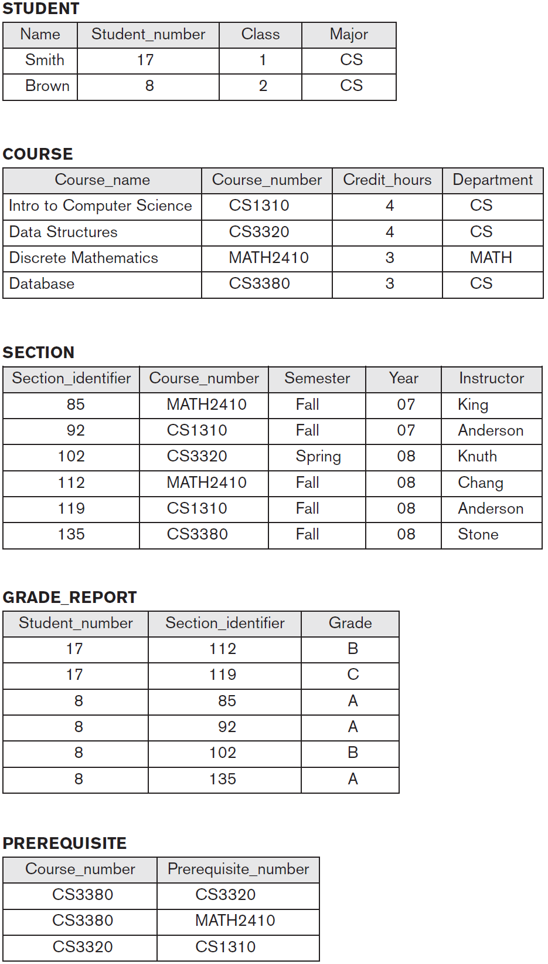

**(a) Retrieve the names and major departments of all straight-A students (students who have a grade of A in all their courses).**

SELECT Name, Major

FROM STUDENT

WHERE EXISTS (

SELECT *

FROM GRADEREPORT

WHERE GRADE = ‘A’ AND Student_number = STUDENT.Student_number

)

**(b) Retrieve the names and major departments of all students who do not have any grade of A in any of their courses.**

SELECT Name, Major

FROM STUDENT

WHERE EXISTS (

SELECT *

FROM GRADEREPORT

WHERE NOT(GRADE = ‘A’) AND Student_number = STUDENT.Student_number

)

**Question 3( Chapter 7) In SQL, specify the following queries on the database specified in the following figure using the concept of nested queries and the concepts described in this chapter.**



1. **Retrieve the names of all employees who work in the department that has the employee with the highest salary among all employees.**

SELECT Lname

FROM EMPLOYEE

WHERE Dno =

(SELECT Dno

FROM EMPLOYEE

WHERE SALARY =

(SELECT MAX (Salary)

FROM EMPLOYEE))

1. **Retrieve the names of all employees whose supervisor’s supervisor has '888665555' for Ssn.**

SELECT Lname

FROM EMPLOYEE

WHERE Super_ssn IN

(SELECT Ssn

FROM EOMPLOYEE

WHERE Super_ssn = ‘888665555’)

1. **Retrieve the names of employees who make at least $10,000 more than the employee who is paid the least in the company.**

SELECT Lname

FROM EMPLOYEE

WHERE SALARY >= 10000 + (SELECT MIN (Salary) FROM EMPLOYEE)