HW 5 Critique

# Requirements

I will use this section to lay out the directions and focuses of the Homework assignment.

Homework 5 was centered around Use Case Diagrams and Use Case Descriptions. These are useful tools in the software lifetime cycle. The use case diagram is a way to visualize the ways in which a user may interact with a system. Use case descriptions are textual guides of how a user may interact with your software. The point of this assignment was to learn to organize and draw a use case diagram and to properly lay out the use case descriptions.

# Errors

I will use this section to talk about what I did wrong in the Homework assignment.

I reuploaded my original homework assignment in Section 3. I will reference this for my mistakes.

I was not given any feedback on my assignment, so I will have to compare it to the answers that were posted after the assignment’s original due date and come to my own conclusions as to what could have been done better.

I’ll start with the use case diagram. While there isn’t necessarily one correct answer to this, I will base it off the sample answers. It seems some of my biggest problems were lack of focus and too much granularity (forgive the grain pun). For example, I put a lot of things that the user wouldn’t necessarily directly interact with, such as the silos, railroad cars, the grain, and the grain dryer. I tried to put all the little things that were mentioned in the text, whereas the sample answer is more focused on the things that the user, the elevator manager in this case, will be directly interacting with. Looking at my answer, I have the manager interacting with the silos and the reports, as well as the trucks interacting with the silos, the grain, and the transaction. In contrast, the sample answer only has the elevator manager, and they are interacting with more software focused things such as EnterArrivalShipment, AllocateSiloManually, EnterDepartureShipment, RequestTransactionLog, and RequestReport.

Looking next to the use case description, I believe I did a lot of this section correctly. However, since I messed up the first part so badly, I believe it cascaded forward into this section, plus I was only instructed to do the description for the grain arrival. Looking at the sample answer, I believe I was supposed to pick one of the use cases and list the actor, the flow of events, and any alternative flows that could proceed. There is a disclaimer on this section that says there are further fields to continue the description that could be used, and I believe I used these well. Seeing as the template for this question looks correct, the biggest thing I could fix here is to do question one correctly so that the information would be correct for question two.

# Original Assignment

I will use this section to post my original assignment from last semester.

Question 1

|  |
| --- |
|  |

Question **2**

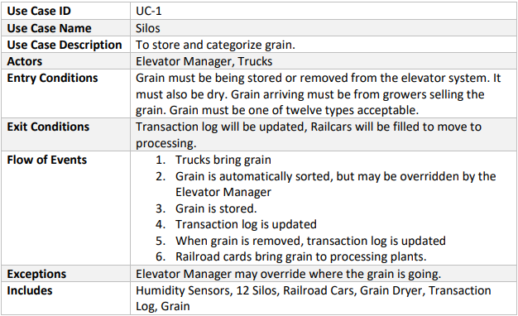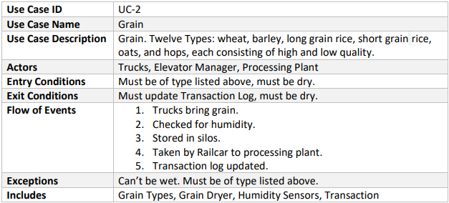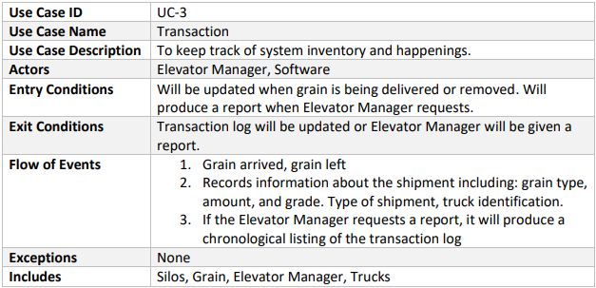

# Corrected Assignment

I will use this section to post my new, corrected assignment.

Question **1**

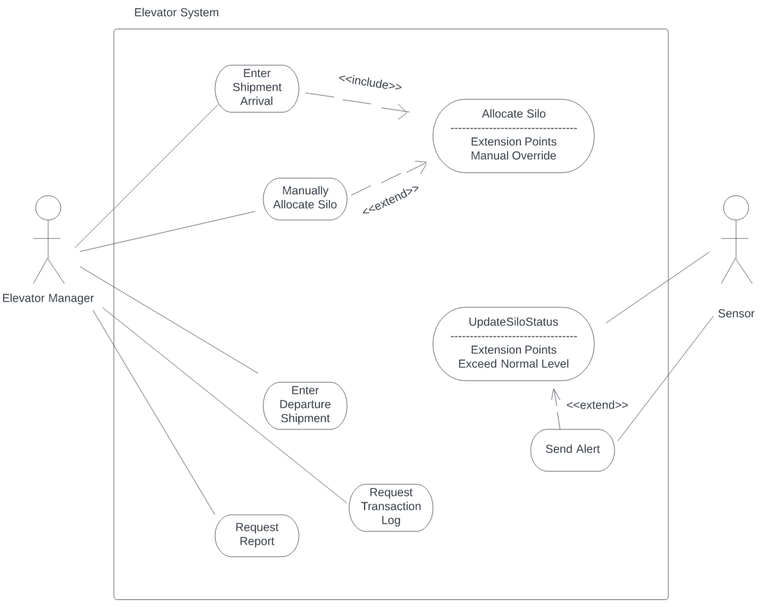

Question **2**

|  |  |
| --- | --- |
| **Use Case** | Enter Shipment Arrival |
| **Actors** | Elevator Manager |
| **Flow of Events** | 1. Elevator Manager selects New Shipment on UI. 2. System will display entry form for new shipment. 3. Elevator Manager enters required data. 4. System will validate data. 5. System will allocate the shipment using **Allocate Silo**. 6. System will add transaction log for the shipment. 7. System will show results for the shipment. |
| **Entry** **Conditions** | Elevator Manager must select New Shipment on UI. |
| **Exit Conditions** | System will display allocation results. |
| **Includes** | None |