**Question 1:**

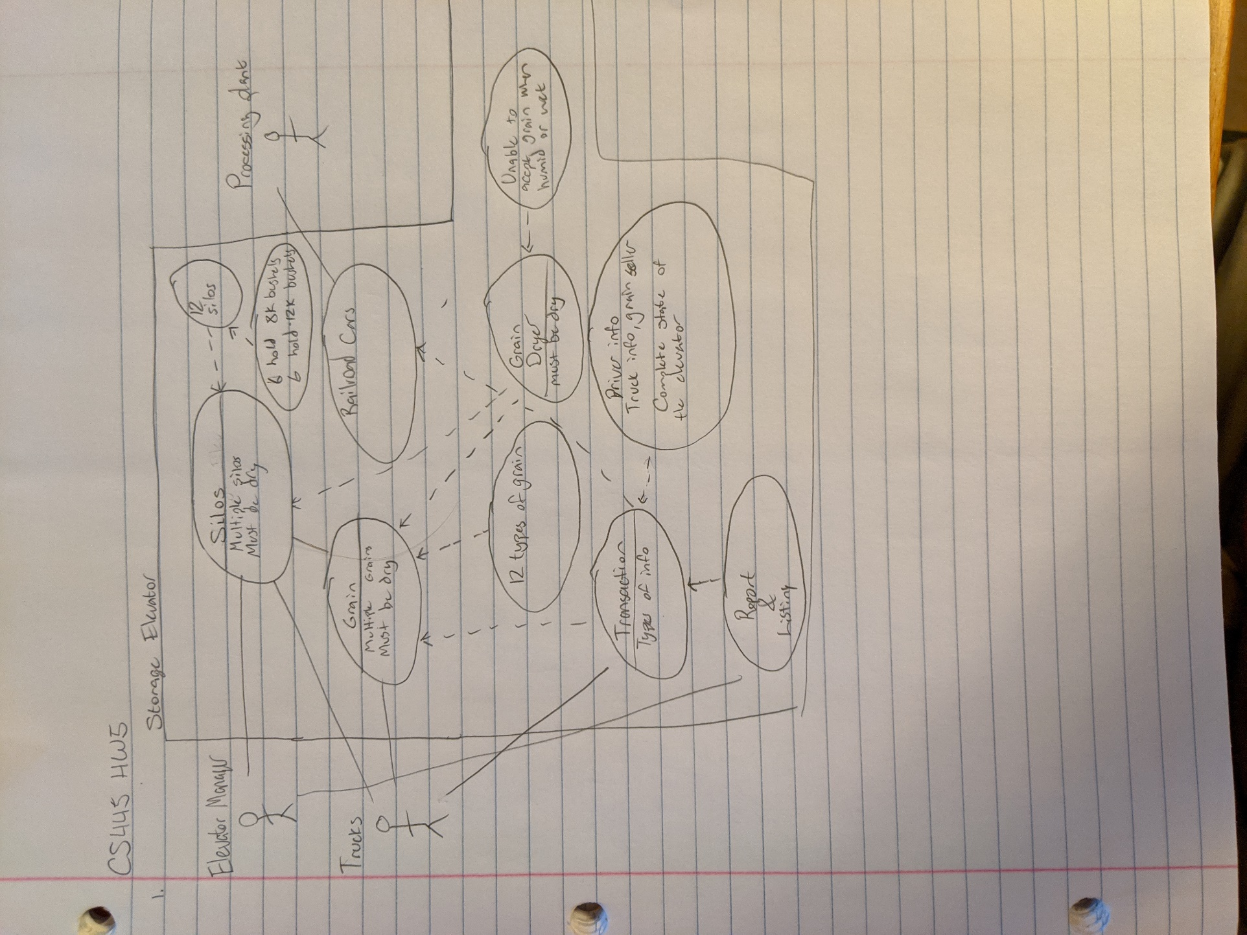

**Question 2:**

|  |  |
| --- | --- |
| Use Case ID | UC-1 |
| Use Case Name | Silos |
| Use Case Description | To store and categorize grain. |
| Actors | Elevator Manager, Trucks |
| Entry Conditions | Grain must be being stored or removed from the elevator system. It must also be dry. Grain arriving must be from growers selling the grain. Grain must be one of twelve types acceptable. |
| Exit Conditions | Transaction log will be updated, Railcars will be filled to move to processing. |
| Flow of Events | 1. Trucks bring grain 2. Grain is automatically sorted, but may be overridden by the Elevator Manager 3. Grain is stored. 4. Transaction log is updated 5. When grain is removed, transaction log is updated 6. Railroad cards bring grain to processing plants. |
| Exceptions | Elevator Manager may override where the grain is going. |
| Includes | Humidity Sensors, 12 Silos, Railroad Cars, Grain Dryer, Transaction Log, Grain |

|  |  |
| --- | --- |
| Use Case ID | UC-2 |
| Use Case Name | Grain |
| Use Case Description | Grain. Twelve Types: wheat, barley, long grain rice, short grain rice, oats, and hops, each consisting of high and low quality. |
| Actors | Trucks, Elevator Manager, Processing Plant |
| Entry Conditions | Must be of type listed above, must be dry. |
| Exit Conditions | Must update Transaction Log, must be dry. |
| Flow of Events | 1. Trucks bring grain. 2. Checked for humidity. 3. Stored in silos. 4. Taken by Railcar to processing plant. 5. Transaction log updated. |
| Exceptions | Can’t be wet. Must be of type listed above. |
| Includes | Grain Types, Grain Dryer, Humidity Sensors, Transaction |

|  |  |
| --- | --- |
| Use Case ID | UC-3 |
| Use Case Name | Transaction |
| Use Case Description | To keep track of system inventory and happenings. |
| Actors | Elevator Manager, Software |
| Entry Conditions | Will be updated when grain is being delivered or removed. Will produce a report when Elevator Manager requests. |
| Exit Conditions | Transaction log will be updated or Elevator Manager will be given a report. |
| Flow of Events | 1. Grain arrived, grain left 2. Records information about the shipment including: grain type, amount, and grade. Type of shipment, truck identification. 3. If the Elevator Manager requests a report, it will produce a chronological listing of the transaction log |
| Exceptions | None |
| Includes | Silos, Grain, Elevator Manager, Trucks |