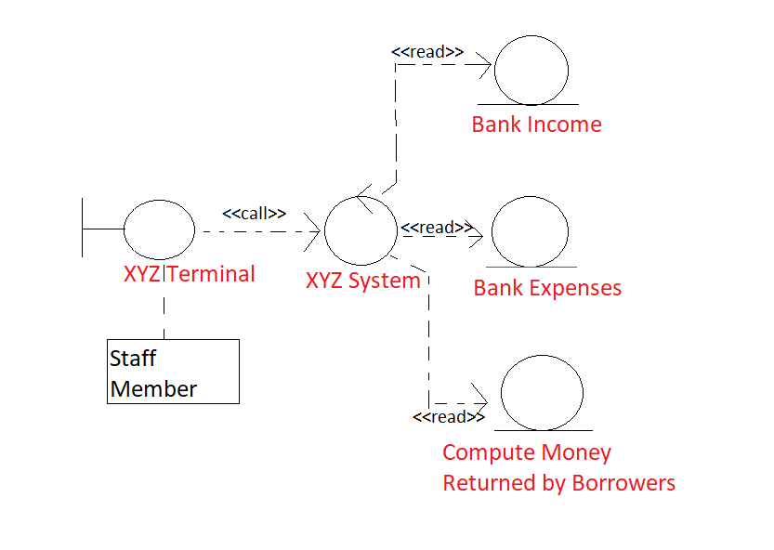

I couldn’t find any online flowchart software with access to these symbols, so this was made in paint. I apologize it’s not up to the “professional” standard you mentioned in your email, so I ask forgiveness as I’m not on a professional budget.