I, again, had trouble importing the given app to modify for the current project. I tried putting the AddressBook app to modify to be the Recipe app, but I had the same issue as last time:

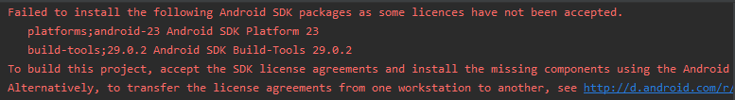

I tried accepting the licenses in the bin file, but nothing seemed to work.