**7.9**

I couldn’t figure this problem out. It seemed simple, where I thought I would just have to plug the pairs into the *elgamald* function on the V200, using a pair as my *y*, then *p* and *a* as in the book. I tried plugging that into a WolframAlpha ElGamal Decryptor widget (<https://www.wolframalpha.com/widgets/view.jsp?id=978d7097ff2a699194ad4282bd27b1dc>), but when I tried to do the method myself, I got 28885 instead of 12354.

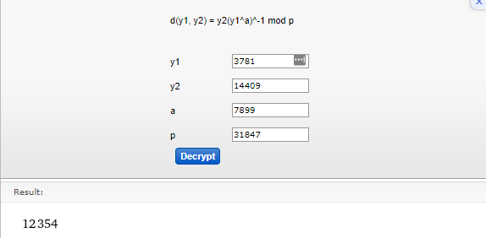

Figure

My process involved using the formula on the top of *Figure 1*. I first did my *y1a*, which was 318477899. I took this mod *p* to make it manageable, which left me with



Figure

Then, I used my program that I’ve added to a previous assignment that finds *all* the invertible elements and their inverses, given a modulus. I searched this table for 3554, and found the inverse, which I then multiplied by *y2* mod *p*.

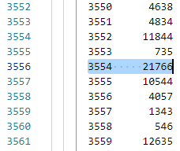

Figure

21766 x 14409 mod 31847 = 28885.

This is also the answer I got when I plugged in the following into the V200:

*[[3871][14409]] -> y*

*31847 -> p*

*7899 -> a*

*elgamald(y, p, a)*

**output:** 28885

However, this differs from the computed value from above, and I can’t figure out how to get to the correct answer.

**7.10**

I tried to follow this top answer’s guide to find these polynomials:

<https://math.stackexchange.com/questions/32197/find-all-irreducible-monic-polynomials-in-mathbbz-2x-with-degree-equal>

However, I had a hard time following, so I fully just checked the problems against his list.

x5 + x4 + 1 – Reducible

x5 + x3 + 1 – Irreducible

x5 + x4 + x2 + 1 – Reducible

**7.12**

I tried setting up the problem as in **7.9**:

(K, H) -> y

K, H = 2x + 2, x2 + 2

y2 (y1a)-1 mod p

x2 + 2 ( (2x + 2)11 ) -1 mod p

However, this seemed impossible to solve without a proper value for *p*, and I had no idea where to go next.

I apologize for the poor workmanship on this and the past few assignments. I got married this past Saturday, and I’ve had no time for anything else.