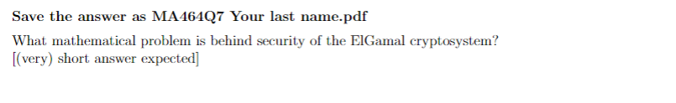

**The discrete logarithm problem (DLP).**