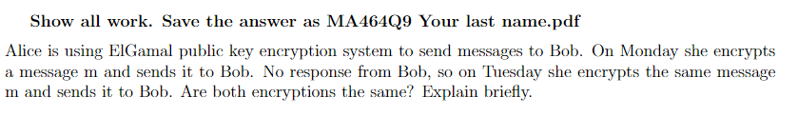

The encryptions will be the same because the public key used to encrypt the message, as well as the message, does not change.