Gavin Grant: CY major, java / python experience – application developer

Jonathan Harsy: CS major, java/python experience – application designer

Sean Poston: CS major, java/python experience – application tester

Alex Shipman: CY major, java/python experience – database developer

Andrew Vermiglio: CY major, java/python experience – Project Lead

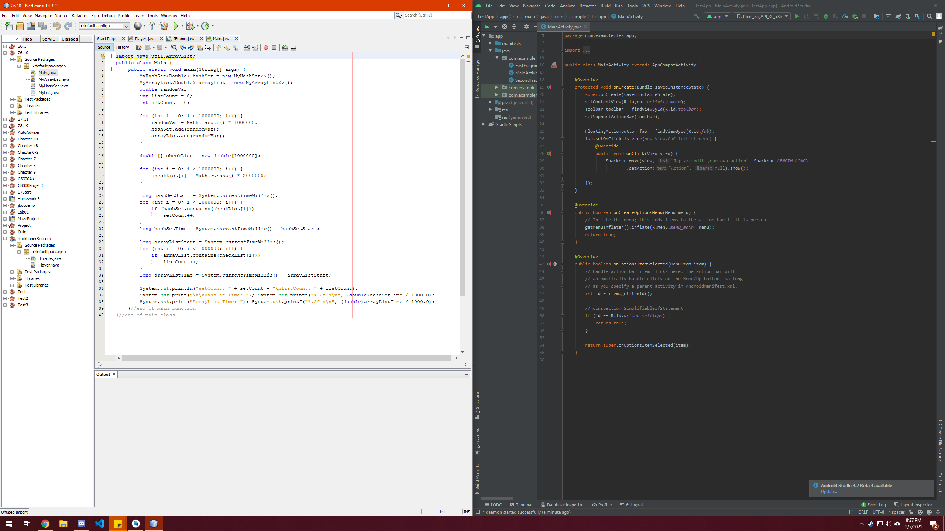

Figure 1: NetBeans on left, Android Studio on right

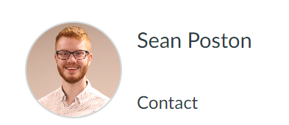

Figure 2: Canvas profile picture