# Set 03 Handout

1. Air flow enters a heat exchanger at the rate of 3.5 kg/s and at a temperature of 24oC. The air leaves the heat exchanger at 75 oC. At what rate is heat transferred to the air? You may assume that the air has constant specific heat of Cp = 1.00 KJ/kg.k.

(Answer: 178.5 KW)

1. 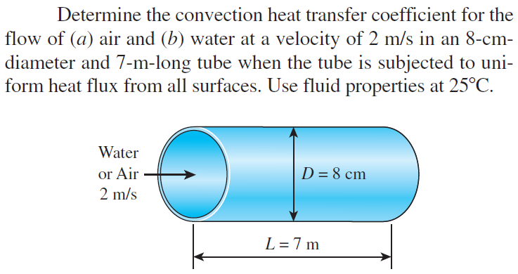

(Answer: a. , b. )

1. 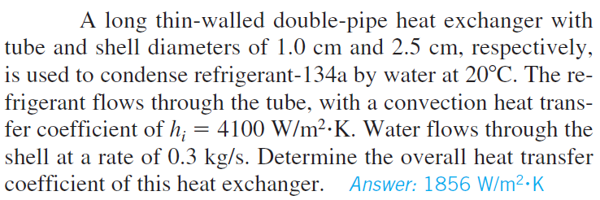
2. 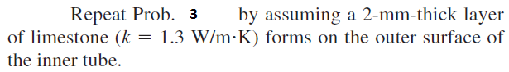

(Answer: )

1. 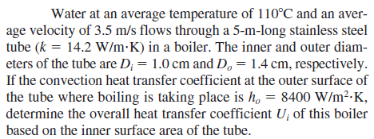

Answer: 

1. 

Answer: 

1. 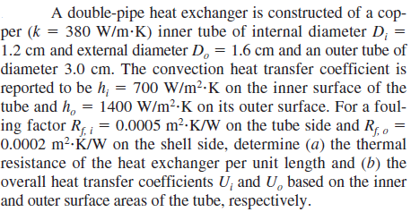

Answer: a. , b.  and 

1. 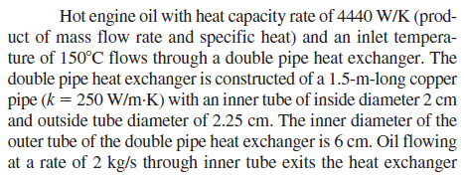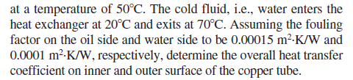

Answer:  and 

1. 

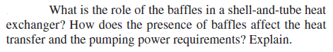

1. 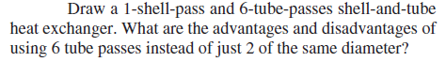
2. 
3. 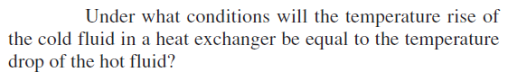
4. 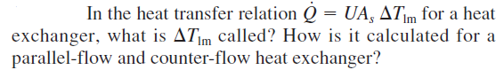
5. 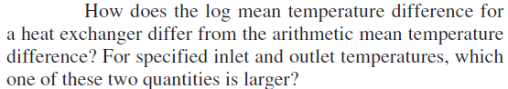

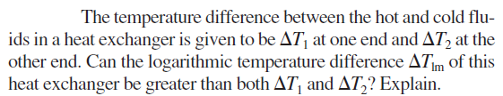

1. 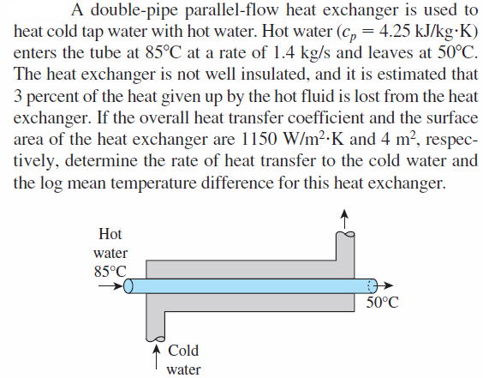

Answer: 43.9 oC

1. 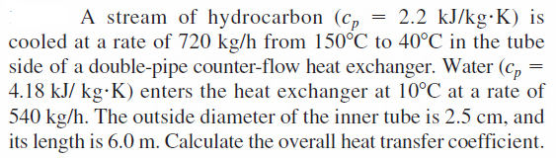





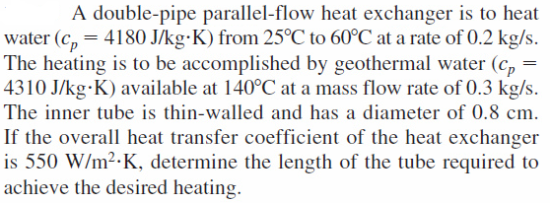

Answer: 25.5 m



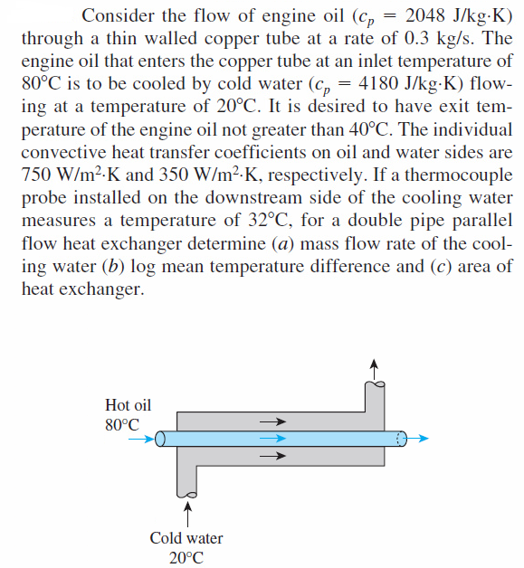

Answer: (a) 0.489 kg/s, (b) 25.8 oC, (c) 3.99 m2



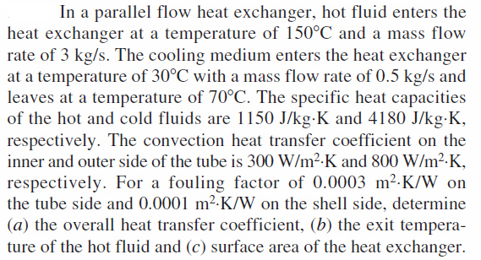

Answer: (a) , (b) 125.8 oC, (c) 4.97 m2



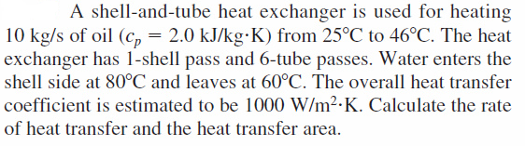

Answer: 420 KW and 13.1 m2



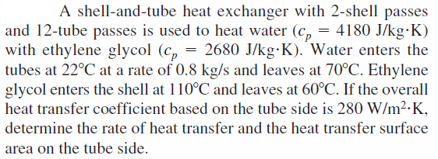

Answer: 160.5 kW and 16.0 m2



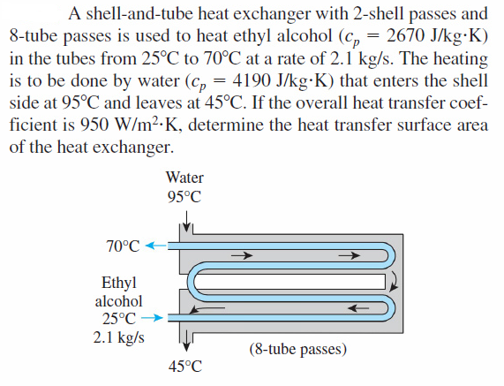

Answer: 14.5 m2







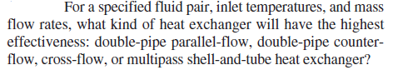







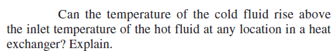



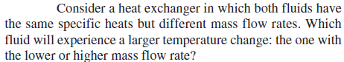



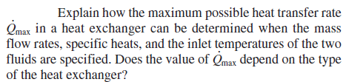



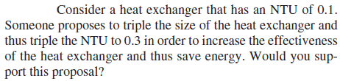



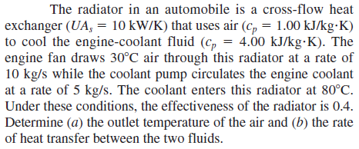

Answer: (a) 50.0 oC, (b) 200 kW



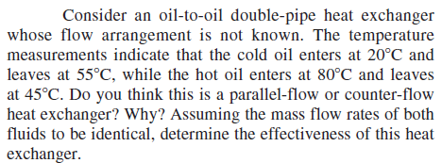

Answer: Counter flow, 0.583



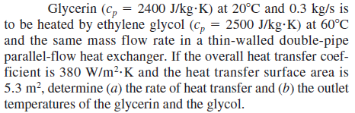

Answer: (a) 14.63 kW, (b) 39.5 oC and 39.7 oC



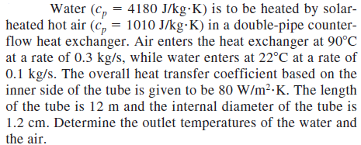

Answer: 27.3 oC and 82.7 oC



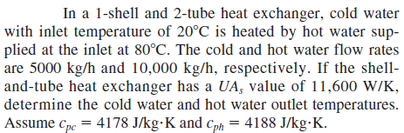

Answer: 61.9 oC and 59.2 oC



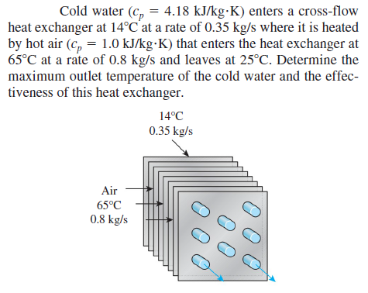

Answer: 41.9 oC and 0.784