**IPoS- Inventory System and Point of Sale**

Project Documentation Submitted

To the Faculty of School of

Computing and Information Technologies

Of

Asia Pacific College

In Partial Fulfillment of the Requirements for the subject

Systems Analysis and Design

By:

Alovera,Joseph

Po,Marco Joaquin

**ASIA PACIFIC COLLEGE**

Approval Sheet

**7th Of May Trading Hardware Store - Inventory System**

Prepared and Submitted by:

Alovera,Joseph

Po,Marco Joaquin

In Partial Fulfillment of the Requirements for the Degree of

Bachelor of Science in

Examined and Recommended for Acceptance and Approval for Research/Capstone Presentation

___________________________

Adviser

Panel of Judges

___________________________

Chairperson

Panel Members

___________________________ ___________________________

Panel Member Panel Member

Acceptance and Approved in partial fulfillment of the requirements for the degree of Bachelor of Science

_______________________________

Executive Director

School of Computing and Information Technologies

Table of Contents

***Background of the Problem*** 6

***Statement of the problem*** 6

-Trouble knowing when to replenish the products. 7

-Problem in producing of reports like daily sale, weekly sale, yearly sale, top-selling product least selling product. 7

***Objectives*** 7

***Significance*** 8

***Scope and Limitations*** 9

**RelatedLiterature Inventory Management: Principles, Concepts and Techniques** 11

. 11

**Related Systems** 12

***Computer-Based Inventory System(2010)*** 12

***An automated POS and inventory system for V.F.C Corp.*** 12

***Case Study on Inventory Management Improvement*** 13

***MCM Merchandise POINT OF SALE (POS) & INVENTORY SYSTEM*** 13

***Computerized inventory system- Program Development and execution*** 13

**Theoretical Background** 15

***Inventory*** 15

***Inventory management system*** 15

***Reorder Point*** 16

***Asset tracking*** 16

***Service management*** 16

***Product identification*** 16

***Inventory optimization*** 17

***Front-end development tools*** 17

***Back-end servers*** 17

***Security add-on layers*** 17

***Point of Sale (POS)*** 18

**Gap Analysis** 20

**USE CASE DIAGRAM** 21

**USE FULL DESCRIPTION** 22

**CONTEXT FLOW DIAGRAM** 27

**DATA FLOW DIAGRAM 0** 28

**DFD Level 1** 29

**CLASS DIAGRAM** 30

**ACTIVITY DIAGRAM** 31

**Entity Relationship Diagram** 37

**References** 47

***Abstract***

The 7th of May Trading is a hardware store that still uses manual inventory and computing of sales. There are numerous hardware store that are growing and there is numerous businesses that also have the same processes. The group aims to create a web application of an inventory system and point of sale in order to lessen. The web application will also make it easier for the personnel to keep track of the business's transactions and reports.

**Introduction**

### 

### ***Background of the Problem***

The 7th of May trading hardware store manually records every in process in the store, they do not have any computerized or automated system that can record the transaction, products, and their daily sale, monthly sale, top selling product or even the least selling product at the store. The staff looks for the product at the stock room when a customer inquires or purchases a product. they always check their logbooks for checking the products in stock, and when a customer purchase an order they manually records the transaction in common printed receipts and the admin staff will collect all the transactions and the updated inventory within the day and make a report to see if they are going to need a product replenishment and also how is the growth of the sales.

However, the manual recording of transactions, product, and daily sale, monthly sale, top selling product and least selling product can affect the accurate record of the transactions, product, and daily sale, monthly sale, top selling product and least selling product and it can also be misplaced in the hardware store.

### ***Statement of the problem***

The general problem of the 7th of May Trading's inventory is using a manual recording of the inventory and transactions and in monitoring the products, transactions and reports.

The specific problems of the 7th of May Trading's are:

### -Trouble knowing when to replenish the products.

### -Problem in producing of reports like daily sale, weekly sale, yearly sale, top-selling product least selling product.

-Redundancy in computing the sales and recording transactions.

### ***Objectives***

The main objective of this project is to create an inventory management and point of sale system for 7th of May Trading it also aims to do the following: Improve the inventory and point of sale system, maintain an updated record of inventory and provide an accurate and definitive reports of daily sales, weekly, monthly sales. Top-selling product and least selling product,Revenue. And it will also show the product that would be needing replenishment it will also provide QR Code for the customer via email when they order online and the admin can scan the QR code to know what the customer ordered through the website application.

The specific objectives will include the following features:

•To lessen redundancy of recording transactions

•To generate daily sale, weekly sale and yearly sale reports

•To keep track of all the items for top selling products and least selling products

### 

### ***Significance***

The purpose of this study is to help the 7th of May “hardware store” have a web app inventory system and point of sale that can help them keep track of the data regarding all the needed materials or equipment for the business. Upon using an inventory system and point of sale, it will be easier to avoid any shortages or surpluses of supply or product.

Also, the owner will benefit from the system because they can check the sale and inventory of their hardware store. The admin staff would easily access or record transactions and check, update and delete items in the inventory and also the staff will able to view the product availability and record the transaction.

As for the future researchers they will see possibilities in upgrading the system. Also for the other hardware store who has a manual system of inventory will have an idea upgrading their system to a web application inventory system with point of sale.

# ***Scope and Limitations***

This study aims to provide an automated inventory system and point of sale where the system can inventory all the product in the storage room of the hardware store. It should have the capabilities in generating a report like daily sale, monthly sale, top selling product and least selling product. It should also add, delete, update and also to provide QRcode via email for the customer when they order online through the web in addition to that the staff can scan the QRcode to know what the customer ordered and to know when the product should be replenish and show the remaining products in the store and should show the transaction and order status.

The 7th of May Trading’s Hardware store inventory and point of sale system will only limit to the following:

• Two separate account for the staff and the admin staff.

• No credit card transaction.

• Admin can view the product and process the order.

• Staff can add, edit, delete, update the inventory and generate the reports.

# **RelatedLiterature Inventory Management: Principles, Concepts and Techniques**

# Inventory Management is relating to the entire supply chain (customer demand, distribution, and product transformation processes). The interrelationships of all functions. Company should understand the many ramifications of inventory management. In today's competitive business environment, inventory management has proven to be most critical. to assist in better understanding the body of knowledge required to operate in a competitive world. Almost all functions such as sales, engineering, and accounting have an impact and are impacted by inventory management.

**Inventory Management: Non-Classical Views**

As business sectors turn out to be more powerful and focused, organizations must rethink how they see inventory and roll out improvements to their generation and inventory management. They should start to think outside the traditional box and build up another worldview of inventory management. Investigating the pattern far from established models in view of monetary request amounts to subordinate request frameworks

vitality and the earth are to be considered in inventory choices, the non-traditional use of inventory management in fields, for example, human services and catastrophe help, and non-established ways to deal with estimating the execution of stock, for example, data hypothesis, fluffy sets, and thermodynamics.

While numerous elements may transform, one sureness is that the worldwide economy is winding up progressively powerful. Planting the seeds for new research in stock control and administration

# **Related Systems**

### ***Computer-Based Inventory System(2010)***

Computer based system makes the work accurate and faster. Information technology plays a major role since it is a complex system. Small and big companies relies on automated scheme to provide a better service but there are still businesses who sticks with manual system where they record the data in their logbooks because they are having hard time using it since they are not that fond of computers, they are afraid to take risk in their business.

Big companies and businesses switched to automated system to improve their business productivity and efficiency. POS and inventory system is the most popular system that they use. It is very helpful as it tracks their products and to avoid inaccurate data.

### ***An automated POS and inventory system for V.F.C Corp.***

Businesses today are retiring to the traditional recording of books and looking forward in utilizing a POS systems and latest technology. Technology are used today as a solution and give an edge in different fields. Businesses like F.V.C, Sales and Inventory System plays an important role. It helps tracks all the transactions made by the business and responsible in monitoring all items supplies. Business transactions must be properly recorded and fully secured. A computerized system is the best and most innovative solution.

The problem in manual recording is outdated that is making a transaction cost much time and money. Manual recording is time consuming and you will easily lose your record book and make mistakes in inserting transaction information. While in automated POS inventory system you will have accurate records in transactions and inventory, you can also tract the stocks and categorize each product.

### ***Case Study on Inventory Management Improvement***

A research that focus on their product to avoid surplus and shortage. A lot of Big Companies should have a place for their products to give their consumer needs. It will help supply chain to have a better inventory and gain knowledge what would be the best kind of system will be applied.

### ***MCM Merchandise POINT OF SALE (POS) & INVENTORY SYSTEM***

MCM is using a manual system process is difficult because they record every item that goes in and out from the store. The cashier records and issue an invoice manually that causes some errors. The problem encountered by mcm is the delayed or slow process experience by the customers. Also, they can not monitor their products efficiently and there are they lost and misplace some information.

A manual inventory system always relies on the actions of people, which increases the possibility of human error. People sometimes forget to record a transaction and sometimes miscount the goods. It results in additional orders increase that carrying cost and use of storage.

### ***Computerized inventory system- Program Development and execution***

Information is important in making current and future decisions. Most business experts know one of the key to successfully managed operations to properly handle data. but decision makers are overwhelmed about the large number of data that has only a limited amount of information’s. Also, one of the major component of a good decision making of any business is to keep track and checking. However, it is a big challenge for business if the inventory is not properly managing, like manual reports that is time consuming.

The main objective of this project is to overall facilitate the operations. Also, the objectives of this is to develop a system that is flexible, accurate, efficient and user-friendly

# 

**EVENTS TABLE**

|  |  |  |  |  |  |
| --- | --- | --- | --- | --- | --- |
| Event | TRIGGER | SOURCE | USE CASE | RESPONSE | DESTINATION |
| Inquires for a product. | Customer inquire for a product | Customer | Customer inquires about products | Staff check product availability details | Products  Customer |
| Customer pays for product ordered | Customer pays product | Customer | product purchased | Payment details | System  Staff  customer |
| Staff process order | Process order | Staff | Order process | Order details | system |
| Staff provides official receipt of transaction | Issue an transaction receipt | Staff | Provide official receipt | Official receipt details | Customer |
| Create reports(daily,weekly,monthly sales) | Report creation | Admin staff | Report creation | Report details | System |
| Request item replenishment | Request item replenish | Admin staff | Inventory request replenishment | Inventory request details | supplier |
| Delivery of supplier | Items delivered | Supplier | Delivery from supplier | Item delivered details | Admin Staff |
| Update inventory stocks | Stock inventory update | Admin staff | Update stock inventory | Stock inventory details | system |
| Review reports | Review of reports | Admin staff | Review reports | Report details | system |

# 

# **Gap Analysis**

|  |  |  |  |
| --- | --- | --- | --- |
| **User Requirements** | **Current System** | **Proposed Changes** | **Remarks/Impacts** |
| Easier for the customer to inquire. | Staff needs to look at the catalogue manually for the code of the product and check if the warehouse staff has it. | All product information will be stored in the database. | Sctaff will be able to check it faster to avoid making the customers wait. |
| Keep track of their transactions and inventory. | They only use receipt if they need to check something. | All transactions and Inventory will be stored in a database. | Transactions will be easier to audit and inventory will be manage. |
| Restock their inventory easier. | Staffs must search the product codes one by one then they will go to the warehouse to check if they need to restock the product. | System will have a Reordering point. | It will be easier to know if the products must be restocked. |
| Manage their inventory. | They weigh and count their products and check if their paper trails match with the counts. | Database will have all the records but they will still weigh and count their products. | They will not depend on paper trails but they can still evaluate their inventory properly because there will be no missing records. |
| Business Reports. | They collect all the transactions and manually make report based on the transactions. | Proposed system will automatically create reports periodically. | Reports will be more accurate |

# **USE CASE DIAGRAM**

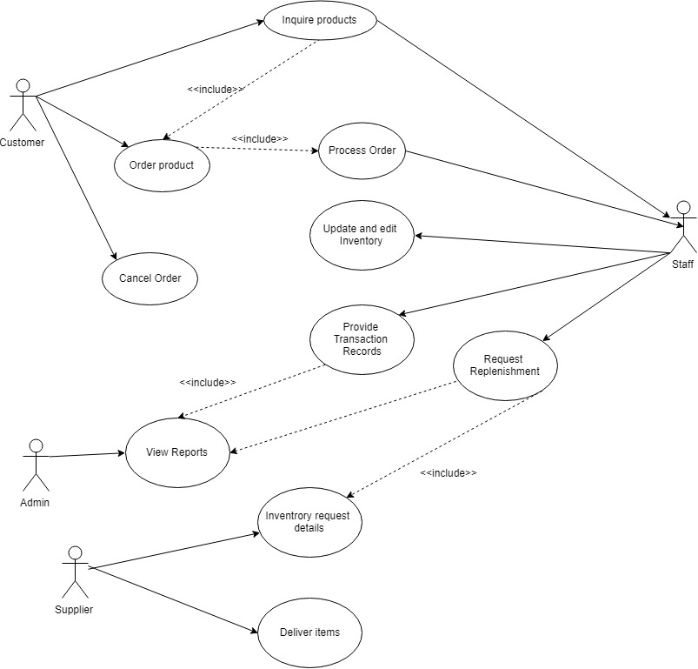

# **USE FULL DESCRIPTION**

|  |  |  |
| --- | --- | --- |
| Use Case Name | Inquires for a product | |
| Scenario | Inquires for a product | |
| Triggering Events | Customer inquires for a product | |
| Brief Description | Customer inquire a product through the web can go walk-ins to inquire a product. | |
| Actor/s | Customer/staff | |
| Related Use Case | Customer inquires about products | |
| Stakeholders | -Staff  -Customer | |
| Pre-Condition | Product must be available | |
| Post Condition | Customer must inquire for a product  Inventory system must be updated once purchase is done. | |
| Flow of Activities | **ACTOR:**  1.Customer Inquiries for a product through the web or walk in.  2.Staff checks the system for the product inquired by the customer | **SYSTEM:**  1.1 the product inquired details is entered through the web or store if walk-ins  2.1Checks the Inventory System. |
| Exception Condition | If no customer inquiries for a product | |

|  |  |  |
| --- | --- | --- |
| Use Case Name | Customer pays for product ordered | |
| Scenario | Customer pays for product ordered | |
| Triggering Events | Customer pays product | |
| Brief Description | Customer pays the product then the staff will process the products ordered | |
| Actor/s | -Staff  -Customer | |
| Related Use Case | Product purchased | |
| Stakeholders | -Staff | |
| Pre-Condition | The product ordered must be prepared | |
| Post Condition | Staff will process the order | |
| Flow of Activities | **ACTOR:**  1.Staff will access the system for the product inquired  2. customer shows the QR code if ordered online | **SYSTEM:**  1.1 System will show the results of the product availability  1.2 staff will process the order  2.1 staff scans the QR code to know the ordered items |
| Exception Condition | If the product ordered is canceled | |

|  |  |  |
| --- | --- | --- |
| Use Case Name | Staff process order | |
| Scenario | Staff process order | |
| Triggering Events | Process order | |
| Brief Description | The staff will process the order once the customer made purchase of the products | |
| Actor/s | -Staff  -Customer | |
| Related Use Case | Order process | |
| Stakeholders | -Staff | |
| Pre-Condition | Customer must inquire for a product | |
| Post Condition | Process the transaction of the customer | |
| Flow of Activities | **ACTOR:**  1.Staff will process the order  2. customer provides the QR code | **SYSTEM:**  1.1 scans the QR code for the product ordered and will show the items ordered. |
| Exception Condition | Customer did not buy the product or the product is not available. | |

|  |  |  |
| --- | --- | --- |
| Use Case Name | Staff provides QR code | |
| Scenario | Staff provides QR code | |
| Triggering Events | Issue an official receipt | |
| Brief Description | Once the transaction has been inputted the staff will issue a QR code as an invoice they will just scan the QR code to know the items. | |
| Actor/s | -Customer  -Staff  -System | |
| Related Use Case | Provide QR code | |
| Stakeholders | Staff | |
| Pre-Condition | Customer buys the product | |
| Post Condition | Process the order of the customer | |
| Flow of Activities | **ACTOR:**  1.Staff provides the QR code to the customer.  2.Customer will show the QR code to the staff when they order through the web | **SYSTEM:**  1.1 The order will be inputted and print the QR code.  2.1 staff will scan the QR code to see the ordered items |
| Exception Condition | Customer cancel the order | |

|  |  |  |
| --- | --- | --- |
| Use Case Name | Generate reports (daily,weekly,monthly sales) | |
| Scenario | Generate reports (daily,weekly,monthly sales) | |
| Triggering Events | Report generation | |
| Brief Description | The system will generate the report of the daily,weekly,monthly sale and the top and least selling product. | |
| Actor/s | -Admin staff | |
| Related Use Case | Report creation | |
| Stakeholders | Admin Staff | |
| Pre-Condition | The transactions must be verified | |
| Post Condition | Creation of reports | |
| Flow of Activities | **ACTOR:**  1.Admin Staff | **SYSTEM:**  1.1 System will show the following reports when viewed by the admin staff. |
| Exception Condition | There are no transaction | |

|  |  |  |
| --- | --- | --- |
| Use Case Name | Request item replenishment | |
| Scenario | Request item replenishment | |
| Triggering Events | Request item replenish | |
| Brief Description | The creation of reports from the system will help the admin staff know when to replenish the product, and the admin staff will request for replenishment to the supplier. | |
| Actor/s | -Admin Staff | |
| Related Use Case | Inventory request replenishment | |
| Stakeholders | Admin Staff | |
| Pre-Condition | There must be report that will support the inventory request replenishment. | |
| Post Condition | Inventory request replenishment | |
| Flow of Activities | **ACTOR:**  1.Admin staff will receive the reports  2.staff request for replenishment. | **SYSTEM:**  1.1 It will show the results and will notify if the products needs replenishment. |
| Exception Condition | No need for replenishment | |

|  |  |  |
| --- | --- | --- |
| Use Case Name | Delivery of supplier | |
| Scenario | Delivery of supplier | |
| Triggering Events | Items delivered | |
| Brief Description | The delivery of the product replenishment has been delivered to the admin staff | |
| Actor/s | -Staff | |
| Related Use Case | Delivery from supplier | |
| Stakeholders | Admin staff | |
| Pre-Condition | The admin staff for request for inventory replenishment. | |
| Post Condition | Items delivered from supplier | |
| Flow of Activities | **ACTOR:**  1. Staff will request for replenishment  2. Supplier delivers the product | **SYSTEM:** |
| Exception Condition | There is no need for replenishment | |

|  |  |  |
| --- | --- | --- |
| Use Case Name | Update inventory stocks | |
| Scenario | Update inventory stocks | |
| Triggering Events | Stock inventory update | |
| Brief Description | Admin staff will update the inventory stocks once the delivery from the suppliers came in. | |
| Actor/s | - Staff  -Supplier | |
| Related Use Case | Update stock inventory | |
| Stakeholders | staff  Supplier | |
| Pre-Condition | Admin staff must request for restockment | |
| Post Condition | Supplier delivers the product | |
| Flow of Activities | **ACTOR:**  1. Staff | **SYSTEM:**  1.1 updates the stock inventory |
| Exception Condition | There is no replenishment. | |

|  |  |  |
| --- | --- | --- |
| Use Case Name | Review reports | |
| Scenario | Review reports | |
| Triggering Events | Review of reports | |
| Brief Description | Admin staff double checks the reports thoroughly. | |
| Actor/s | Admin staff | |
| Related Use Case | Review reports | |
| Stakeholders | Admin staff | |
| Pre-Condition | Creation of reports | |
| Post Condition | Review of reports | |
| Flow of Activities | **ACTOR:**  1.Admin staff checks the reports | **SYSTEM:**  1.1 It will show the reports (daily sale, weekly sale, yearly sale, top selling products,least selling products) |
| Exception Condition |  | |

# 

# **CONTEXT FLOW DIAGRAM**

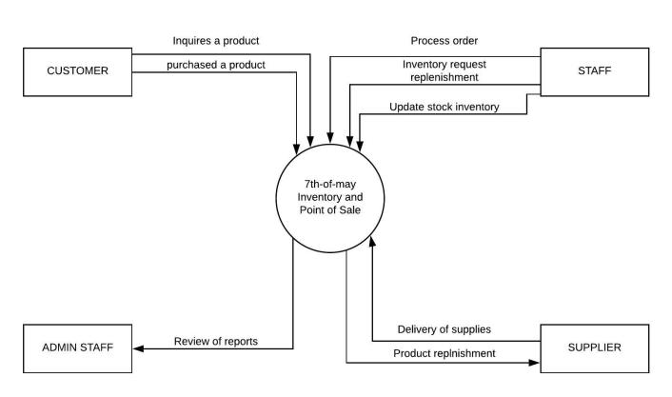

# 

# **DATA FLOW DIAGRAM 0**

# **MACINTOSH:Users:jovenalmartinez:Downloads:DFD0.jpeg**

# **DFD Level 1**

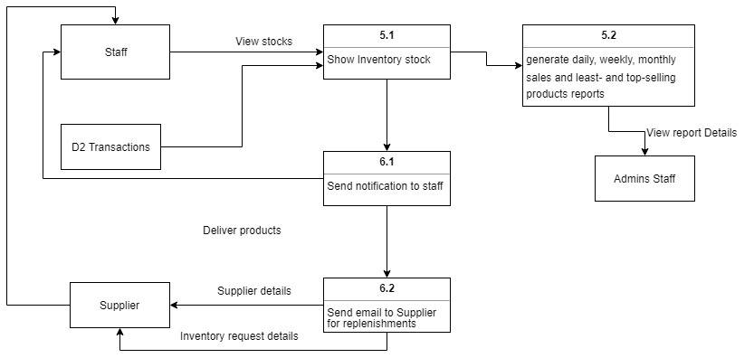

# **CLASS DIAGRAM**

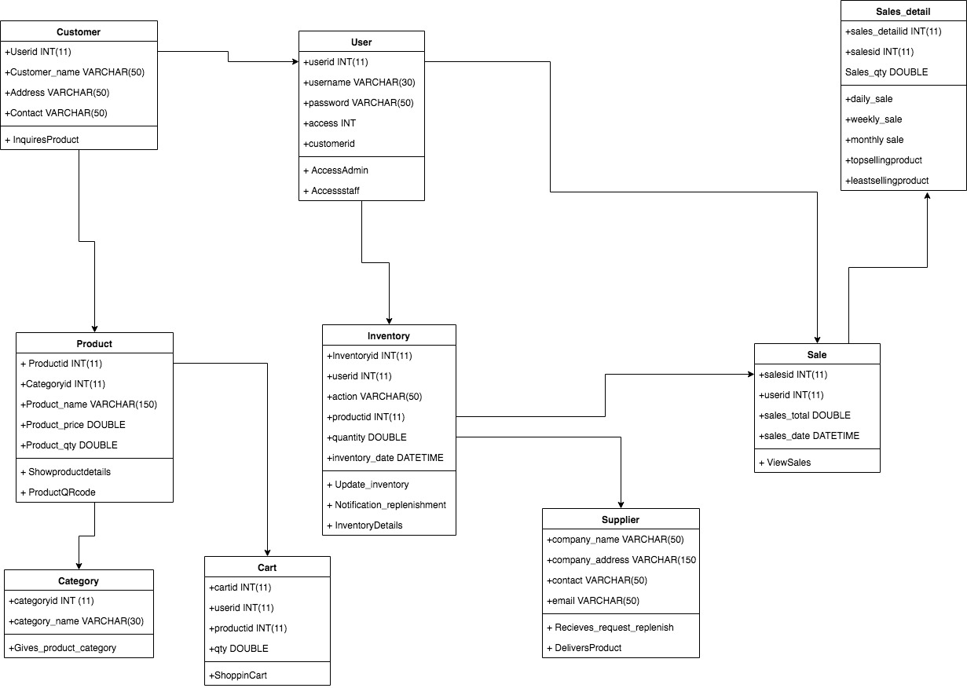

# **ACTIVITY DIAGRAM**

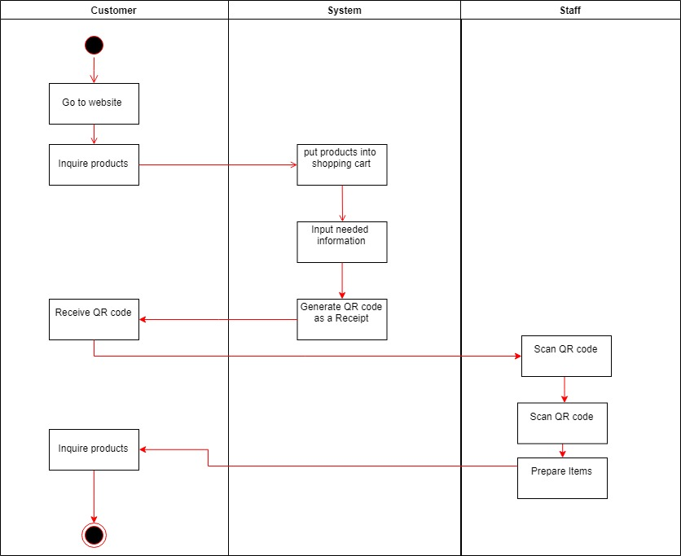

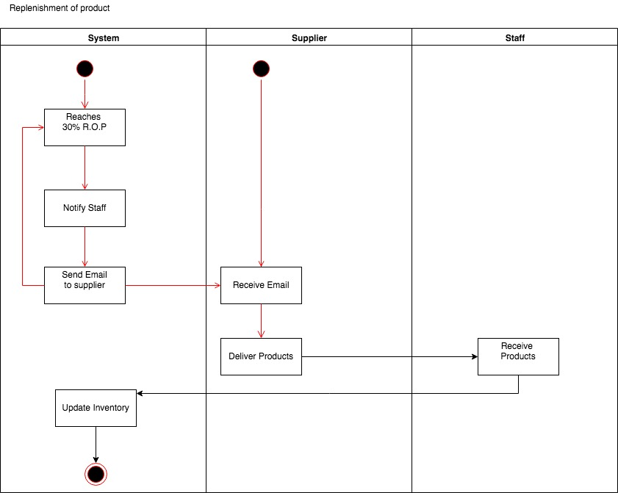

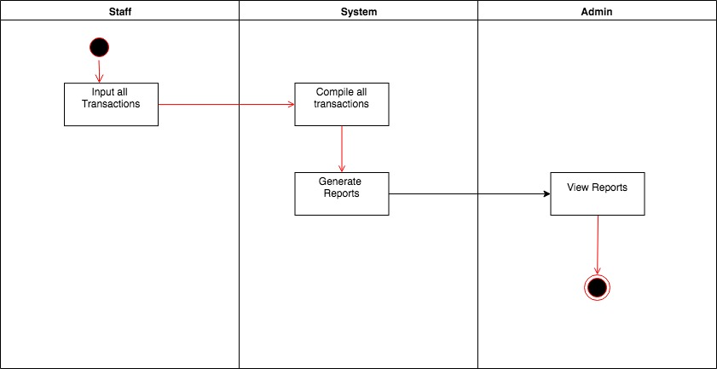

**System Sequence Diagram**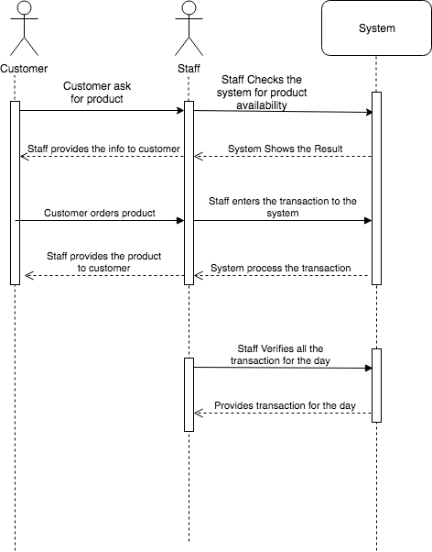

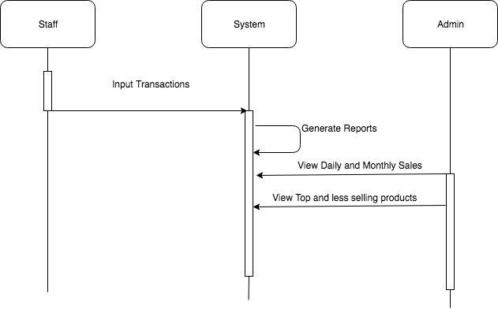

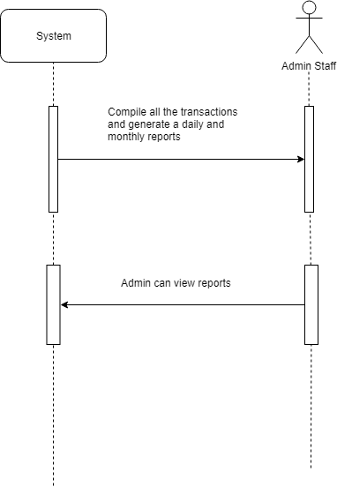

**Finite State Machine Diagram**

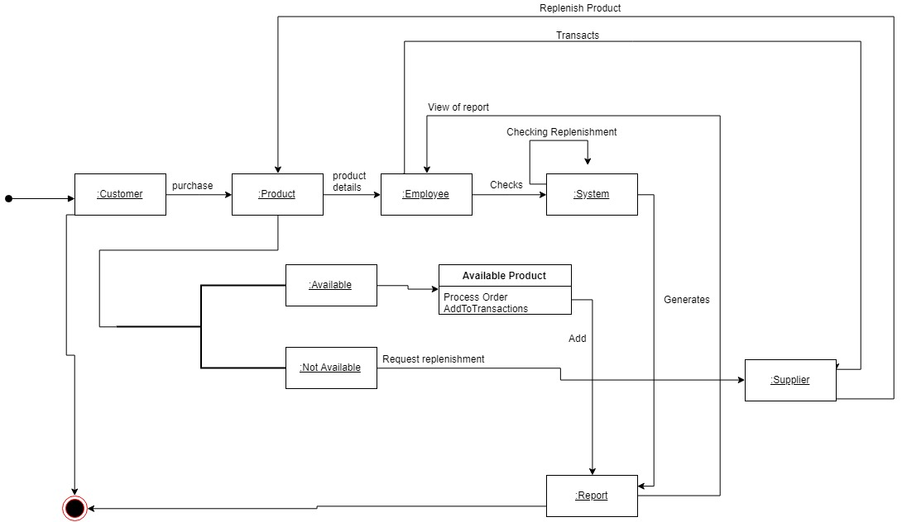

# **Entity Relationship Diagram**

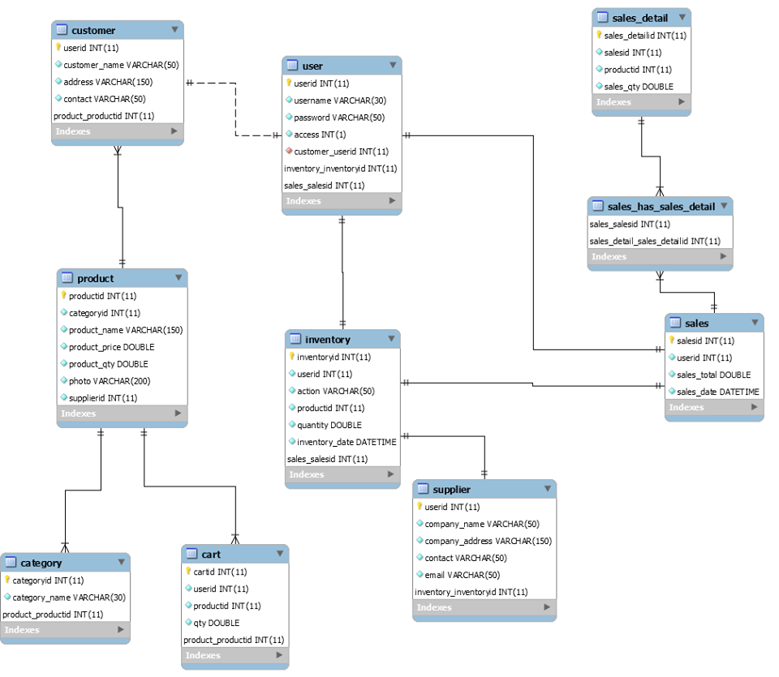

***Wireframe***

*Login page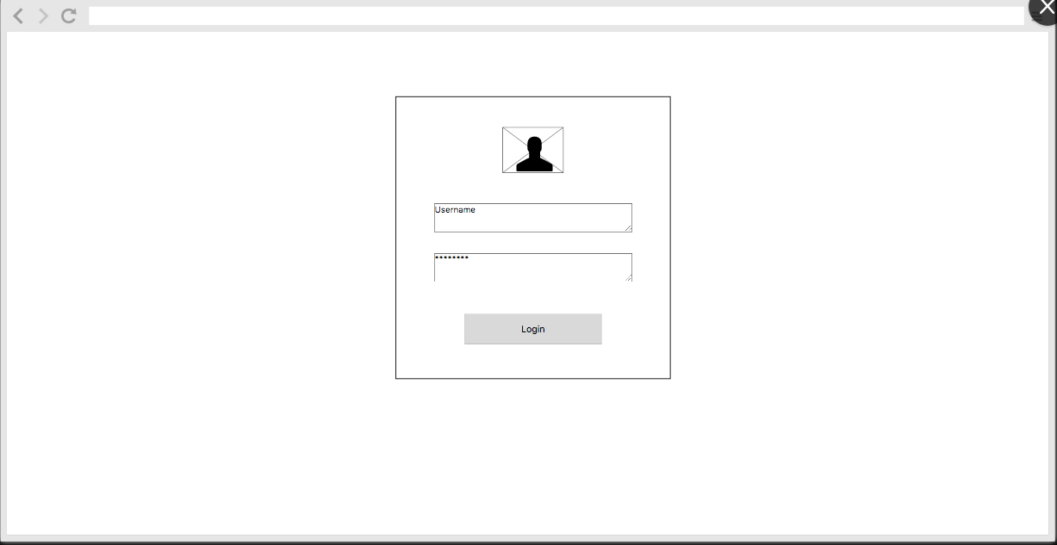

*Dashboard (Reports)

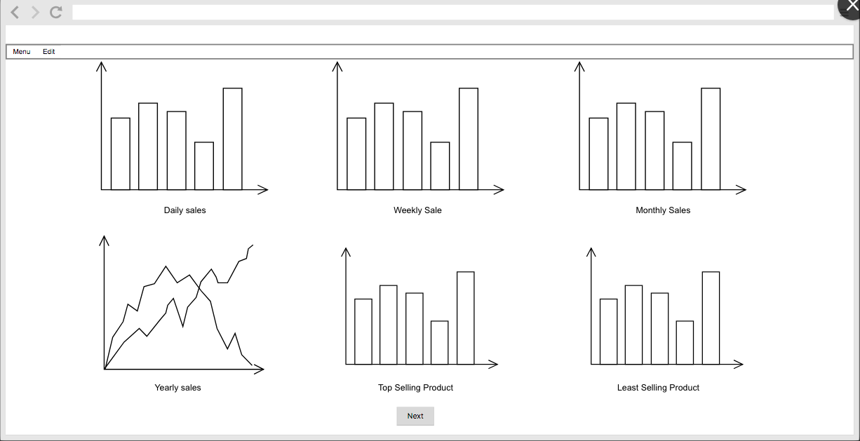

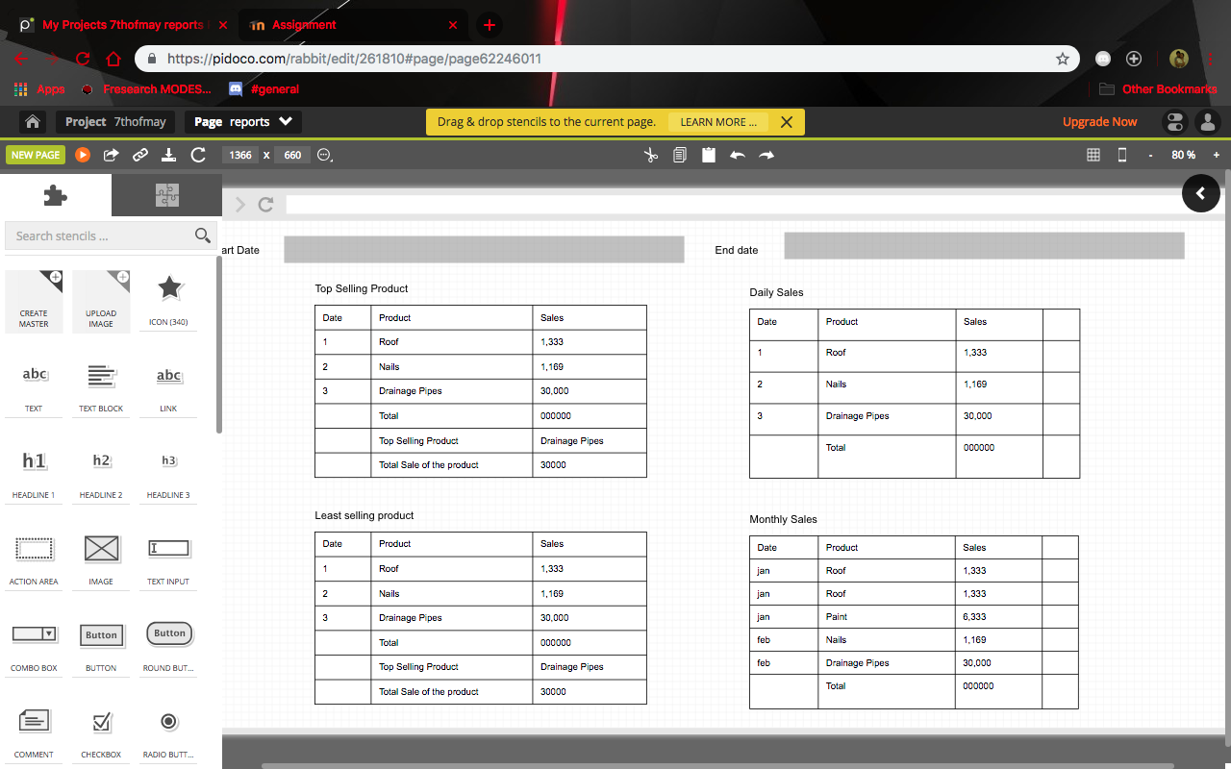

*Notification for replenishment

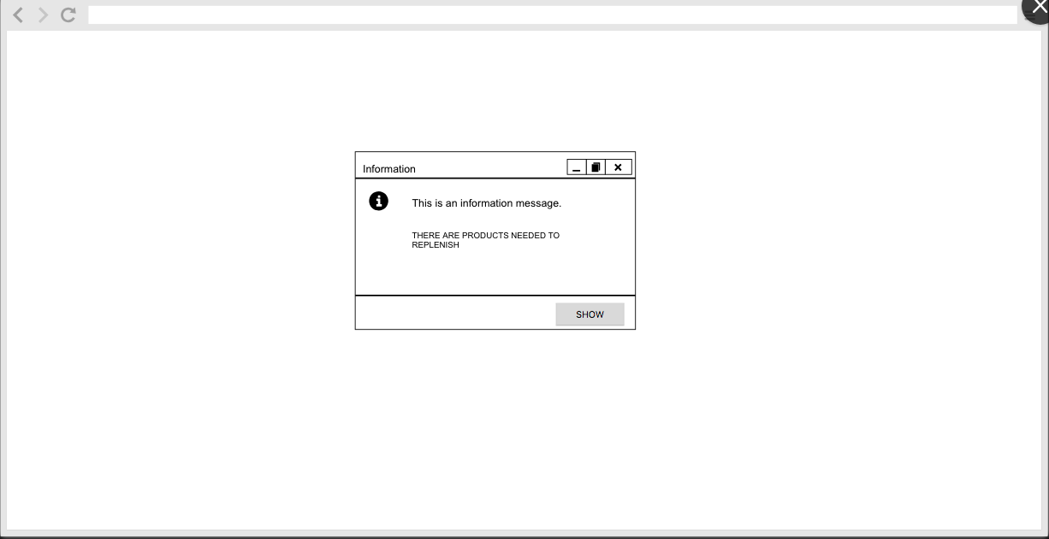

*Item replenishment list

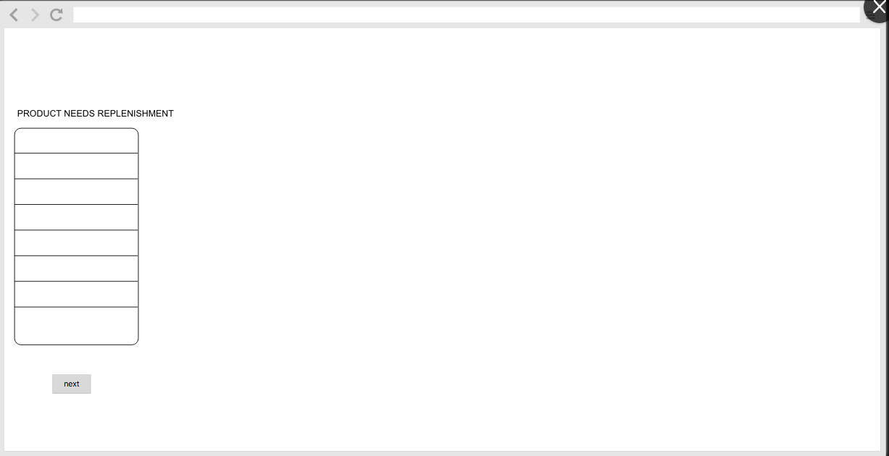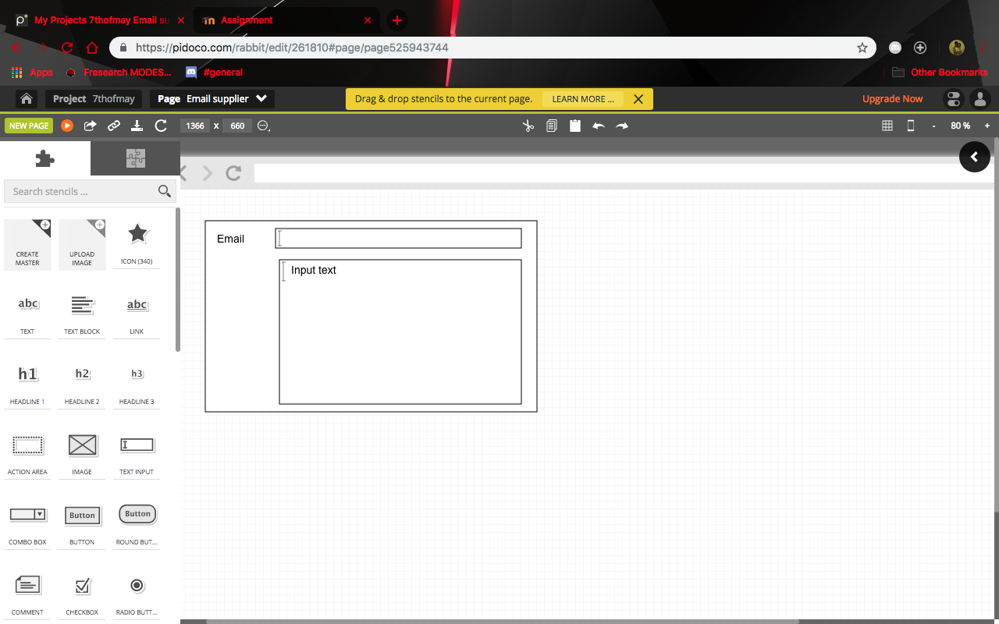

*Product list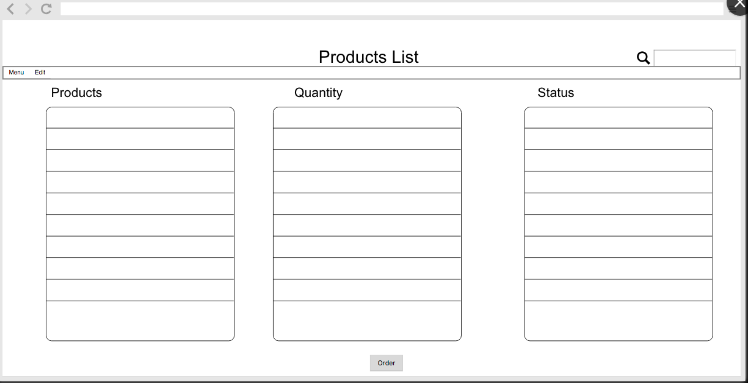

*Order Form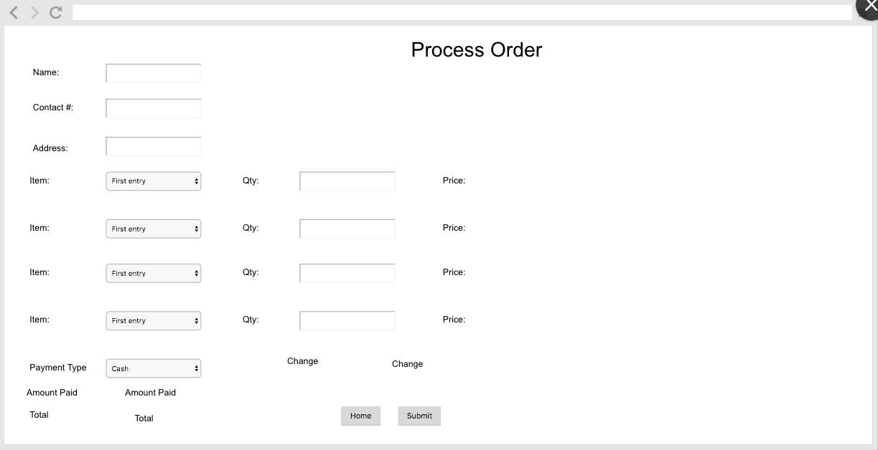

*Print Official receipt

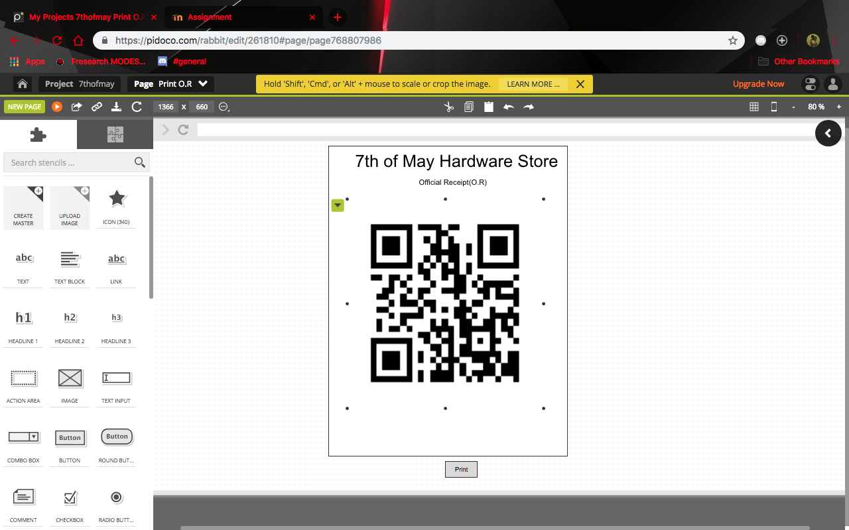

*Transaction list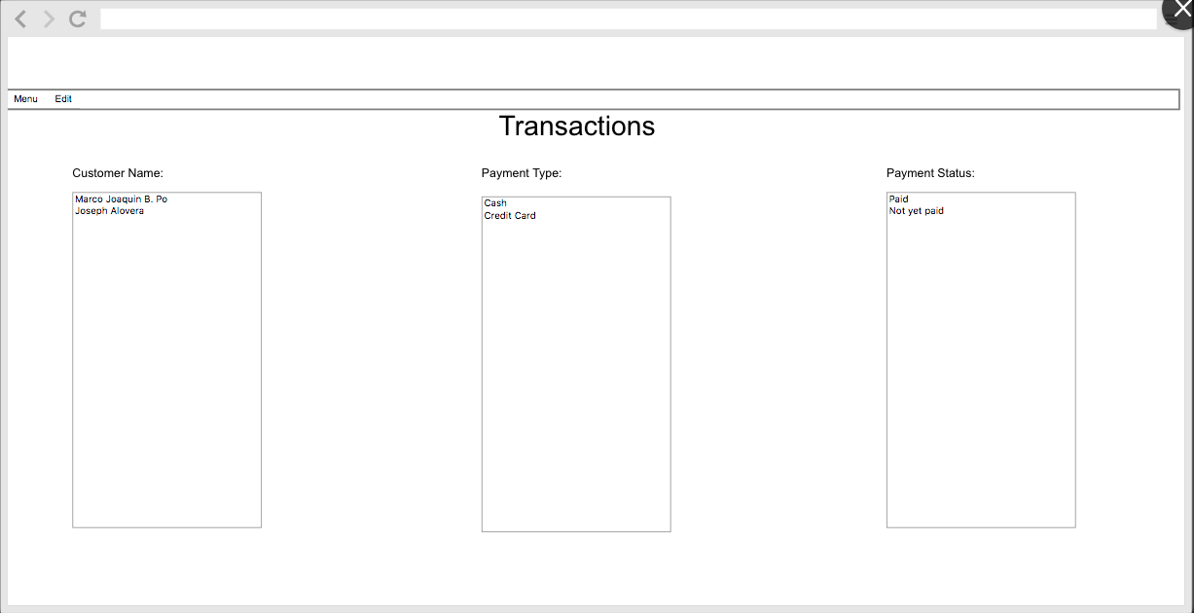

*To update the inventory of the system (add,update,delete)

-Adding product to the list

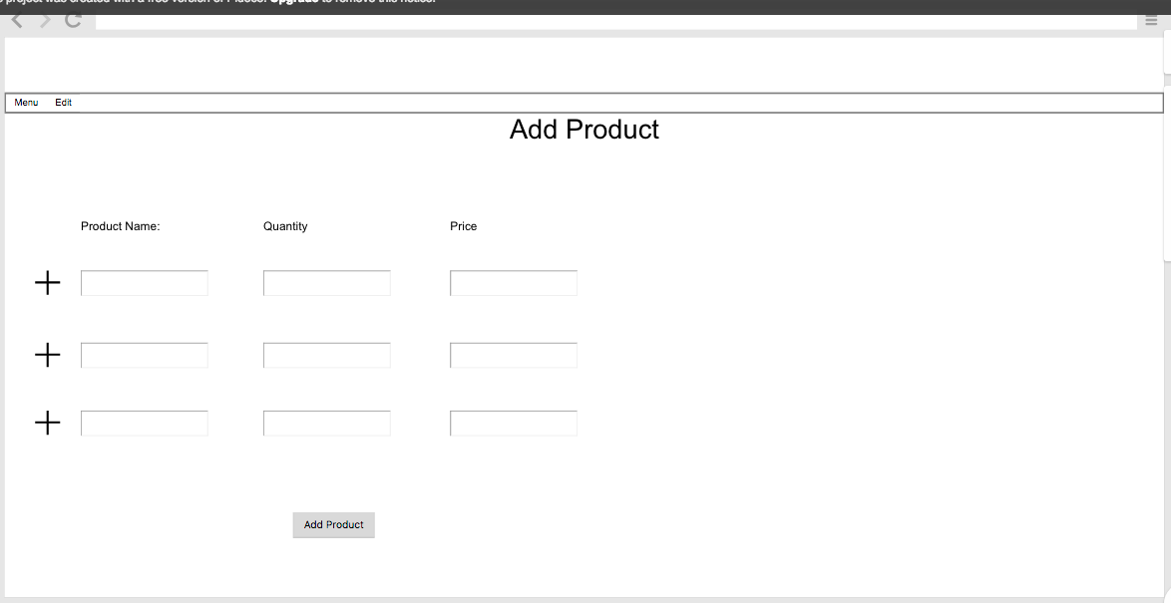

-Updating the current product in the system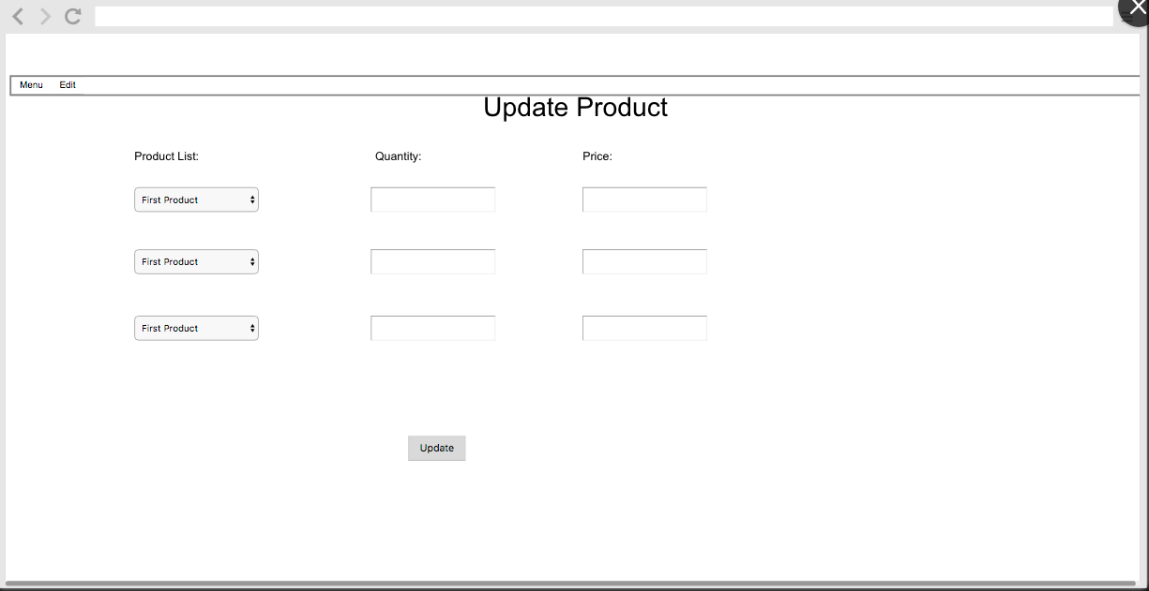

-deleting the product that are not yet available or has been removed in the shop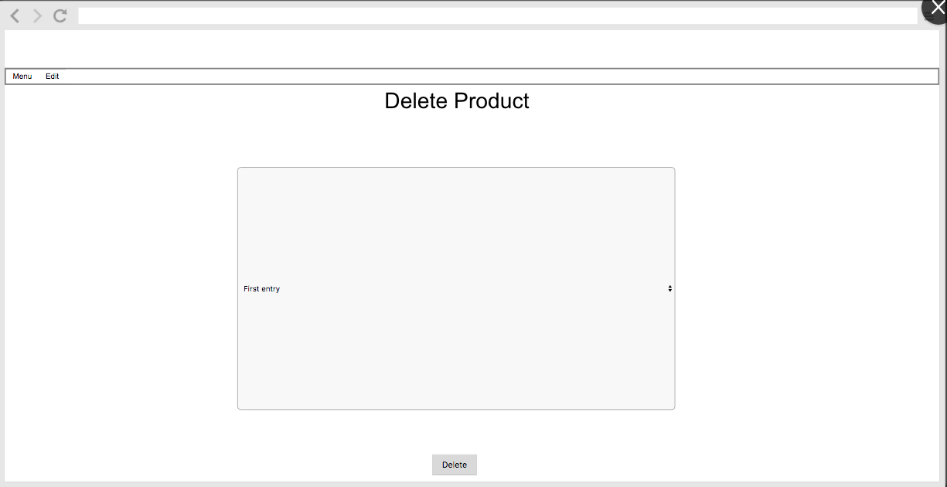

***Proposed Solution to the Problem***

The hardware store, 7th of May Trading, is currently using a work routine where staffs manually count their items and record it in a log book. The routine is a time-consuming process that are more prone to errors, thus resulting to the business's loss. Some of the items are also located in different parts of the store, which adds to the difficulty of checking the products' availability.

The group aims to create an inventory system and point of sale for the 7th of May Trading that can keep track of the items and track the top-selling product,least selling product,daily sales,weekly sales of the hardware store with this we also provided a QR code that can be used as ordering online and can be scan by the admin to know what the customer ordered. In addition, the inventory system can easily be updated to show the current availability status of all the items, thus demanding less time and effort from the staffs.

- Reordering Point will be included to make sure that products will not be out of stock.

- Data Analysis for computation and reference of their daily, monthly, and annual sales.

-User Accounts function will be added for creation, editing and removing of accounts. Only the Admin has an access for this feature.

-User Type will be added on the user accounts but it will limit the access to the system depending on the type of the user. There will be 2 types of employees, staff who can add, edit and the admin can have access to all functions of the system.

-Data reports will be consisting of Inventory Report, Product List including it's Daily Sales, Monthly Sales, Annual Sales.

-QR code will be use when ordering online and can be scan by the admin to know what the customer ordered online.

# **References**

[1] Computer-Based Inventory System. (September 2010). Retrieved March, 2018 from <http://www.studymode.com/essays/Computer-Based-Inventory-System-401903.html>

[2] Darya Plinere, Arkady Borisov. Case Study on Inventory System. (2015). Retrieved March, 2018 from <https://www.degruyter.com/view/j/itms.2015.18.issue-1/itms-2015-0014/itms-2015-0014.xml>

[3] Hong Shen, Qian Deng, Rebecca Lao, Simon Wu. A Case Study of Inventory Management in Manufacturing Company in China. (April 26, 2017). Retrieved March, 2018 from <https://www.degruyter.com/downloadpdf/j/nybj.2016.5.issue-1/nybj-2017-0003/nybj-2017-0003.pdf>

[4] Jonick Boguat, Anthony Ventura, Mary Kris Oliver, Elma Juelo. Computerized Inventory System and POS of Brother’s Burger. (March 5, 2014). Retrieved March, 2018 from <https://www.slideshare.net/JONICK_BOGUAT09/full-docu-it-thesis-project-in-computerized-inventory-system-in-brother-burger-visual-basic-60-back-end-ms-access>.

[5] Shazia Arshad, Muhamamd Shoaib, Muhammad Sajijad Khan. Computerized Inventory System – Program Development and Execution. (Feb 07, 2017) Retrieved March, 2018 from <https://www.researchgate.net/publication/313397095_Computerized_Inventory_System_-_Program_Development_and_Execution>

[6] Inventory management software. Retrieved from: <https://en.wikipedia.org/wiki/Inventory_management_software>

[8]Anon. 2018. What Is a Point of Sale System? A Guide to POS Features. (January 2018). Retrieved April 18, 2018 from <https://www.softwareadvice.com/resources/what-is-a-point-of-sale-system/>

[9]Mary Ann Canales. " MCM Merchandise POINT OF SALE (POS) & INVENTORY SYSTEM ". Retrieved April 18, 2018 from <https://www.academia.edu/34301783/_MCM_Merchandise_POINT_OF_SALE_POS_and_INVENTORY_SYSTEM_>

[10]Nars Ulep. An automated POS and inventory system for V.F.C Corp. Retrieved April 18, 2018 from <https://www.academia.edu/35997610/An_automated_POS_and_inventory_system_for_V.F.C_Corp>

**Transcript of Interview:**

Marco Joaquin Po: Good afternoon, May I ask if what are the processes that you do when a customer inquires or purchase a certain product?

Anne Santos (admin staff): First we check for the product in the storage room then will double check the logbook (List of products) then after we check if the product is available we then now process it just writing down in a small paper (official Receipt). After we make a sale we then now just update the logbook to deduct the item.

Joseph Alovera: Does the other staff have any authority to open the logbook or checks the list of products in the logbook?

Marco Joaquin Po: And also did you encounter problems doing everything in manual? For example the computation of your sale?

Anne Santos (admin staff): I’m the only one who can write down in the logbook and checks the list of product from time to time. We do have a hard time in keeping track of our items in stock, and knowing when the items are short for the day or the following day.

Joseph Alovera: How about your computation of sales?

Anne Santos (admin staff):I do the computation of sale I do it manually, I will compute for a daily sales first after we close the hardware store. Computing for the sales are difficult because you need to do it right to know so that I can know if we have an income.

Marco Joaquin Po: Do you have your own supplier?

Anne Santos (admin staff): Yes we do have our own supplier.

Marco Joaquin Po: How do you know when to call or tell the supplier that you’re needing supplies for the store?

Anne Santos (admin staff): Before the day ends I tell the staff to manually check the inventory, checks the list if we still have the product. Then if there is no stock left for we’ll just call the supplier for restockment.

Joseph Alovera: Does your store accepts credit card? Cheque?

Anne Santos (admin staff): We only accept cash here in our store.

Marco & Joseph: Thank you for accepting our interview, Bye.