Marco Joaquin Po

Installing Git

1. Download the installer and run it ang click next.

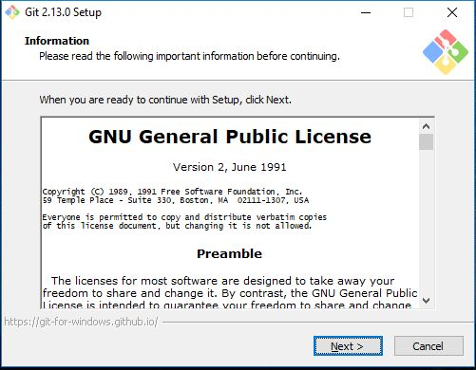

2.Select where to install Git. Then click next.

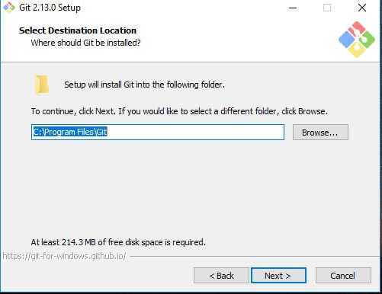

3.Select the components you want to install.

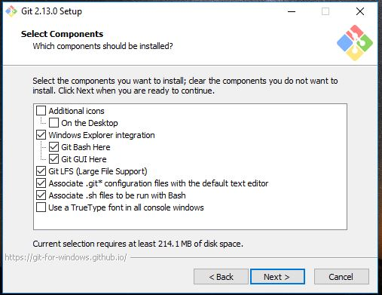

4.Click next, if you want to select another folder click browse.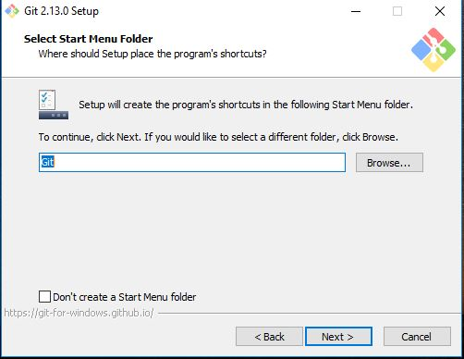

5.Select your PATH.

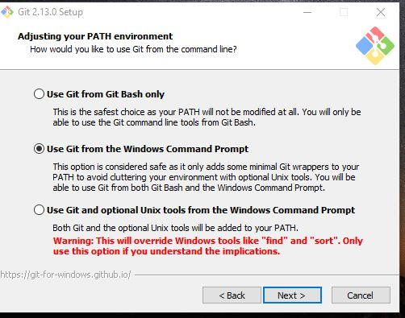

6.Select which library you like the Git to use for connections.

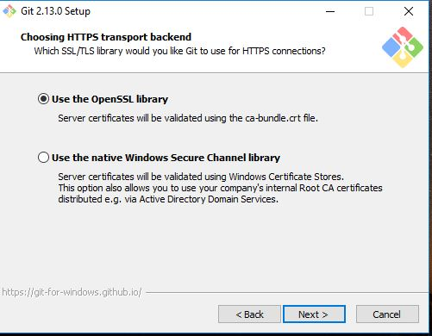

7.Choose how you want your Git treat line endings in text file.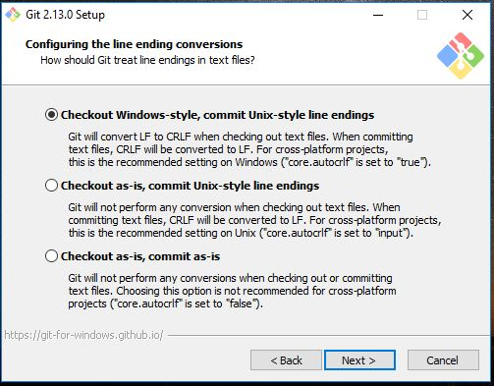

8.Choose the terminal you want tp use for your Git bash.

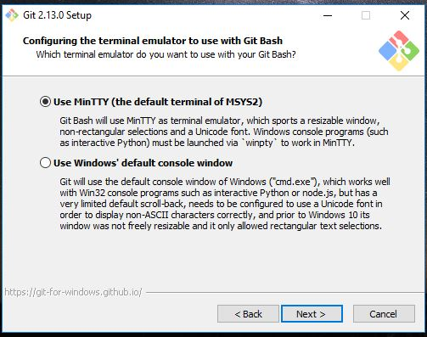

9. select the features you want. Then install.

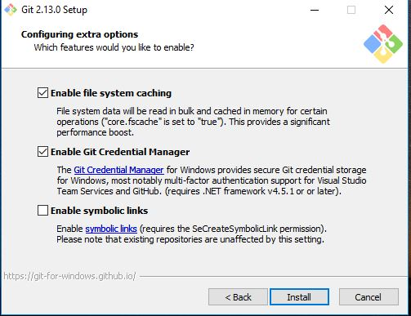

10. Wait until the setup is finish.

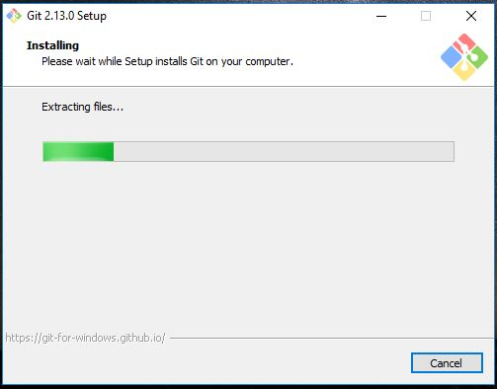

11. Click finish

