

APPLIED PROJECTS 2

PROJECT A5MMS

Lopez, Carlucenne

Naperi, Jayson

Dela Cuesta, Georgette

Rocero, Earl Jerome

**Team Members**

Mr. Manuel S. Sanchez

**Professor**

**Table of Contents**

1. **Business Case**…………………………………………………………………….………………………………………………3
2. Project Overview…………………….…………………………………………………………………………………………3
3. Purpose…………….…………………………………………………………………………………………………………….…3
4. Objectives of the Proposed System……………………………………………………………………………….…. 4
5. Review of Related Software……………………….…………………………………………………………….….…….4
6. Organizational Chart……………………………………………………………………………………………….…………5
   1. Agency Organizational Chart…………………………………………………………………….…………..5
   2. Team Organizational Chart…………………………………………………………………………..….…...6
7. Roles & Responsibilities……………………………………………………………………………………….…………...6
8. Work Breakdown Structure……………………………………………………………………………………............7
9. Benefits……………………………………………………………………………………………………..........................7
10. Scope and Limitations………………………………………………………………………………………………………10
11. Risk Management……………………………………………………………………………………………….……………10
12. Success Factor.…………………………………………………………………………………………………………………10
13. **Diagrams**………………………………………….………………………………….…………………………………………..11
14. Functional Decomposition Diagram……….…………………………………………………………………….…..11
15. Context Diagram………………..……….……………………………………………………………………………….…..11
16. Data Flow Diagram (Diagram 0) ………………..……….……………………………………………………….……12
17. Entity – Relationship Diagram………………..……….…………………………………………………………..…..13
18. Use Case Diagram ………………..……….…………………………………………………………..………………..….14
19. Use Case Narrative Description ………………..……….………………………………………………………..….15
20. Class Diagram ………………..……….………………………………………………………………………………..…….26
21. State Transition Diagram.………..……….………………………………………………………………………........27
22. Sequence Diagram ..………………..……….……………………………..…………………………………..............29
23. Activity Diagram ..………………..……….……………………………..………………………………….................36
24. Component Diagram………………………………………………………………………………………………………..42
25. Deployment Diagram………………………………………………………..……………………………………………..43
26. Software Requirements Specifications Checklist ..………………..………………………….................43
27. Screen Layouts………………………………………………………………………………………………………………...46
28. **BUSINESS CASE**

**Project Overview**

A5MMS is a corporation, formed and organized under the laws of the Republic of the Philippines, duly registered with the Security and Exchange Commission (SEC) and licensed to operate a manpower/janitorial services.

The team conducted interviews with the A5MMS regarding on the issues they had been experiencing in their business and these are:

* The need of A5MMS’ clients for highly qualified employees
* The need for accessible information on available jobs
* The need to improve the manual and time – consuming application and employment process. Currently these are the processes on application and employment:
  + Applicant personally inquires for a job.
  + Applicant applies and submits requirements to the agency.
  + Agency process and file submitted requirements.
  + Agency conducts initial interview then training.
  + Agency endorses qualified applicants to the A5MMS’ clients.
  + A5MMS’ client conducts final interview to the qualified applicant and hires qualified applicants.
* The need for an improved, secured and automated payroll system of the employees.

Thus, the team aims to propose a Human Resource Management System that focuses on the job inquiry, application, employment and payroll process for the agency.

**Purpose**

To provide the client a Human Resource Management System that will minimize the afore mentioned issues.

**Objectives of the Proposed System**

**General Objective**

To be able to design and develop a web – based Human Resource Management System for the Area 5 Manpower Management Services (A5MMS).

**Specific Objectives**

* To increase the number of qualified applicants assessed by the agency by 20% in annual basis.
* To provide faster transaction on application process of applicants by less than a day.
* To provide faster and more secured payroll computation and distribution of pay slip to the employees by 50% every cut - off period.

**Review of Related Software**

|  |  |  |  |
| --- | --- | --- | --- |
|  | **Ramco** | **WebHR** | **Project A5MMS** |
| **Description** | A global talent management application that has been designed to facilitate a changing work environment. Its flexible architecture is designed to handle proliferating employment, measurement, and wage models, and it provides an integrated HR services experience. | Facilitates all functions of the Human Resource Department that deals with recruitment, employees' management, payroll, performance, training etc. | A Human Resource Management System that focuses on the job inquiry, application, employment and payroll process. |
| **Features / Functions** | * Time attendance * Payroll * Talent management * Recruitment * Planning & Analytics | * Feature Rich Social HR * Complete Recruitment Solution * Employees Self Service * Extremely User Friendly * Effortless Payroll * Employees Attendance / Biometrics * Very Cost Effective * Comprehensive Reports & Graphs * Extensive Leaves Management * Online Job Portal * Extensive Employee Profile * Customizable Data Fields * Documents Managements * Reports Generator | * Online Job Inquiry * Online Application Form * HR Management * Import employee attendance * Payroll and Pay Slip |

**Organizational Chart**

**Agency Organizational Chart**

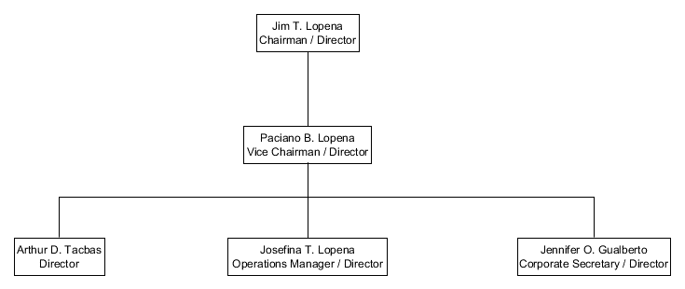

**Team Organizational Chart**

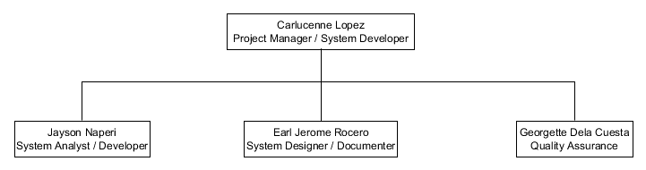

**Roles and Responsibilities**

|  |  |
| --- | --- |
| **ROLES** | **RESPONSIBILITIES** |
| Project Manager | * Leads and Manages the team * Plans the project requirements * Assigns the roles and responsibilities * Monitors the project progress |
| System Analyst | * Analyzes client’s business process * Analyzes the system requirements * Analyzes the system structure |
| System Designer | * Follow and creates diagrams analyzed by the system analyst |
| System Developer | * Follow the diagrams created by the system designer and developed it into a system |
| System Documenter | * Creates the project documentation including the business case, diagrams, development and design phase |
| Quality Assurance | * Assures the correct and appropriate analyzation, design, developed system, and documentation * Leads and Conducts System Testing |

**ESTIMATES**

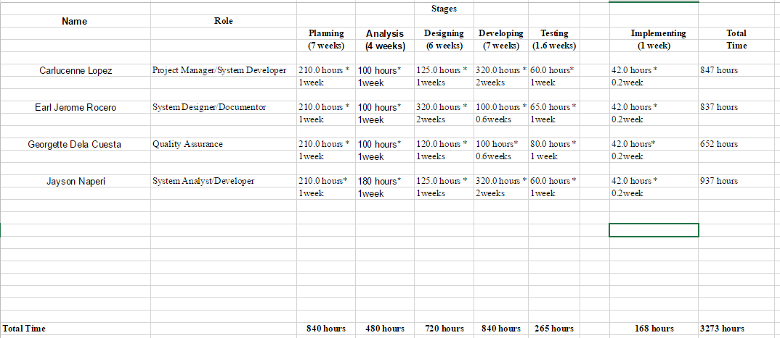

**Work Breakdown Structure**

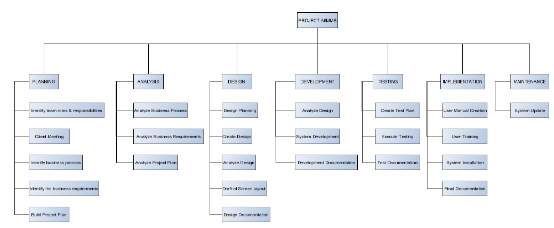

**GANTT Chart**

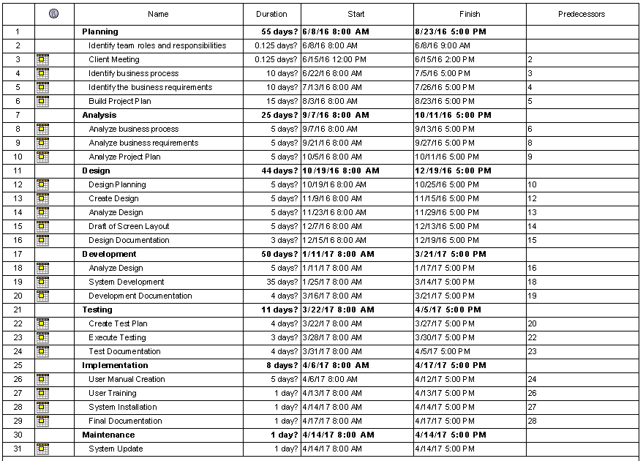

**Benefits**

* New Client Opportunity
  + This benefit may occur because of faster employment process or endorsement highly qualified applicants
* Increase of Applicants
  + This benefit occurs because of faster application process.
* Automated Payroll System
  + Faster computation of payroll of employees.

**Scope & Limitations**

**SCOPE:**

* Vacant jobs provided by the A5MMS’ clients shall be posted to the system.
* Attendance, payroll and pay slip details shall be processed in the system.

**LIMITATIONS:**

* Client details will be managed, if the client approved contract agreement.
* Employee details will be managed, if the applicant has been already hired.
* Attendance details will be managed every payroll or cut – off period.

**Risk Management**

|  |  |  |  |  |  |
| --- | --- | --- | --- | --- | --- |
| **Risk** | **Description** | **Probability** | **Impact** | **Category** | **Contingency** |
| INFORMATION LEAK | Chances of system information going to be leaked | 40% | HIGH | **Information Security Risk** | Integrate and study more on securing the system further. |
| USER PARTICIPATION | Users are not intimately involved in planning the project | 10% | MEDIUM-HIGH | **Schedule Risk** | Early involvement and manage the user’s expectation |
| MID-PROJECT SCOPE CHANGES | Scope of the project changing due to client demand or business process change/update | 30% | MEDIUM | Operational Risk/Schedule Risk | Adjust the schedule and adapt to the new scope |

**Success Factor**

* 20% increase in number of applicants applying in annual basis. Regarding on the interview them team conducted in the agency, 100 – 120 applicants applying jobs in the agency annually. As a success factor, we shall meet the 20% increase of applying applicants through the system.

**II. DIAGRAMS**

**Functional Decomposition Diagram**

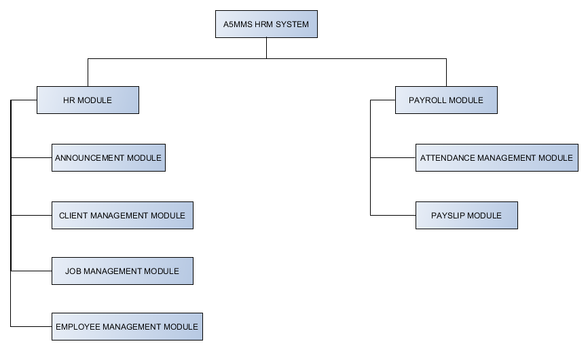

**Context Diagram**

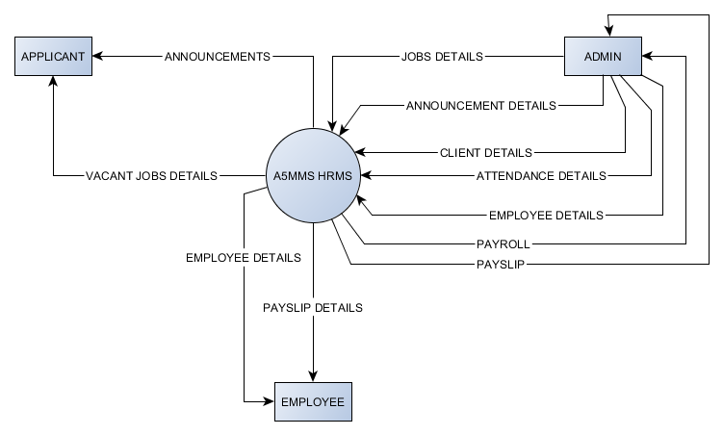

**Data Flow Diagram**

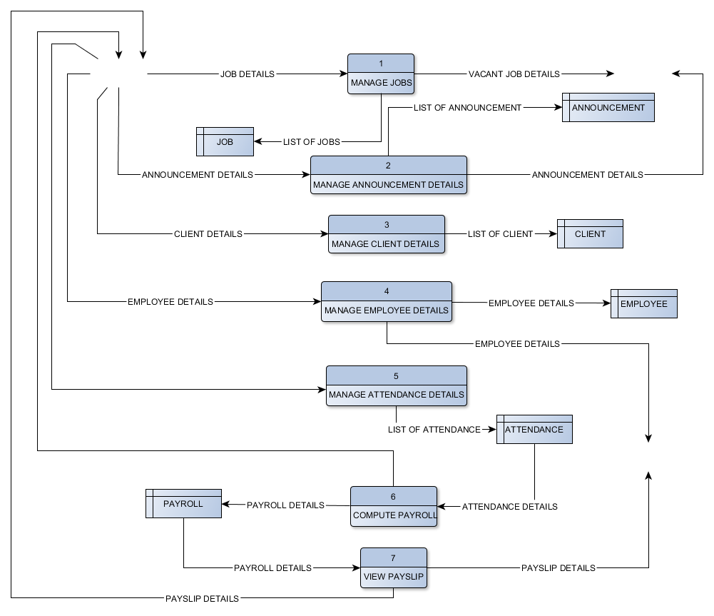

**Entity – Relationship Diagram**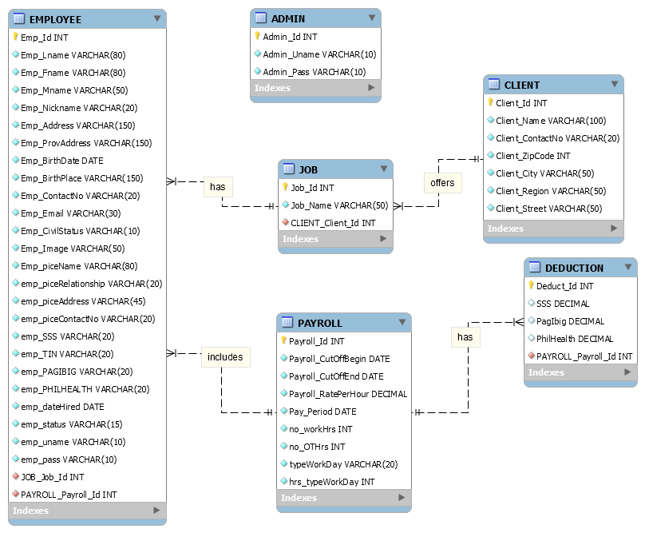

**Use Case Diagram**

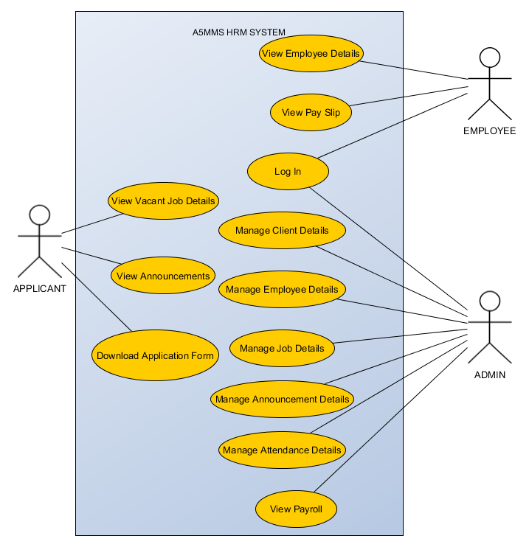

**Use Case Narrative Description**

|  |  |  |  |
| --- | --- | --- | --- |
| **USE CASE NAME** | | View Vacant Job Details | |
| **ACTOR** | | Applicant | |
| **DESCRIPTION** | | Describes the process in viewing the vacant job details. | |
| **SUCCESSFUL** **COMPLETION** | ACTOR  1. Applicant access the system.  3. Applicant selects vacant jobs.  5. Applicant selects desired vacant job. | | SYSTEM  2. System displays the vacant jobs, announcements, and download application form.  4. System access job module and displays list of vacant jobs.  6. System displays details of vacant job. |
| **ALTERNATIVE** | | * 1. Applicant can walk – in/contact the agency regarding on the vacant job.   6.1 Applicant search for another job online if he/she doesn’t like the listed vacant jobs in the system. | |
| **PRE – CONDITION** | | Applicant searches for a job. | |
| **POST – CONDITION** | | Applicant knows what are the vacant job the agency offers and what company he/she is applying for. | |
| **ASSUMPTION** | | List of vacant job and details will be viewed in the system. | |

|  |  |  |  |
| --- | --- | --- | --- |
| **USE CASE NAME** | | Download Application Form | |
| **ACTOR** | | Applicant | |
| **DESCRIPTION** | | Describes the process downloading the application form in the system. | |
| **SUCCESSFUL** **COMPLETION** | ACTOR  1. Applicant access the system.  3. Applicant selects download application form.  5. Applicant downloaded the application form. | | SYSTEM  2. System displays the vacant jobs, announcements, and download application form.  4. System downloads application form. |
| **ALTERNATIVE** | | * 1. Applicant can walk-in to the agency to get an application form and fill up. | |
| **PRE – CONDITION** | | Applicant opens the system. | |
| **POST – CONDITION** | | Downloaded the application form and fill up. | |
| **ASSUMPTION** | | The application form is up to date and can be downloaded in the system. | |

|  |  |  |  |
| --- | --- | --- | --- |
| **USE CASE NAME** | | View Announcements | |
| **ACTOR** | | Applicant | |
| **DESCRIPTION** | | Describes the process viewing of announcements in the system. | |
| **SUCCESSFUL** **COMPLETION** | ACTOR  1. Applicant access the system.  3. Applicant selects announcements.  5. Applicant views the announcement details such as interviews and trainings. | | SYSTEM  2. System displays the vacant jobs, announcements, and download application form.  4. System access application module and displays announcements. |
| **ALTERNATIVE** | | 1.1 Applicant can walk – in/contact the agency regarding on the announcements of interview and training.  1.2 HR Admin contact the applicants for the announcements of interviews and trainings. | |
| **PRE – CONDITION** | | Applicant applied a job. | |
| **POST – CONDITION** | | Applicant notified about the announcements. | |
| **ASSUMPTION** | | Up to date announcements posted in the system. | |

|  |  |  |  |
| --- | --- | --- | --- |
| **USE CASE NAME** | | View Employee Details | |
| **ACTOR** | | Employee | |
| **DESCRIPTION** | | Describes the process of viewing the employee details. | |
| **SUCCESSFUL** **COMPLETION** | ACTOR  1. Employee access the system.  3. Employee selects view employee details.  5. Employee views the employee details. | | SYSTEM  2. System displays the employee details and pay slip details.  4. System access employee management module and display the employee details. |
| **ALTERNATIVE** | | 1.1 Employee can walk – in to the agency regarding on the employee details. | |
| **PRE – CONDITION** | | Employee logged in to the system. | |
| **POST – CONDITION** | | Employee successfully views employee details. | |
| **ASSUMPTION** | | Displayed employee details. | |

|  |  |  |  |
| --- | --- | --- | --- |
| **USE CASE NAME** | | View Pay Slip | |
| **ACTOR** | | Employee | |
| **DESCRIPTION** | | Describes the process of viewing the payslip details. | |
| **SUCCESSFUL** **COMPLETION** | ACTOR  1. Employee access the system.  3. Employee selects view pay slip details.  5. Employee selects pay period.  6. Employee views pay slip. | | SYSTEM  2. System displays the employee details and pay slip details.  4. System access payroll module and display the pay periods.  5. System displays the pay slip in a specific pay period. |
| **ALTERNATIVE** | | 3.1 Employee walk – in to the agency to get pay slip. | |
| **PRE – CONDITION** | | Employee logged in to the system. | |
| **POST – CONDITION** | | Employee successfully views pay slip. | |
| **ASSUMPTION** | | System computed payroll every cut-off. | |

|  |  |  |  |
| --- | --- | --- | --- |
| **USE CASE NAME** | | Log In | |
| **ACTOR** | | Admin /Employee | |
| **DESCRIPTION** | | Describes the process of logging – in to the system of the Admin and Employee. | |
| **SUCCESSFUL** **COMPLETION** | ACTOR  1 Admin/Employee log in to the system  3. Admin/Employee accessed the system. | | SYSTEM  2. System verifies the account. |
| **ALTERNATIVE** | | 2.1 System allows the admin / employee to verify the account. | |
| **PRE – CONDITION** | | Admin/Employee has an accessed to the system. | |
| **POST – CONDITION** | | Admin/Employee successfully log in to the system. | |
| **ASSUMPTION** | | Admin/Employee has an account. | |

|  |  |  |  |
| --- | --- | --- | --- |
| **USE CASE NAME** | | Manage Employee Details | |
| **ACTOR** | | Admin | |
| **DESCRIPTION** | | Describes the process of managing the employee details. | |
| **SUCCESSFUL** **COMPLETION** | ACTOR  1. Admin access the system.  3. Admin selects employee management module.  5. Admin selects manage employee details.  7.Admin selects a client.  9. Admin selects an employee.  11. Admin manages employee details.  13. Admin views employee details. | | SYSTEM  2. System displays the job assignment, application, and employee management modules.  4. System displays the manage employee details.  6. System displays list of agency’s clients.  8. System displays list of employees working on the client.  10. System allows the HR Admin to manage employee details.  12. System displays updated employee details. |
| **ALTERNATIVE** | | 1.1 Admin contact the employee regarding on the employee details. | |
| **PRE – CONDITION** | | Employee sent employee details. | |
| **POST – CONDITION** | | Admin updated employee details. | |
| **ASSUMPTION** | | Admin received the employee details. | |

|  |  |  |  |
| --- | --- | --- | --- |
| **USE CASE NAME** | | Manage Job Details | |
| **ACTOR** | | Admin | |
| **DESCRIPTION** | | Describes the process of managing the job details. | |
| **SUCCESSFUL** **COMPLETION** | ACTOR  1. Admin access the system.  3.Admin selects job module.  5. Admin selects manage job details.  7.Admin selects a client.  9. Admin selects a job.  11. Admin manages job details.  13. Admin views job details. | | SYSTEM  2. System displays the job assignment, application, and employee management modules.  4. System displays the manage job details.  6. System displays list of agency’s clients.  8. System displays list of jobs given by the client.  10. System allows Admin to manage job details.  12. System displays updated job details. |
| **ALTERNATIVE** | | 1.1 Admin contact / personally meet the client regarding on the job details. | |
| **PRE – CONDITION** | | Client sent job details. | |
| **POST – CONDITION** | | Admin updated job details. | |
| **ASSUMPTION** | | Admin received the job details from the client. | |

|  |  |  |  |
| --- | --- | --- | --- |
| **USE CASE NAME** | | Manage Announcement Details | |
| **ACTOR** | | Admin | |
| **DESCRIPTION** | | Describes the process of managing the announcement details. | |
| **SUCCESSFUL** **COMPLETION** | ACTOR  1. Admin access the system.  3.Admin selects application module.  5. Admin selects manage announcement details.  7. Admin posts announcement details.  9. Admin views announcements details. | | SYSTEM  2. System displays the job assignment, application, and employee management modules.  4. System displays the manage applicant and announcement details.  6. System allows the HR Admin to manage announcement details.  8. System displays updated announcement details. |
| **ALTERNATIVE** | | 1.1 Admin contact the applicants regarding on the announcement details. | |
| **PRE – CONDITION** | | Admin logged in to the system. | |
| **POST – CONDITION** | | Admin updated announcement details. | |
| **ASSUMPTION** | | Admin validated the announcements**.** | |

|  |  |  |  |
| --- | --- | --- | --- |
| **USE CASE NAME** | | Manage Client Details | |
| **ACTOR** | | Admin | |
| **DESCRIPTION** | | Describes the process of managing the client details. | |
| **SUCCESSFUL** **COMPLETION** | ACTOR  1. Admin access the system.  3.Admin selects client management module.  5. admin selects manage client details.  7. Admin manages client details.  9. Admin views client details. | | SYSTEM  2. System displays the client management module.  4. System displays the manage client details.  6. System allows the HR Admin to manage client details.  8. System displays updated client details. |
| **ALTERNATIVE** | | 1.1 Admin contact / personally meet the client regarding on the client details. | |
| **PRE – CONDITION** | | Admin logged in to the system. | |
| **POST – CONDITION** | | Admin updated announcement details. | |
| **ASSUMPTION** | | Contract agreement approved by the client. | |

|  |  |  |  |
| --- | --- | --- | --- |
| **USE CASE NAME** | | Manage Attendance Details | |
| **ACTOR** | | Admin | |
| **DESCRIPTION** | | Describes the process of managing the attendance details of employees every cut – off period. | |
| **SUCCESSFUL** **COMPLETION** | ACTOR  1. Admin access the system.  3. Admin access payroll module.  5. Admin selects manage attendance details.  7.Admin selects a client.  9. Admin manages attendance details.  11.Admin selects compute attendance. | | SYSTEM  2. System displays the payroll module.  4. System displays manage attendance details, view payroll, and view pay slips.  6. System displays lists of agency’s clients.  8. System allows Admin to manage attendance of employees working on the client.  10. System stores and display updated attendance details of employees in the system.  12. System computes payroll and generate pay slip from the attendance. |
| **ALTERNATIVE** | | 1.1 Admin contact / personally meet the client regarding on the attendance details.  1.2 Admin manually compute the payroll. | |
| **PRE – CONDITION** | | Client sent the attendance details. | |
| **POST – CONDITION** | | System computed the payroll and generated pay slip from the attendance of employees every cut – off period. | |
| **ASSUMPTION** | | Admin received the attendance details of the employees every cut – off period. | |

|  |  |  |  |
| --- | --- | --- | --- |
| **USE CASE NAME** | | View Payroll | |
| **ACTOR** | | Admin | |
| **DESCRIPTION** | | Describes the process of viewing the payroll of employees every cut – off period. | |
| **SUCCESSFUL** **COMPLETION** | ACTOR  1. Admin access the system.  3. Admin access payroll module.  5. Admin selects view payroll.  7. Admin selects a client.  9. Admin selects pay period.  11. Admin views payroll. | | SYSTEM  2. System displays the payroll module.  4. System displays manage attendance details, view payroll, and view pay slips.  6. System displays list of agency’s clients.  8. System displays pay period.  10. System displays payroll in a specific client and pay period. |
| **ALTERNATIVE** | |  | |
| **PRE – CONDITION** | | Admin logged in to the system. | |
| **POST – CONDITION** | | Admin views payroll in a specific client and payroll period. | |
| **ASSUMPTION** | | System computed payroll. | |

|  |  |  |  |
| --- | --- | --- | --- |
| **USE CASE NAME** | | View Pay Slip | |
| **ACTOR** | | Admin | |
| **DESCRIPTION** | | Describes the process of viewing the payslip details. | |
| **SUCCESSFUL** **COMPLETION** | ACTOR  1. Admin access the system.  3. Admin access payroll module.  5. Admin selects view pay slips.  7. Admin selects a client.  9. Admin selects an employee.  11. Admin selects a pay period.  13. Admin views employee pay slip in specific pay period. | | SYSTEM  2. System displays the payroll module.  4. System displays manage attendance details, view payroll, and view pay slips.  6. System displays list of agency’s clients.  8. System displays employees working on the client.  10. System displays pay period.  12. System displays selected employee pay slip in a specific pay period. |
| **ALTERNATIVE** | |  | |
| **PRE – CONDITION** | | Admin logged in to the system. | |
| **POST – CONDITION** | | Admin successfully views pay slip. | |
| **ASSUMPTION** | | System computed payroll. | |

**Class Diagram**

**State Transition Diagram**

**Sequence Diagram**

**ADMIN**

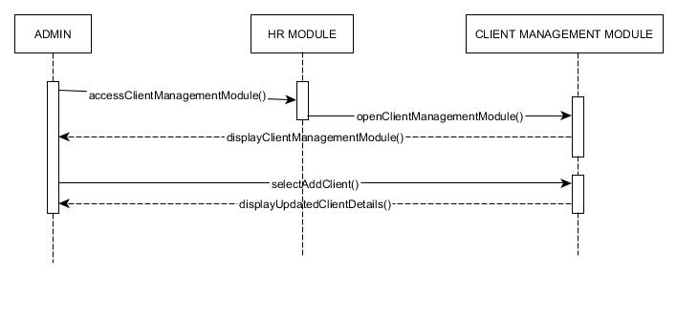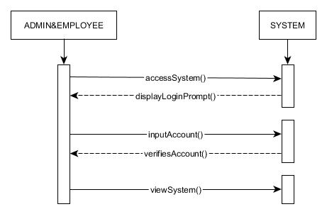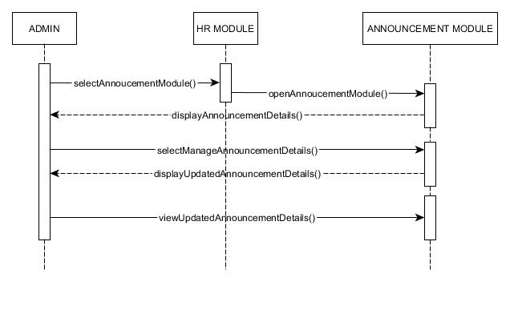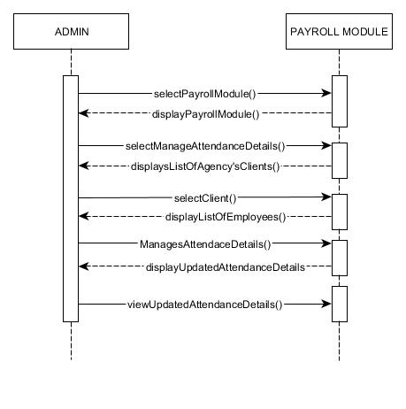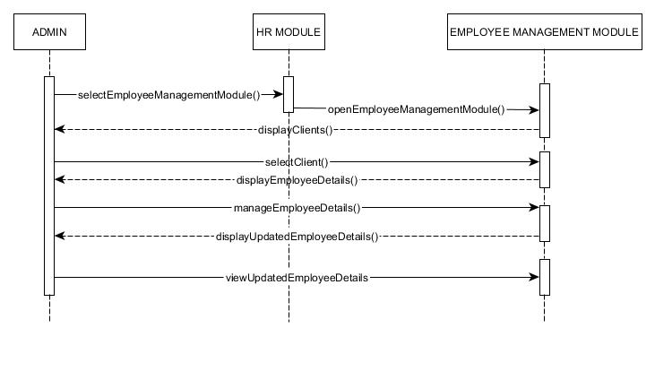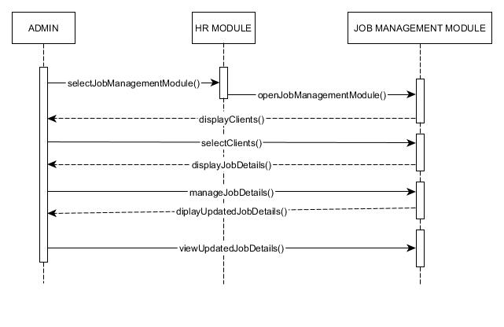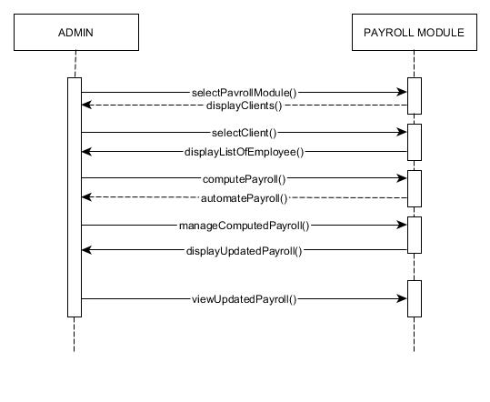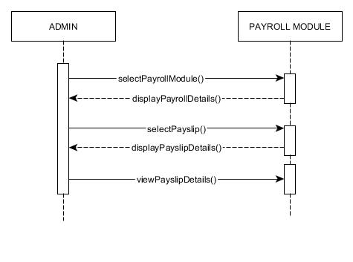

**APPLICANT**

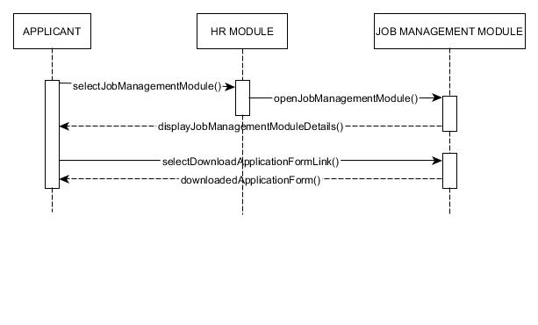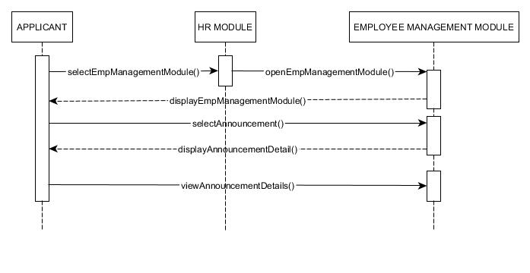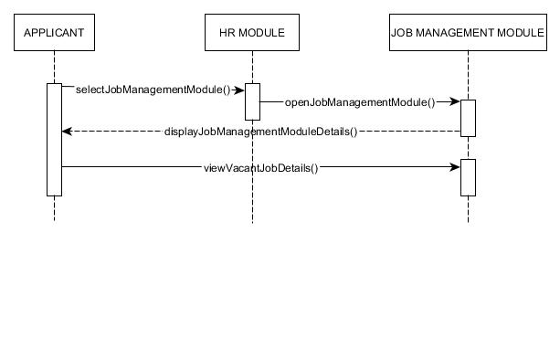

**EMPLOYEE**

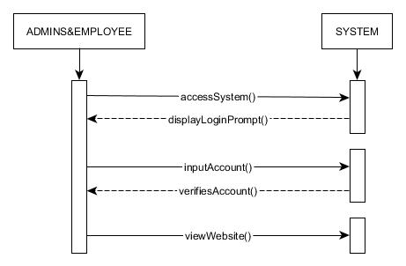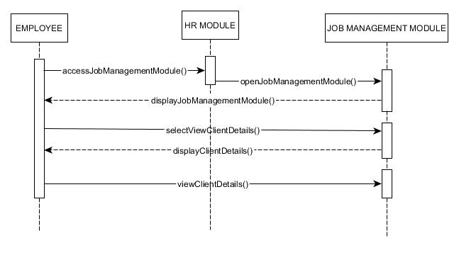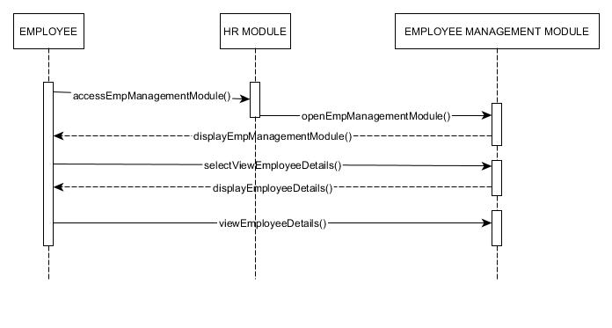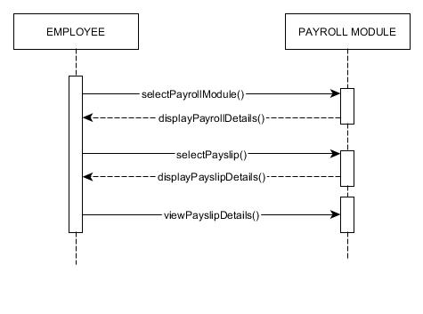

**Activity Diagram**

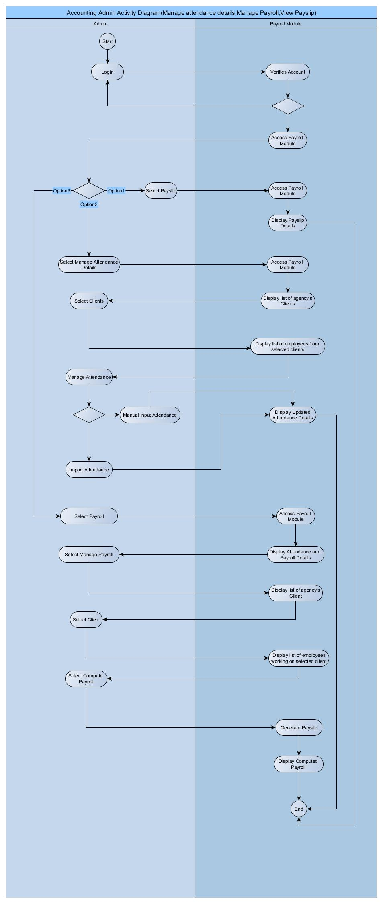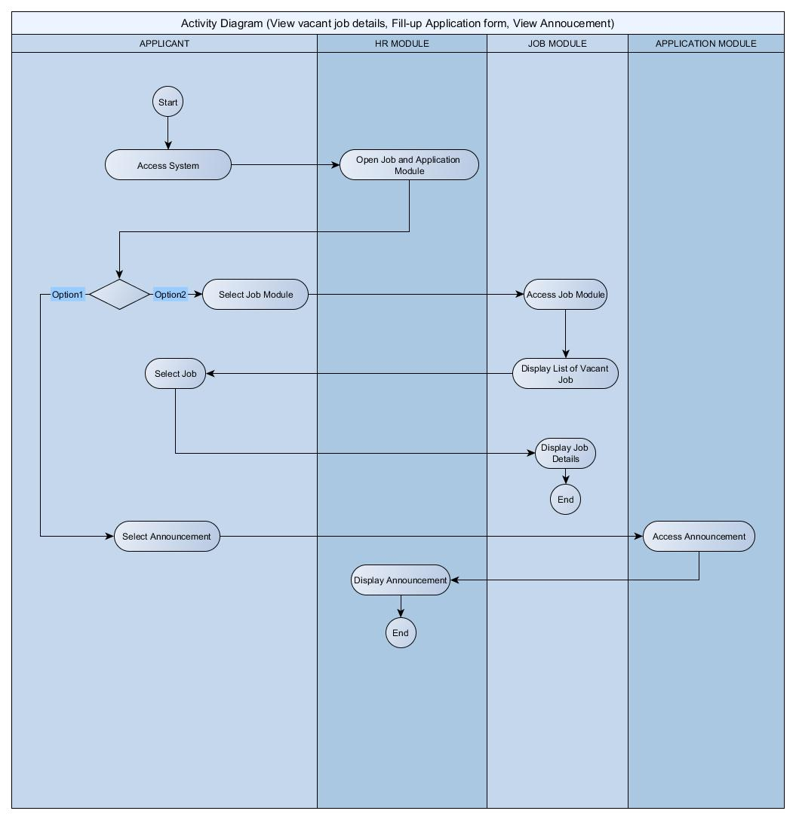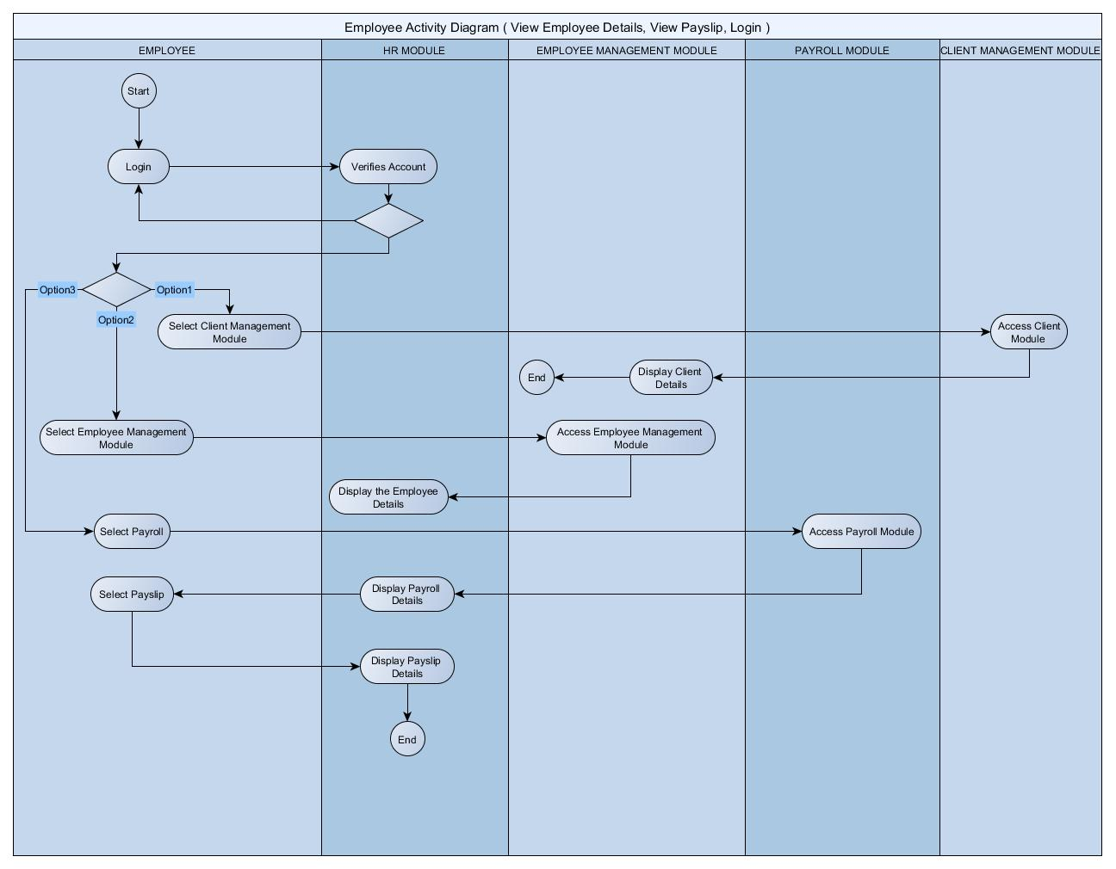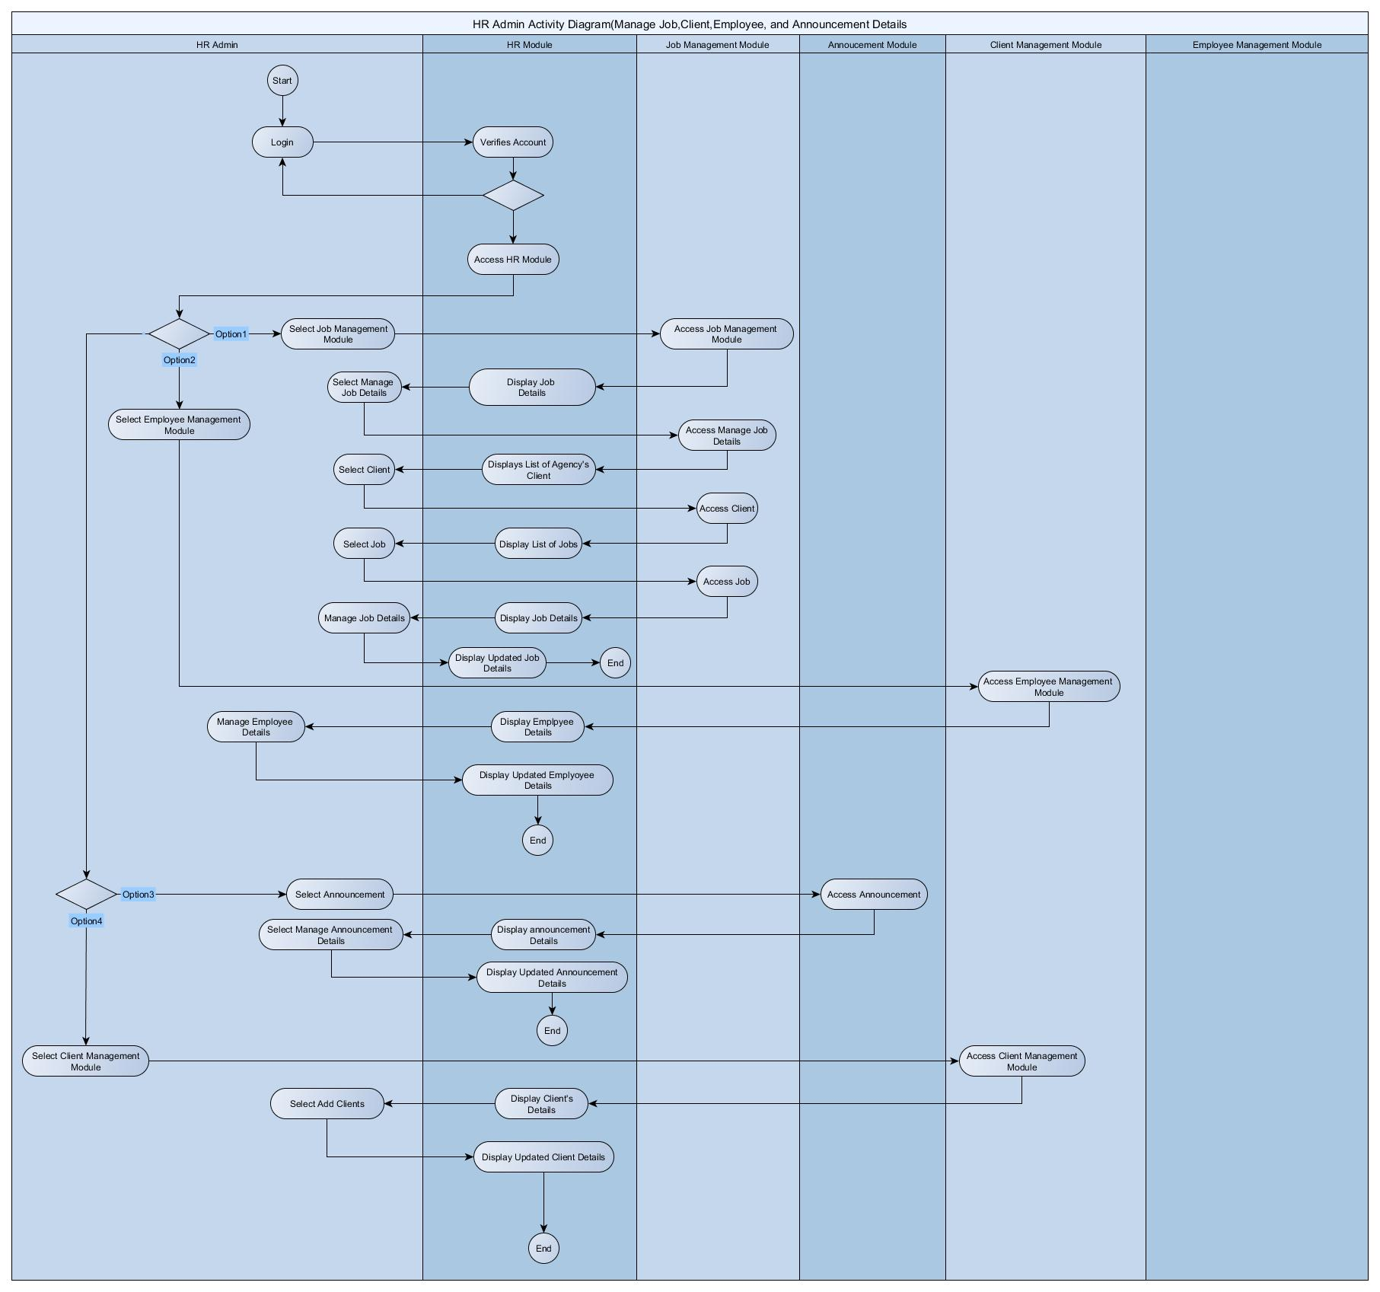

**Component Diagram**



**Deployment Diagram**

