1. Download Tortoise SVN 1.8.2 and Git.

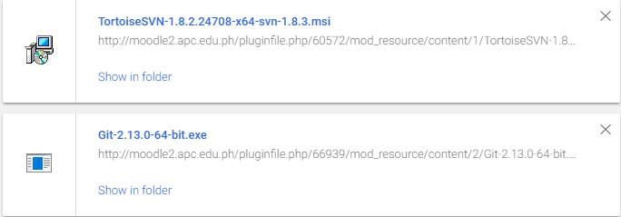

2. Click the TortoiseSVN installer and this will appear. Click Next.

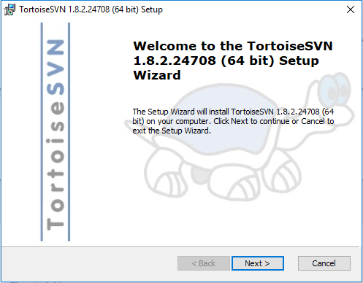

3. Choose to accept the terms in the License Agreement then click Next.

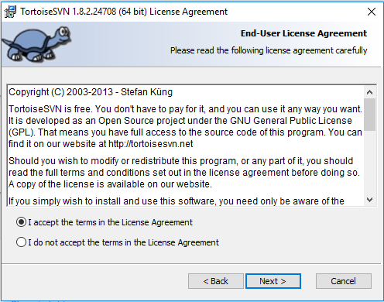

4. This page will let you setup the software then click Next.

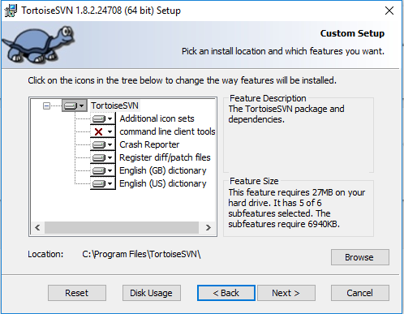

5. Click Install.

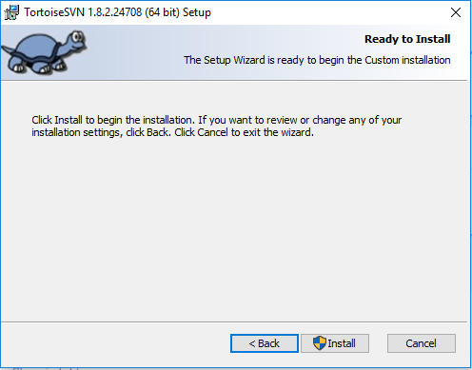

6. Tortoise will be installing and click “Yes” when it asked for changes in your computer.

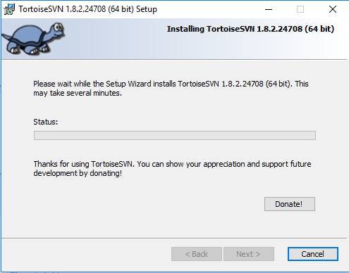

7. After installation, click Finish.

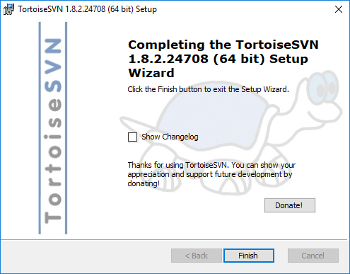

1. Click Git Installer. Click Next.

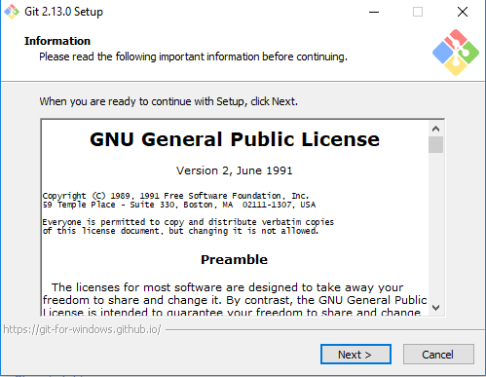

2. Choose the file location of Git. Click Next.

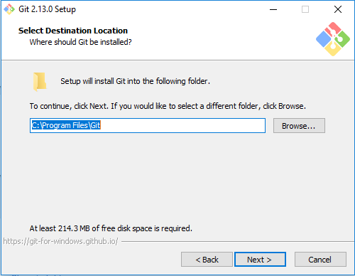

3. Select the components you want then click Next.

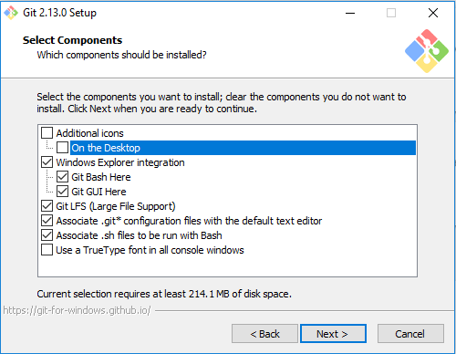

4. Select Start Menu Folder then click Next.

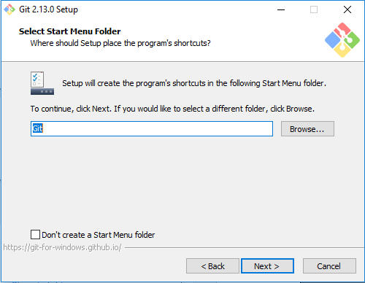

5. Select the command line then click Next.

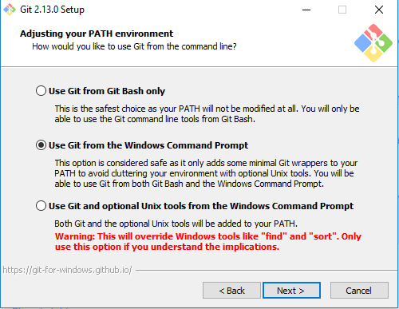

6. Choose the HTTPS transport backend then click Next.

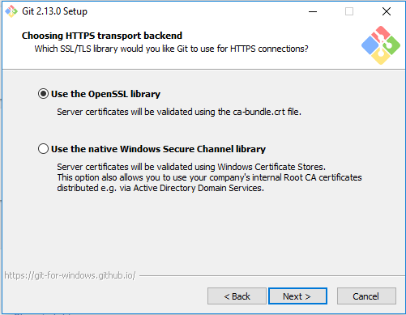

7. Choose the line ending then click Next.

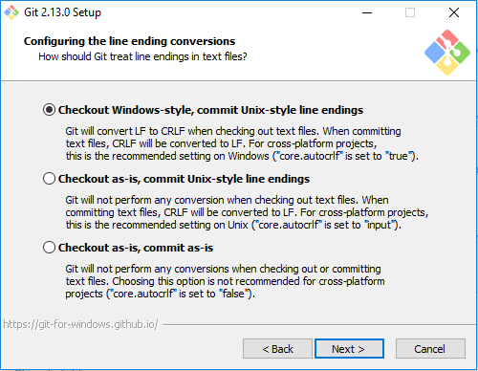

8. Choose the terminal emulator then click Next.

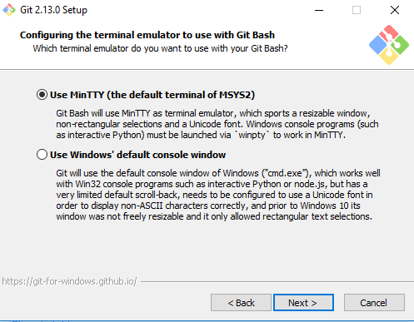

9. Select the features you want then click Install.

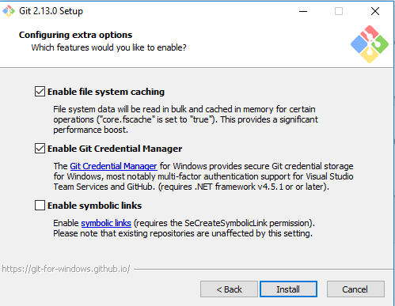

10. This will appear when installing.

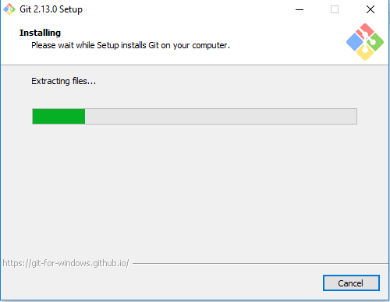

11. Click finish.

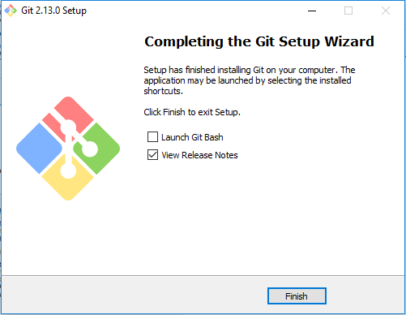

1. Create a folder that contains your file.

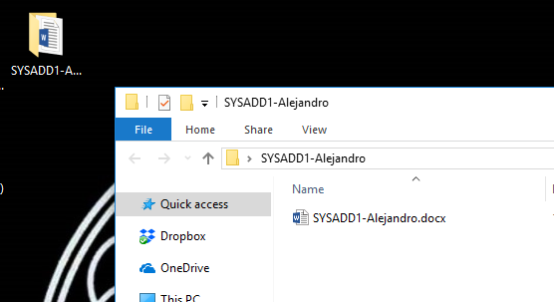

2. Right click the folder you created and find SVN Checkout.

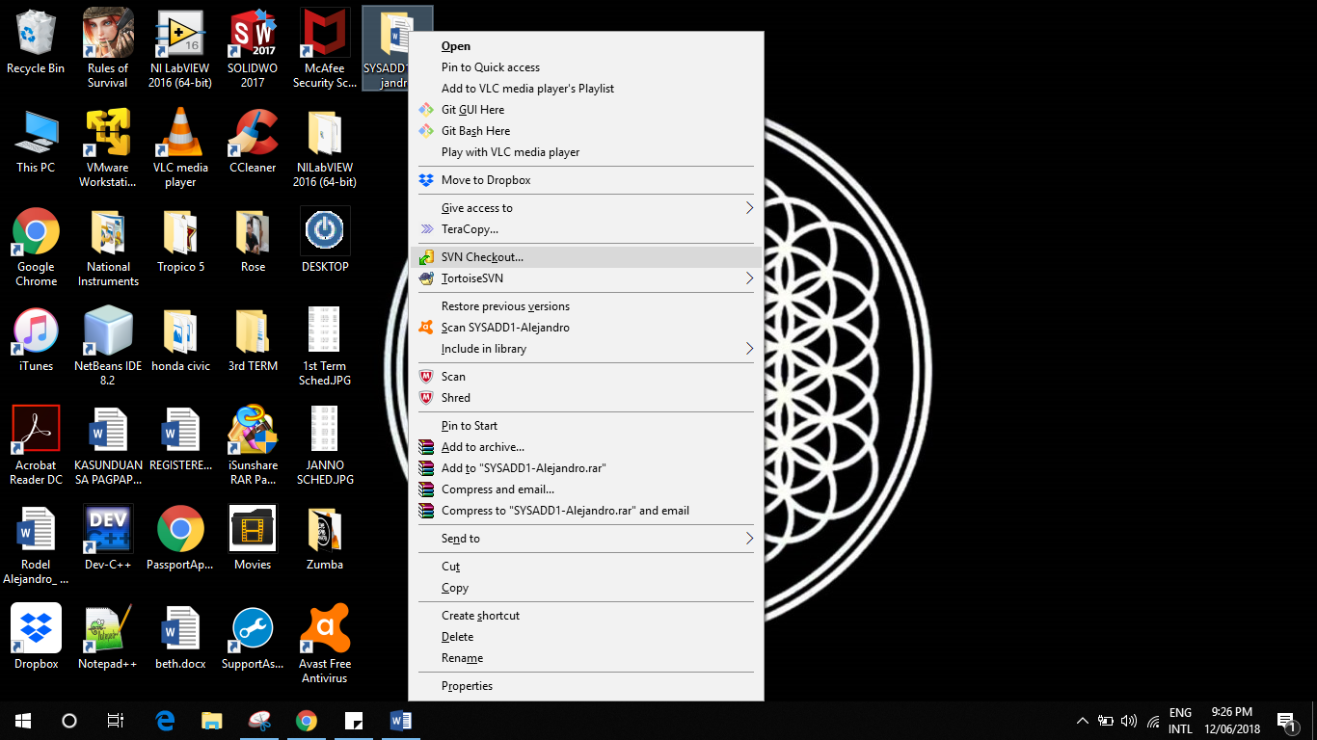

3. Copy the link of the Github Repository you want to upload the files in. Click the Clone or Download and copy the link.

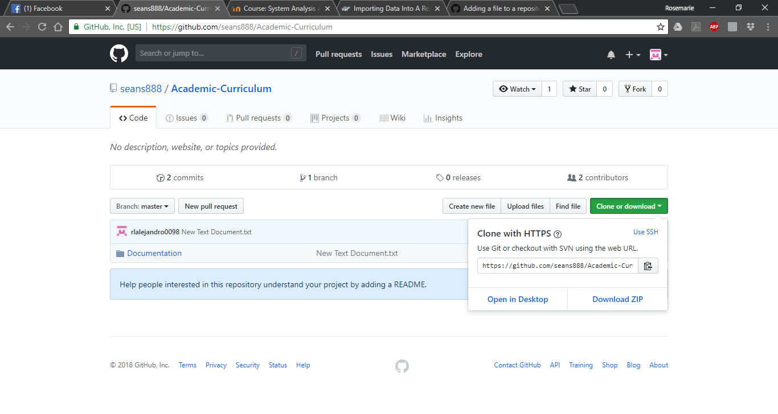

4. Paste the link to the URL of repository then click OK.

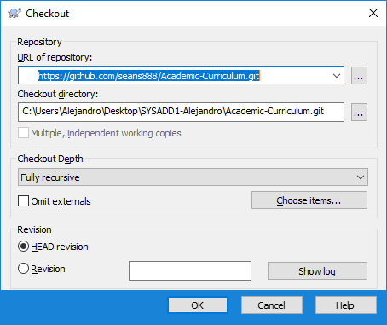

5. Once done, click OK.

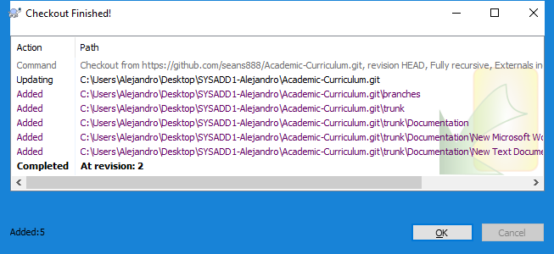

6. Go back to the folder you created then right click onto it. Find the Tortoise SVN then click Import.

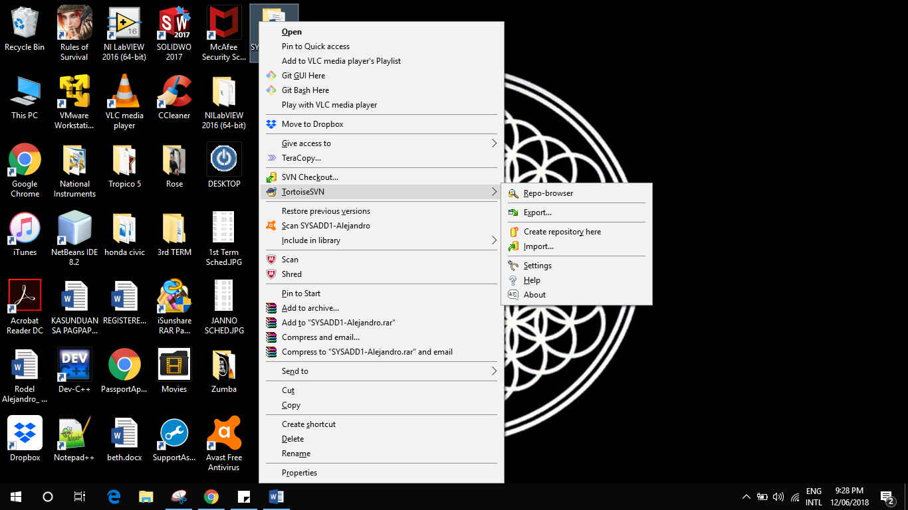

7. Paste the link you copied earlier then click OK.

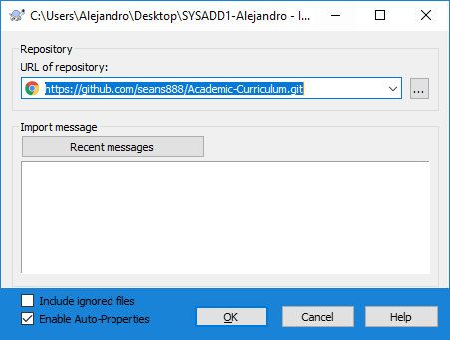

8. Input your Username and Password in github.

