**Chapter 5**

**Results and Discussion**

**Development Phase**

The developmental phase of the system started with the revision of the user interface (UI). After the group found a programmer that will help with the creation of the system, the group and the programmer decided to revise the user interface to provide a faster access to the functions and will give simplicity to the entire system. The revision of the user interface will be listed below.

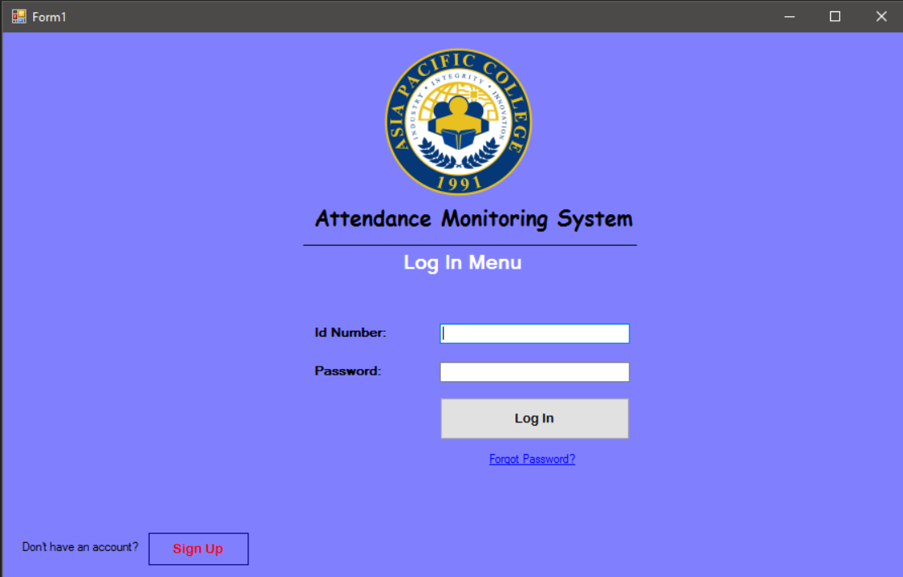

Figure 5.1: Proposed Login Interface

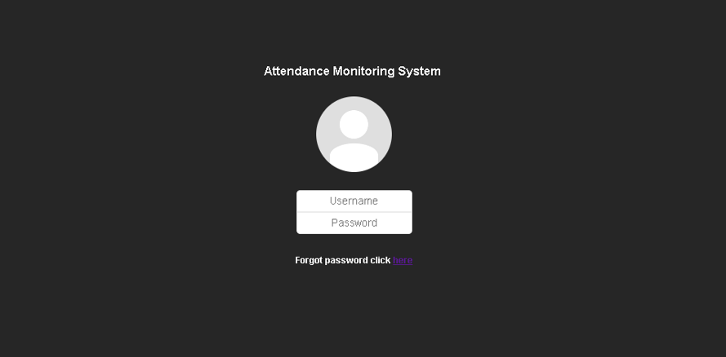

Figure 5.2: Revised Login Interface

Figure 5.1 and 5.2 displays the proposed and the revised login interface. As seen, the revised login interface provides simplicity to the user. And other buttons are removed like the login button to make sure that the interface will suit its function.

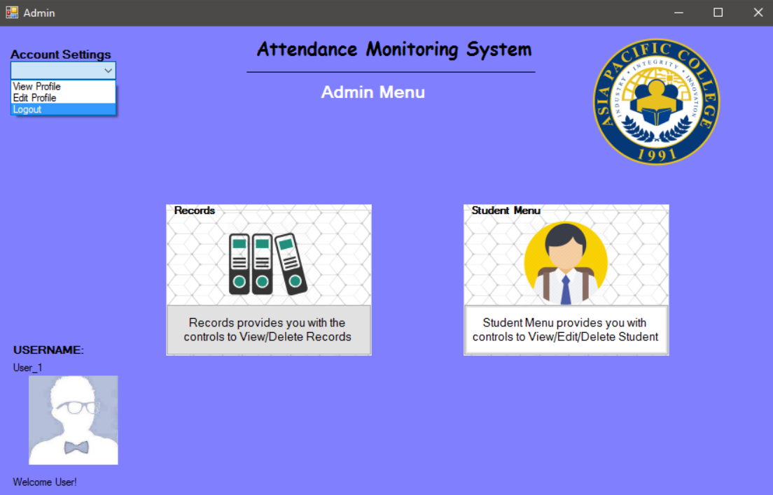

Figure 5.3: Proposed Home Page

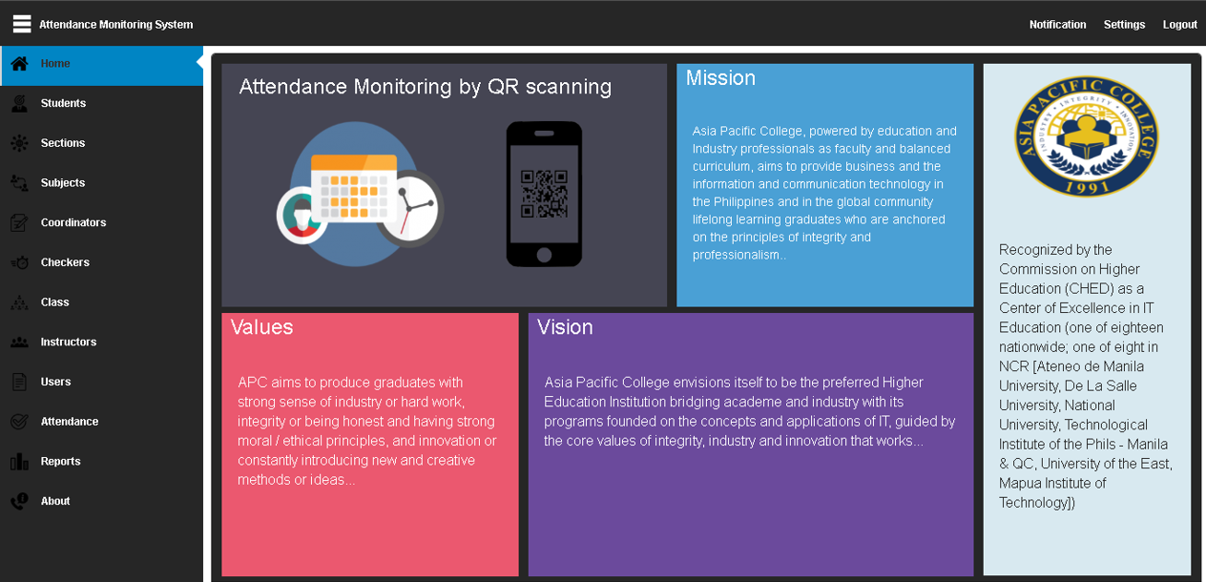

Figure 5.4: Revised Home Page

Figure 5.3 and 5.4 shows the home page of the administrator. On the proposed home page of the system it is based on the old layout of user interface. And the revised home page is based on the new user interface with added feature of the dashboard. The dashboard contains all the functions based on user type. The main change is that there is now a Home page where the information like Vision, Mission, Values, and APC is displayed.

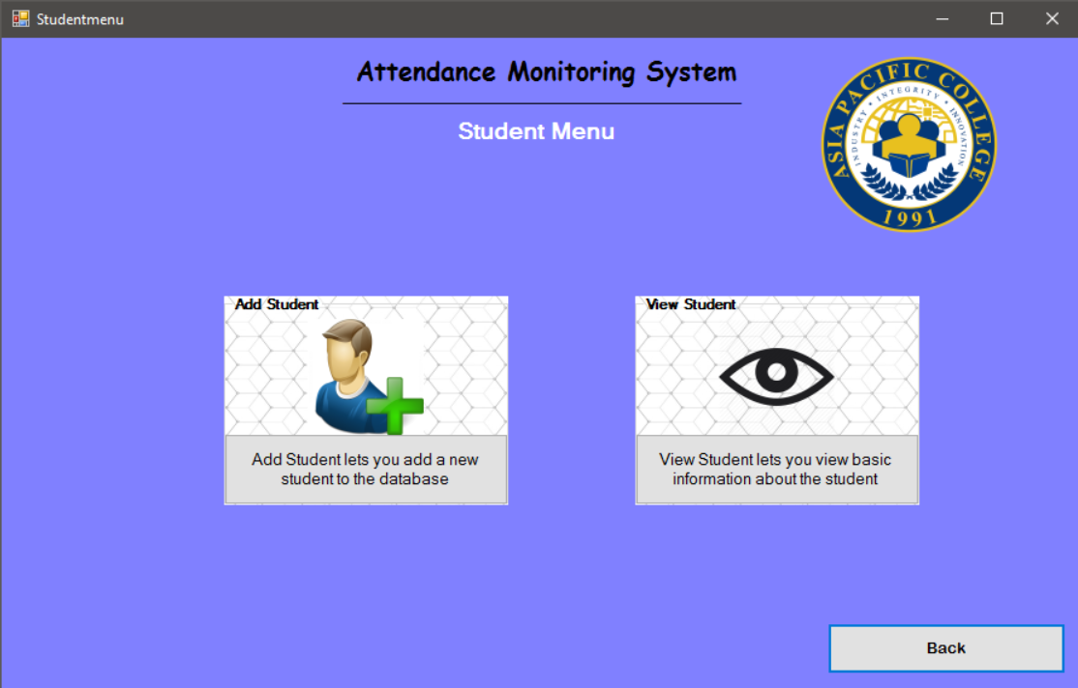

Figure 5.5: Proposed Student Menu

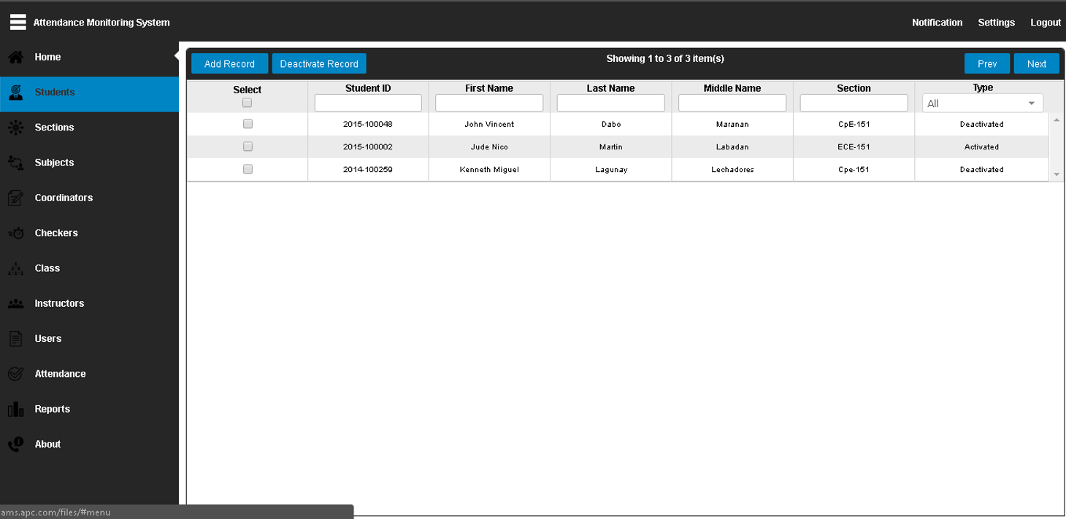

Figure 5.6: Revised Student Menu

Figure 5.5 and 5.6 shows the student menu. The proposed student menu shows the two menu that when clicked will be redirected to another menu. On the other hand, the revised will redirect the user straight to the add record. The advantage of the revised student menu is that the user can immediately see the data inside the students’ database.

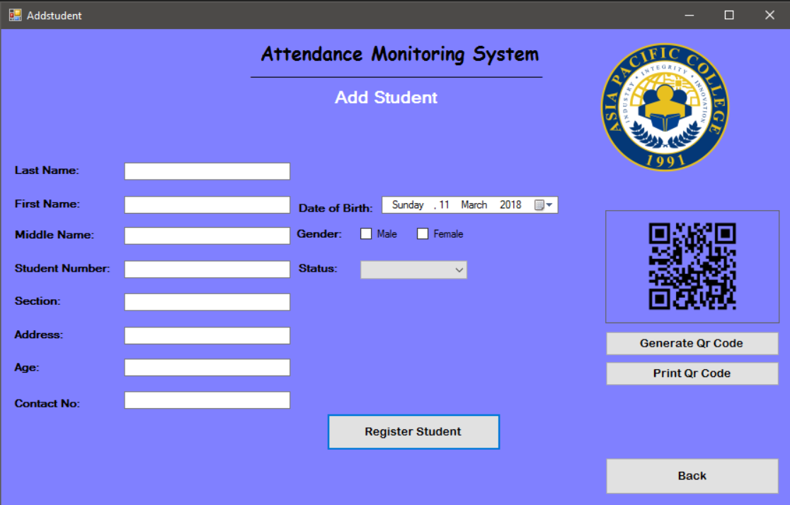

Figure 5.7: Proposed Add Student Page

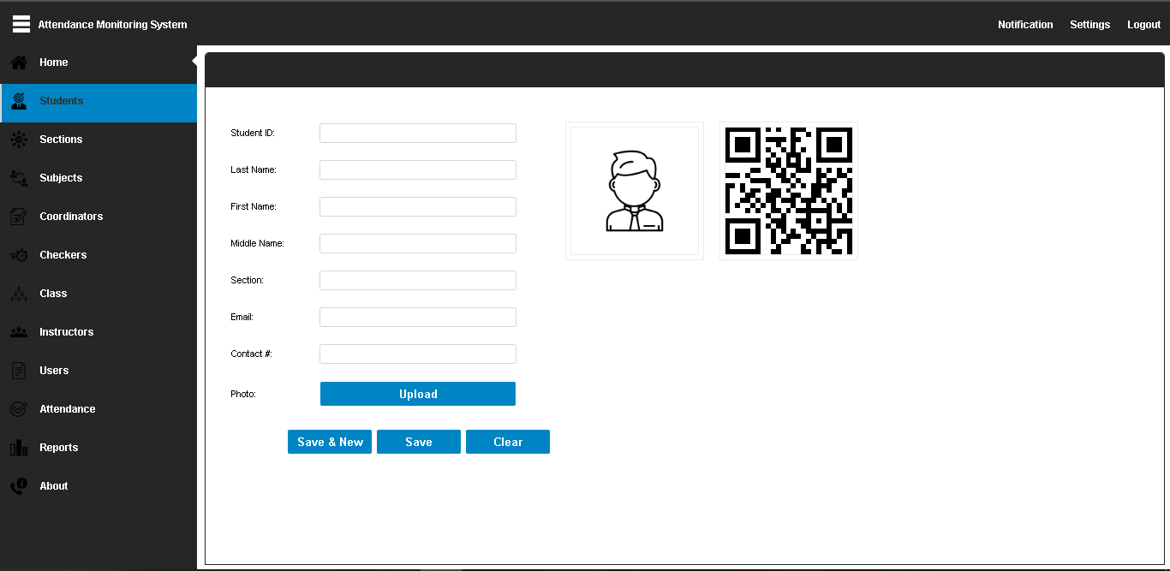

Figure 5.8: Revised Add Student Page

Figure 5.7 and 5.8 shows the add student page. On the proposed student page there are buttons that can be minimized to retain the simplicity and to understand easily the function of the page. The minimized buttons can be seen on the revised page. Maintaining the simplicity with the functionality to be easily understood.

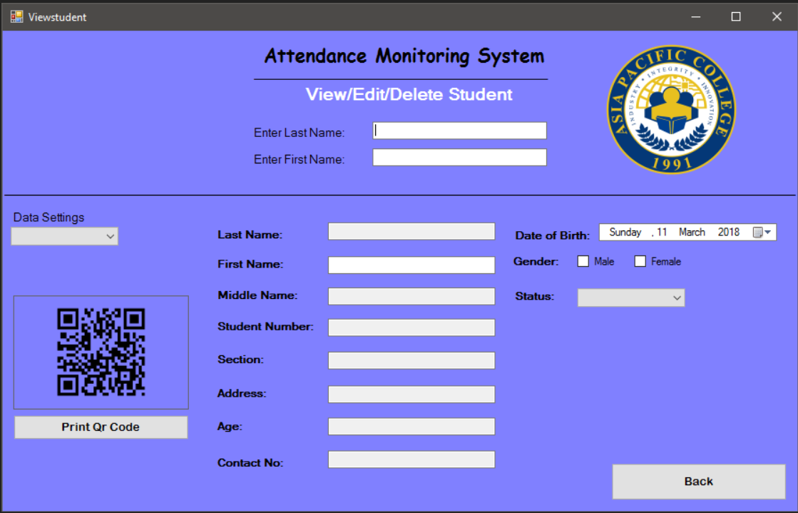

Figure 5.9: Proposed View / Edit / Deactivate Student page

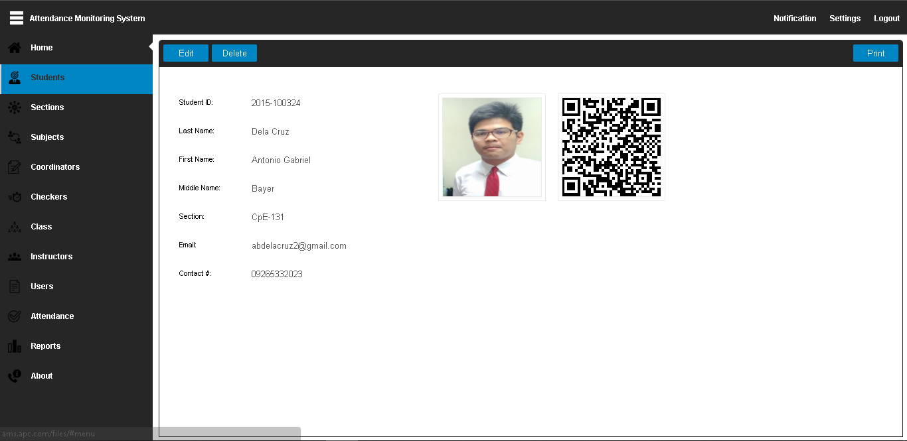

Figure 5.10: Revised View Student page

Figure 5.9 and 5.10 shows the view and edit student page. On the proposed page there are many fields and buttons. While on the revised page, some of the buttons are removed for the user to easily understand the function of the page and the function desired by the user to fulfill with the system. Removing other elements on the proposed page has been reflected to the revised to maintain the simplicity and to remove the other elements that will not be used. Another function that has been added is that while the user is typing the student number, the QR code is automatically generated.

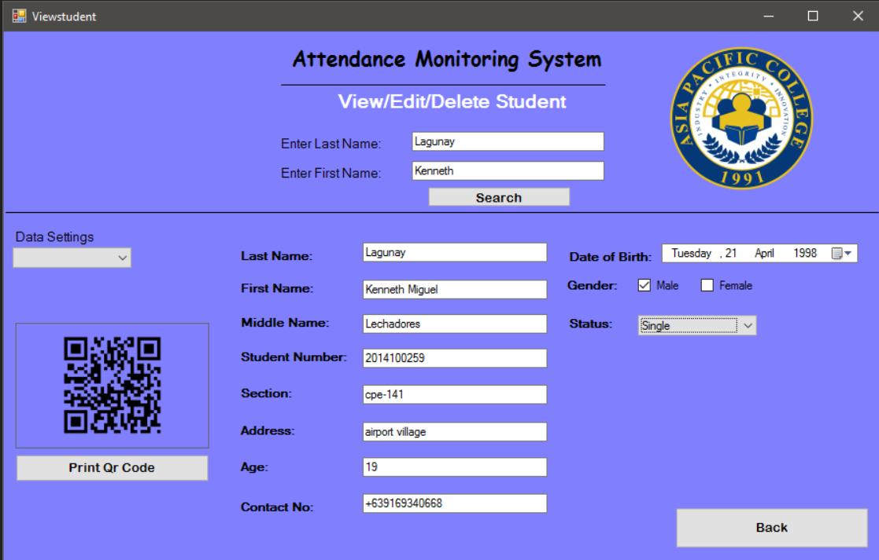

Figure 5.11: Proposed Edit Student Page

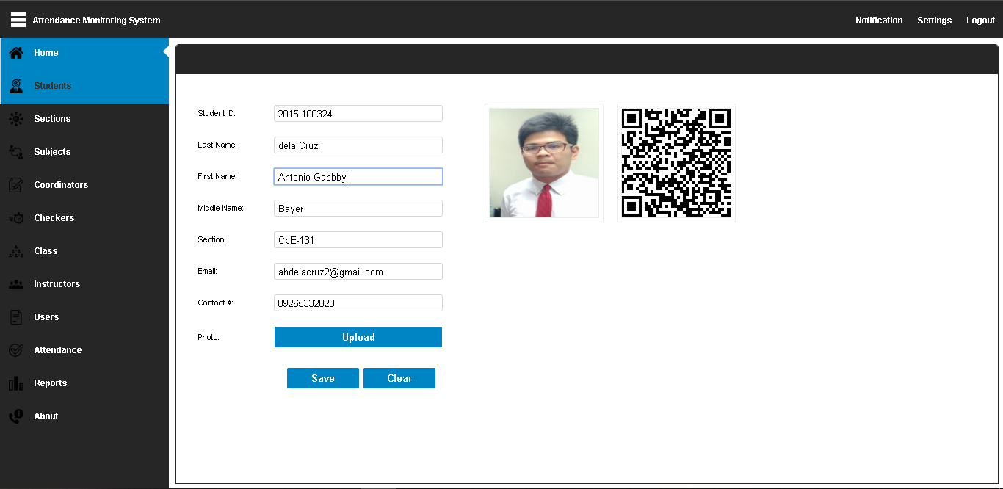

Figure 5.12: Revised Edit Student page

Figure 5.11 and 5.12 shows the edit student page. On the proposed edit page, the fields are scattered. While on the revised page the fields are aligned in the left side to provide the simplicity and for easy readability of the information of the student. The picture of the student has been added to the page so that the student can be easily identified and can also be edited by the administrator.

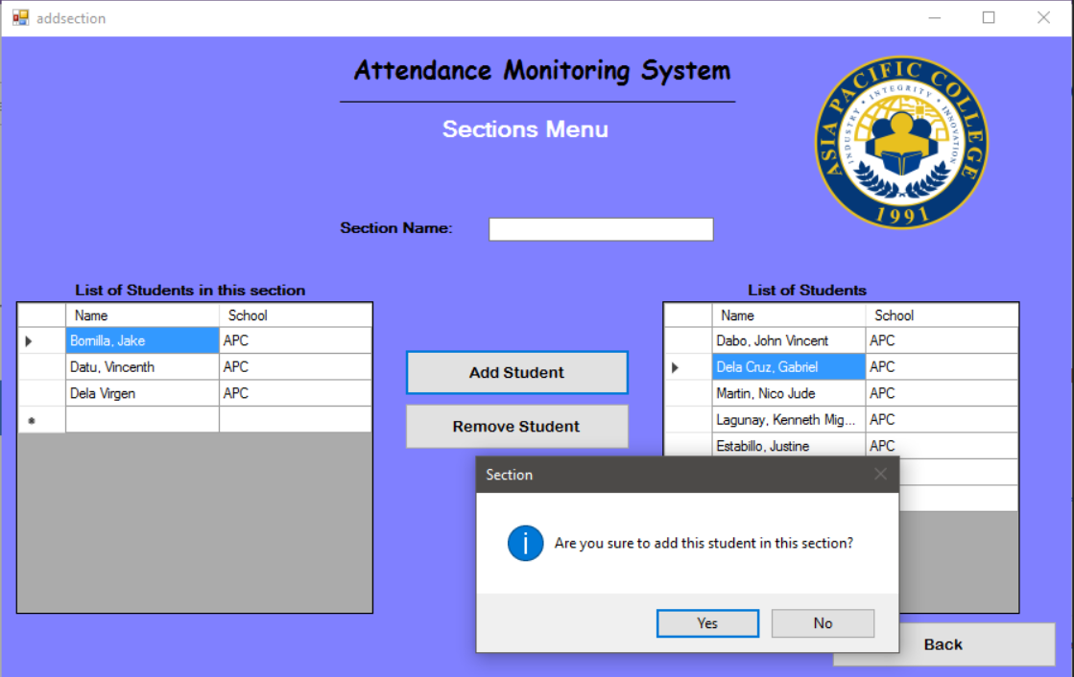

Figure 5.13: Proposed Section Page

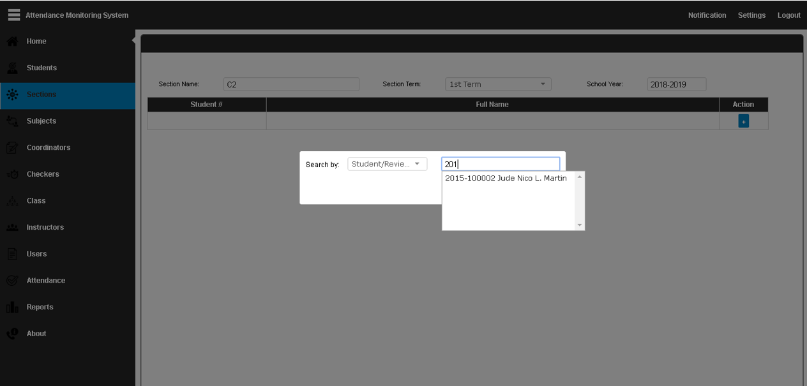

Figure 5.14: Revised Section Page

Figure 5.13 and 5.14 shows the section page. In the proposed section page there are two columns that will represent the database of students that will be added and students already in that section. While on the revised, the user will click the “+” button and search for the name or Id number or section of the student to be added to that certain section. Using the revised user interface, it will make adding of student easy due to typing of name rather than finding the name of the student inside the database of the students. The time-consuming process can now be modified into time efficient process.

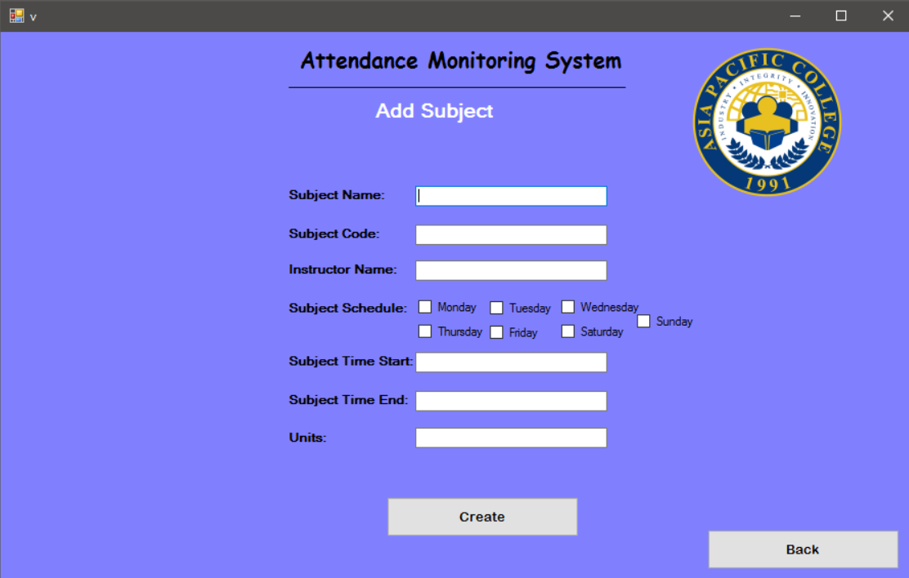

Figure 5.15: Proposed Add Subject Page

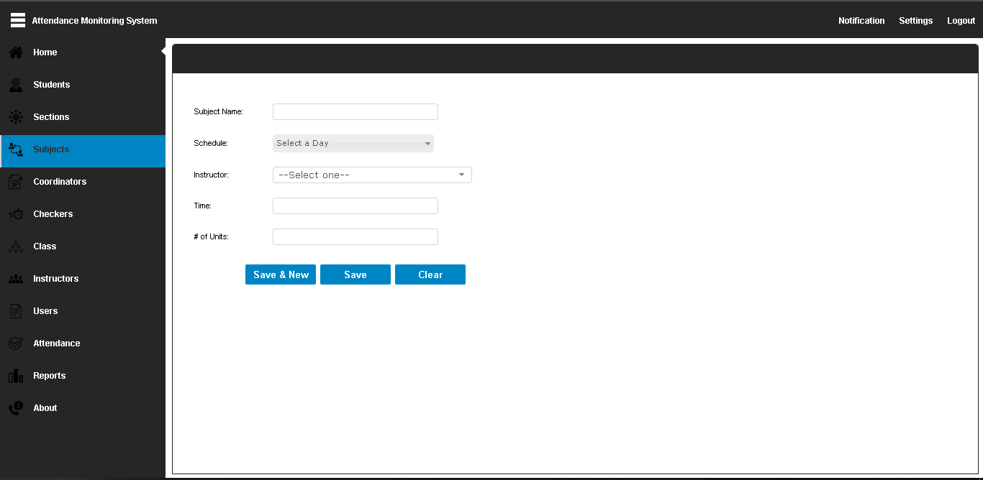

Figure 5.16: Revised Add Subject Page

Figure 5.15 and 5.16 shows the add subject page. The two different interface has the same content, but the difference is some of the fields are removed and merged into one field. The checkbox for the subject schedule can now be found on the drop-down list box in the schedule field.

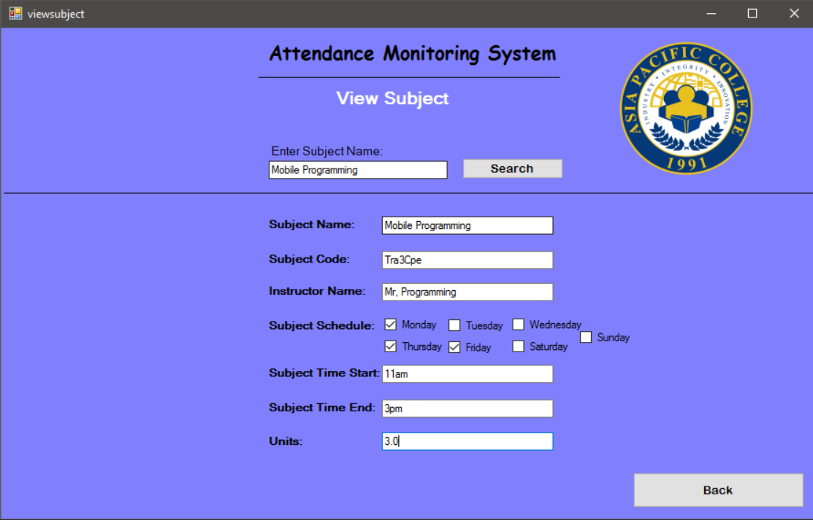

Figure 5.17: Proposed View Subject

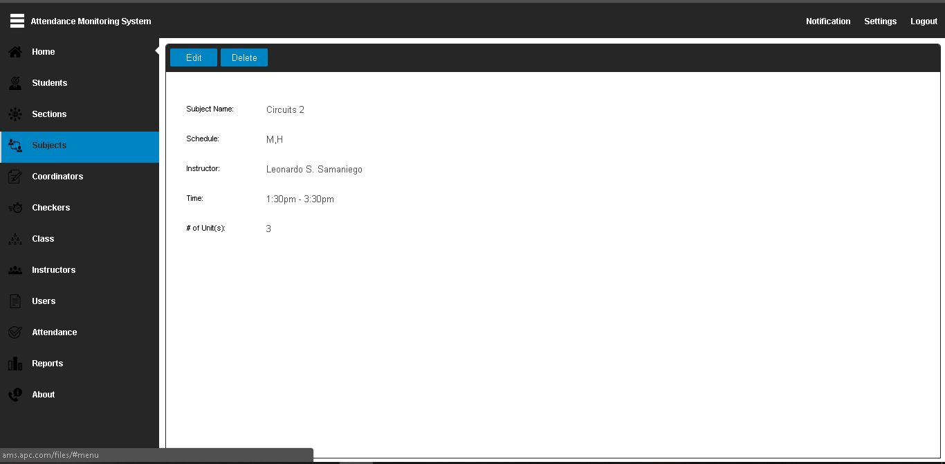

Figure 5.18: Revised View Subject

Figure 5.17 and 5.18 shows the view subject page. Inside the proposed view subject all the schedule days are displayed with check if that subject is scheduled on that day. While on the revised view subject, there is a field that is labeled schedule and the checkbox that is checked while the add subject can now be viewed as a text inside the schedule field. The main change is that the subjects in the database are in a list and can be immediately seen when the user navigates the subjects tab.



Figure 5.19: Proposed Edit Subject

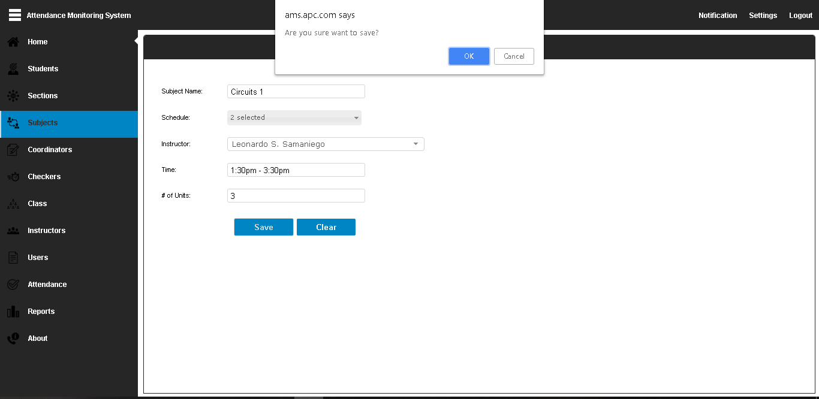

Figure 5.20: Revised Edit Subject

Figure 5.19 and 5.20 shows the edit subject of the system. In the proposed edit subject all the schedule checkbox is shown on the user interface. While on the revised to make it more simple and easier to use the user interface.



Figure 5.21: Proposed Search Subject

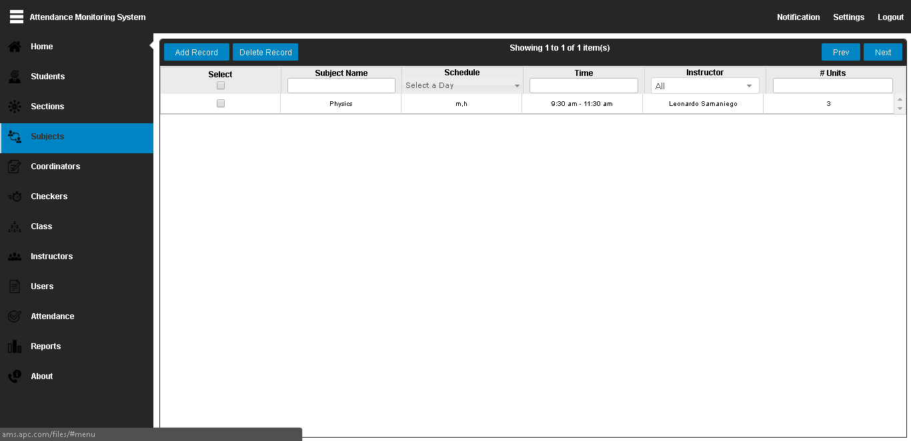

Figure 5.22: Revised Search Subject

Figure 5.21 and 5.22 shows the search subject. In the proposed search subject there is one field where the user can enter the subject name to be searched. While on the revised search subject there is four methods on how to search the subject: subject name, time, instructor and number of units. In this way searching of the subject was made easy. Another thing about the revised search subject is that the subject is already shown in table form with the information. Unlike on the proposed that the subject needs to be searched before the interface displays data.

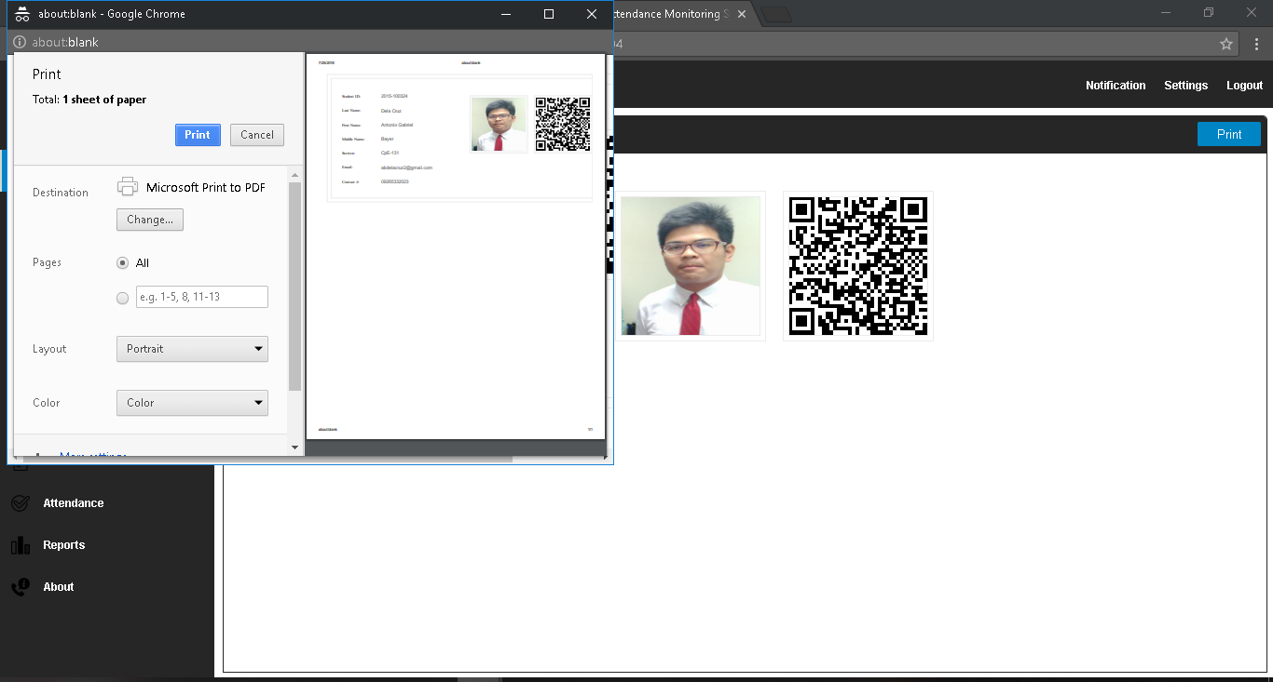

Figure 5.23: Print QR code

Figure 5.23 shows the print QR code. This is an added user interface where the QR code can be can be printed by the administrator. The QR code can be viewed in searching the student information. There is a button labeled print for this print function to work.

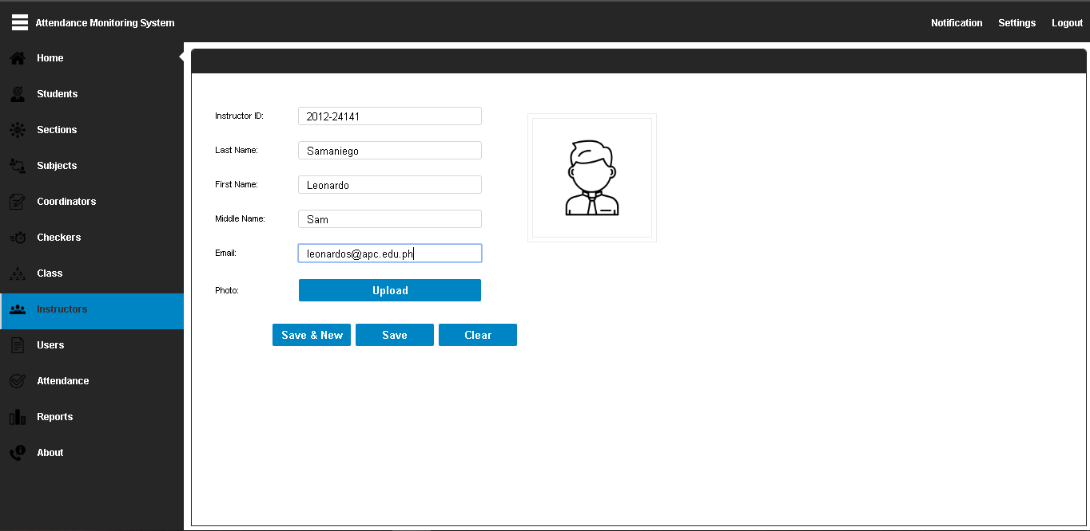

Figure 5.24: Add Instructor

Figure 5.24 shows the add instructor menu. This is an added feature to the system that will be used in creating the section. There will be a drop-down list of available instructors created by the administrator. This is another primary method of searching for the section.

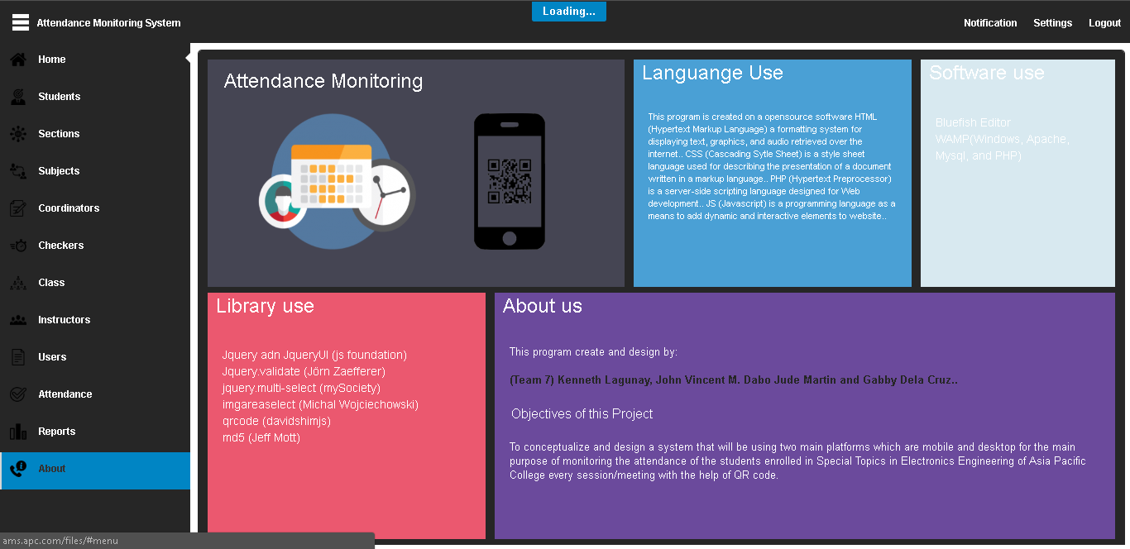

Figure 5.25: About Page

Figure 5.25 shows the about page of the system. An added feature to provide information about the language, software, library used and group information.

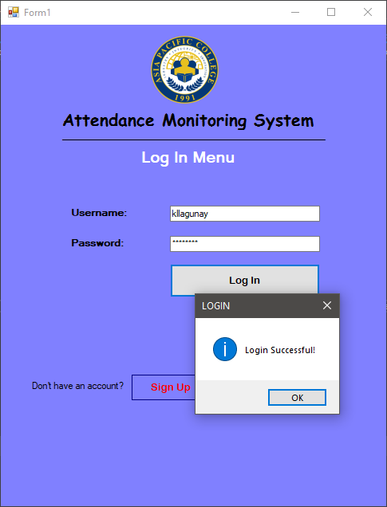

Figure 5.26: Proposed Login Page (Android)

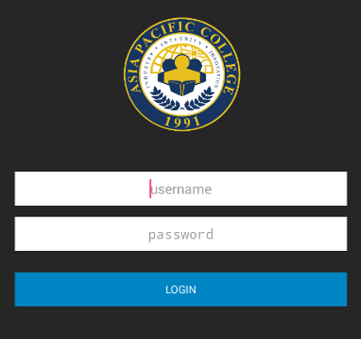

Figure 5.27: Revised Login Page (Android)

Figure 5.26 and 5.27 shows the login page for the android application. Both the user interface has the same function and content. The only difference was how the field and arrangement of the elements on the page was revised to give a simple and clean look. Also, the primary change here is that the sign up function has been removed because the admin will now be the one responsible in adding checker accounts.

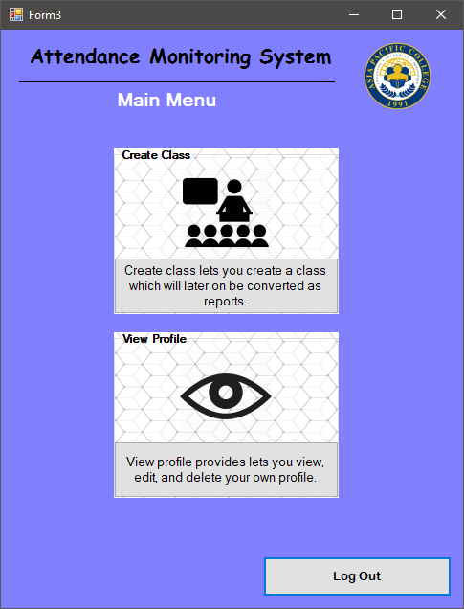

Figure 5.28: Proposed Android Main Menu

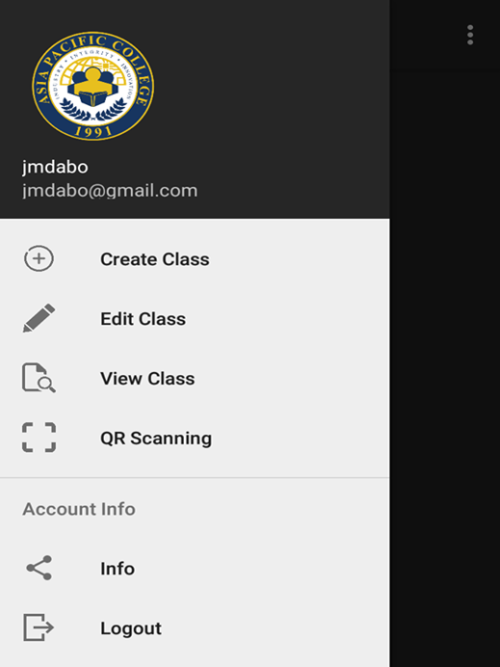

Figure 5.29: Revised Android Main Menu

Figure 5.28 and 5.29 shows the main android menu. This is the next page after the login page. On the proposed user interface, there is two sub-menu that will be clicked to achieve the task to be done. While on the revised android menu, a dashboard was added. The dashboard was added to replace the method of browsing from one menu to another menu to achieve the task. Using the dashboard, it will lessen the time to achieve the specific task.

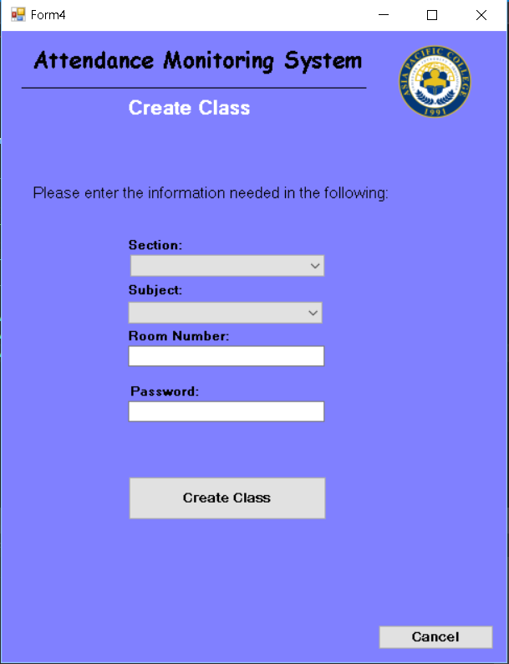

Figure 5.30: Proposed Create Class Menu

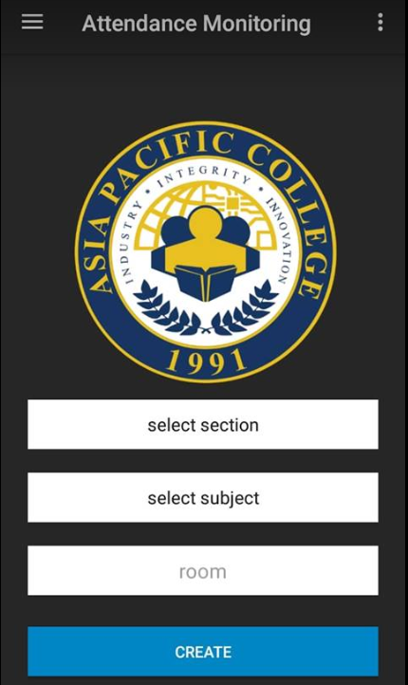

Figure 5.31: Revised Create Class Menu

Figure 5.30 and 5.31 shows the create class menu. This is used in creating the class that will generate the reports for the system. The user interface on the revised and the proposed has almost identical elements. The only difference was the password field and it was removed in the revised because it doesn’t affect or is not important in creating the class since the checker has the only access to the application.

Figure 5.32 and 5.33 shows the scanning menu for the system. On the proposed interface the checker must choose the time in or time out before the QR scanner will pop up to the screen. While on the revised all the information can be seen at the bottom and the QR scanner can already be seen at the top part of the interface. The advantage of using the revised user interface is that this lessens the pages before acquiring the actual function needed and also provides the class details.

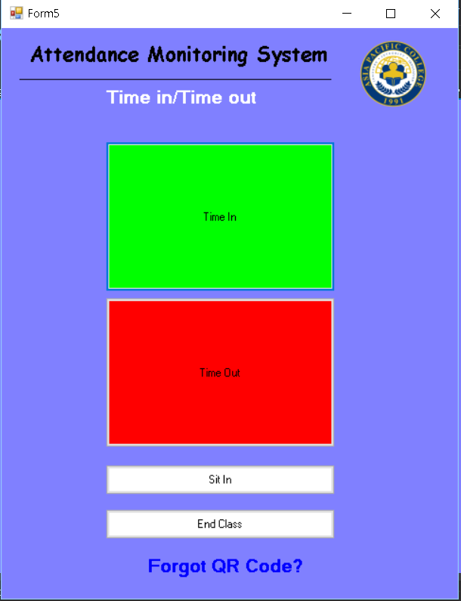

Figure 5.32: Proposed Scanning Menu

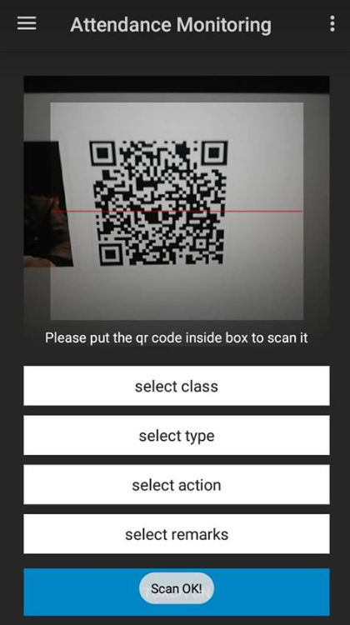

Figure 5.33: Revised Scanning Menu

After the revisions for the user interface was made the next step was to re-evaluate the proposed system. After evaluating the proposed system some of the function can be simplified into a single function. For example, for the menus, in the proposed system the user must navigate from one menu to another to achieve the specific task. This process can be seen in the user interfaces of the proposed system. To simplify this method, the group decided to provide the interface with a dashboard. Not only that the dashboard will give a modern look to the system, but this will enable the user to navigate to the process accordingly. Since the dashboard has already tabs that will redirect the user to the specific function of the system.

There were suggestions from the programmer that the group didn’t notice or came up to when proposing the system. One of this was about the QR code. QR code can easily be generated through the internet. Entering the specific details on the fields provided by the websites can already generate QR codes. The programmer suggested that, to prevent that situation the QR code can be encrypted. The example encryption can be seen below.

**Table 5.1: QR Code Comparison**

|  |  |
| --- | --- |
| Encrypted QR Code (System Generated) | Web-Generated QR Code |
|  |  |
| Data Used: Jude Nico Martin | Data Used: Jude Nico Martin |
| Output: | Output: |

The QR Code encryption removes the process that when a student scan their QR code their picture will popup. Because the QR code is encrypted and it can’t be generated in a way that students can tamper the QR code. Table 5.1 compares the QR code generated from the internet and from the website. Each QR were scanned using android 8.0 and each scan result were displayed to prove that the QR code generated by the system is encrypted and can’t be generated that easily.

After these things has been considered in creating the system. The group and the programmer proceed with the other contents and function of the system. The development of the system follows these activities.

* Admin Asia Pacific College
  + Login Module
  + Main System Module
  + Student Module (add, edit, view)
* Admin Review Center
* Login Module
* Subject Module (add, edit, view, delete)
* Section Module (add, edit, view, delete)
* Review Center Checker
* Login Module
* Class Module (create, edit, delete)
* QR Scanning Module
* Records Module

Upon the schedule of the development of the system, the group encountered problems that affects the schedule allotted for each module. The problem encountered by the group was

* Communication Problems
* Function Problems for some of the module
* Programmer can’t be easily reach since he lives far from the group
* Current school year schedule conflicts with programmer’s schedule for meetups.
* Internet connection between the android and the desktop app always fails (communication error because of weak signals acquired by the packet modem)

While on the android application, it was tested on three mobile devices and one virtual android machine using nox player. The first development on android was tested on OPPO NEO5 with android 5.1. followed by VIVO v7 with android 8.0 running and lastly HUAWEI NOVA 2i running android 8.0. The results on the development side of the android can be interpret using this table.

**Table 5.2: Android Development**

|  |  |  |  |  |
| --- | --- | --- | --- | --- |
|  | NEO5 (Android 5.1) | V7 (Android 8.0) | NOVA 2i (Android 8.0) | NOX Player(Android 4.4 |
| Automatic Camera permission for QR Scanning | YES | Needs to be configured in system settings. | Needs to be configured in system settings. | YES |
| Rate of QR Scanning | Fast | Fast | Fast | - |
| Rate of Communicating with the desktop application. | Internet Connection Dependent | Internet Connection Dependent | Internet Connection Dependent | Internet Connection Dependent |

Table 5.2 interpret the development phase for the android for each testing devices. Android 8.0 denies the automatic permission of the camera that will be used in QR scanning. The permission should be set on manually for the application for the camera to work for android 8.0. The rate of QR scanning is based on how fast each device scan the QR code. The rate of communicating with the desktop application was based on testing all the device using the same pocket modem, at the same room and within interval of minutes.

Desktop application was originally based and conceptualized on Visual Basic. As the group talked further with the programmer. He explained that instead of using visual basic for the system he insisted on using php and html. He demonstrated on how efficient php and html if used for the system. On the visual basic, each function has its own page with different buttons and elements. While on the php and html, the dashboard was already fixed. The good thing about this was instead of loading another dashboard with another page, php fetches the html page that will be used for the desired process. This would lessen the storage consumption for the desktop and the memory allocation that will be used.

**System Test**

**Table 5.3: Login Module (APC)**

Table 5.3: Login Module (APC) This table shows the testing phase of the login module of the APC administrator. This shows different cases with the scripts on how these cases are tested and their results.

|  |  |  |
| --- | --- | --- |
| **Case** | **Script** | **Result** |
| Incorrect login information | The tester will input a wrong data into the field. The system will determine that the entered data does not match any data at the database. | The system refuses to login the user if one or both fields are left blank. The system will show the user that the username or password are incorrect. |
| Case sensitivity | The tester will let the caps lock on. The system will show a message box that will inform that caps lock is on. | The system has no case sensitivity and will still login the user regardless of the case. |
| Correct Login Process | The tester will input the correct username and password. The system will login the user into the system. | The system logs-in the user into the system. |
| The user will input his/her account using username and password. | The user’s input is correct and the systems will redirect the user to the interface allotted for the account. | When the user inputs the correct username and password, the system logs them in to the system. |
| The user will input his/her account using the wrong username and password. | The user’s input is incorrect because it did not match the id number with the password. The system will notify the user via pop-up that his/her login was unsuccessful. | The system will indicate to the user that the either the username or the password is incorrect and they will have to input correctly. |

**Table 5.4: Add Student**

|  |  |  |
| --- | --- | --- |
| **Case** | **Script** | **Results** |
| One or more field are left null | The tester will leave field/fields blank. Testing if the system will still accept data even if there’s null fields. | The system will insist that the user enter data into the field and will not allow the user to continue unless the field is filled with data. |
| Correct Add Student Process | The tester will enter appropriate data into the fields and will save the data correctly. | The system will insist that the user enter data into the field and will not allow the user to continue unless the field is filled with data. |
| The user will click the add student button. | The system should go to the add student page. | The system redirected the tester on add student page. |
| The user will click the add student button and fill up all the information needed. | Qr code should be automatically generated by the system.  The data should be saved in the student database | The system automatically generates QR code after the information was entered and the data is saved on the student database. |
| The user will generate a QR code. | The user will be able to print the QR and click the register account button. | The user is able to print the QR and click the register account button. |

Table 5.4: Add Student (APC) This table shows the testing phase of the add student module of the APC administrator. This shows different cases with the scripts on how these cases are tested and their results.

**Table 5.5: View, Edit, Deactivate, Activate Student**

|  |  |  |
| --- | --- | --- |
| **Case** | **Script** | **Results** |
| Deactivate student data | The tester will click a selected student’s name and he/she will choose either to edit or deactivate student data. When the tester clicks the deactivate button, the student will not be seen when creating a section. | The system can deactivate the students account successfully. The student cannot be seen in the database while creating a section |
| Activate student data | The tester will click a deactivated student’s name and he/she will choose either to edit or activate student data. When the tester clicks the activate button, the student will can now be seen when creating a section. | The system can activate the students account successfully. The student can now be seen in the database while creating a section |
| Editing student data | The tester will click a selected student’s name and he/she will choose either to edit or deactivate student data. When the tester clicks the edit button, the student’s data can now be edited and saved into the database. | The system can successfully allow the tester to edit the student’s data and is able to save the changes into the database. |
| Case sensitivity on view/edit field | The tester will let the caps lock on and will search for a certain student data, the system will retrieve data even if the character inputted was all caps. | When editing, the system saves whatever the user types on the selected field. For the search, the search fields are not case sensitive. |
| After searching, no data was retrieved | The tester will search a non-existing student info, will the system display a message that no student exists in the database. | The system will show the user that there is no data found. |
| The tester will input the student id for viewing. | The user will be able to see the information of the students. | The user is able to view the student’s information. |
| The tester will input the student first name for viewing. | The user will be able to see the information of the students. | The user is able to view the student’s information. |
| The tester will input the student last name for viewing. | The user will be able to see the information of the students. | The user is able to view the student’s information. |
| The tester will input the student middle name for viewing. | The user will be able to see the information of the students. | The user is able to view the student’s information. |
| The tester will input the student section for viewing. | The user will be able to see the information of the students. | The user is able to view the student’s information. |
| The tester will click the student’s name and will click edit. | The user will be able to edit the students’ information. | The user is capable of editing the student’s information. |
| The tester will click the student’s name and will click deactivate. | The user will be able to deactivate the student in the database. | The user can deactivate the student’s account but he/she is not able to delete the student entirely. |
| The tester will click the deactivated student’s name and will click activate. | The user will be able to activate the student in the database. | The user can activate the student’s account and is now visible while making a section. |

Table 5.5: View, Edit, Deactivate Student (APC) This table shows the testing phase of the View, Edit, Deactivate Student module of the APC administrator. This shows different cases with the scripts on how these cases are tested and their results.

**Table 5.6: Create Class (Android)**

|  |  |  |
| --- | --- | --- |
| **Test Script** | **Expected Output** | **Actual Output** |
| The user will choose all the necessary information and input the room number. | The user will be able to click the create class button. | The user is able to click the create class button and save the data into the class database. |
| The user will not choose all the necessary information and will not input the room number. | The user won’t be able to create class and a popup message will appear saying that the input password is incorrect. | The user is not able to save the class and the system asks the user to complete all the necessary fields. |
| The tester will choose from the drop down list box what section and subject that will be used and input the room number | The drop down list box will display the section data in the section database and the subjects from the subjects database. | The data from the subject and section database can be seen on the drop down list box in create class, |

Table 5.6: Create Class (Checker) This table shows the testing phase of the Create Class module of the Checker administrator. This shows different cases with the scripts on how these cases are tested and their results.

**Table 5.7: Time in and Time out (Android)**

|  |  |  |
| --- | --- | --- |
| **Test Script** | **Expected Output** | **Actual Output** |
| The tester will choose from the dropdown list to time-in the student. | The camera app will launch and let the student scan his/her unique QR code. | The system uses the camera app and allows the student to let his/her QR code to be scanned. The time of login will be saved into the attendance database. |
| The user will choose from the dropdown list the time-out even though the time end is not parallel to the time of desktop device. | The user will be notified that the time out button is still unavailable because the class hasn’t ended yet. | The system will not scan the QR code for logout because the class has not ended yet. |
| The tester will use android 5.1 version for the scanning of QR code | The camera will automatically have the permission by the android system to be used. | The camera was automatically permitted by the android system to be used by the android application |
| The tester will use android 8.0 version for the scanning of QR code | The camera will automatically have the permission by the android system to be used. | The camera was not automatically permitted by android 8.0. to allow the camera to be used for QR scanning the android app for AMS should have permission to use camera |

Table 5.7: Time in and Time Out (Checker) This table shows the testing phase of the Time in and Time out module of the Checker. This shows different cases with the scripts on how these cases are tested and their results.

**Table 5.8: Dashboard Android**

|  |  |  |
| --- | --- | --- |
| **Test Script** | **Expected Output** | **Actual Output** |
| The tester will click one of the buttons that he wishes to go to. | The user will be navigated to the window he wishes to go to. | The user, after clicking the desired button, is navigated to the desired page. |
| The tester will not click anything. | The user will stay in the main menu. | The system stays on the current page. |
| The tester will not click the dashboard button | The user will stay in the main menu | The system stays on the home page |
| The tester will click on the dashboard button | The dashboard will pop out on the left side of the interface | The dashboard popped out on the left side of the interface showing the different functions inside it. To be used by the tester. |

Table 5.8: Dashboard (Checker) This table shows the testing phase of the Dashboard module of the Checker. This shows different cases with the scripts on how these cases are tested and their results.

**Table 5.9: Subject Module (Excel)**

|  |  |  |
| --- | --- | --- |
| **Test Script** | **Expected Output** | **Actual Output** |
| The administrator will click the subjects tab. | The user will be navigated to the subjects’ menu window. | The user is navigated to the page where he can add, edit, and deactivate a subject. |
| The user will press the add button in the upper left corner. | The user can now add a subject. | There will be a form to be filled up by the admin and once complete, he can now press the save button to save the subject in the database. |
| The user will click the created subject in the list. | The user will be navigated to a page where all the details entered in the subject can be seen. | The user will be navigated to a page where all the details entered in the subject can be seen. |
| The user will click the edit button in the upper left corner. | The user can now edit the details of the subject and after editing, he can now save the subject. | The user can now edit the details of the subject and after editing, he can now save the subject. |
| The user will select the subject and press the deactivate button. | The user can now deactivate the subject. | The user deactivated the subject and the deactivated subject cannot be used anymore and will now go to the deactivated subjects tab. |

Table 5.9: Time in and Time Out (Excel) This table shows the testing phase of the Subject module of the Excel. This shows different cases with the scripts on how these cases are tested and their results.

**Table 5.10: Sections Module**

|  |  |  |
| --- | --- | --- |
| **Test Script** | **Expected Output** | **Actual Output** |
| The administrator will click the sections tab. | The user will be navigated to the subjects’ menu window. | The user is navigated to the page where he can add, edit, and deactivate a section. |
| The user will press the add button in the upper left corner. | The user can now add a section. | There will be a form to be filled up by the admin and once complete, he can now add students from the students’ database and when he press the save button to save the section in the database. |
| The user will click the created section in the list. | The user will be navigated to a page where all the details entered in the section and the students added can be seen. | The user will be navigated to a page where all the details entered in the section and the students added can be seen. |
| The user will click the edit button in the upper left corner. | The user can now edit the details of the subject and can edit the students in that section then after editing, he can now save the subject. | The user can now edit the details of the subject and can edit the students in that section then after editing, he can now save the subject. |
| The user will select the section and press the deactivate button. | The user can now deactivate the section. | The user deactivated the section and the deactivated section cannot be used anymore and will now go to the deactivated sections tab. |

Table 5.10: Sections (Excel) This table shows the testing phase of the Sections module of the Excel. This shows different cases with the scripts on how these cases are tested and their results.

**Chapter 6**

**Summary of Finding, Conclusion and Recommendation**

**Summary of Findings**

The Attendance Monitoring System is a system that was conceptualized and proposed by Engr. Leonardo Samaniego, Engineering and Sciences Laboratory Office head, with a desire of lessening the hassle that the current system between the APC and EXCEL creates. The system has two main platforms which are Web and Android application.

The system aims to provide a solution to the problem of having difficulties in monitoring the attendance of the students of the review center. The system also aims to provide convenience to the three major entities and the student that will be using the system.

* + For the Coordinator, the system provides a more accurate and concise student attendance report that allows them to monitor each student’s punctuality.
  + For the Attendance Checker, the system allows a faster and more efficient way of checking the attendance.
  + For the Student, the system provides them with a more convenient way of logging in their attendance.
  + For the Review Center, the system lessens the burden of submitting reports to the APC subject coordinator.

The proposed process of the system is that it will all start from the APC administrator creating a Students’ database then the EXCEL administrator will now create a section using the students from the students’ database and will now create the Section’s and Subject’s database. After creating all these, the checker can now use the app to scan the different QR codes of each students.

The system has also achieved its main function which is to scan and monitor the students’ attendance and lessening the burden that the EXCEL and APC coordinators experience.

**Conclusion**

The System is designed for checking and monitoring the attendance of the students in excel review center. using this system the apc coordinator can easily monitor the attendance and behavior of the students rather than waiting for the email of the excel admin containing the attendance reports pf the student that is sent once a month. the group come up with alternative way to remove the process of sending the attendance report once a month by creating a system that will automatically generate reports that can viewed by the coordinator of APC.

After conducting an interview in the review center to dig dipper on the matter, the group learned that the first idea that has been made will not be possible inside the review center. the main problem would be is about the hardware to be used. since the software engineering subject doesn't require to build hardware to support the software that will be proposed for the problem. the first idea is to have a web application to monitor student's attendance using a laptop. the problem with this setup was the review center will not provide a laptop for the system that will be created. with this matter the group come up with the idea of using mobile applicatiion to monitor the student attendance using QR Code. Qr based attendance monitoring was the choice of the group because it is available and can be found on the internet. the good thing about using the QR code was there was library that is open source. and almost all of the new android system version has a built in QR code scanner.

The system can provide a solution to the problem experienced by the APC Coordinator and the Excel Review Center. Since students leaves the class after signing the attendance the system can prevent the situation by having a time - in and time - out attendance method to secure that they will not leave the class after the timing in in the system.

The Coordinator can benefit in using the system since it gives real time attendance monitoring therefore he/she can monitor all of the students enrolled in Special Topics in Electronics Engineering. The system generates reports that are essential in monitoring the behavior of the students inside the review center this can also avoid the denial excuses of the students that they are finishing the class but in reality they just sign the attendance sheet for attendance purposes and then leaves the class.

For the Review Center, they also experienced the same difficulties with the APC Coordinator regarding with the attendance of the students. The focus of the Review Center is to provide students with exellence and knowledge in preparing them for the board exam. The difficulties experienced negates the mission of the Review Center "To deliver excellent review program in a culture of continuously adapting the latest technology available.

CORE VALUES: EXcellence, Commitment, Enthusiasm, Leadership".

The Attendance Checker can minimize the issues regarding the signing of attendance by the students. Some cases includes students ask their classmates to sign their attendance which the attendance checker doesn't know the legitimacy of the signatures in the attendance sheets. The system provides a way to prevent this situation by using qr code which the group has proposed that is secured by encryption. The only to decrypt the qr is using the system. It can benefit the checker because it lessens the works that needs to be done because the system automatically compiles the attendance record and generates reports that the coordinator can use to monitor the attendance and behavior of the students enrolled in Special Topics in Electronics Engineering inside the review center.

**Recommendations**

* As for creating a system like this, one should be able to identify the problem first to be able to formulate an objective. Once the general objective is set, one can now be able to branch down this objective into more specific objectives.
* The main purpose of this automated system is to be able to provide convenience to its users by means of simplifying their work and not add more burden to them.
* The people working on their system should focus more on the diagrams because these diagrams will be the foundation of their system.
* When creating the paper, the group should finish it as early as possible so that if it needs revision, one would not procrastinate.
* When choosing the right programmer, one should know the reach of the knowledge in programming of the said programmer and then briefly explain the whole program to avoid confusion and misunderstanding. They should also create a timeline for the programmer so that they can track the progress of the system and to be able to determine if they are on time or delayed.
* Lastly, one should not take the system for granted because everything takes time, from identifying the problem to testing the whole system.