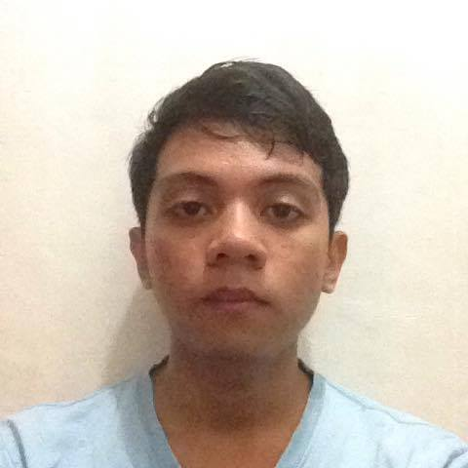

Daren Mar Galindo Cabral

98 B Alligator St. Brgy. Rizal, Makati City

09366541204

dgcabral@student.apc.edu.ph

**EDUCATION**

**Tertiary**

**2013-2017: Asia Pacific College, 3 Humabon Place, Magallanes, Makati City**

* Bachelor of Science in Information Technology Major in Mobile and Internet Technology
* Year of Graduation: 2017
* Relevant Coursework: Web & Mobile Application Developer, Networking, Database Designer

**Secondary**

**2009-2013: Benigno “Ninoy” S. Aquino High School, Aguho St., Commembo, Makati City**

**SKILLS AND INTERESTS**

* Typing, Editing (Using Paint, Photoshop and SAI Paint Tool).
* Web Application Developing through HTML5, PHP, JavaScript, and Python Programming using Django Framework.
* Android Application Developing through Java Programming.
* Play computer games, playing instruments like guitar, Reading Books, Manga, Light Novels, and Articles in the internet.

**REFERENCES**

* Mr. Manuel Sanchez

College Professor, Project-Based Learning Professor and Adviser

Asia Pacific College