**Target Audience**

Our focused users will be the barangay citizens and officials. Helping them in managing and securing their own records.

**General Objectives**

Create organized and secured information details for the barangay citizen to provide fast and accurate transactions. Help lessen complications such as information redundancy caused by repetitive registration and avoid missing data thus leading to successful document processes.  
 Educate the citizens by providing them with appropriate content of information and giving them easy access to this information.

**Event Table**

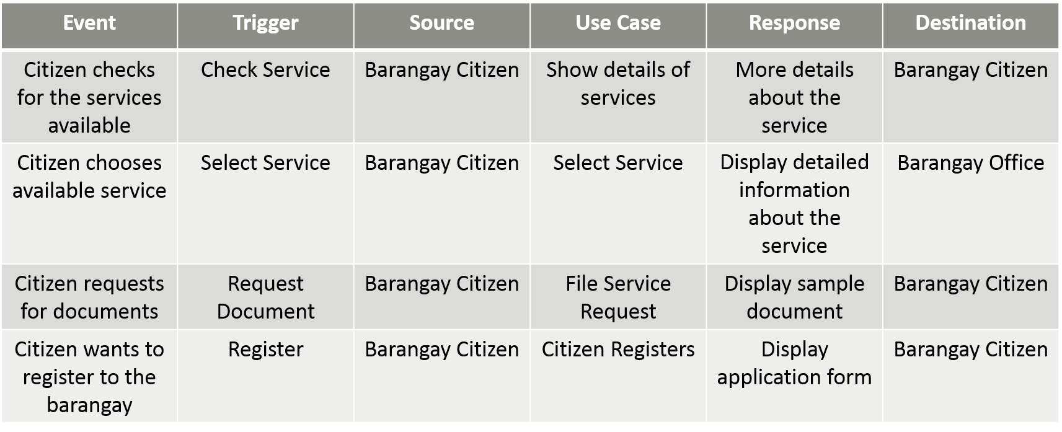Citizen

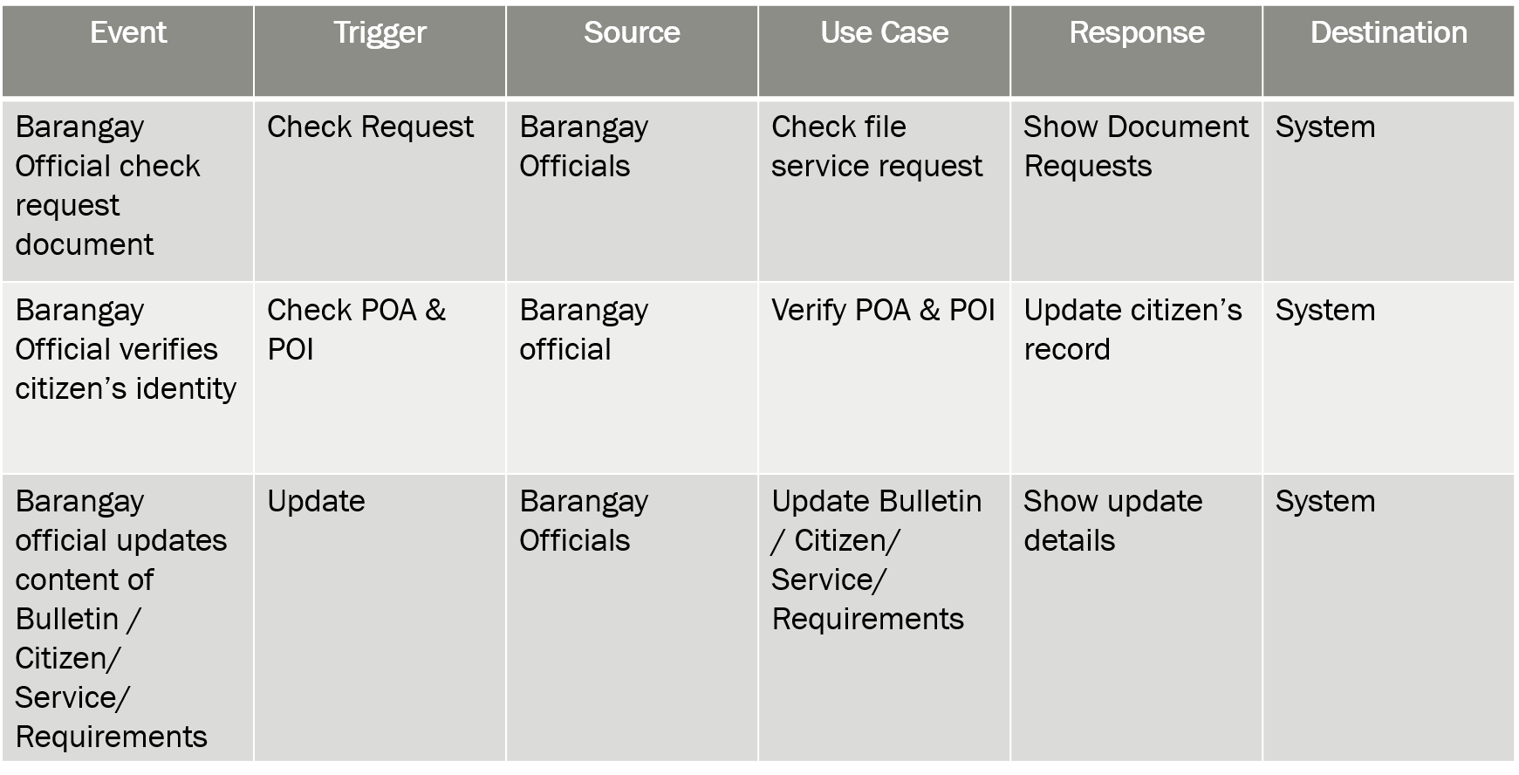Official

**Entity Relationship Diagram**

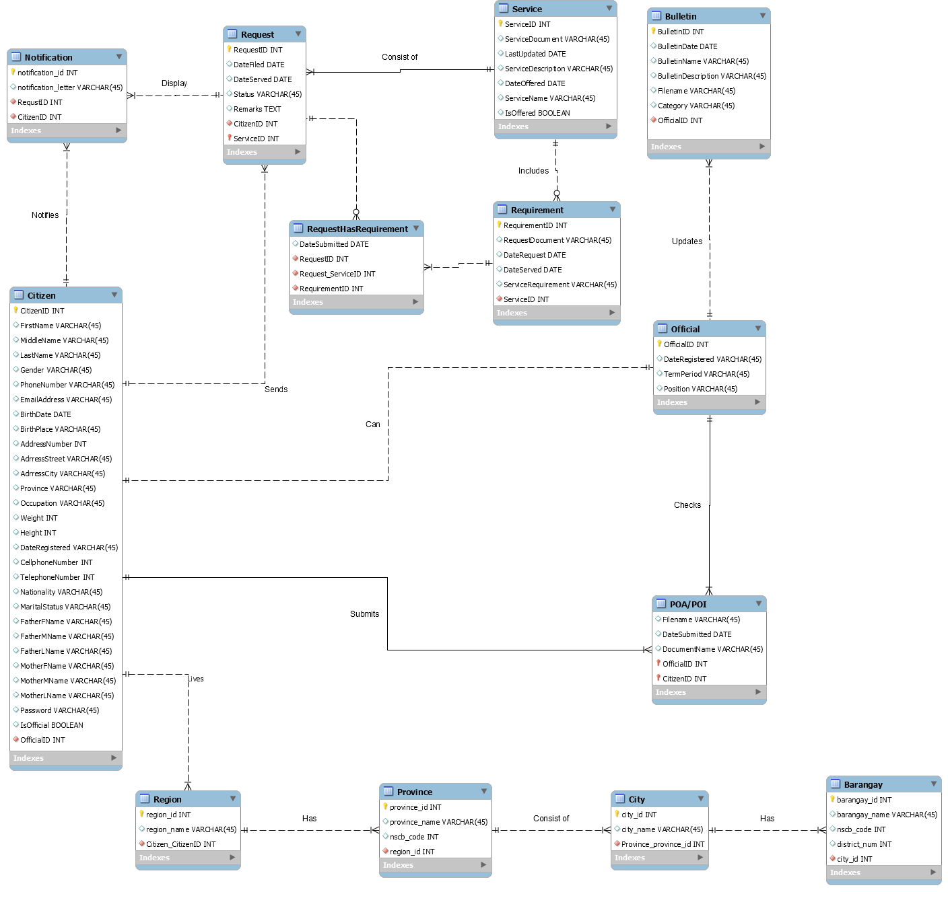

**Diagrams**

**Class Diagram**

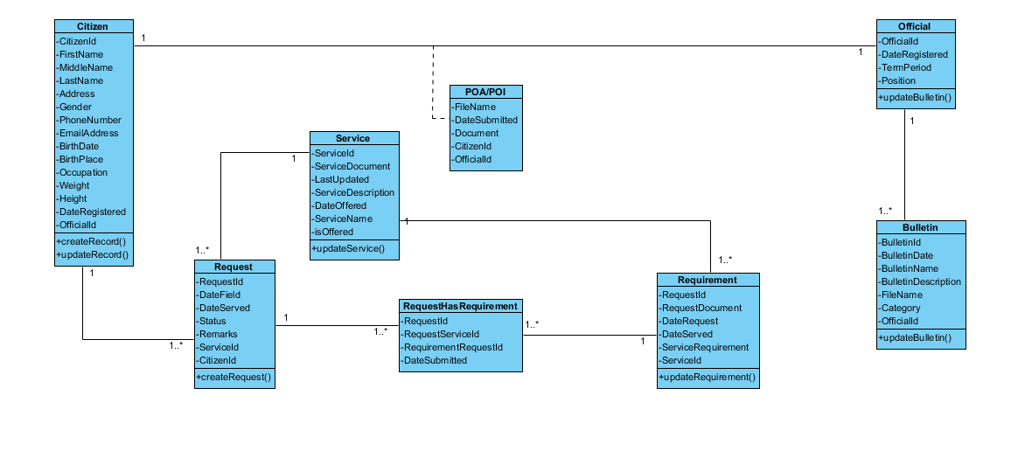

**Use Case Diagram**

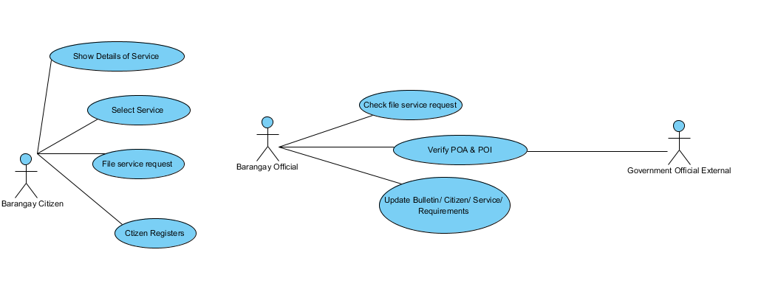

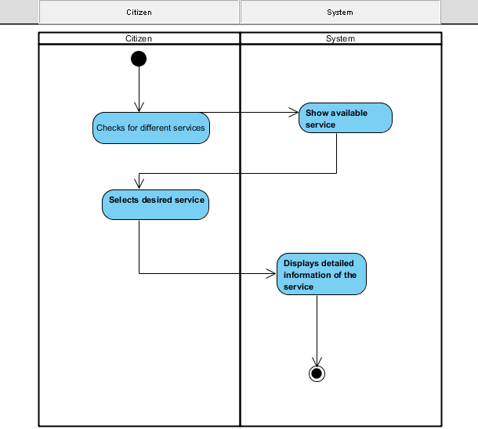**Activity Diagram**

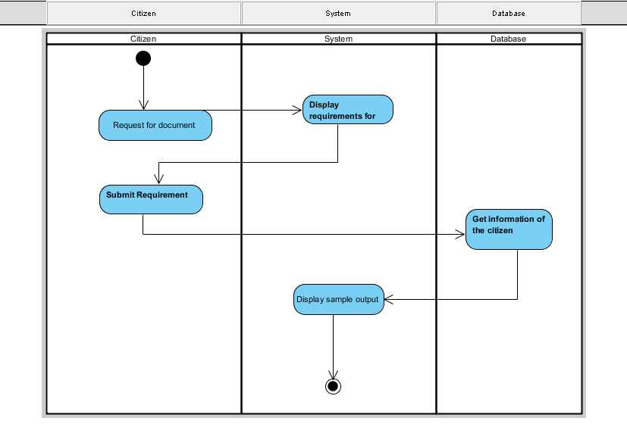Select Service

File Service Request

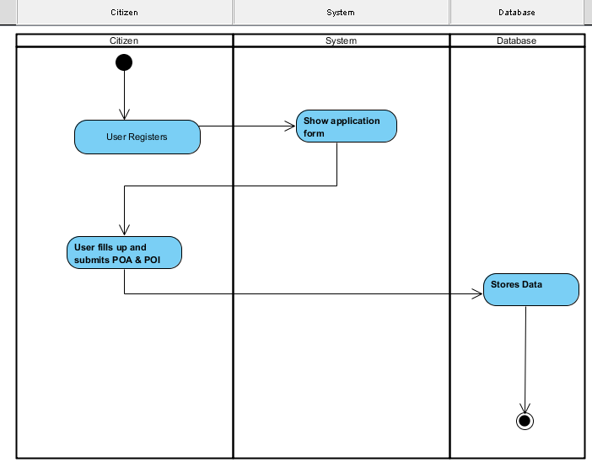Citizen Registers

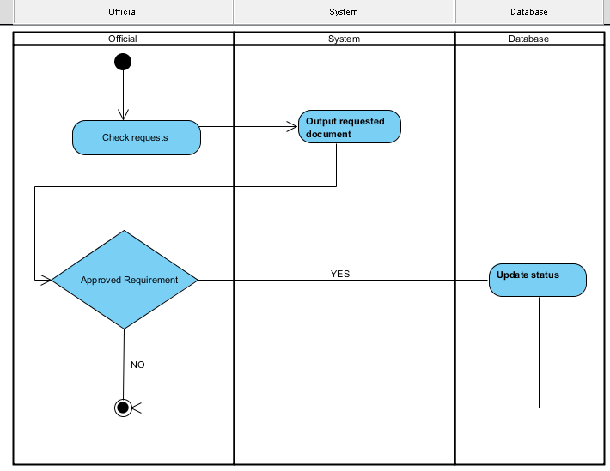

Check file service request

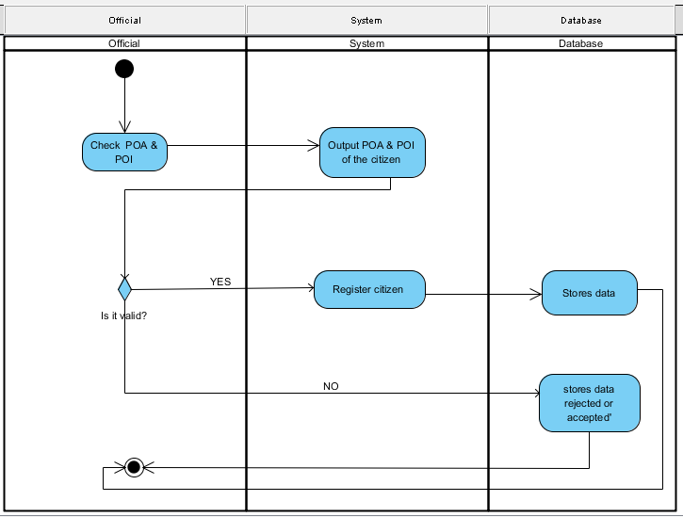

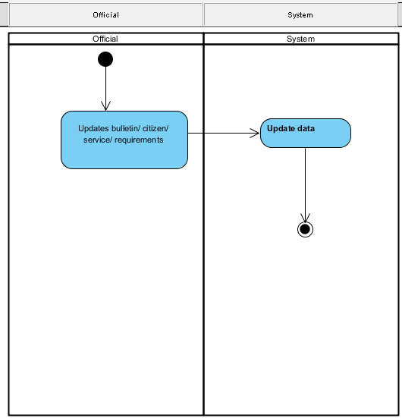Verify Proof of Identity / Address (POI / POA)

Update Bulletin

**Sequence Diagram**

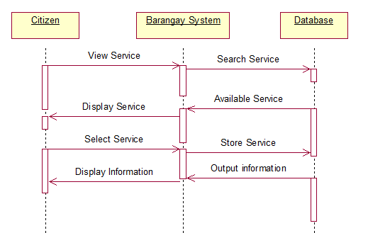

Select Service

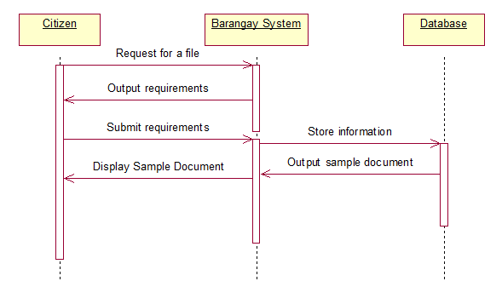File Service Request

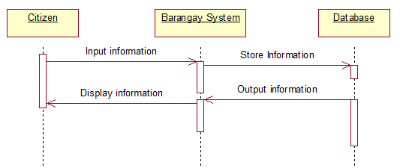

Citizen Registers

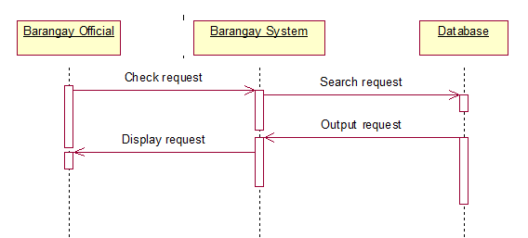

Check file service request

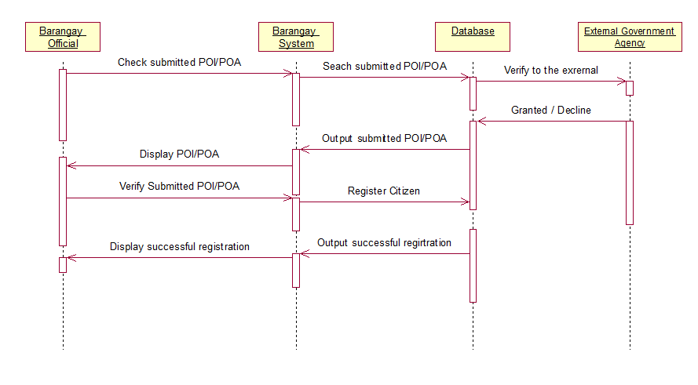

Verify Proof of Identity / Address (POI / POA)

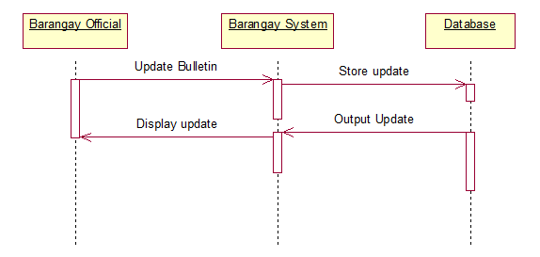

Update Bulletin

**Collaboration Diagram**

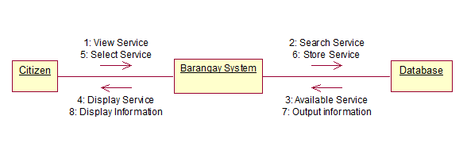

Select Service

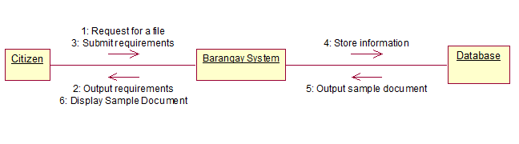

File Service Request

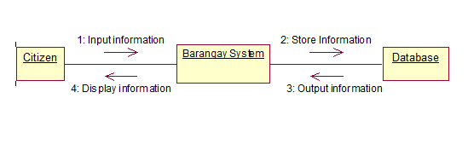

Citizen Registers

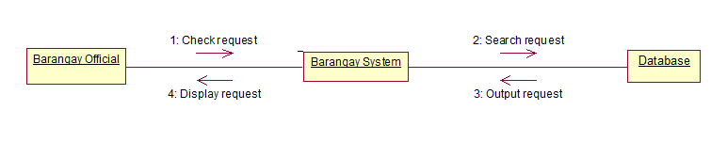 Check file service request

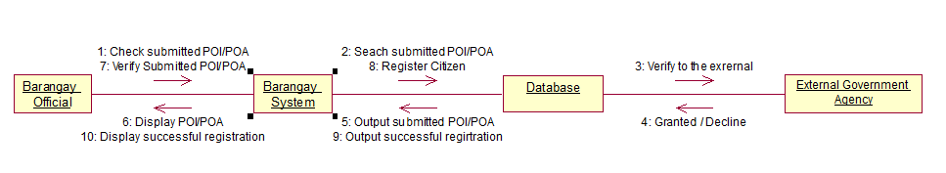

Verify Proof of Identity / Address (POI / POA)

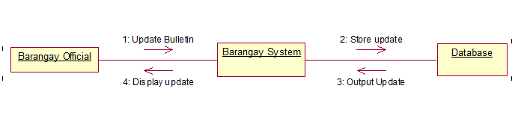

Update Bulletin