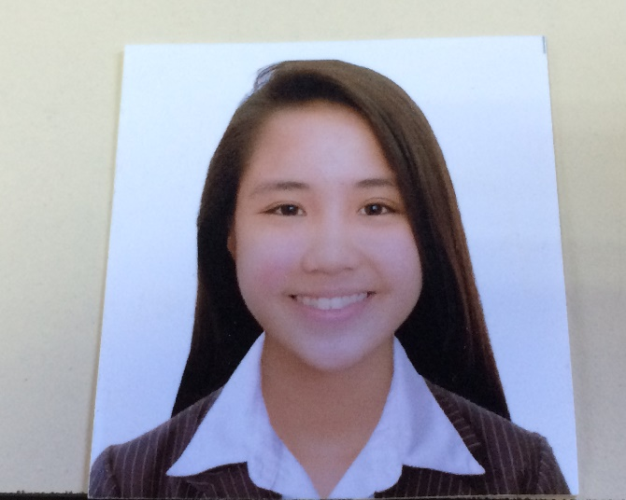

**LAGMAN, KAMILA R.**

**B.S. COMPUTER SCIENCE**

**SYSTEM SOFTWARE**

Unit # 923 central park condominium Pasay city

lagmankamila85@gmail.com

09954888256

**I. CAREER OBJECTIVE**

To work in a progressive organization which can expand all my knowledge and provided me exciting opportunities to utilize my skills and qualification to produce result fidelity. And To be part of reputed organization which provides a steady career growth along with job satisfaction, challenges and give value contribution in the success of organization.

**II. ACADEMIC INFORMATION**

2013-Present APC Asia Pacific College

#3 Humabon Place, Magallanes, Makati City

Bachelor of Science in Computer Science

2009-2013 BHS Bangkal High School

2003-2009 HPDPESM Heneral Pio Del Pilar Elementary School Main

|  |  |
| --- | --- |
| **Software Proficiency**   * My SQL * Microsoft Visual Studio * Green foot * XAMPP * Eclipse * Packet Tracer * Cobalt Framework * Yii2 Framework | **Programming Languages**   * JAVA * HTML * CSS * PHP * SQL * Visual Studio * Django Python |

**III. Activities**

* Finance Director of Microsoft Community, 2015- present
* Member of Student Ambassador and Models, 2014-present
* Assistant director in marketing and promotions of JPCS(Junior Philippine Computer Science), 2013-2014