**BARANGAY STA. CRUZ**

**First District, Quezon City**

**Clearance for Construction / Building Permit/Excavation**

**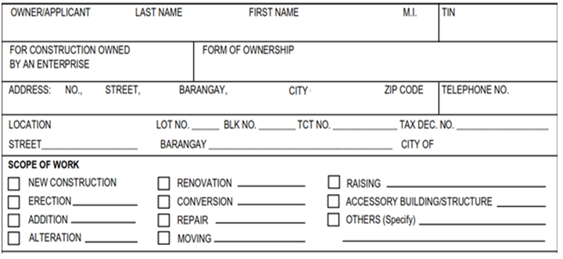 *Date of Application:___________________***

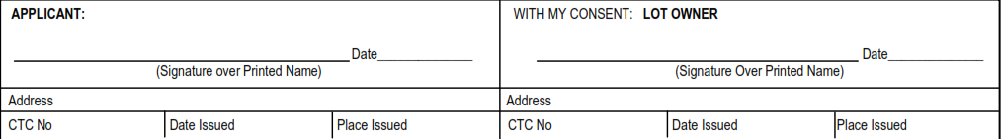

**Requirements:** (photocopy as applicable))

* Blueprint
* Transfer Certificate of Title with Declaration of Real Property and Tax Payment;
* Notarized Deed of Sale (If TCT is not under the Applicant’s Name);
* Neighbor’s Consent;
* Homeowner’s Clearance for Construction from Homeowner’s Association;