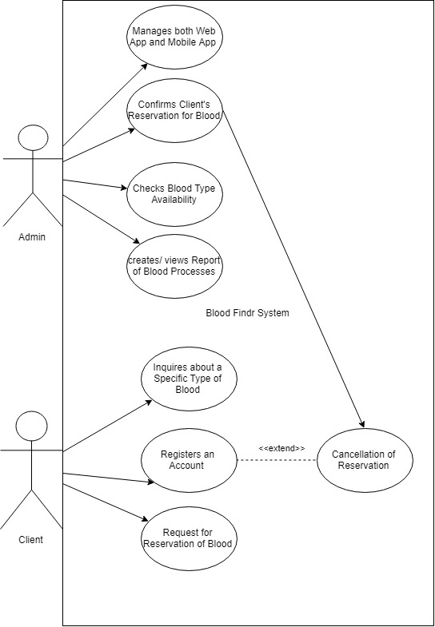

|  |  |  |
| --- | --- | --- |
| Use Case Name: | Manages both web app and mobile app | |
| Scenario: | Admin will manage both web app and mobile app | |
| Triggering Event: | Both mobile app and web app is managed by Admin | |
| Brief Description: | Admin will create, update, delete stored data in the system. All data (client, blood, branch, and system) will be managed by the admin. | |
| Actor: | Admin | |
| Related Use Case: | -Admin registers an account | |
| Stakeholders: | Web App / Mobile App | |
| Preconditions: | - Admin must have an account | |
| Post conditions: | Stored data will be kept confidential. | |
| Flow of Events: | Actor | System |
| 1. Admin logs in to the System. 2. Admin performs CRUD (create, read, update, delete) in the Database. | 2.1 System stores the database |
| Exception conditions: |  | |

|  |  |  |
| --- | --- | --- |
| Use Case Name: | Confirms Client’s Reservations for Blood | |
| Scenario: | Admin will confirm Client’s reservation of blood | |
| Triggering Event: | Client’s reservation of blood is confirmed by Admin | |
| Brief Description: | Admin will confirm client’s reservation of blood and will notify the client that its desired blood type is reserved and ready for pick up. | |
| Actor: | Admin | |
| Related Use Case: | -Admin registers an account | |
| Stakeholders: | Clients, Web App / Mobile App | |
| Preconditions: | - Admin must have an account  - Stocks in Blood is known  - Client is verified through registration | |
| Post conditions: | Client will be notified of the confirmation. | |
| Flow of Events: | Actor | System |
| 1. Admin logs in to the System. 2. Admin double checks blood type availability. 3. Admin confirms Client’s reservation of blood. | * 1. System provides details of blood type and it availability.   2. System approves confirmation |
| Exception conditions: |  | |

|  |  |  |
| --- | --- | --- |
| Use Case Name: | Checks Blood Type Availability | |
| Scenario: | Admin will check blood type availability in the Database | |
| Triggering Event: | Blood type availability is checked by the Admin | |
| Brief Description: | Admin will check whether the blood type is available and update the application’s database. | |
| Actor: | Admin | |
| Related Use Case: | Admin registers an Account | |
| Stakeholders: | Web App / Mobile App | |
| Preconditions: | - Admin must have an account  - Stocks in Blood is known | |
| Post conditions: | The Application will display current Blood Type Availability | |
| Flow of Events: | Actor | System |
| 1. Admin logs in to the System. 2. Admin double checks blood type availability in the system. 3. Admin updates the blood type availability in the application’s database, according with the branch’s stock. | 2.1 System provides availability of blood type.  3.1 System updates its blood type availability regarding the Admin’s input. |
| Exception conditions: |  | |

|  |  |  |
| --- | --- | --- |
| Use Case Name: | Creates / Views Report of Blood Processes | |
| Scenario: | Admin will create / view Report of blood processes | |
| Triggering Event: | Report of blood processes is created or viewed by the admin | |
| Brief Description: | Admin will create a report regarding blood transactions completed. | |
| Actor: | Admin | |
| Related Use Case: | -Admin registers an account | |
| Stakeholders: | Web Application | |
| Preconditions: | -Admin must have an account | |
| Post conditions: | Total number of transactions made about blood will be known. | |
| Flow of Events: | Actor | System |
| 1. Admin logs in to the system. 2. Admin |  |
| Exception conditions: |  | |

|  |  |  |
| --- | --- | --- |
| Use Case Name: | Inquires about a specific type of blood | |
| Scenario: | Client will inquire about a specific type of blood. | |
| Triggering Event: | Blood type is inquired by client. | |
| Brief Description: | Client will inquire about a specific type of blood, whether if it’s available or not and where it’s available. | |
| Actor: | Client | |
| Related Use Case: |  | |
| Stakeholders: | Web App / Mobile App | |
| Preconditions: | -Client must have access to the application (no account needed) | |
| Post conditions: | The Application will display current Blood Type Availability of the inquiries of the client. | |
| Flow of Events: | Actor | System |
| 1. Client uses the web app / mobile app. 2. Client inquires about a specific type of blood. 3. Client can opt to reserve for that blood or not. | 2.1 System displays and provides information about blood. |
| Exception conditions: | Client must have an account to reserve for the blood. | |

|  |  |  |
| --- | --- | --- |
| Use Case Name: | Registers an Account | |
| Scenario: | Client will register an account | |
| Triggering Event: | Account is registered by client | |
| Brief Description: | An account is needed to avail of the service to request a reservation of blood. The client must register first an account. | |
| Actor: | Client | |
| Related Use Case: |  | |
| Stakeholders: | Web App / Mobile App | |
| Preconditions: | -Client must provide required information for the account registration | |
| Post conditions: | Client will have access to avail blood through the system. | |
| Flow of Events: | Actor | System |
| 1. Client fills up registration form and necessary information needed through the web app / mobile app. | 1.1 System approves registration |
| Exception conditions: | Client does not need to register if the client already has an account. | |

|  |  |  |
| --- | --- | --- |
| Use Case Name: | Request for Reservation of Blood | |
| Scenario: | Client will request for a reservation of blood. | |
| Triggering Event: | Reservation of blood is requested by client. | |
| Brief Description: | Client will request for a reservation of blood, so the admin can confirm and have the blood ready for the client to pick up. | |
| Actor: | Client | |
| Related Use Case: | -Client registers an account | |
| Stakeholders: | Admin, Web App / Mobile App | |
| Preconditions: | -Client must have access to the application  -Client must have an account | |
| Post conditions: | Through the application, a request for confirmation of blood from the client will be forwarded to the admin. | |
| Flow of Events: | Actor | System |
| 1. Client logs in to the System. 2. Client requests for the reservation of blood. 3. Client will receive confirmation. | 2.1 System will reserve blood.  3.1 System will confirm reservation through the admin. |
| Exception conditions: | Client must claim the blood at a given time, otherwise reservation of blood will be cancelled. | |