

**COMMUNITECH**

**Submitted by:**

**Rhudolf Flores**

**Recelyn Jarilla**

**Ma. Antonnette Laming**

.

**Event Table:** User Event Table

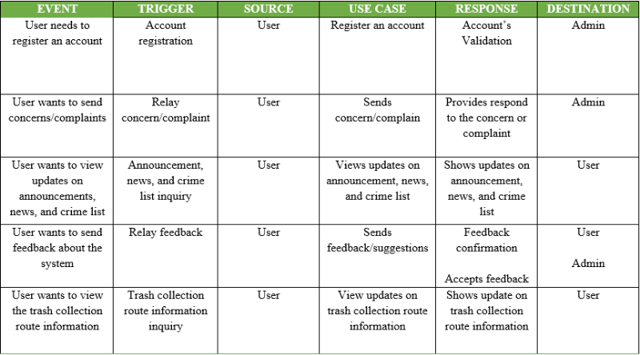

**Admin Event Table**

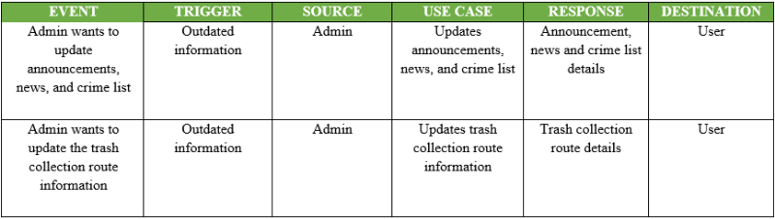

**Use Case Diagram:**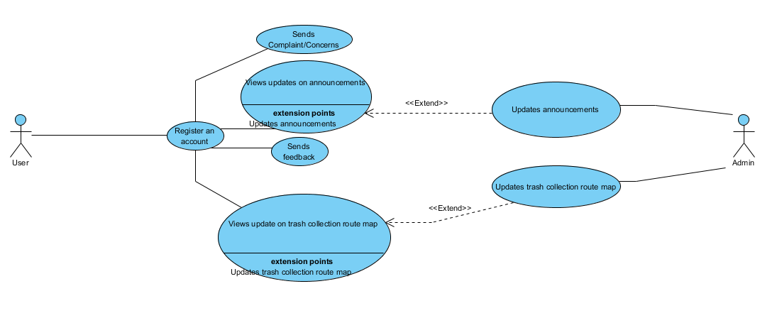

**Use Case Full Description:** 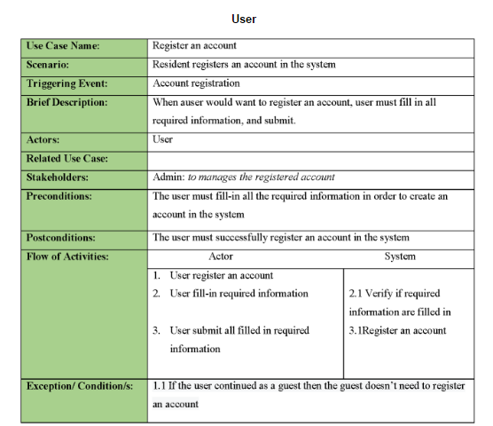

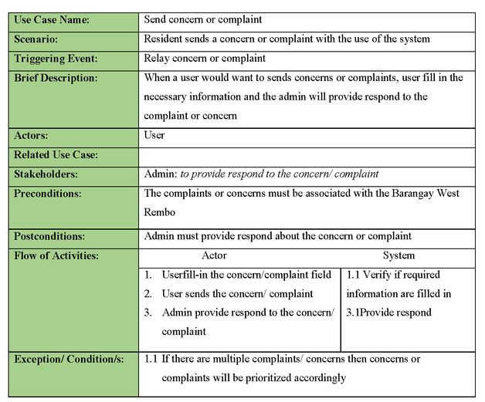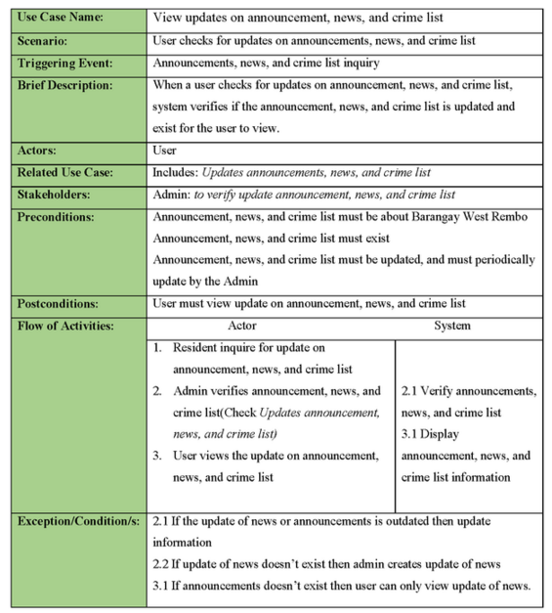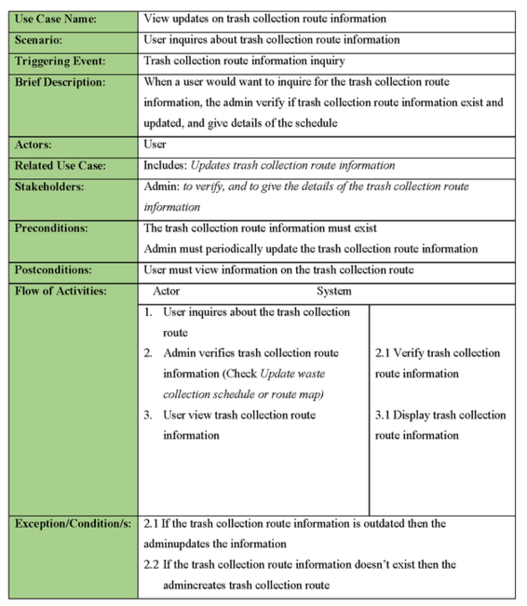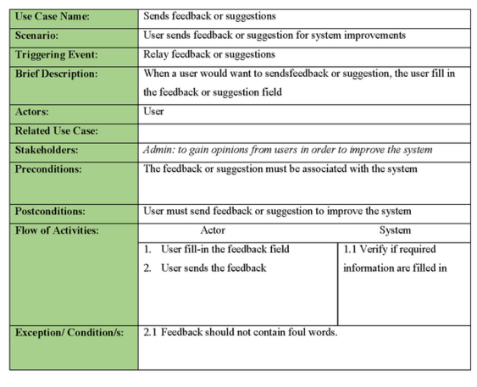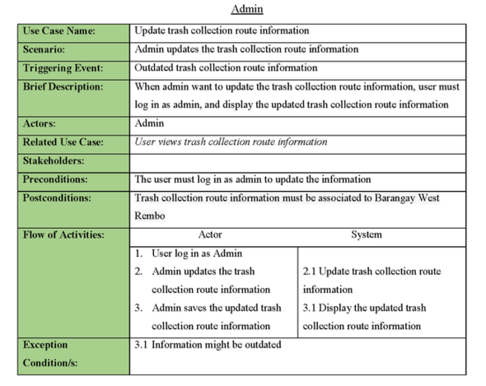

**Class Diagram:**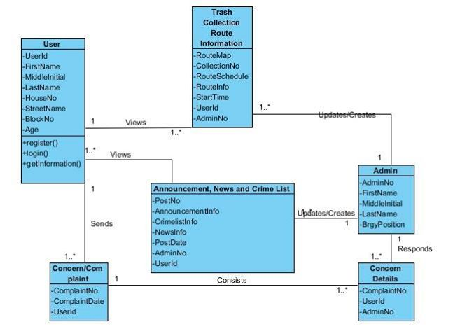

**Sequence Diagram:**

**(Register an Account)**

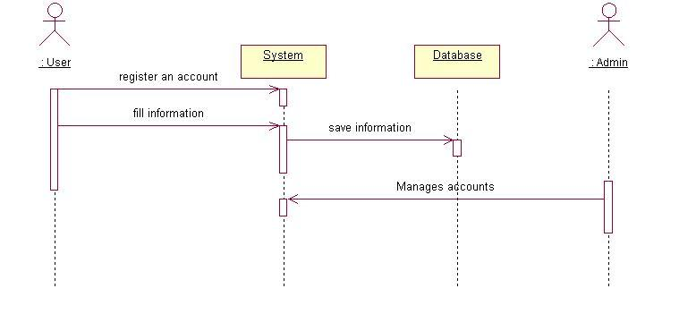 **(Send Concern or Complaint)** 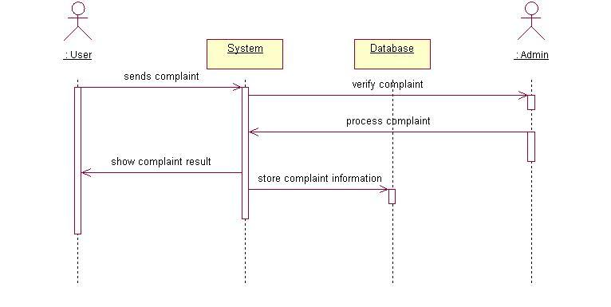

**(View Announcements)**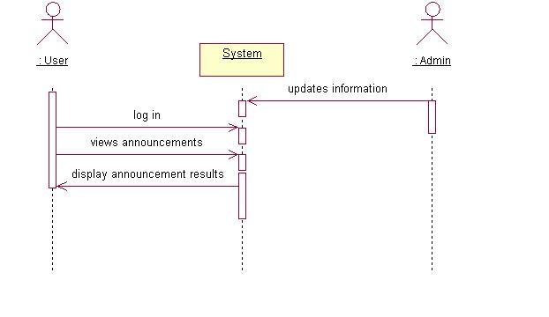

**(View trash collection route map)**

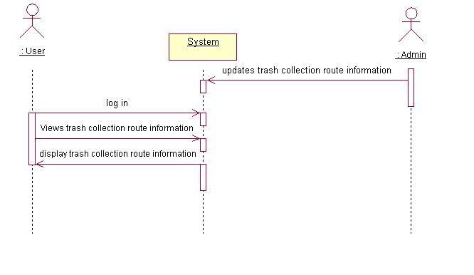

**(Send Feedback)**

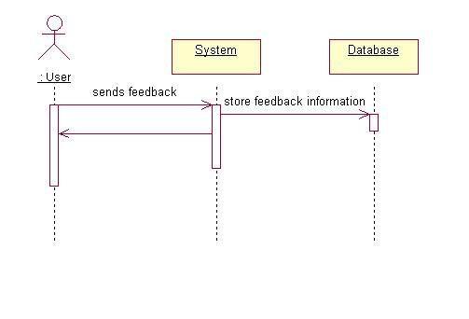

**Collaboration Diagram:**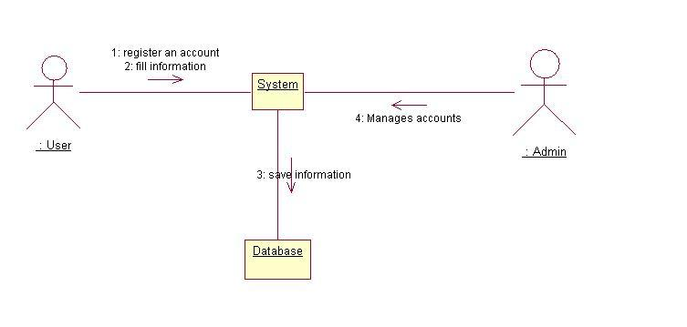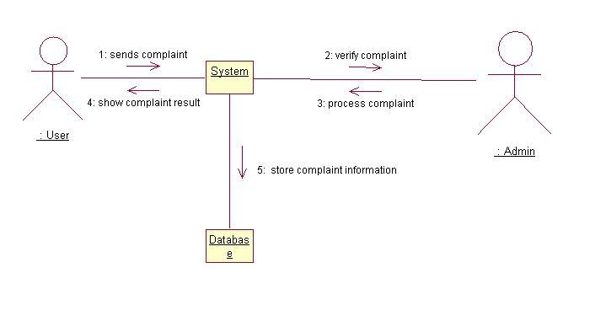 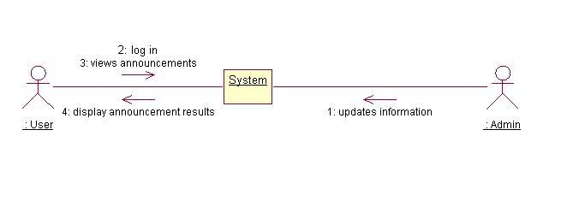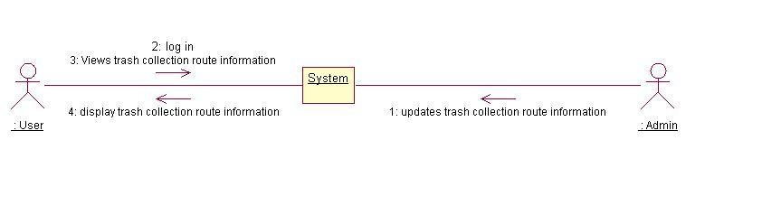 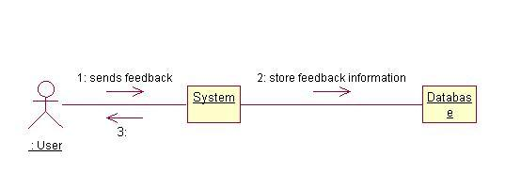

**Activity Diagram:**

Sending concerns/complaints

|  |  |  |
| --- | --- | --- |
| **User** | **Admin** |  |
|  |  |  |
|  |  |  |
|  |  |  |
|  |  |  |
|  | Receives concern/ complaints |  |
| Sends concern/ complaints | Provide respond to complaint/ concerns |  |

Trash collection route information

|  |  |  |
| --- | --- | --- |
| **User** | **Admin** |  |
|  |  |  |
|  |  |  |
|  |  |  |
| Inquire about waste collection schedule or route map  Receive schedule or route map details | **­**  Address the inquiry  Verifies the schedule or route map details  Is waste schedule or route map exist?  Creates schedule or route map  no  yes  Gives schedule or route map details  Is waste schedule or route map outdated?  Update schedule or route map details  yes  no |  |

Announcements, crime list and news

|  |  |  |
| --- | --- | --- |
| **User** | **Admin** |  |
|  |  |  |
|  |  |  |
|  |  |  |
| Inquire for announcement, news, and crime list  View announcement, news, and crime list | **­**  Address the inquiry  Verifies announcement, news, and crime list  Is announcement, news, and crime list exist?  no  Creates announcements, news, and crime list      yes    Gives announcement, news, and crime list  Is announcement, news, and crime list outdated?    Update announcements, news, and crime list  yes |  |

Sending feedbacks

|  |  |  |
| --- | --- | --- |
| **User** | **Admin** |  |
|  |  |  |
|  |  |  |
|  |  |  |
|  |  |  |
|  |  |  |
| Sends feedback  Compose feedback |  |  |