**Software Requirements Specification**

**For**

**DrDentAssist**

**Version 1.0 approved**

**Prepared by:**

**Chloe Tañada**

**Maria Kristina Punla**

**Reimarie Princess Quirante**

**Asia Pacific College**

**July 11, 2017**

# Table of Contents

Table of Contents 2

Revision History 3

1. Introduction 3

1.1 Purpose 3

1.2 Document Conventions 3

1.3 Purpose 3

1.4 Product Functions 3

1.5 Intended Audience and Reading Suggestions 4

1.6 Product Scope 4

2. Overall Description 4

2.1 Product Perspective 4

2.2 Product Functions 5

2.3 User Classes and Characteristics 6

2.4 Operating Environment 7

2.5 Design and Implementation Constraints 7

2.6 User Documentation 7

3. External Interface Requirements 8

3.1 User Interfaces 8

3.2 Hardware Interfaces 9

3.3 Software Interfaces 9

3.4 Communications Interfaces 9

4. System Features 9

5. Other Nonfunctional Requirements 11

5.1 Performance Requirements 11

5.2 Safety Requirements 12

5.3 Security Requirements 12

5.4 Software Quality Attributes 12

5.5 Business Rules 12

Appendix A: Glossary 13

Appendix B: Analysis Models 13

# Revision History

|  |  |  |  |
| --- | --- | --- | --- |
| **Name** | **Date** | **Reason for Changes** | **Version** |
| Chloe Tañada | July 11, 2017 | First Draft | 1 |
| Chloe Tañada | July 15, 2017 | Second Draft | 2 |

# Introduction

## Purpose

The purpose of Software Requirements Specification (SRS) is to provide a detailed explanation about the technical prerequisite of DrDentAssist. The requirements specified are implemented by the developers before the end of term. After the implementation, this will give the assigned administrator in Happy Clinique a documented guideline of the technical requirements and objectives of the system.

## Document Conventions

This document was created in Microsoft Office 2016, with font sizes (12 – content, 14 – section, 18 – subtitles, 32 – title) and a standard font (Times New Roman). Typographical conventions are:

|  |  |  |
| --- | --- | --- |
| Typeface or Symbol | Meaning | Example |
| **AaBbCc123** | Bold font style was used on highlighted topics. | PurposeProduct Functions |
| AaBbCc123 | Italicized fonts were used to emphasize a specific word. | Major functions the product must perform:  Major functions the user must perform: |

## Intended Audience and Reading Suggestions

* Developers – The developers are those who manage the entire system. This document is used by developers as a guideline to create the functionalities required for the completion of the project.
* Technical Writers – The technical writers are the people assigned to prepare the user manuals and other requisite documents of the project.
* Testers/Users – The testers/user can examine and estimate the performance outcome of the system 'DrDentAssist and to be able to check the technical necessities whether the requirements had been accurately implemented.

## For the full content of Project Product Scope

# Overall Description

## Product Perspective

Scope, please proceed to page 5 in the Vision and Scope document.

DrDentAssist is a new production for Happy Clinique, it is a replacement for the organization’s traditional method in accumulating loads of patient records. For the organization to become flexible in their services and can cope up with the fast pacing technology world, the team developed a system (DrDentAssist) that can benefit both the customers and the company itself.

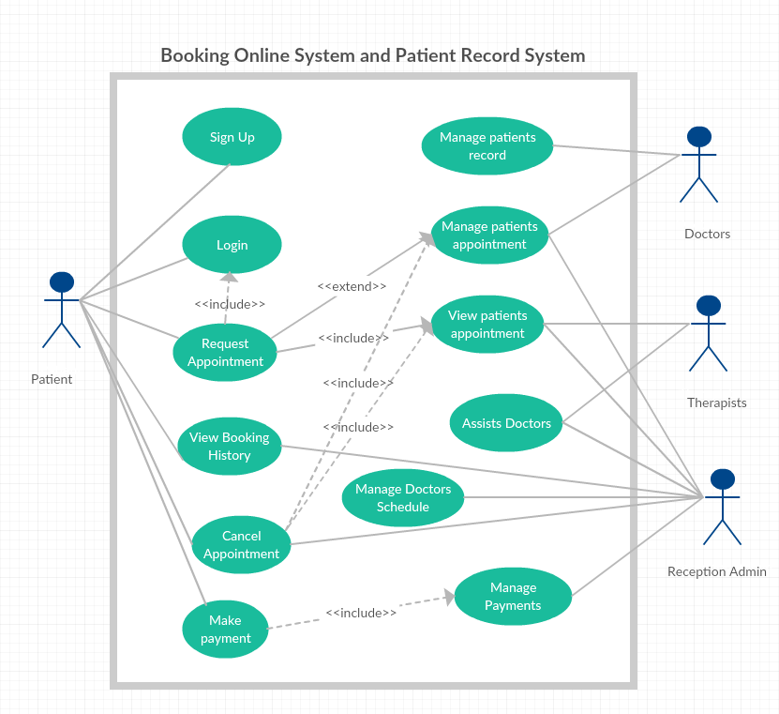

## Product Functions

Major functions the product must perform:

* Online booking system
* Online documentation of the patient’s dental and derma information
* Revamp the clinics day-to-day operation

Major functions the user must perform:

* Management
* Book appointment
* Cancel appointment
* 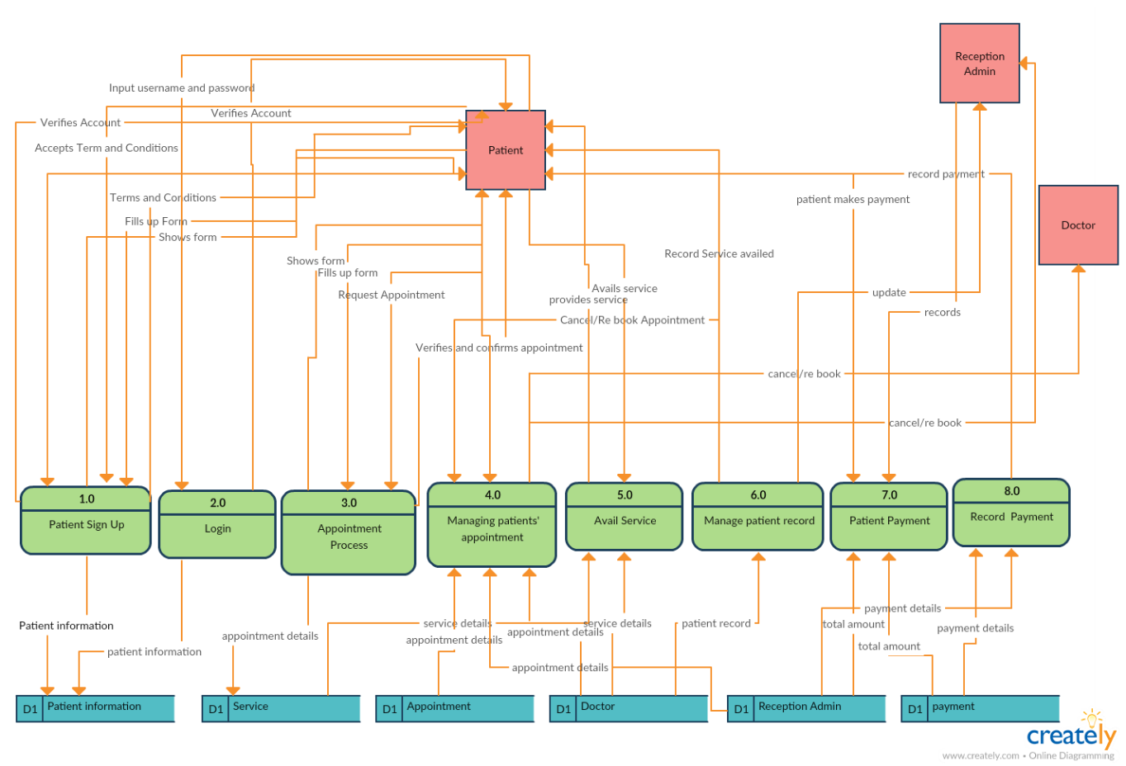View appointment history

## User Classes and Characteristics

There are four types of users that can use DrDentAssist:

|  |  |
| --- | --- |
| **User** | **Activities** |
| Administrator | * Manage doctor’s schedule * Manage payments * Manage appointment schedule   Re-schedule appointment |
| Doctor | * View appointment schedule * Manage appointment schedule * Manage patient record |
| Therapist | * View patient’s appointment schedule |
| Patient | * Create an account * Book an appointment * Cancel appointment * View appointment history |

## Operating Environment

* Digital Ocean Cloud (cloud-based)
* CentOS 7 (server-based)
* Windows 8 (minimum of 32-bit RAM)

## Design and Implementation Constraints

* DrDentAssist design must meet the standards given by the client.
* DrDentAssist must perform validation check in user’s input.
* The system uses phpmyadmin MySQL for the database.
* The system uses Laravel as the framework.
* PHP, CSS, HTML and JavaScript are being combined in creating the system interfaces.

## User Documentation

A printed manual has been published to provide instruction on how to use DrDentAssist. The user manual contains written guidelines and has nontechnical terminologies so that the readers will have a better understanding about the given instructions. The user manual includes step-by-step procedures.

**2.7 Assumptions and Dependencies**

The website will be accessible on desktops and laptops and it will be mobile responsive. It will be hosted initially on a free DNS service. Client can have the option to purchase a web domain. Server can initially run on the clinic's existing desktop but the team will be assisting the client in case of a future migration to upgrade platform.

# External Interface Requirements

## User Interfaces

A screenshot of a social media post

Description generated with very high confidenceHere are some screenshots of the system’s user interface.

A screenshot of a social media post

Description generated with very high confidence

## A screenshot of a social media post Description generated with very high confidenceHardware Interfaces

* Hardware: Minimum System Requirement
* Processor: 2.4 GHZ processor speed
* Memory: 1GB RAM (2 GB recommended)
* Screen resolution:  800 x 600 colors or above

## Software Interfaces

* Windows, Linux, iOS and Android operating system environment
* The user interface and other parts of DrDentAssist system were created using Laravel advanced framework, including HTML, CSS, PHP 5.4, Bootstrap.
* Browsers like Google Chrome, Microsoft Edge, Firefox, etc. is used for the viewing of the system.
* MySQL and PHP My Admin for the database.

## Communications Interfaces

The patient will interact with the system through a web browser and can be accessible to the patient’s computer and network, while from the admin side the system can be accessed using intranet. Any browser may use the system, from Google Chrome, Microsoft Edge and Firefox.

# System Features

**4.1.1. User Registration**  
  A user is required to have an account to be able to manage the reservation online.   
  
**4.1.2. Description/Priority (User)**  
 Users can create an account by completing the online registration and it is a high priority.

**4.1.3. Stimulus/Response Sequences**  
  Stimulus: A user creates an account by completing the registration form.   
 Response: The system will verify if the required information is valid i.e. username, password, email address and contact number. The system will store the information in the database and redirect the user to the login page.

**4.2.1. Access, View, and Manage**

Users can access, view and manage the necessary requirements accessible based on its user privilege (Receptionist, Doctor, Therapist, or Patient) upon logging in.

**4.2.2. Description/Priority**  
  User can manage his/her account upon logging in. 

**4.2.3. Stimulus/Response Sequences (Admin/Receptionist)**  
  Stimulus: The admin manages patient appointments / doctor schedule upon logging in.    
  Response: The system will display all pending reservation or doctor schedule.

Stimulus: The admin approves/cancel the reservation in the calendar and/or edit doctor schedule.    
  Response: The system updates the information in the calendar. If the reservation is cancelled upon reason, the admin will select other available slot for reservation for the patient.

**4.2.3. Stimulus/Response Sequences (Doctor)**  
  Stimulus: Doctor views request appointments.   
  Response: The system will display the calendar.

Stimulus: Doctor either accept or cancel the appointment.

Response: If the selected date is cancelled, the system will notify the following users (Receptionist and Patient) and proceed to the reservation page to allow the user to file another reservation or not. If the date selected is accepted, the system will save the appointment schedule.

**4.3.1. Stimulus/Response Sequences (Patient)**

Stimulus: Patient views available schedule.   
  Response: The system will display the calendar.   
  Stimulus: Patient booked and send the requested appointment.   
  Response: Receptionist/Doctor will be notified.

Stimulus: Receptionist/Doctor will accept, cancel or edit the schedule.

Response: The patient will be notified.

Stimulus: If the approved appointment is cancelled by the patient, the system will notify the following users (Receptionist and Doctor) and proceed to the reservation page to allow the patient to file another reservation or not. While, if the approved appointment is confirmed by the patient, the system will save the appointment schedule.   
  
**4.3.1. Stimulus/Response Sequences (Therapist)**

Stimulus: Therapist views scheduled appointments.   
  Response: The system will display the appointments.   
  Stimulus: Therapist confirms.

  Response: Therapist will assist on the procedure of the service chosen by the patient.   
.

**4.4.1 Functional Requirements**

* + - * + **REQ-1:**The admin/doctor/patient/therapist should have an account
        + **REQ-2:**The admin/doctor/patient/therapist should be connected to the internet

# Other Nonfunctional Requirements

## Performance Requirements

* The responsiveness of the system depends on the speed of its internet connection of the user.
* The system should provide real-time information about the doctor’s available schedule.
* Pending approval should be managed by the admin in order in which the reservation was received.

## Safety Requirements

A patient can access certain features based on its user privilege. The system will secure all outlets of transaction that includes any confidential patient records. The system will automatically log out users after a certain period of inactivity.

## Security Requirements

The system must maintain separate levels of security for users and the system administrator as well as for doctors and therapists. All users are required to have an account to be able to access DrDentAssist website. Users can access certain functionalities depending on their role.

## Software Quality Attributes

* + 1. Security
* DrDentAssist will support different privileges for users such as patient, receptionist, doctor and therapist. The user upon logged in with the given role should only be allowed to access functionalities based on its privilege.
* In HTTPS, it enables web application to securely access confidential information like patient records.
* The patient’s personal information is protected.
  + 1. Reliability
* DrDentAssist service descriptions and doctor description are clear and understandable.
  + 1. Scalability
* DrDentAssist must be scalable to many users for all the patients to have better user experience.

5.4.4 Availability

* DrDentAssist is available 24/7

## Business Rules

* Each patient can select one or more service/s. Each service can be provided to one or more patient.
* Each patient can request for one appointment. Each appointment can be associated with one patient only.
* Each patient can make one payment only. Each payment is associated to one patient.
* Each patient has one patient record. Each patient record is associated to one patient.
* Each patient record can consist of dental or derma record. Each dental or derma record is associated to one patient record.
* Each employee can provide one or more service/s. Each service is provided by one or more employee.
* All employee is consisting of doctor, reception admin and therapists.
* All doctors are consisting of dentist or dermatologists.
* Each reception admin manages patients’ schedule.

# Appendix A: Glossary

* GHz - means 1 billion cycles per second and when it talks about 2.4 GHz processor, it is usually mean that this is the maximum frequency of the clock to each core.
* RAM - Random Access Memory is the memory or information storage in a computer that is used to store running programs and data for the programs.
* HTTPS - Hypertext Transport Protocol Secure. HTTPS is the same thing as HTTP, but uses a secure socket layer (SSL) for security purposes.
* DrDentAssist – System name/Project name.
* Happy Clinique – Name of the company.

# Appendix B: Analysis Models

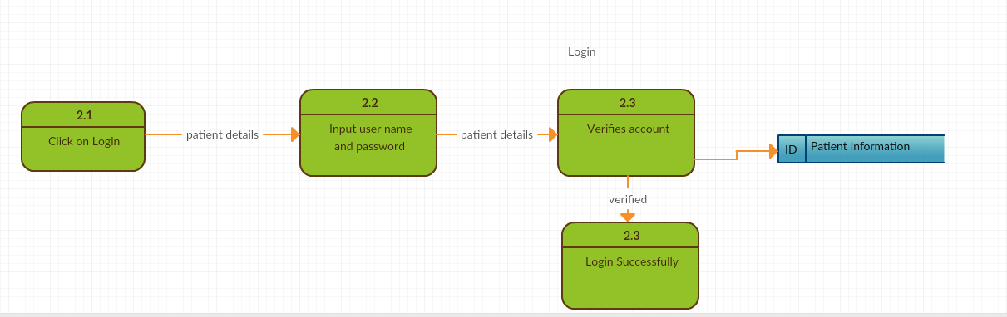Data Flow Diagram:

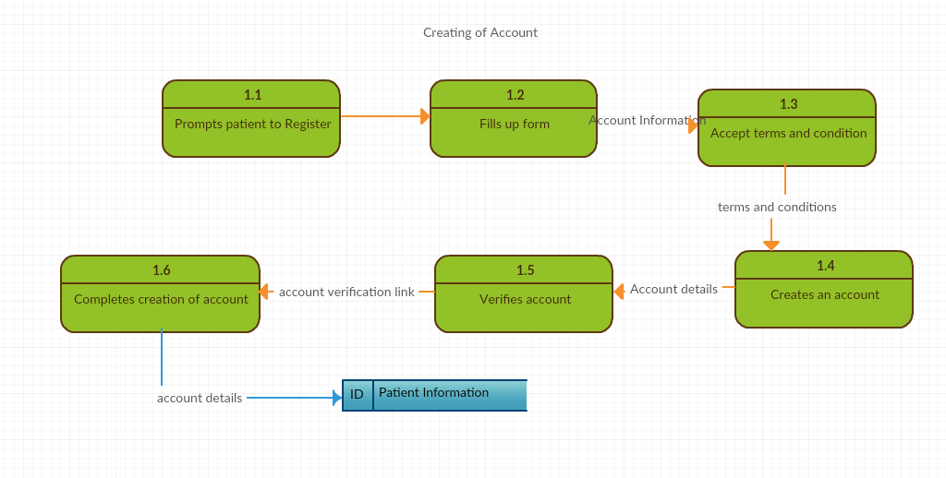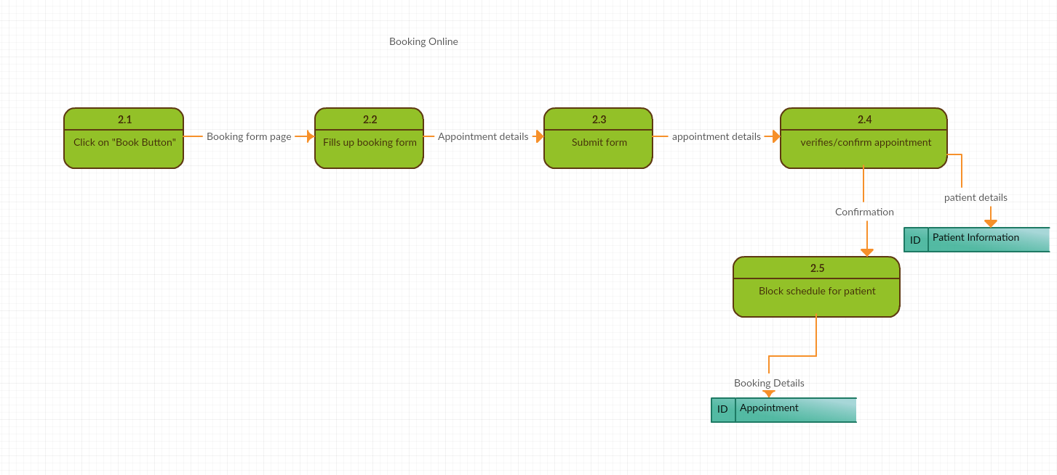

Class Diagram:

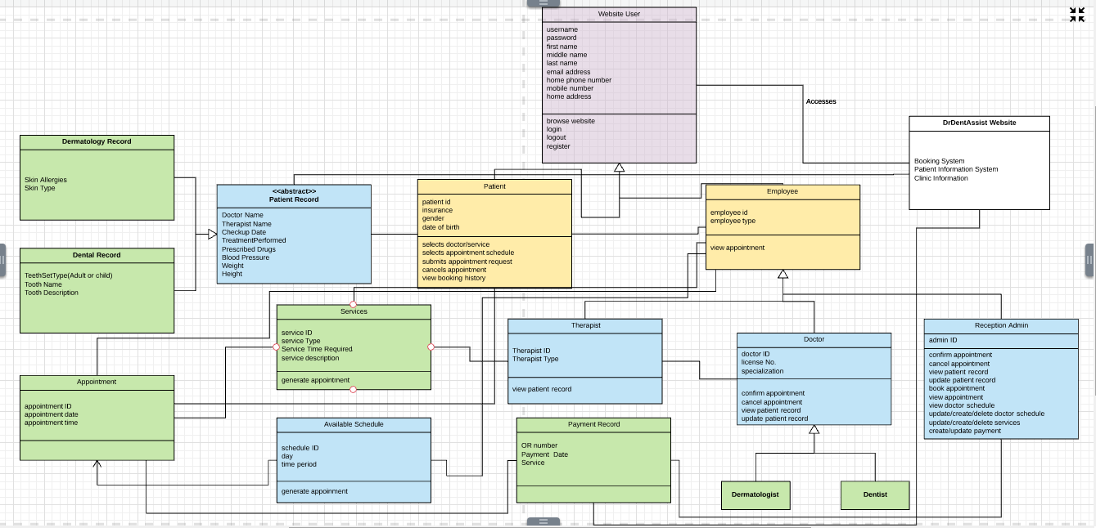

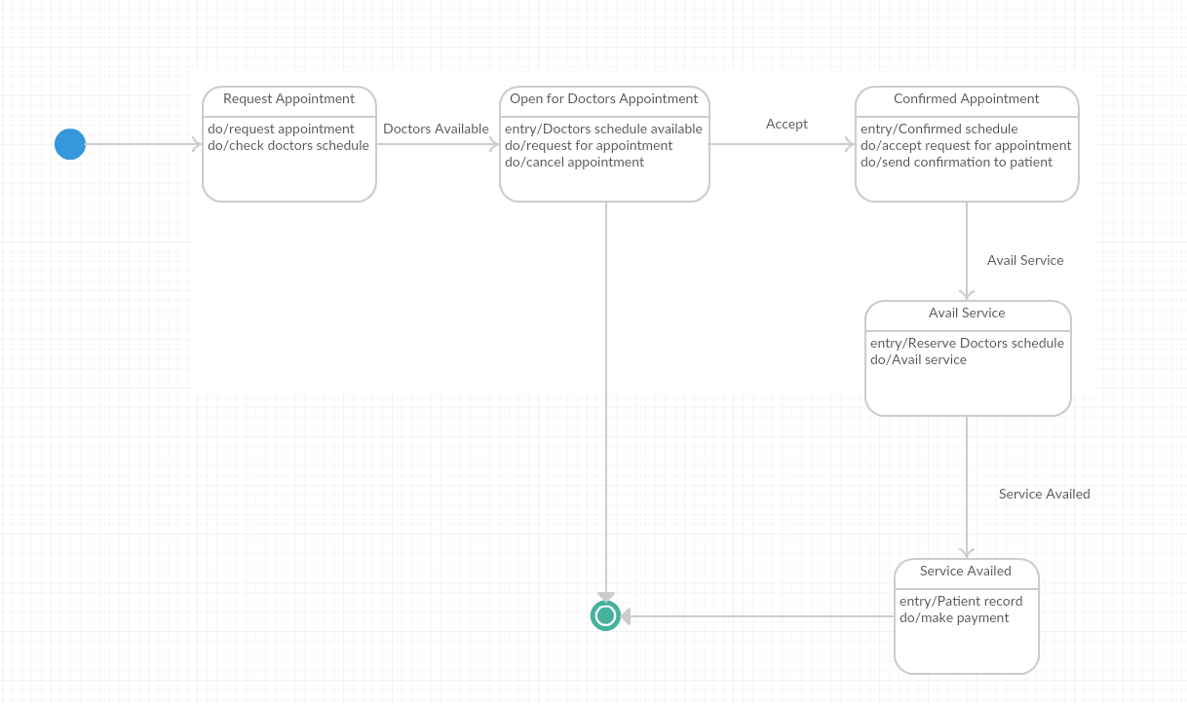State Transition Diagram:

Entity Relationship Diagram (ERD):

