

Project Documentation Submitted

To the Faculty of School of

Computer Science and Information Technology

Of

Asia Pacific College

In Partial Fulfillment of the Requirements for the subject

Applied Projects 2 or Software Development

By

**Table of Contents**

Page no

Project Title 1

I.             Narrative 4

A.      Executive Summary 4

B.       Introduction. 4

1.        Client Profile 4

2.        Project Organization. 5

a.        Project Team. 5

b.       Project Professor 5

c.        Project Adviser(s) 5

3.        Client’s Mission and Objectives 5

4.        Project Objectives 5

5.        Purpose of the Project 6

6.        Rationale of the Project 6

a.        The Current Process Flow. 6

b.       User Information Needs 6

c.        How the Information is being processed. 6

C.       Systems Features and Functions 6

1.        Software Environment 6

a.        Programming Languages 6

b.       Specific Software 6

c.        Web Server Application. 7

d.       Operating System. 7

e.        Other Software 7

2.        Hardware Environment 7

3.        Networking and Security 8

a.        Security 8

b.       Server 8

4.        Application System Modules 8

a. 8

b. 8

c. 8

d. 8

II.            System Diagrams and Screenshots 9

A.      Data Flow Diagrams 9

1.        Context Level Data Flow Diagram 9

2.        Level 0 Data Flow Diagram. 9

B.       UML Diagrams 11

C.       Entity – Relationship Diagram. 17

D.      Data Dictionary 18

E.      Screenshots 19

F.       Lessons Learn. 22

III.          Appendices 22

**I.**                  **Narrative**

**A.**     **Executive Summary**

As we all know, Filipinos are well-known in loving and eating food. They even tend to explore and discover different places and different cultures starting from their hometowns, neighboring towns and cities, then across the country just to satisfy themselves in their desires of eating different food. Here in Makati, Metro Manila, food is a leisure to different kinds of citizens, and the financially-abled people are the majority of the seekers of this kind of leisure. The drive to try out every dish in this region is inevitable since human beings are provided the power of curiosity. Hence, the financially-abled citizens living there are doing different kinds of effort just to satisfy one’s self and one another. They do effort in exploring by commuting but the thing is, lack of information and guidance in the directions are becoming a problem since it gives inconvenience to the diners/customers. That is why the project “Foodtrip Search Engine” seems the most viable solution in solving the problem.

**B.**     **Introduction**

FoodTrip Restaurant Search Engine is a web and mobile-based application wherein you can easily discover and explore high class restaurants around Metro Manila in cuisines of different cultures and whenever you choose a restaurant you wish to visit, you can view their detailed information, provide feedback and alsocheck out their promotion deals.

1. **Client Profile**

**Personal Information**

|  |  |  |  |  |  |  |  |  |  |  |  |  |  |  |  |  |  |
| --- | --- | --- | --- | --- | --- | --- | --- | --- | --- | --- | --- | --- | --- | --- | --- | --- | --- |
| Last Name: | | Ferrer | | | | | | First: | | Gef Gail | | | | | Middle: | | D |
| Maiden Name: | | | | Gef | | | | | | | | Date of Application: | | | | April 10,2016 | |
| Date of Birth: | | | | | | June 18, 1989 | | | Place of Birth: | | | | Calgary | | | | |
| Address: | Imus Cavite City | | | | | | | | | | | | | | | | |
| Phone Number: | | | | | | | N/A | | | | Work Number: | | | 8017879 | | | |
| Cell Number: | | | 09778267382 | | | | | | | | Email Address: | | | gefyu@gmail.com | | | |
| Occupation: | | | | | General Manager | | | | | | | | | | | | |

**Company Information**

|  |  |  |  |  |
| --- | --- | --- | --- | --- |
| Company Name: | Abigle Cafe | | Position Title: | General Manager |
| Company Address: | | 2nd & 3rd floor RCT Building, 252 Urban Ave, 252 Urban Avenue, Pio Del Pilar, Makati, 1230 Metro Manila | | |

**2.**      **Project Organization**

**a.**      **Project Team**

|  |  |  |
| --- | --- | --- |
| Name | Position | Email |
| Jimmy Tan | Project Leader | [iftan@student.apc.edu.ph](mailto:iftan@student.apc.edu.ph) |
| Rouzandra Zuniga | Project Developer and Designer | [rbzuniga@student.apc.edu.ph](mailto:rbzuniga@student.apc.edu.ph) |
| Jason E. Juarez | Project Developer | [jejuarez@student.apc.edu.ph](mailto:jejuarez@student.apc.edu.ph) |
| Iñigo Marquez | Project Web Developer | [iumarquez@student.apc.edu.ph](mailto:iumarquez@student.apc.edu.ph) |

**b.**     **Project Professor**

|  |  |  |
| --- | --- | --- |
| Name | Position | Email |
| Mr. Manuel "Sean" Sebastian Sanchez | Professor | [manuels@apc.edu.ph](mailto:manuels@apc.edu.ph) |

**c.**      **Project Adviser(s)**

|  |  |  |
| --- | --- | --- |
| Name | Position | Email |
| Mr. Ernesto “Boogie” Boydon | Project Advisor |  |
|  |  |  |

**3.**      **Client’s Mission and Objectives**

 To ensure that each guest receives prompt, professional, friendly and courteous service. To maintain a clean, comfortable and well maintained premises for our guests and staff. We are Committed to using the finest ingredients in our recipes. To provide a good place for business meetings, group party, and Gaming experience with our High Equipped Razer Gaming Internet Café for Hardcore Gamers.

**4.**      **Project Objectives**

**General Objectives:**

The general objective of this project is to provide diners/users convenience in accessing, and exploring locations and information about high class restaurants around Metro Manila.

**Specific Objectives:**

• To provide a hassle-free restaurant search around Metro Manila.

• To find desired restaurants a diner/user wants to visit.

• To show updated menus and promotions offered by restaurants.

**5.**      **Purpose of the Project**

The purpose of this document is to present a detailed description of theFoodTrip Search Engine Mobile App. It will explain the purpose and features of the system, the interfaces of the system, what the system will do, the constraints under which it must operate. This document is intended for both of the stakeholders and the developers of the system.

**6.**      **Rationale of the Project**

**a.**      **The Current Process Flow**

Traditional marketing encompasses direct sales, TV, radio, mail, print advertising (magazines, coupon, billboards, newspaper, flyers)

**b.**     **User Information Needs**

Our Mobile Application provides all the information that our user’s needs to know. Starting from restaurant details (address, food rating, price rating, working hours, amenities) with restaurant pictures and a map is also provided for the exact location of the user and the restaurants.

**Admin**

-Restaurant Records (Add, Delete, Update)

-Menu Records (Add, Delete, Update)

-User Feedback (View)

**c.**      **How the Information is being processed**

The information is being process by the pages of the website that will be shown to the user, admin and restaurant owner. It will be gathered into our database such as food feedback, comments, updated price, update menu, updated promos.

**C.**     **Systems Features and Functions**

**1.**       **Software Environment**

**a.**      **Programming Languages**

HTML 5, CSS3, java script, java

**b.**     **Specific Software**

Android Studio IDE

Android SDK tools

Android 6.0(Marshmallow) platform

Android 6.0 emulator

Notepad++

Adobe Photoshop

Eclipse

Adobe Dreamweaver

**c.**      **Web Server Application**

Apache Tomcat

SQLite Database

MySQL Workbench

Java

HTML

CSS

PHP

Eclipse Mars

**d.**     **Operating System**

Windows 7,8 and 10

**e.**      **Other Software**

Sublime 2

1. **Hardware Environment**

Workstations with at least Pentium Dual Core 1.86 Ghz processor, 80GB of hard disk space and 1GB of RAM

**Minimum Requirements:**

1.6 GHz processor

RAM: At least 1 GB RAM

OS: Windows 7,8 and 10

Free Disk Space:4 GB

Internet connection: mobile data or Wifi connection (3G,4G,LTE,HSDPA)

**3.**      **Networking and Security**

**a.**      **Security**

SSL (Secure Socket Layer)

**b.**     **Server**

LOCAL SERVER SQL (Structured Query Language)

**4.**      **Application System Modules**

**a.**      Restaurant Menu

**b.**     Restaurant Promos

**c.**      User Feedback and comments

**d.**     GPS(Global Positioning System)

**II.**              **System Diagrams and Screenshots**

**A.**        **Data Flow Diagrams**

1. **Context Level Data Flow Diagram**

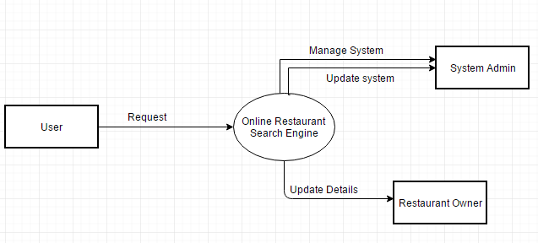

1. **Level 0 Data Flow Diagram**

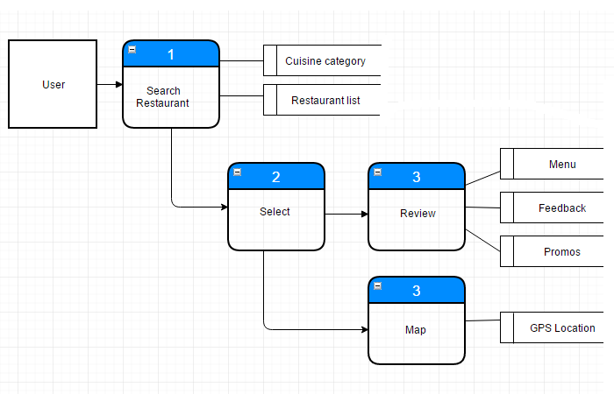

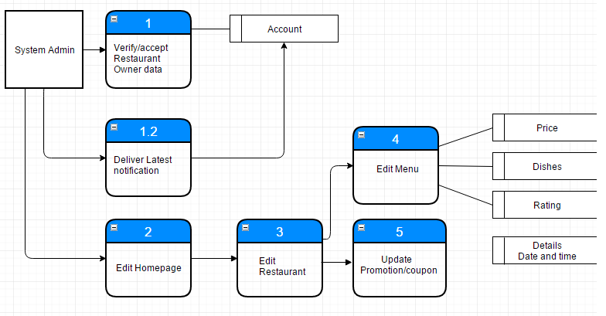

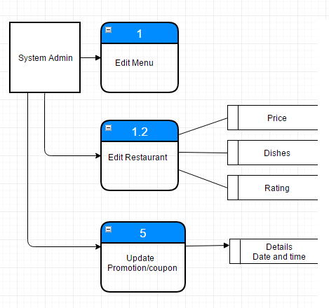

**B.**        **UML Diagrams**

**Activity Diagram**

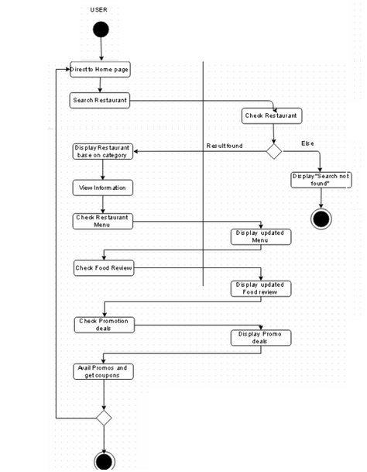

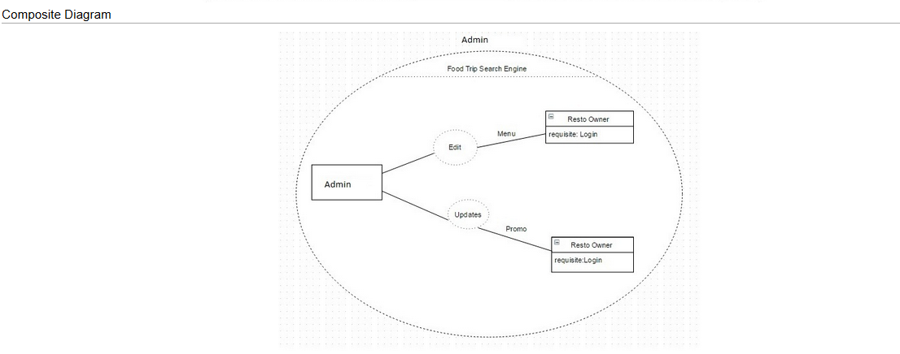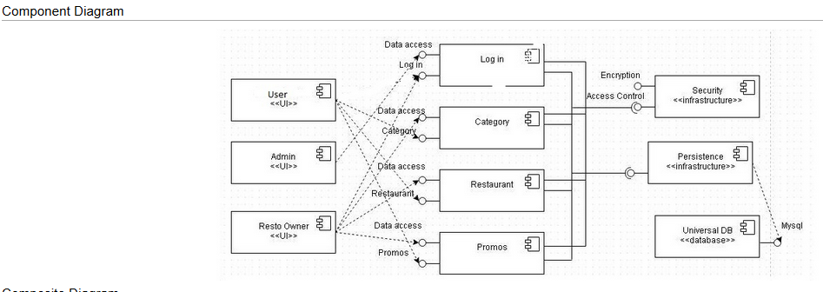

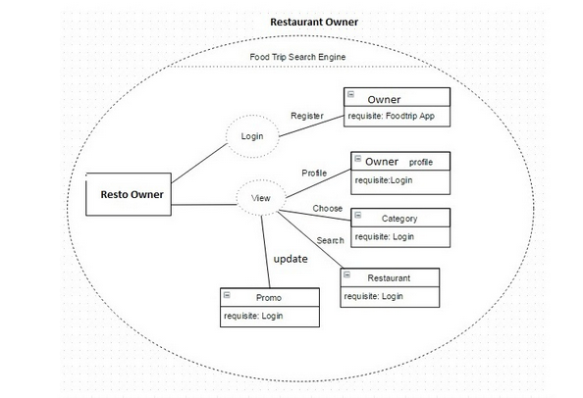

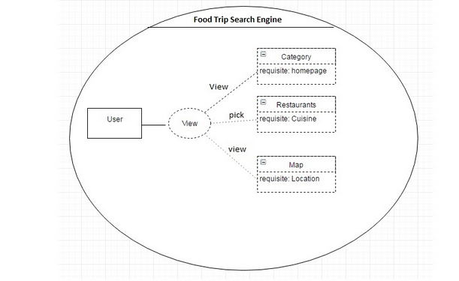

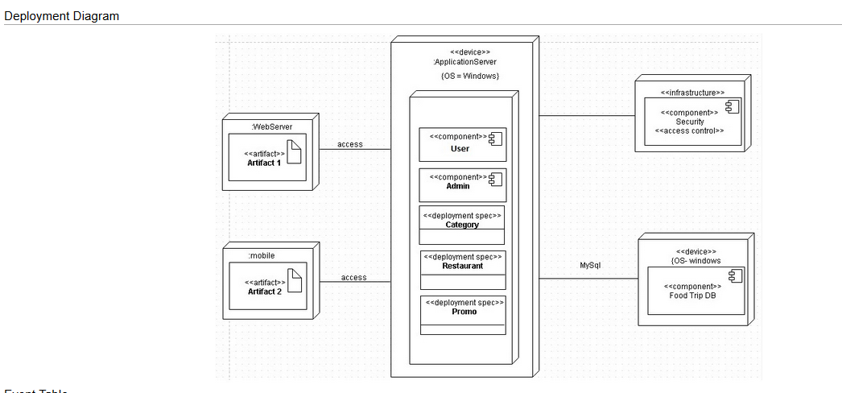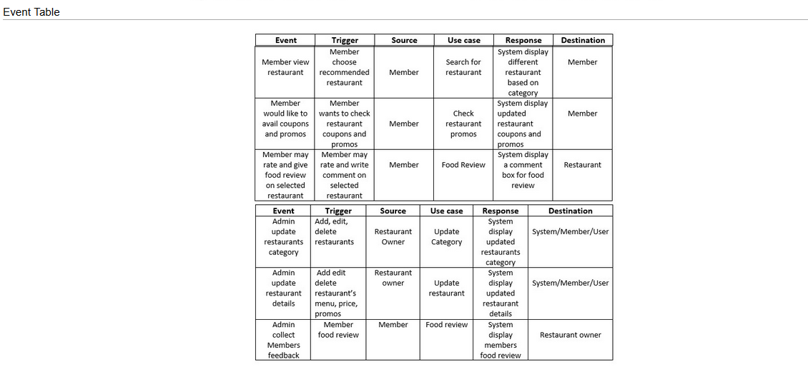

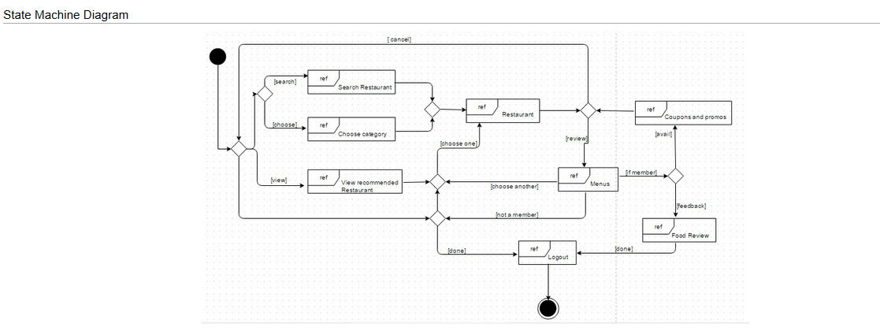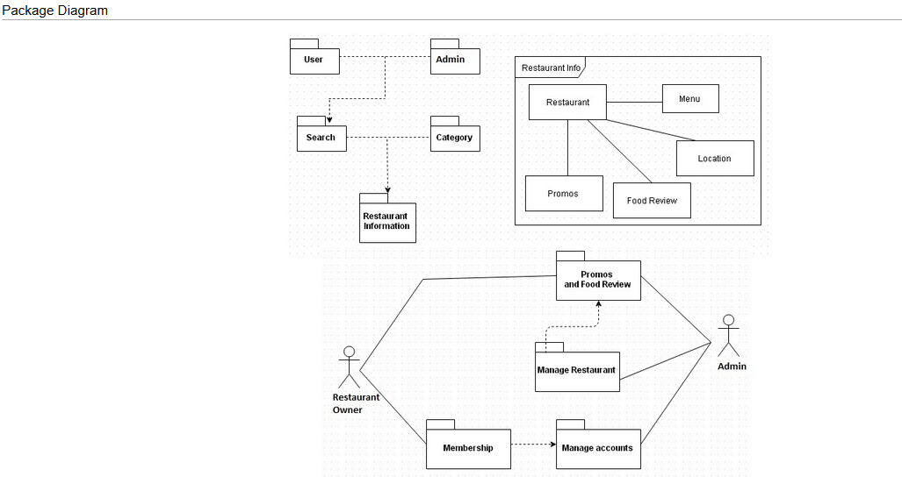

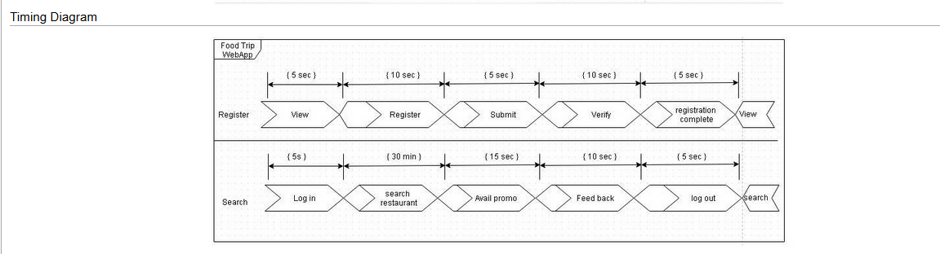

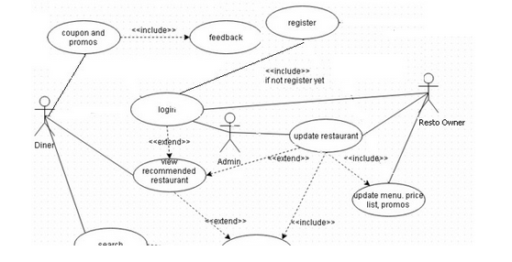Use Case Diagram

**C.**        **Entity – Relationship Diagram**

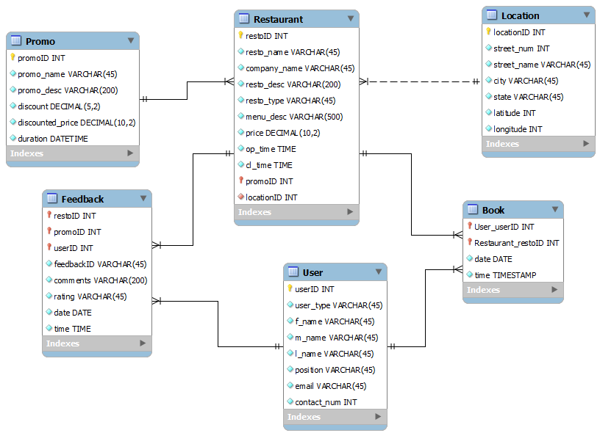

**D.**       **Data Dictionary**

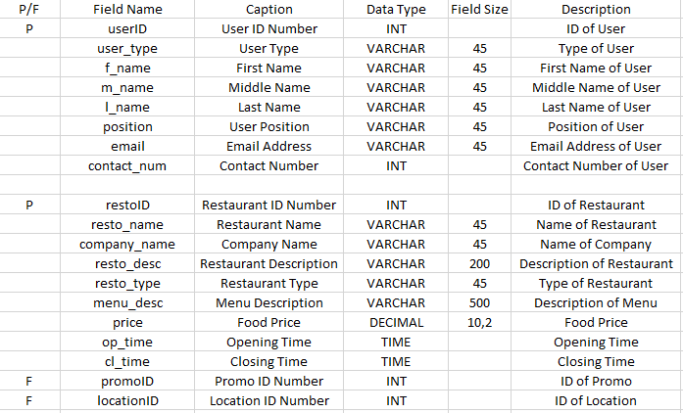

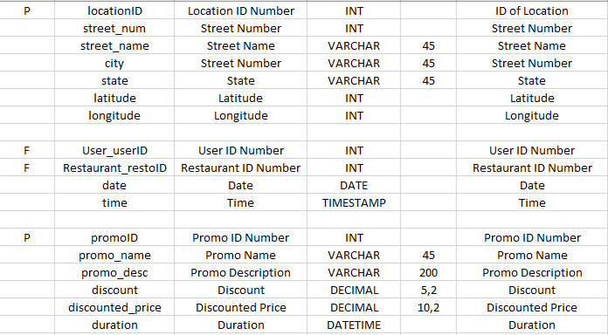

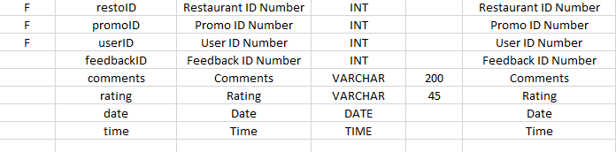

**E.**       **Screenshots**

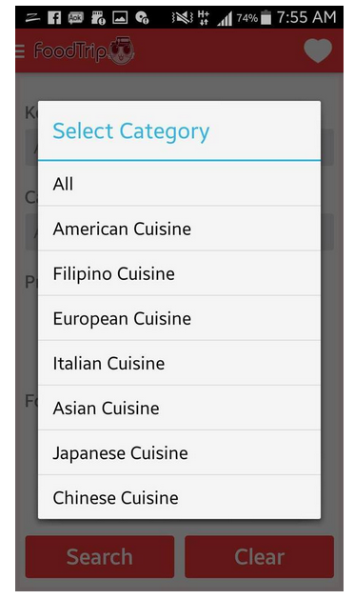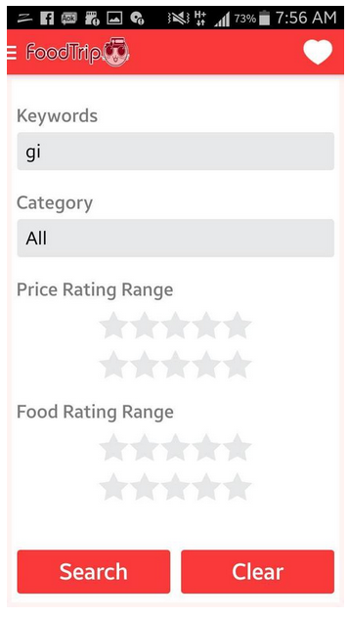

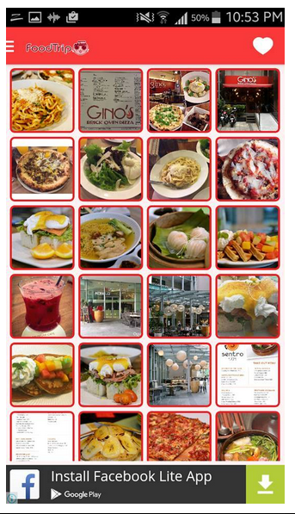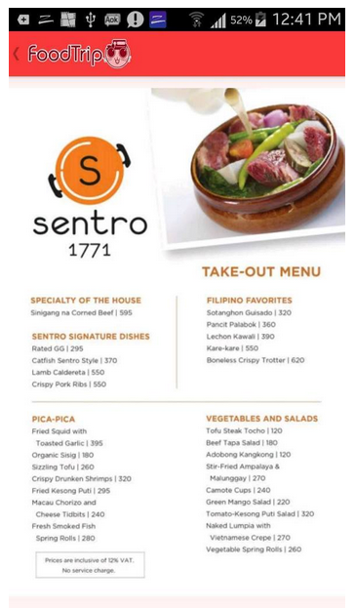

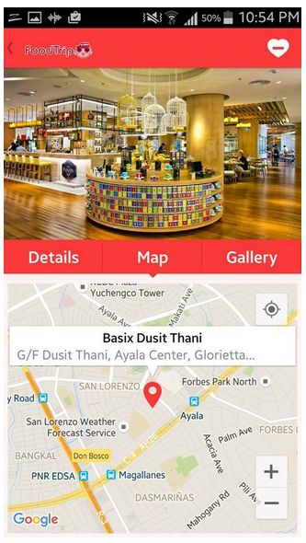

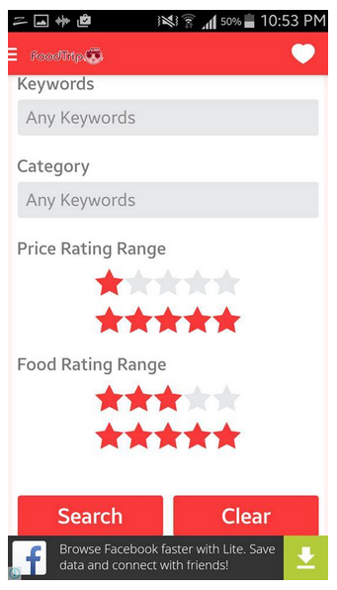

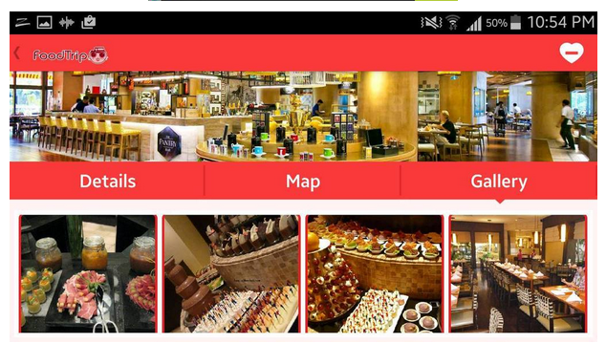

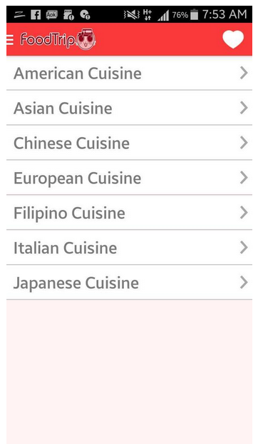

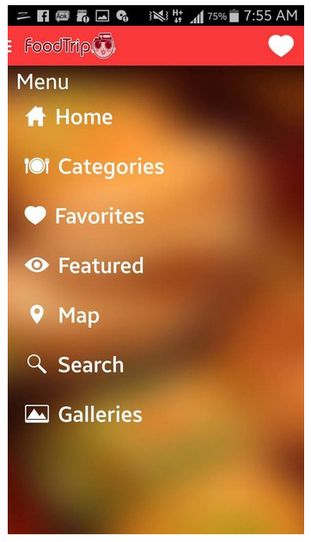

**F.**        **Lessons Learned**

We do believe that whenever a problem arises, we must act and think simultaneously to ensure that we won’t be wasting time in certain situations. Focus and determination is a must when it comes to problem solving since it is already proven that calm and focused ones produce more effective and efficient results than those of the ones who are tense and cannot think straight.

**III.**           **Appendices**