****

**Golden Cup**

Project Document Submitted

To the faculty of School of Computing and Information Technologies of

**ASIA PACIFIC COLLEGE**

Business Case

**Cuasay, Amiel Kristian Magnaye, Corinne T.**

School of Computing and          School of Computing and

Information Technologies          Information Technologies

  Asia Pacific College Asia Pacific College

   Makati, Philippines Makati, Philippines

[amcuasay04@gmail.com](mailto:amcuasay04@gmail.com)           [cmagnaye85@gmail.com](mailto:cmagnaye85@gmail.com)

**Embrador, Ronel Bandong, Mary Allyson**

School of Computing and School of Computing and

       Information Technologies Information Technologies

Asia Pacific College    Asia Pacific College

Makati, Philippines     Makati, Philippines

     ronelembrador@gmail.com          allysonbandong17@gmail.com

Contents

[I. Purpose 1](#_Toc469906668)

[II. Project Overview 1](#_Toc469906669)

[III. Objectives of the Proposed System 2](#_Toc469906670)

[IV. Review of Related Software 2](#_Toc469906671)

[V. Organizational Chart 7](#_Toc469906672)

[VI. Roles and Responsibilities 8](#_Toc469906673)

[VII. Cost and Benefits 8](#_Toc469906674)

[VIII. Assumptions & Limitations 9](#_Toc469906675)

[IX. Risk Management 10](#_Toc469906676)

[X. Metrics/Success Factors 11](#_Toc469906677)

[XI. References 12](#_Toc469906678)

[XII. Use Case Diagram 13](#_Toc469906679)

[XIII. Use Case Narrative 13](#_Toc469906680)

[XIV. Context Diagram Level 0 22](#_Toc469906681)

[XV. Data Flow Diagram Level 1 – Customer 23](#_Toc469906682)

[XVI. Data Flow Diagram level 1 – Sales Staff 24](#_Toc469906683)

[XVII. Data Flow Diagram level 1 – Admin 25](#_Toc469906684)

[XIX. Entity Relationship Diagram 27](#_Toc469906685)

[XX. Functional Decomposition Diagram 28](#_Toc469906686)

[XXI. Sequence Diagram 28](#_Toc469906687)

[XXII. State Transition Diagram 30](#_Toc469906688)

[XXIII. Package Diagram 32](#_Toc469906689)

[XXIV. Component Diagram 33](#_Toc469906690)

[XXV. Deployment Diagram 33](#_Toc469906691)

[XXVI. Activity Diagram 34](#_Toc469906692)

[XVII. Screen Layout 36](#_Toc469906693)

# **Purpose**

This paper will provide a solution onto Golden Cup Exim Marketing Corporation regarding

web based ordering system and explain thoroughly the proposed solution which is to develop

an automated and dynamic version. The team will present a dynamic based ordering system

that the intent is easy navigation, automatically update and display prices of each product.

# **Project Overview**

Golden Cup is an established company formed since 1987 with years of experience in sales, rentals, and services of reconditioned and brand new copier machines. The company aim is “to provide efficient and affordable copier machines” to customers.

The main problem of Golden Cup is the existing web-based ordering system, it is Time-consuming, the website is hard to navigate, customer could not see up to date prices, the website is not automated.

Basically, The Team proposed a solution to developed a new version of web based ordering system wherein the system will be having two actors the Customer and the Admin. For Customer, the system will provide an ordering system similarly on Amazon ordering process particularly in – Account Authentication, Add to Cart process, and payment option. For Admin, the system will also provide an Account Authentication, Updating Products and Prices, and Tracking Sales and Inventory. In these proposed solutions concept the ordering process will be more easily, synchronized and understandable by our valued customers.

Thus, the Golden Cup will now be having a separate account for Customer, Admin, and Sales staff that helps the company to monitor each order and inventory. The customer can now browse the website with updated prices on every item. The new version of web based ordering system will offer a real-time ordering process and each process is easy to navigate. Therefore, this new version of web based ordering system will make the business process detailed and easier for all customers.

# **Objectives of the Proposed System**

**General Objectives**

    To developed an automated and dynamic ordering system for Golden Cup Exim Marketing

Corporation.

**Specific Objectives**

* To developed a user interface website that the intent is easy navigation.
* To developed the website by changing it from static to dynamic.
* To automatically display prices of each product and customer's orders.
* To create an automated ordering system to supplement their current call and walk in process.

# **Review of Related Software**

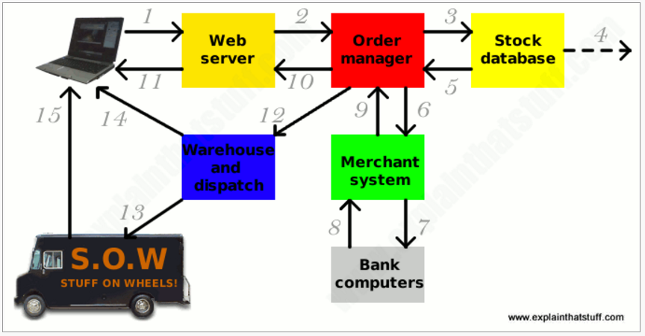

*Amazon.com: the world's most successful e-shop. Originally just a bookstore, now it sells almost anything you can imagine. It even allows third-party vendors to sell products alongside its own offerings with something called Amazon Marketplace. Amazon has consistently set the standard for online retailers with pioneering features like one-click shopping.*

**Amazon ordering Process**

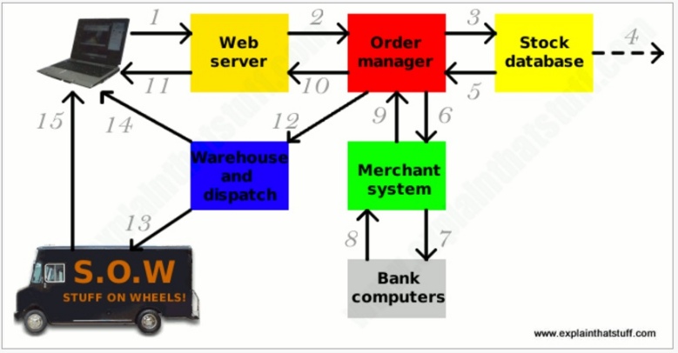

Here's one example of how a sophisticated, fully computerized e-commerce system might work. Not all e-commerce systems work in exactly this way:

1. Sitting at her **computer**, a customer tries to order a book online. Her Web browser communicates back-and-forth over the Internet with a Web server that manages the store's website.
2. The **Web server** sends her order to the order manager. This is a central computer that sees orders through every stage of processing from submission to dispatch.
3. The **order manager** queries a database to find out whether what the customer wants is in stock.
4. If the item is not in stock, the **stock database** system can order new supplies from the wholesalers or manufacturers. This might involve communicating with order systems at the manufacturer's HQ to find out estimated supply times while the customer is still sitting at her computer (in other words, in "real time").
5. The stock database confirms whether the item is in stock or suggests an estimated delivery date when supplies will be received from the manufacturer.
6. Assuming the item is in stock, the order manager continues to process it. Next it communicates with a **merchant system** (run by a credit-card processing firm or linked to a bank) to take payment using the customer's credit or debit card number.
7. The merchant system might make extra checks with the customer's own bank computer.
8. The **bank computer** confirms whether the customer has enough funds.
9. The merchant system authorizes the transaction to go ahead, though funds will not be completely transferred until several days later.
10. The order manager confirms that the transaction has been successfully processed and notifies the Web server.
11. The Web server shows the customer a Web page confirming that her order has been processed and the transaction is complete.
12. The order manager sends a request to the warehouse to dispatch the goods to the customer.
13. A truck from a dispatch firm collects the goods from the warehouse and delivers them.
14. Once the goods have been dispatched, the warehouse computer e-mails the customer to confirm that her goods are on their way.
15. The goods are delivered to the customer These things are invisible—"virtual"—to the customer except the computer she sits at and the dispatch truck that arrives at her door.

Basically, Amazon is the chosen website to use as basis for ordering process of the Golden Cup particularly in:

* **Sign in Page**

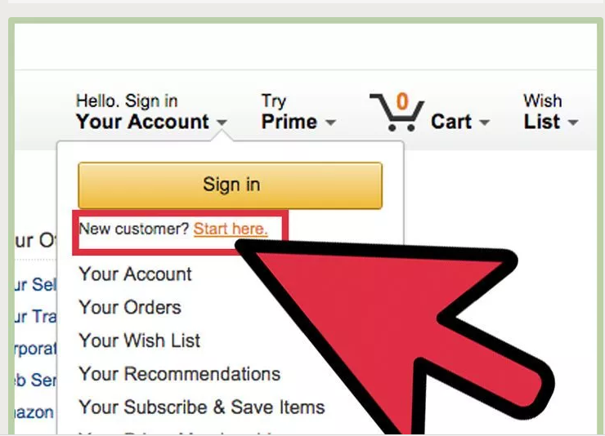

The new proposed web based ordering system customer need to have a verified account for login. Otherwise, customer could not place an order and they can only canvas the products and accessories page.

* **Shop by Department**

**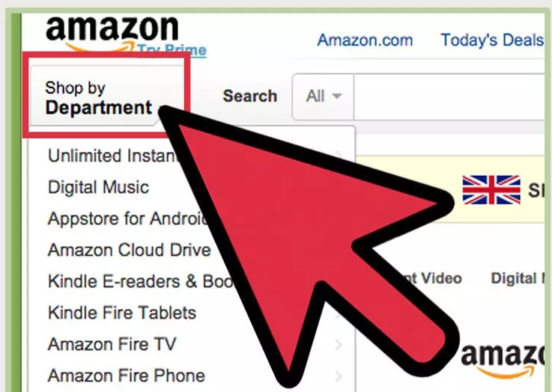**

The new proposed web based ordering system allow the customer to browse the categories neither your login or not on the other hand, Amazon has shop by Department options and can browse items even though the customer is not login.

* **Add and View Cart**

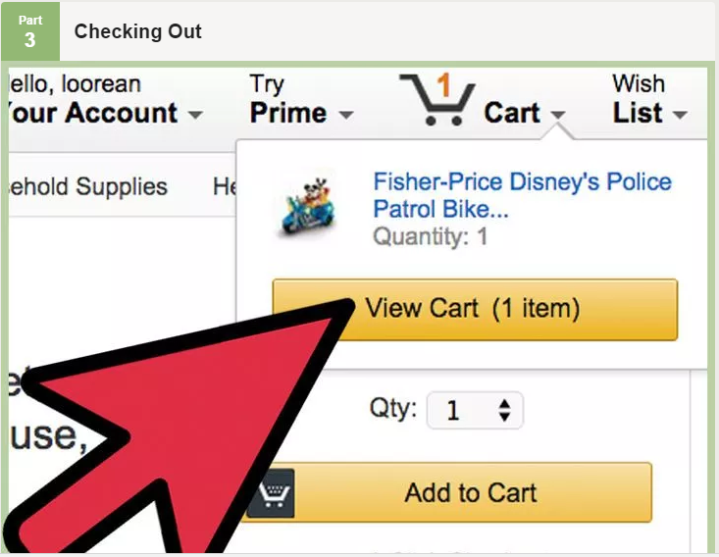

The new proposed web based ordering system has a view and add to cart features similarly to Amazon wherein the system will put and show all the items that customer bought.

# **Organizational Chart**

**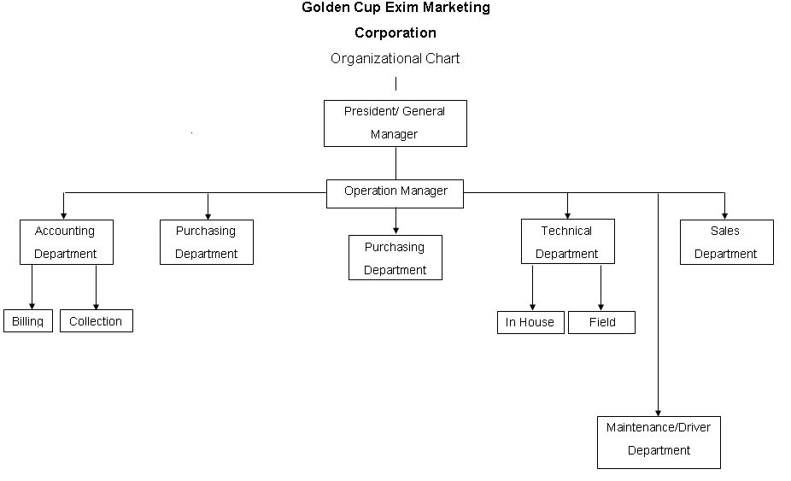**

# **Roles and Responsibilities**

|  |  |  |  |
| --- | --- | --- | --- |
| Group Member | Roles | Qualifications | Responsibilities |
| Amiel Cuasay | Project Manager/ Programmer | Knowledgeable in Ruby, Java, Php, HTML | * Has the overall responsibility for the monitoring, controlling and closure of the project. |
| Allyson Bandong | System Analyst / Project Documenter | Knowledgeable in Ruby, Java, Php, HTML | * Responsible for the diagrams that are needed to comply. |
| Coreen Magnaye | System Analyst / Project Documenter | Knowledgeable in, Java, Php, HTML | * Responsible for the diagrams that are needed to comply. |
| Ronel Embrador | Programmer | Knowledgeable in Java, Php, HTML | * Responsible for the development of the proposed system |

# **Cost and Benefits**

**Benefits**

**Company Side**

* Since there is a database to track customers they can identify loyal customers.
* They can also identify best seller products through customer orders.

**Customer Side**

* System will lessen instances where sales staff are on the phone making them more cost efficient in their duties for the company

**Costs**

* **Labor Costs**

Project Manager -  P299,369 (per project) = P299,369

System Analyst - P207,473 (per project) X 3 = P622, 419

* **Developmental Costs**

Domain Name Registration – P 174.50 per month

(1pc) Web Server ([1U 140W Low Power Web Host Server Intel Xeon Quad Core 24GB 1TB SATA 14" Depth](http://www.ebay.com/itm/1U-140W-Low-Power-Web-Host-Server-Intel-Xeon-Quad-Core-24GB-1TB-SATA-14-Depth-/152300711870)) – P9797.55

(3pcs) Terminal (HP Pavilion 550-153WB Core i3-4170 Dual-Core 3.7GHz 6GB 1TB W10 PC w/23" Monitor)– P15,189.51 X 3 = P45,568.53

* **Operational Costs**

Employee Training – P10,000 per session

System Maintenance – P 15,000 per month (1pc) Company Internet (64Mbps Unlimited Internet) – P3999 per month

# **Assumptions & Limitations**

**Assumptions**

* All the products in the categories are available and has no factory defects.
* Customers who canvasing and inquiring are interested to avail the products.

**Limitations**

* The system’s security relies on the web host provider.
* The system does not have a mobile version.
* The system relies on the internet access and on the company’s available bandwidth.

# **Risk Management**

|  |  |  |  |  |
| --- | --- | --- | --- | --- |
| *Criteria* | *4 – Highly likely* | *3- Likely* | *2- Unlikely* | *1-Higly Unlikely* |

|  |  |  |  |  |  |  |  |
| --- | --- | --- | --- | --- | --- | --- | --- |
| Risk | Ordinal Scale | Impact | Cost | Category | Description | Mitigation | Contingency |
| MI1 | 3 | Likely | Daily Income of Company \* Number of days |  | Migration of System | Put updated website and system on a separate folder while fixing bugs/errors so the current website won’t go down during migration period | Create a trial WordPress or the like website to test the new website and system on while the website to avoid accidents from happening to the original website |
| CU1 | 2 | Unlikely | None |  | Non-deployment of System | Use XAMPP localhost server to simulate how the website and system will work | Create a trial WordPress or the like website to simulate the website and system on |
| LD1 | 3 | Likely | None in terms of money but it may delay production of system and/or website |  | Client Dissatisfaction on the Layout Design of the New Website | Work on the back-end/system of the website while trying to make a layout design of the website that the client will like | Inquire the client if they have specific requests on how the website should look and what color scheme the website will use before making the design and work on the system on a temporary layout in the meantime |
| WF1 | 2 | Unlikely | Daily Income of Company \* Number of days |  | Failure on prompt payment of website fees such as domain registration and web hosting | Remind client on payment of website fees and keep a backup of the updated website and server files on various devices and/or locations | Make a similar backup of the website on a XAMPP localhost server |

# **Metrics/Success Factors**

**Success Factors:**

* Our Team enhances the Ordering System of Golden Cup Exim Marketing Corporation to be more user-friendly.
* We create an up-to-date Ordering System to Golden Cup.
* Our Team greatly improves the existing Golden Cup website.
* We accomplish all the proposals to our client on time.
* We accomplish all the requirements in our projected system.

# **References**

[1] PayScale Human.Capital (2016). Project Manager, Information Technology (IT) Salary

<http://www.payscale.com/research/PH/Job=Project_Manager,_Information_Technology_(IT)/Salary> [retrieved December 07, 2016]

[2] PayScale Human.Capital (2016). Project Manager, Information Technology (IT) Salary

<http://www.payscale.com/research/PH/Job=Project_Manager,_Information_Technology_(IT)/Salary> [retrieved December 07, 2016]

[3] PayScale Human.Capital (2016). Systems Analyst Salary

<http://www.payscale.com/research/PH/Job=Systems_Analyst/Salary>

[retrieved December 07, 2016]

[4] GoDaddy (1999) Web Hosting

<https://ph.godaddy.com/promos/hot-deals> [retrieved December 07, 2016]

[5] ebay (1995)

<http://www.ebay.com/itm/1U-140W-Low-Power-Web-Host-Server-Intel-Xeon-Quad-Core>

[retrieved December 07, 2016]

[6] Golden Cup (1987) GOLDEN CUP Exim Marketing Corporation *Home of Quality Copiers*

<http://goldencupexim.com.ph/about-us/> [retrieved December 09, 2016]

[7] Walmart (NA) HP Pavilion 550-153 wb Desktop PC with Intel Core i3-4170 Dual-Core Processor, 6GB Memory, 23" Monitor, 1TB Hard Drive and Windows 10 Home

<https://www.walmart.com/ip/HP-Pavilion-550-153wb-Desktop-PC-with-Intel-Core-i3-4170-Dual-Core-Processor-6GB-Memory-23-Monitor-1TB-Hard-Drive-and-Windows-10-Home/46429968#about-item> [retrieved December 10, 2016]

[8] EXPLAINTHATSTUFF! (2008) How e-commerce works.

<http://www.explainthatstuff.com/ecommerce.html> [retrieved December 10, 2016]

# **Use Case Diagram**

# **Use Case Narrative**

**Customer**

|  |  |  |
| --- | --- | --- |
| Name | Place order | |
| Actor | Customer | |
| Description | Before placing an order, the customer must create an account, and the customer must login. | |
| Successful completion | User:   1. Customer clicks on sign up      1. Customer fills up necessary information 2. Customer approves email verification 3. Customer logs in 4. Customer hovers on categories 5. Customer clicks on “Products” 6. Customer chooses a product 7. Customer selects add to cart 8. Customer places an order 9. Extends usecase ‘Edit Order’ | System Response:   * 1. System displays sign up page.   2.1 System will send verification link to customer’s email  4.1 System displays account page  6.1 System displays product catalog  8.1 System displays list of item/s selected. |
| Alternative | 2.1.1 Invalid inputs of data   * + 1. Invalid username or password   6.2 Customer clicks on “Accessories” | |
| Pre-condition | Customer proceeds to sign up page.  Sales staff gets customer id | |
| Post condition | Customer proceed to checkout. | |
| Assumptions | 1. Customer doesn’t have an account. 2. Customer order/s placed on the cart. | |

|  |  |  |
| --- | --- | --- |
| Name | Checkout | |
| Actor | Customer | |
| Description | After placing an order, the customer proceeds to checkout. | |
| Successful  Completion | User:   1. Customer places an order 2. Customer clicks “Checkout” | System Response:   * 1. System displays order details   2.1 System displays checkout page |
| Alternative | 2.1.1 Customer cancels checkout | |
| Pre-condition | Customer placed an order | |
| Post condition | Customer proceeds to payment | |
| Assumptions | 1. Customer’s order is final. | |

|  |  |  |
| --- | --- | --- |
| Name | Payment | |
| Actor | Customer | |
| Description | After placing an order, the customer proceeds to checkout , and the customer proceeds to payment. | |
| Successful  Completion | User:   1. Customer places an order 2. Customer clicks “Checkout” 3. Customer proceeds to payment. 4. Customer chooses preferred method of payment. | System Response:  3.1 System will ask the customer what type of payment. |
| Alternative | * 1. Customer cancels payment. | |
| Pre-condition | Customer has finished checkout phase | |
| Post condition | System will display order details, preferred mode of payment and payment status. | |
| Assumptions | Customer is ready for payment. | |

|  |  |  |
| --- | --- | --- |
| Name | Browse products | |
| Actor | Customer | |
| Description | Customer views categories inside the catalog. | |
| Successful  Completion | User:   1. Customer hovers on categories 2. Customer clicks on “Products” | System Response:  2.1 System displays product catalog |
| Alternative | 2.1.1 Customer selects “ Accessories “   * 1. Customer selects “ About us “   2. Customer selects “ Log in “   3. Customer selects “ Sign up “ | |
| Pre-condition | Customer must be inside the homepage. | |
| Post condition | Customer proceeds to log in/ sign up | |
| Assumptions | Customer chose a product | |

|  |  |  |
| --- | --- | --- |
| Name | Create an account | |
| Actor | Customer | |
| Description | Before ordering, the customer must create an account. | |
| Successful  Completion | User:   1. The customer selects the option to create an account 2. The customer enters their username , email address and password | System Response:   * 1. System displays the “Create an account”page. |
| Alternative | 2.1 Invalid email address or taken.  2.2 Username is taken  2.3 Password is too short  2.4 Required input is missing  2.5 Password and confirm password doesn’t match. | |
| Pre-condition | Customer clicks create an account button | |

|  |  |  |
| --- | --- | --- |
| Name | Login account | |
| Actor | Customer | |
| Description | Before logging in, the customer must create an account. | |
| Successful  Completion | User:   1. Customer proceeds to log in 2. Customer enters username and password | System Response:   * 1. System displays the “ login” page. |
| Alternative | * 1. Either username or password or both is invalid.   2. Customer forgot his/her password and needs to click the “Forgot your password” link. | |
| Pre-condition | Customer must click “login” button. | |
| Post condition | System will redirect customer to their account page. | |
| Assumptions | Customer has registered account. | |

|  |  |  |
| --- | --- | --- |
| Name | View Order | |
| Actor | Sales Staff | |
| Description | Sales Staff views order of customer | |
| Successful  Completion | User:   1. Sales Staff logs in 2. Sales staff enters his/her username and password 3. Sales Staff clicks on view orders button 4. Sales staff processes the order one by one. | System Response:  1.1 System displays “System login” page   * 1. System displays list of orders sorted by most recent |
| Alternative | * 1. Either username or password or both is invalid.   2.2 Sales staff forgot his/her password and needs to click the “Forgot your password” link.  3.1 Customer cancels order | |
| Pre-condition | Sales Staff must have a registered account in the system. | |
| Post condition | System will update and display the details processed by the sales staff | |
| Assumptions | Sales Staff has an account, Product that has been ordered by the customer is available | |

|  |  |  |
| --- | --- | --- |
| Name | Update Inventory | |
| Actor | Admin | |
| Description | Admin checks for inventory to be able to check product availability, admin can also edit the inventory. | |
| Successful  Completion | User:   1. Admin enters his/her username and password 2. Admin selects “Update inventory” 3. Admin inserts image/s or description in the product details 4. Admin selects “Save Changes” | System Response:   * 1. System will display “Administrator panel”   2.1 System displays the list of products  4.1 System displays updated inventory page |
| Alternative | 1.2 Admin’s username or password is invalid.   * 1. Admin selects “Sales record”   2. Admin edits product quantity | |
| Pre-condition | Admin must have an appropriate username and password.  Admin must log in. | |
| Post condition | System displays updated inventory | |
| Assumptions | Admin has an account. | |

|  |  |  |
| --- | --- | --- |
| Name | Edit order | |
| Actor | Customer | |
| Description | Before the customer proceeeds to checkout, the customer decided to edit his/her order. | |
| Successful  Completion | User:   1. Customer clicks on log in 2. Customer hovers on categories 3. Customer clicks on “Products” 4. Customer chooses a product 5. Customer selects add to cart 6. Customer places an order 7. Customer selects “Edit Order” | System Response:  1.1 System displays log in page    3.1 System displays product catalog.   * 1. System displays list of item/s selected.   7.1 System displays edit order page. |
| Alternative | 1.1 Either username and password is invalid  7.1 Customer proceeds to checkout | |
| Pre-condition | Customer logs in | |
| Post condition | System will display customer’s updated order | |
| Assumptions | Customer must have an order  Customer has an account | |

|  |  |  |
| --- | --- | --- |
| Name | Manage Call/Walk-in | |
| Actor | Sales staff | |
| Description | This Usecase describes when a customer chose to order through call or walk-in. | |
| Successful  Completion | User:   1. Sales Staff logs in 2. Sales staff enters his/her username and password 3. Sales staff clicks on “Call/walk-in” button 4. Extends ‘Process order’ 5. Includes ‘Finalize details’ | System Response:  1.1 System displays “System login” page    3.1 System displays “Call/walk-in” page |
| Alternative | * 1. Either username and password is invalid   3.2 Sales staff clicks on “View orders” | |
| Pre-condition | A customer calls or walks-in the store | |
| Post condition | Sales staff chooses between finalize details and process order | |
| Assumptions | Customer already has specific functions that they’re looking for | |

|  |  |  |
| --- | --- | --- |
| Name | Process order | |
| Actor | Sales staff | |
| Description | This usecase describes when the customer already has a specific functions that they’re looking for and found a satisfactory product to buy | |
| Successful  Completion | User:   1. Sales Staff logs in 2. Sales staff enters his/her username and password 3. Sales staff clicks on “Call/walk-in” button 4. Sales staff clicks “Process order” 5. Sales staff fills in customer details ,their order and payment option 6. Sales staff confirms customer’s order | System Response:  1.1 System displays “System login” page    4.1 System displays “Process order” page |
| Alternative | 2.1 Either username and password is invalid  6.1 Customer cancels their order | |
| Pre-condition | Customer calls/walks-in the store | |
| Post condition | Sales staff returns to view order | |
| Assumptions | Customer already has a specific product that they’re planning to buy | |

|  |  |  |
| --- | --- | --- |
| Name | Finalize details | |
| Actor | Sales staff | |
| Description | This usecase describes when sales staff processes details of customer who call or walk-in to canvas. | |
| Successful  Completion | User:  1. Sales Staff logs in   1. Sales staff enters his/her username and password 2. Sales staff clicks on “Call/walk-in” button 3. Sales staff clicks “Finalize details” 4. Sales staff registers customer account using their details | System Response:  1.1 System displays “System login” page  3.1 Sysetm displays “Call/walk-in” page  4.1 System displays “Finalize details” page |
| Alternative | 2.1 Either username and password is invalid | |
| Pre-condition | Customer calls/walks-in the store | |
| Post condition | Sales staff has created an account for unregistered customer as basis for their inquiry | |
| Assumptions | Customer doesn’t have an account  Customer is performing an inquiry | |

# **Context Diagram Level 0**

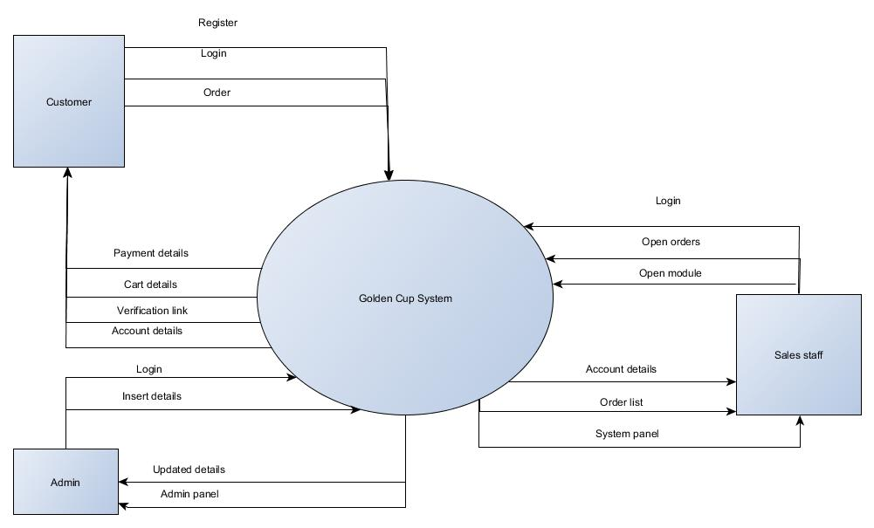

# **Data Flow Diagram Level 1 – Customer**

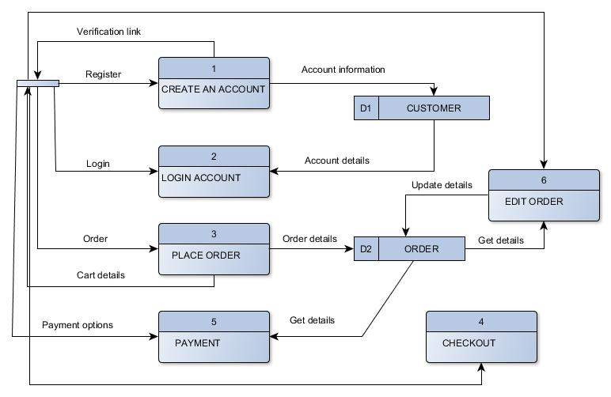

# **Data Flow Diagram level 1 – Sales Staff**

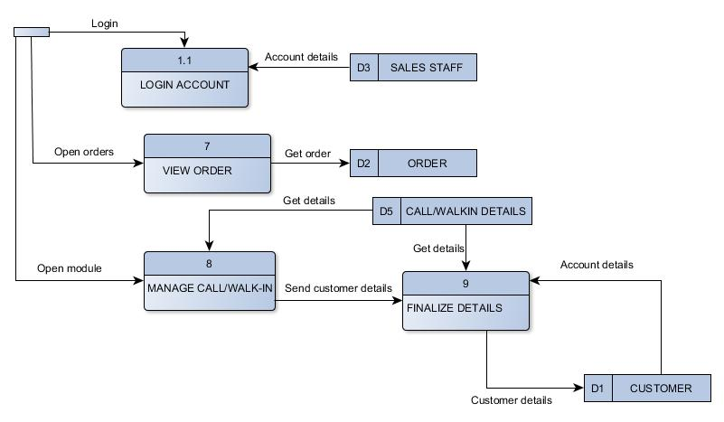

# **Data Flow Diagram level 1 – Admin**

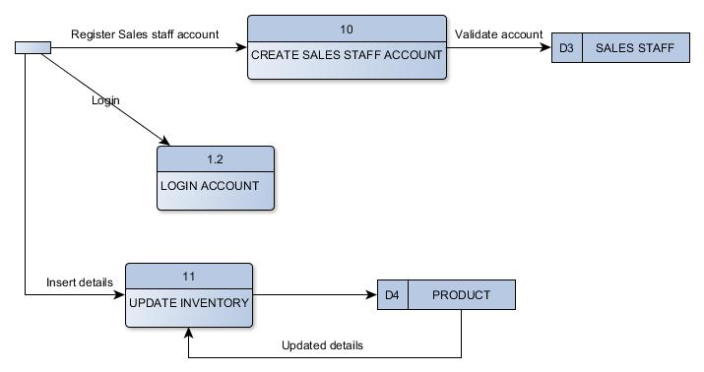

1. **Object Diagram**

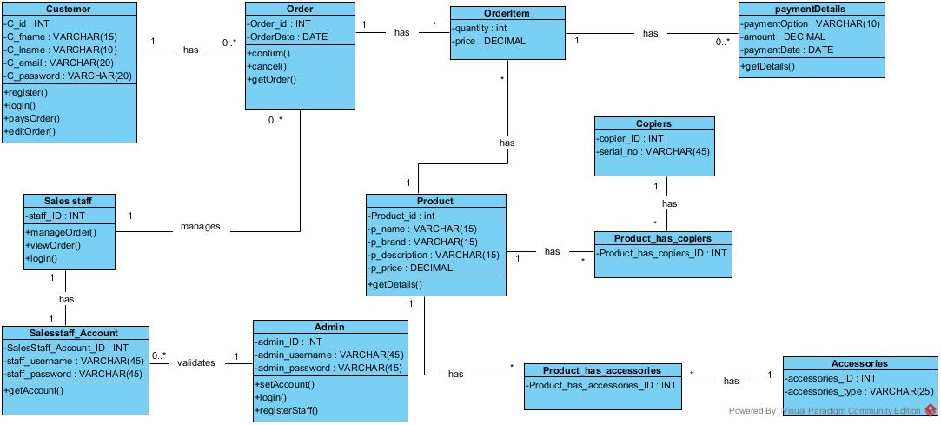

# C:\Users\Amiel\AppData\Local\Microsoft\Windows\INetCacheContent.Word\REVISEDERD7.png**Entity Relationship Diagram**

# C:\Users\Amiel\AppData\Local\Microsoft\Windows\INetCacheContent.Word\fdd.png**Functional Decomposition Diagram**

# **Sequence Diagram**

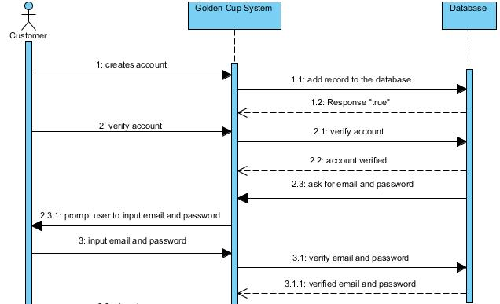

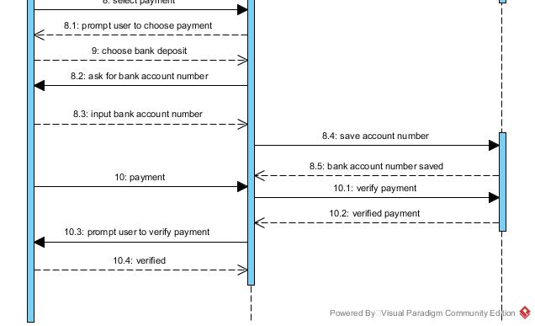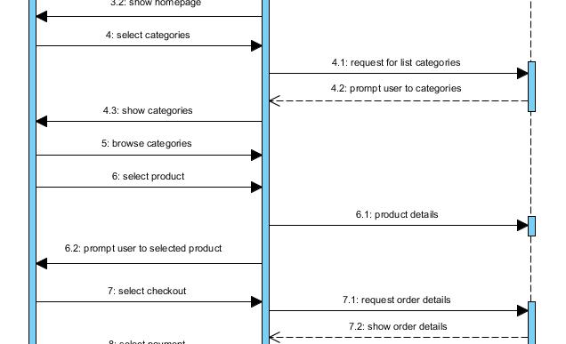

# **State Transition Diagram**

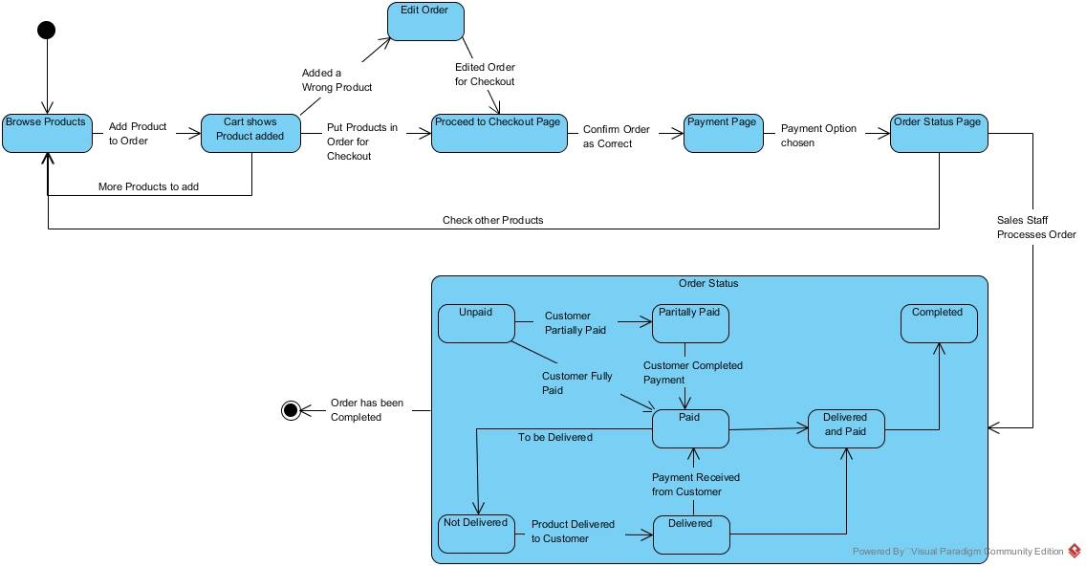

For Sales Staff

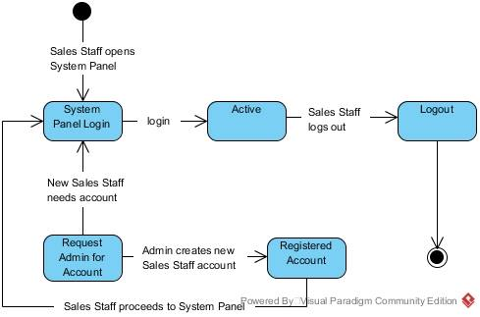

**For Customer**

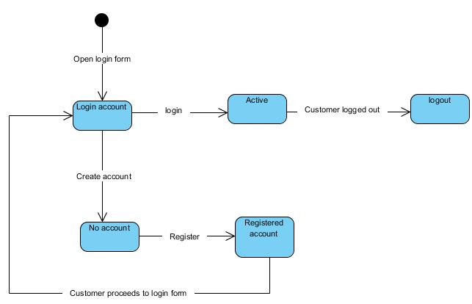

# C:\Users\Amiel\AppData\Local\Microsoft\Windows\INetCacheContent.Word\package.jpg**Package Diagram**

# C:\Users\Amiel\AppData\Local\Microsoft\Windows\INetCacheContent.Word\componentDiagram1.jpg**Component Diagram**

# **Deployment Diagram**

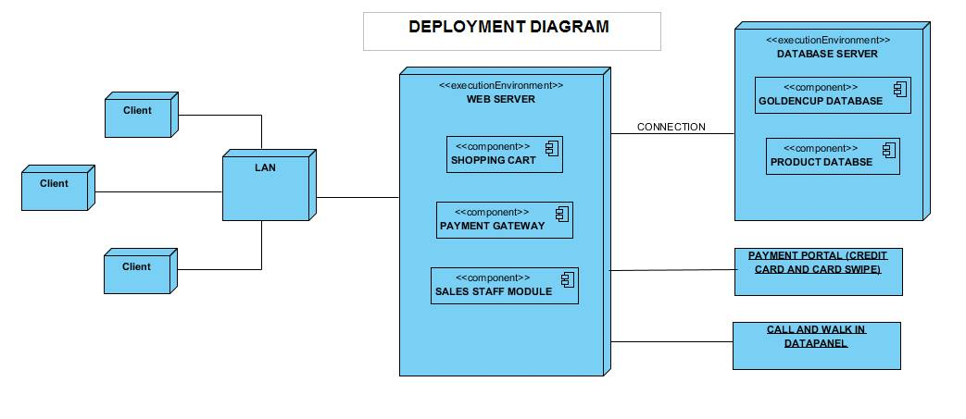

# C:\Users\Amiel\AppData\Local\Microsoft\Windows\INetCacheContent.Word\received_10211109344594727.jpeg**Activity Diagram**

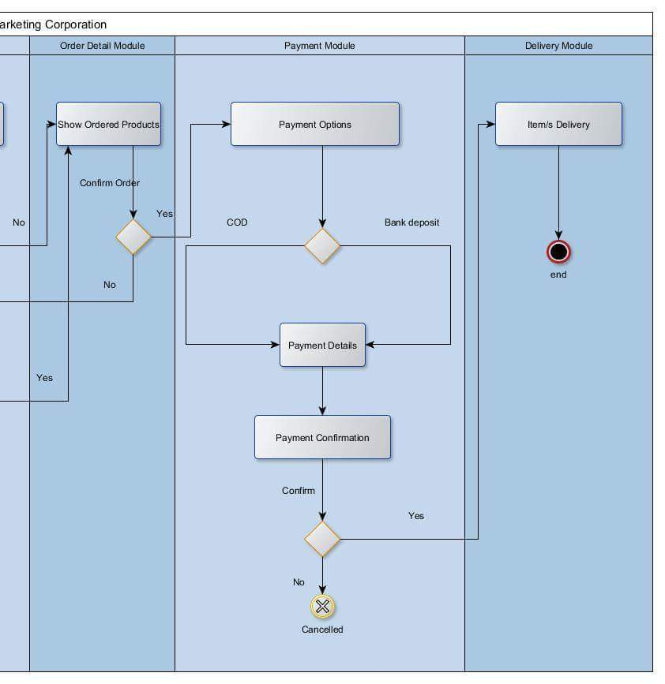

# **Screen Layout**