Adriano, Patrick Cedie P.

BSIT-MI

SYSADD1 – CSIT01

Step 1: Download and install Git and TortoiseSVN

Step 2: Once installed, go to your GitHub Repository. In my case it is “seans888/Grade-Archive”

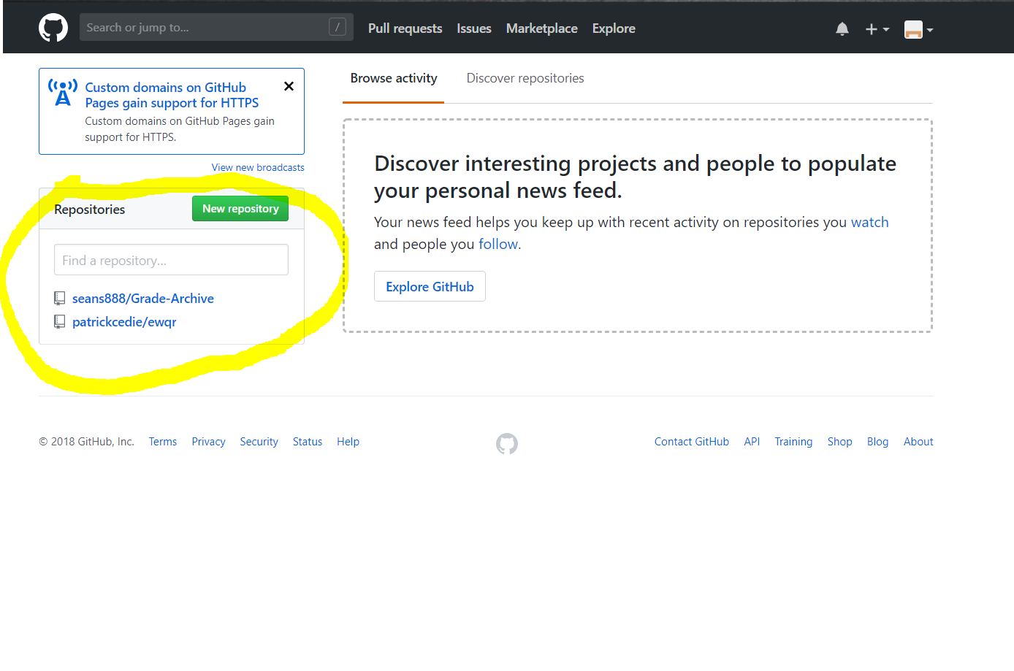

Step 3: After choosing your repository, click “Clone or download” to clone your repository into your desktop

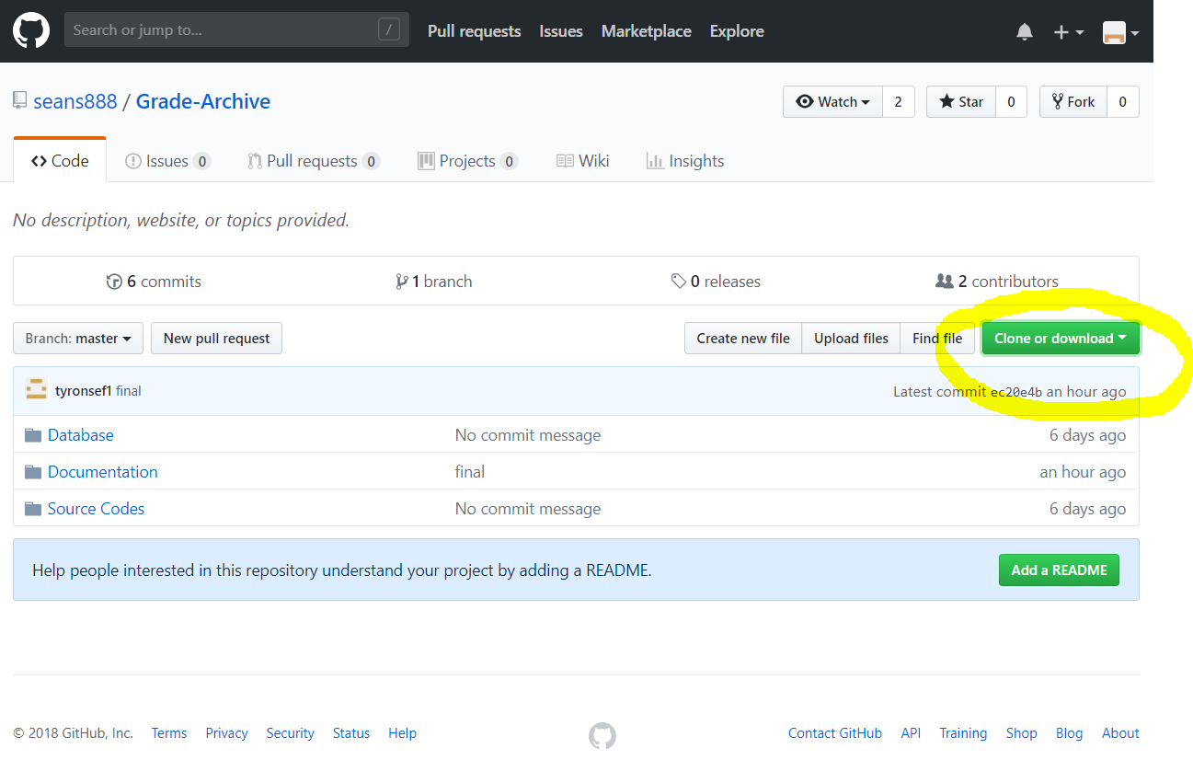

Step 4: Copy the link that is shown after clicking “Clone or download”

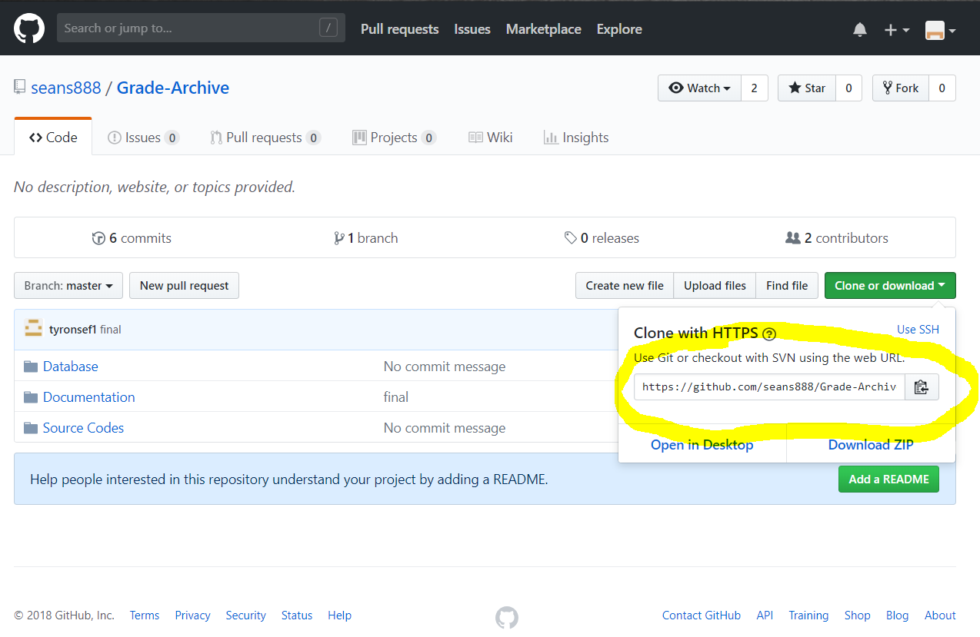Step 5: Go to the folder where you want the repository to be cloned, right click on an empty area and click SVN checkout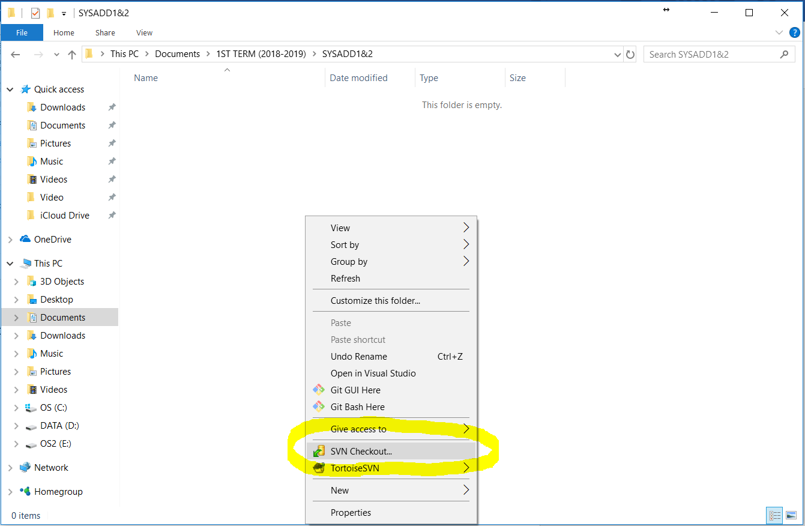

Step 6: Paste the link of the repository that you copied in step 4 and click OK

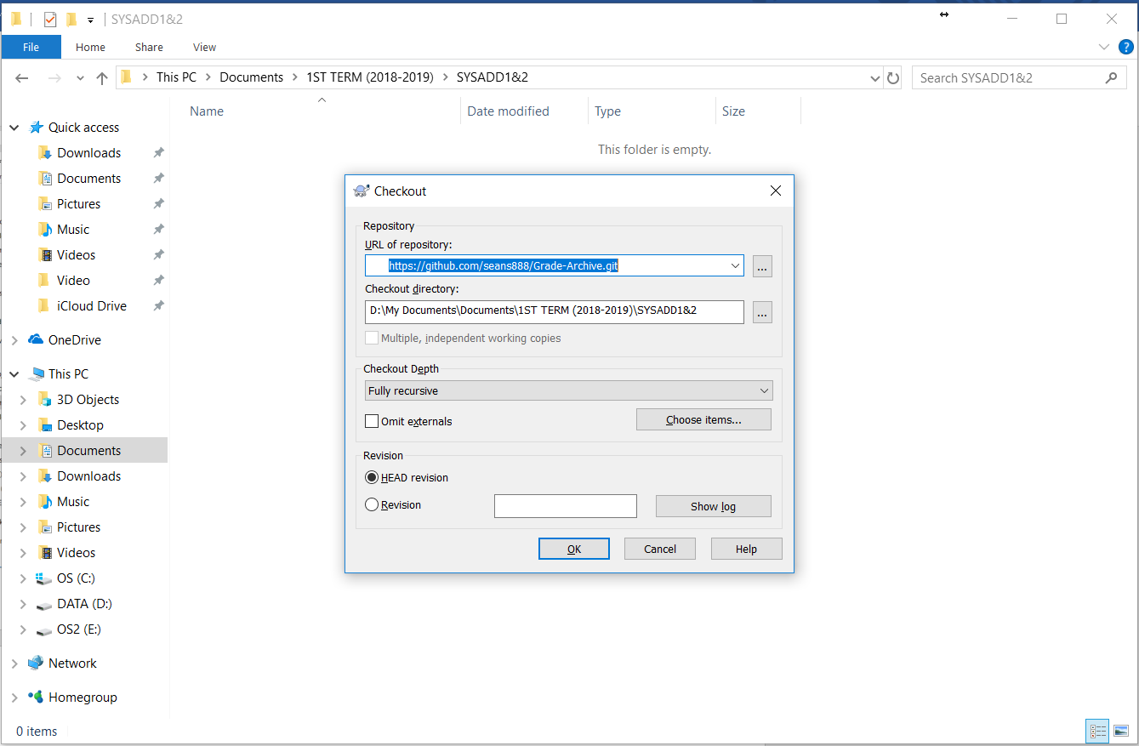

Step 7: Prompt will appear saying adding files, click OK once it is finished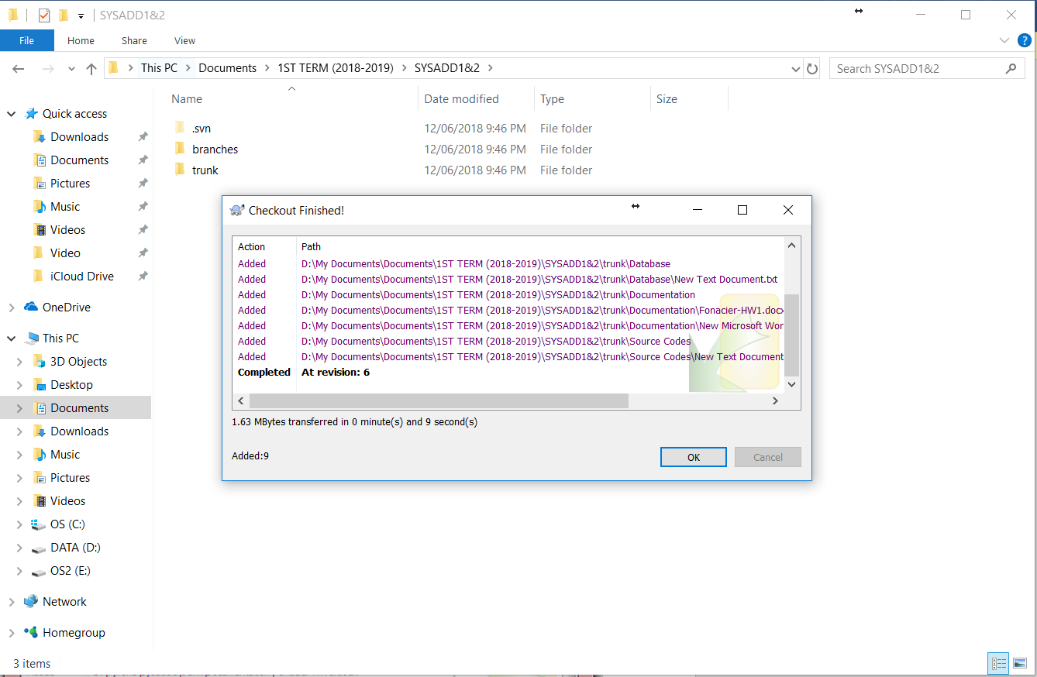

Adding files on your repository from your desktop

Step 1: Go to the directory where you want the file to be saved in your repository. In my case it is in …\trunk\Documentation. Right click on an empty area and click on SVN Commit

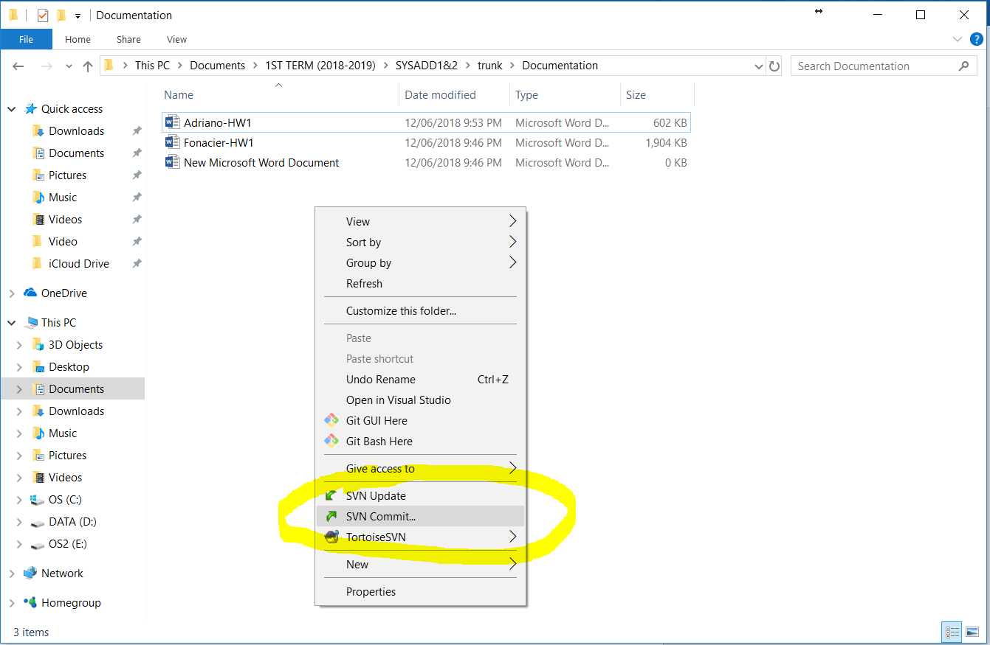

Step 2: Check the file you want to be copied and click OK

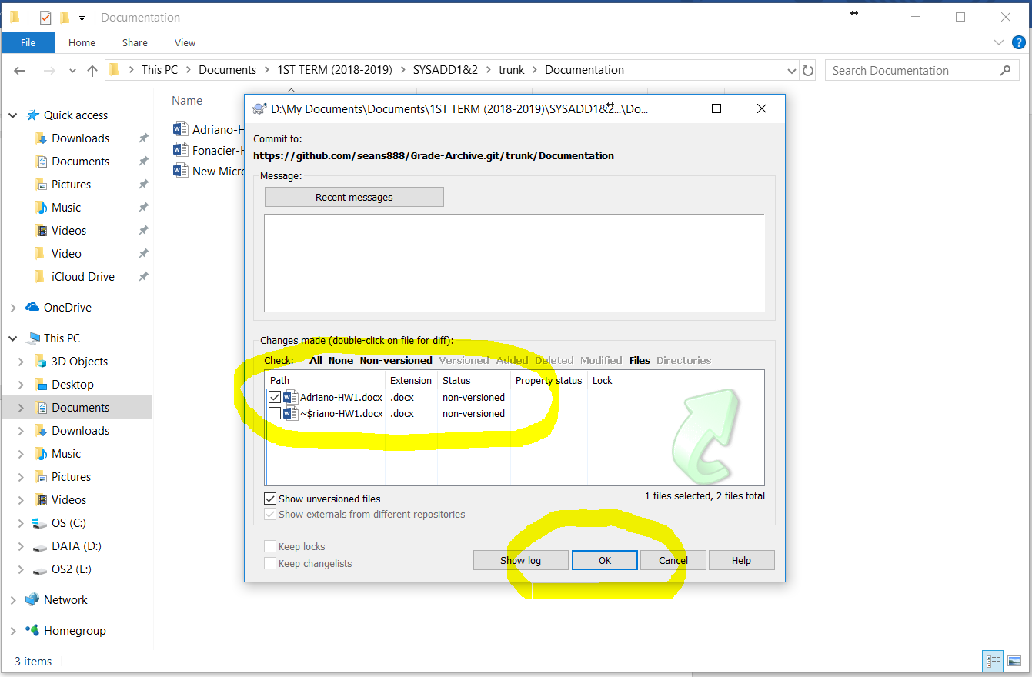

Step 3: Prompt will appear for verification purposes, input your GitHub username and password and press OK

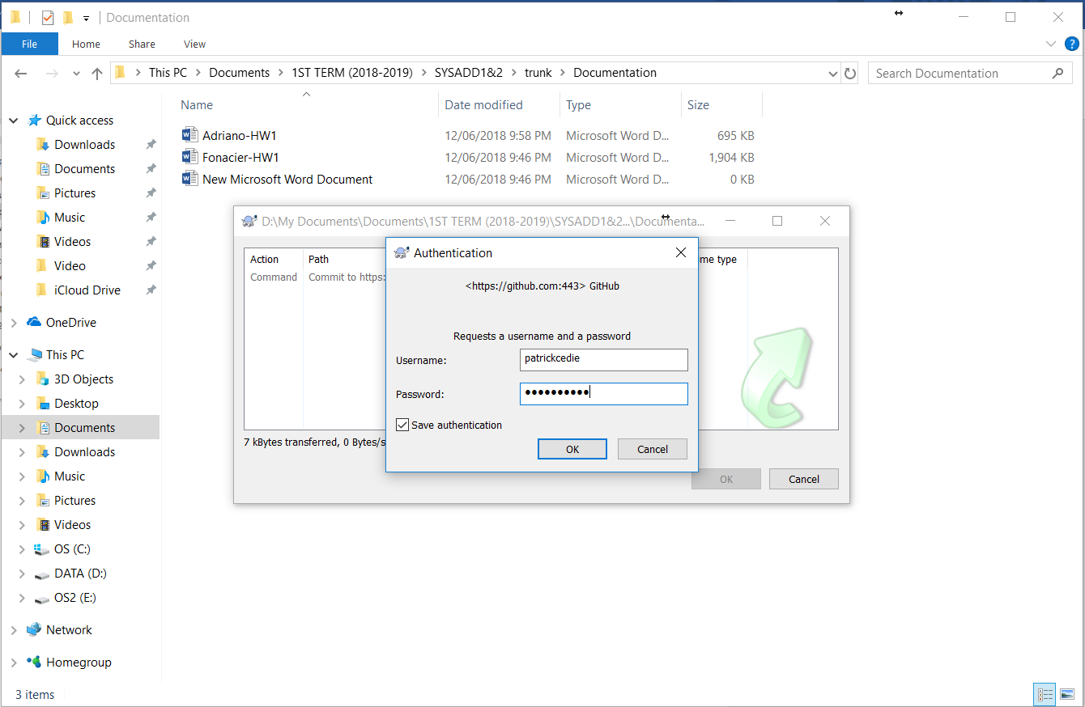

Step 4: If the commit was a success press OK

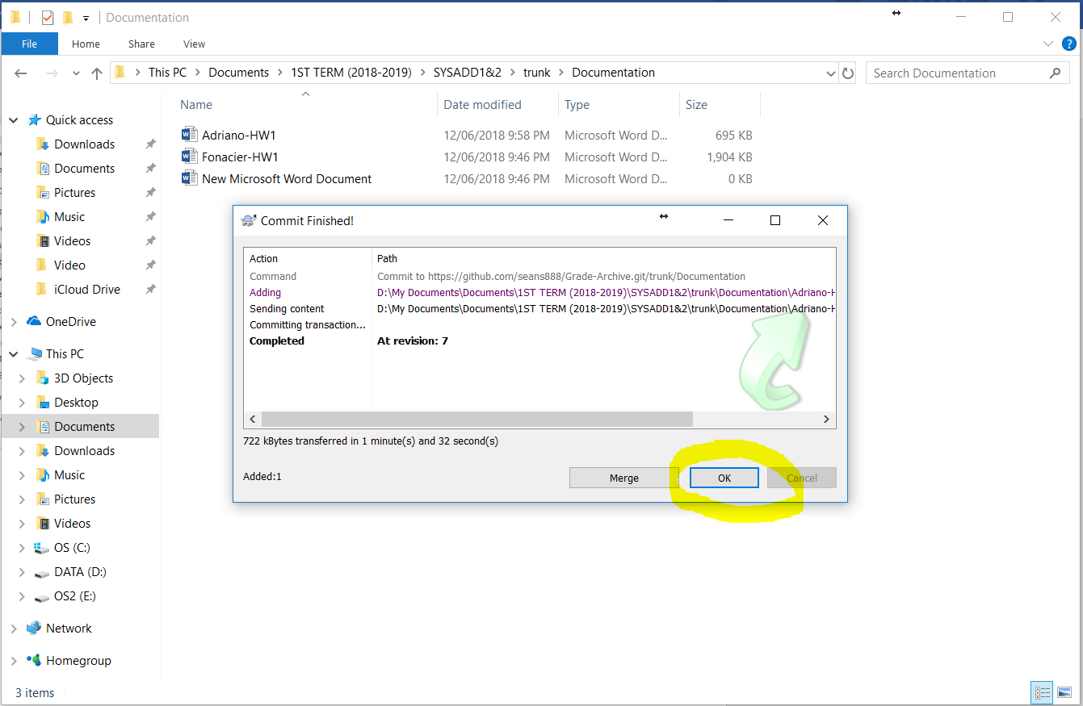

Step 5: Login to your GitHub account and double check if the file you committed is in your repository

