Fonacier, Tyrone Edward B.  
BSCS-SS152  
  
Homework 1 – Sysadd 1

Installing Git 2.13.0 64 bit

Step 1: Download the installer and run it.

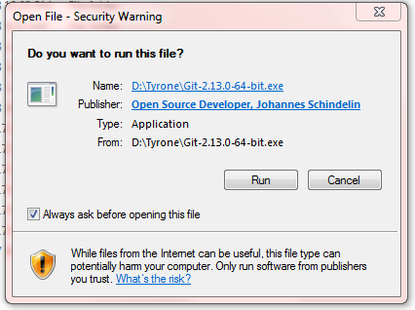

Step 2: Click Next when you are ready to continue with Setup.

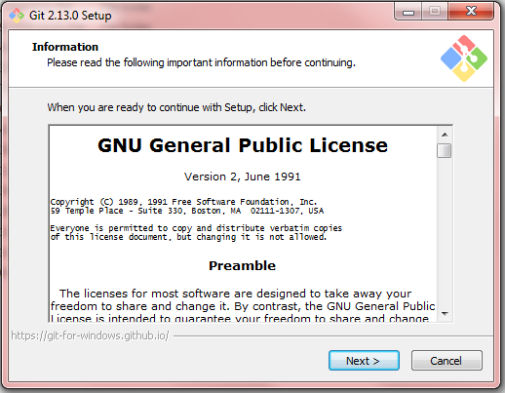

Step 3: Select where you want to install Git. To continue, click Next.

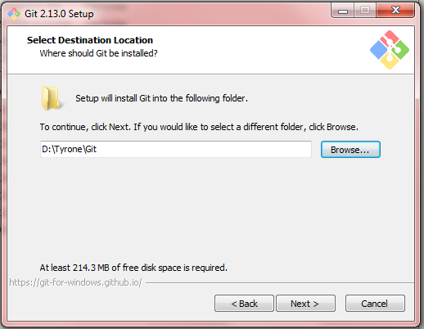

Step 4: Select the components that you want to install and Click Next when you are ready to continue.

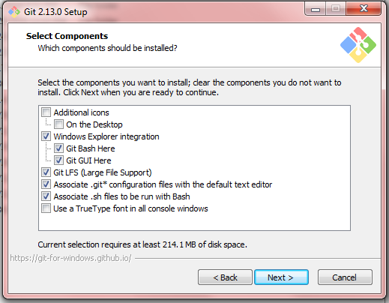

Step 5: To continue, click Next. If you would like to select a different folder, click Browse.

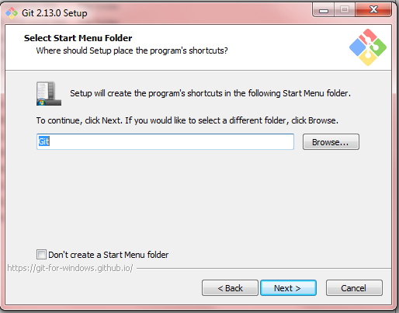

Step 6: Select your PATH environment, then click Next.

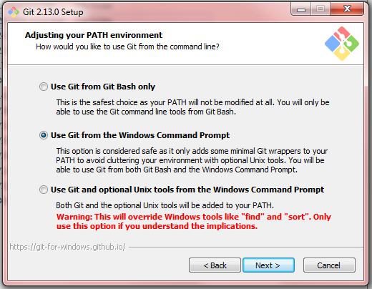

Step 7: Select which SSL/TLS library would you like Git to use for HTTPS connections, then click Next.

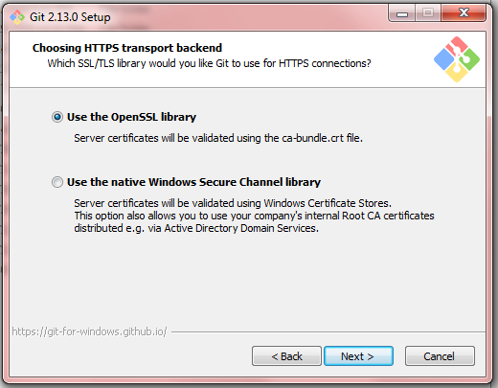

Step 8: Select how you want your Git treat line endings in text files, then click Next.

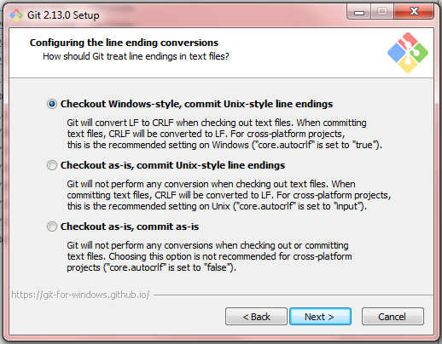

Step 9: Select which terminal emulator you want to use with your Git Bash, then click Next.

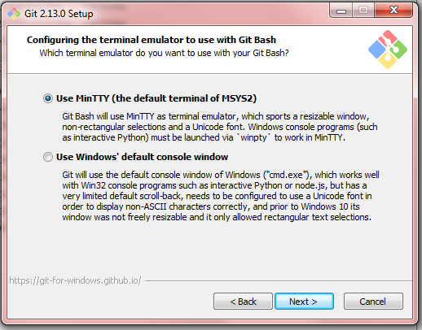

Step 10: Select which features you like to enable, then click Install.

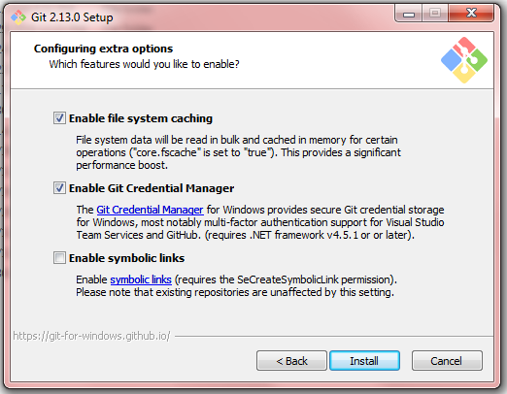

Step 11: Wait while Setup installs git on your computer.

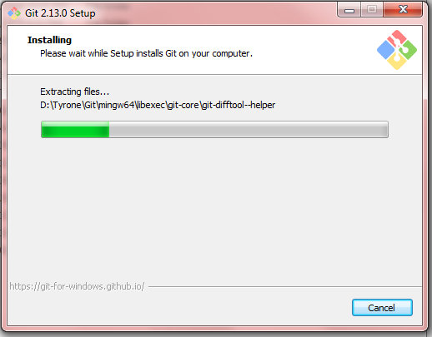

Step 12: Click Finish.

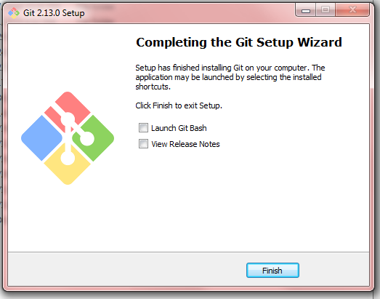

Installing TortoiseSVN-1.9.2.24708 64 bit

Step 1: Download the installer and run it.

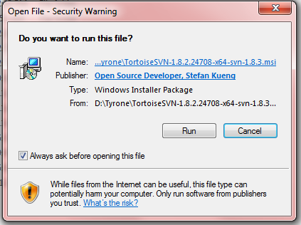

Step 2. Click Next when you are ready to continue with Setup.

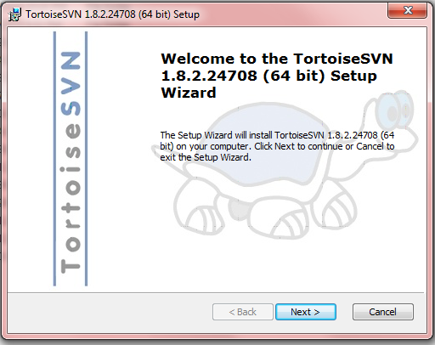

Step 3: Select “I accept the terms in the License Agreement”, then click Next.

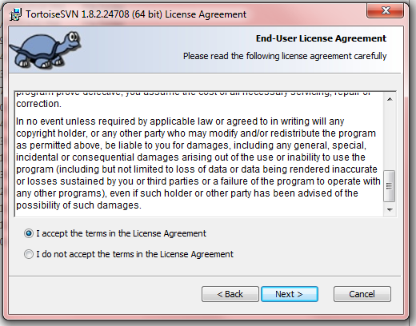

Step 4: Pick an install location and which features you want, then click Next.

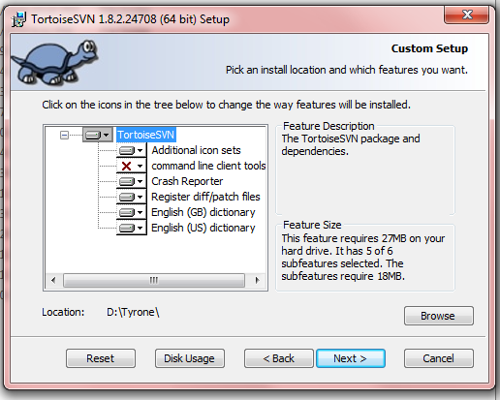

Step 5: Click Install to begin the installation.

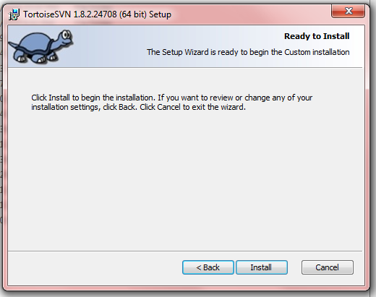

Step 6: Wait while the Setup Wizard installs TortoiseSVN 1.8.2.24708 64 bit

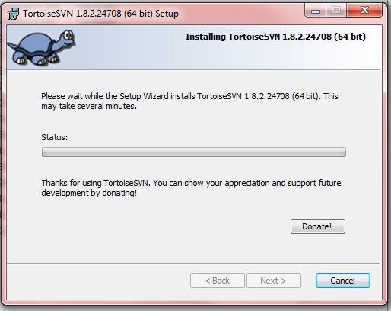

Step 7: Click the Finish button to exit the Setup Wizard.

