# Student Record Management System for Bangkal Elementary School - Main

Project Documentation Submitted

to the Faculty of School of

Computing and Information Technologies

of

Asia Pacific College

In Partial Fulfillment of the Requirements for the Subject

Introduction to Systems Development (INTSDEV)

By

Patrick Cedie P. Adriano

Mark Justine V. Apit

Tyrone Edward B. Fonacier

**ASIA PACIFIC COLLEGE**

# Approval Sheet

Student Record Management System for Bangkal Elementary School - Main

Prepared and Submitted by:

Patrick Cedie P. Adriano

Mark Justine V. Apit

Tyrone Edward B. Fonacier

In Partial Fulfilment of the Requirements for the Degree of

Bachelor of Science in Computer Science with Software Development

Examined and Recommended for Acceptance and Approval for Research/Capstone Presentation

\_\_\_\_\_\_\_\_\_\_\_\_\_\_\_\_\_\_\_\_\_\_\_\_\_\_\_

Adviser

Panel of Judges

\_\_\_\_\_\_\_\_\_\_\_\_\_\_\_\_\_\_\_\_\_\_\_\_\_\_\_

Chairperson

Panel Members

\_\_\_\_\_\_\_\_\_\_\_\_\_\_\_\_\_\_\_\_\_\_\_\_\_\_\_ \_\_\_\_\_\_\_\_\_\_\_\_\_\_\_\_\_\_\_\_\_\_\_\_\_\_\_

Panel Member Panel Member

Acceptance and Approved in partial fulfillment of the requirements for the degree of Bachelor of Science in Computer Science with Software Development

\_\_\_\_\_\_\_\_\_\_\_\_\_\_\_\_\_\_\_\_\_\_\_\_\_\_\_\_\_\_\_

Executive Director

School of Computing and Information Technologies

Table of Contents

[Grade Archive System for Bangkal Main Elementary School with Implementation of AWS 1](#_Toc511962661)

[Approval Sheet 2](#_Toc511962662)

[Abstract 4](#_Toc511962663)

[List of Figures, List of Tables, List of Notations 5](#_Toc511962664)

[I. Introduction 6](#_Toc511962665)

[1.1 Project Context 6](#_Toc511962666)

[1.2 Statement of the Problem 6](#_Toc511962667)

[1.3 Purpose and Description 6](#_Toc511962668)

[1.4 Objectives 7](#_Toc511962669)

[1.5 Scope and Limitations 7](#_Toc511962670)

[II. Related Literature 7](#_Toc511962671)

[III. Technical Background 9](#_Toc511962672)

[IV. Design and Methodology 14](#_Toc511962673)

[4.1 Requirements Analysis 14](#_Toc511962674)

[4.2 Requirements Documentation 15](#_Toc511962675)

[4.3 Gap Analysis/Needs Assessment 21](#_Toc511962676)

[4.4 Design of Software, Systems, Product, and/or Process 21](#_Toc511962677)

[4.5 System Architecture 21](#_Toc511962678)

[V. Results and Discussion 22](#_Toc511962679)

[VI. UML Diagrams 23](#_Toc511962680)

[6.1 Use Case Diagram 23](#_Toc511962681)

[6.2 Context Level Diagram 24](#_Toc511962682)

[6.3 Data Flow Diagram Level 1 24](#_Toc511962683)

[6.4 Data Flow Diagram Level 2 24](#_Toc511962684)

[6.5 Entity Relationship Diagram 26](#_Toc511962685)

[6.6 Activity Diagram 27](#_Toc511962686)

[6.7 System Sequence Diagram 28](#_Toc511962687)

[6.8 Object Diagram 28](#_Toc511962688)

[6.9 Class Diagram 29](#_Toc511962689)

[VII. Appendices 29](#_Toc511962690)

# Abstract

Smartphones have become a necessity for people that they have trouble imagining a day without them. Smartphones makes a person's life easier and more convenient. Through the installation of apps, the list of possible uses of smartphones grows every day. The fast processing of information is a must when competing in the business world. Being able to process the information in a short period of time results in more productivity. In this study, the team proposed to develop a Student Records Management System for Bangkal Elementary School - Main. It will be a mobile application and the system will be cloud-based using Firebase. The system will cover the assignment of teachers for each section, the registration of students, the submission of subject grades the computation of final subject grades and evaluation of learner observed values and attendance for the report card, and the submission of Transcript of Record. The system's purpose is to create a consolidated record of student information. With the system being mobile-based, viewing and recording of grades will be faster, handy, just a click away.

# List of Figures, List of Tables, List of Notations

[Figure 1. Cloud Computing Architecture 10](#_Toc511959986)

[Figure 2. Web Application in AWS Cloud 11](#_Toc511959987)

[Figure 3. Symmetric Database Encryption 12](#_Toc511959988)

[Figure 4. Flow of AES Algorithm 14](#_Toc511959989)

[Figure 5. Events Table 15](#_Toc511959990)

[Figure 6. Input Grades 16](#_Toc511959991)

[Figure 7. Save ECR 17](#_Toc511959992)

[Figure 8. Print ECR 18](#_Toc511959993)

[Figure 9. Submit Data 19](#_Toc511959994)

[Figure 10. Produce Transcript of Record 20](#_Toc511959995)

[Figure 11. Storing in the Database 21](#_Toc511959996)

[Figure 12. System Architecture 23](#_Toc511959997)

[Figure 13. Use Case Diagram 24](#_Toc511959998)

[Figure 14. Context Level Diagram 25](#_Toc511959999)

[Figure 15. Data Flow Diagram Level 1 25](#_Toc511960000)

[Figure 16. Data Flow Diagram Level 2 26](#_Toc511960001)

[Figure 17. Entity Relationship Diagram 27](#_Toc511960002)

[Figure 18. Activity Diagram 28](#_Toc511960003)

[Figure 19. System Sequence Diagram 29](#_Toc511960004)

[Figure 20. Object Diagram 29](#_Toc511960005)

[Figure 21. Class Diagram 30](#_Toc511960006)

# Introduction

## Project Context

DepEd has started to address the technology gaps among teachers and students. The public school in the Philippines is coping in what they call the Information Age. With DepEd providing technology support, public schools have begun integrating technology both in teaching and learning. In her speech during the Education Summit, DepEd's Bureau of Curriculum Development Director Jocelyn DR said that filling the gap in technology is the first step to further enhance the quality of education in the Philippines. She also called the students as digital natives, fluent in terms of digital technology, while teachers are called digital immigrants, not born into the digital era but have adopted. School heads all over the country have raised their concerns in technology integration regarding the improvement of the schools, emphasizing the importance of external partnerships with private sectors.

The team has proposed a project about implementing a Student Records Management System for Bangkal Elementary School - Main. The team aims to provide a centralized record management system for the records of the students in Bangkal Elementary School - Main, which can only be accessed through mobile devices. This will allow teachers of the school to be able to access and grade their students anywhere. All the information will be stored in the Firebase Storage that is backed by Google Cloud Storage.

## Statement of the Problem

**General Problem**

* How to develop a Student Records Management System for Bangkal Elementary School – Main to easily consolidate student’s records?

**Specific Problem**

* How can the system register new students and update the status of old students?
* How can the system facilitate the submission of grades efficiently?
* How can the system mitigate the excessive use of paper?
* How can the system consolidate the grade records of the students?

## Purpose and Description

The purpose of the project is to develop a Students Record Management System to centralize all the student information in Bangkal Elementary School - Main. The system will be a mobile application which allows registered faculties to access and grade students efficiently. The data is on the cloud which enables the teacher to take their work anywhere as long as they are connected to the internet allowing them to grade their student with no delay.

## Objectives

**General Objectives**

* To develop a Student Record Management Mobile Application for Bangkal Elementary School - Main

**Specific Objectives**

* + - To develop a Teacher Module
    - To develop a Class Adviser Module
    - To develop a Principal Module
    - To develop a Registrar Module
    - To develop a Parent Module
    - To lessen the process time of grade recording
    - To mitigate the excessive usage of papers

## Scope and Limitations

* T The researchers focused on the processes of recording and storing of grades on Bangkal Elementary school - Main
* The researchers will use the processes gathered from Bangkal Elementary School - Main as a basis in developing the Student Records Management System.
* The system is only accessible through mobile devices.
* The team will use Firebase Storage
* The application needs internet connection to be used.

# Related Literature

# *Backend as a Service(Baas)*

Sliim Plangi conducted a study entitled “Overview of Backend as a Service platforms”. Sliim Plangi states that developing a fully featured mobile application often depends on server side capabilities. To lessen the burden of developing server side code, a new platform as a service type has emerged: Backend as a Service or BaaS gives application the most common server side capabilities like create, read, update, and delete (CRUD) operations for data and authorization, in a cloud-hosted model. Sliim Plangi added that BaaS does not require any server side code writing and is fairly easy to setup thus reducing development time. Backend as a service providers differ slightly and offer their own advantages over others but most of them have these key features.

* CRUD operations – The ability to create, read, update and delete data.
* Authorization – Integration with existing social Open Authorization providers.
* Native notifications for mobile applications – Sending push notifications to engage or notify users.
* Query functions over data - Search and retrieve specific parts of data to reduce network latency and memory consumption.
* Administration console – Edit the configuration of the BaaS. May include a visual data representation with data editing options.

#### Firebase

According to an article posted by CMARIX, Firebase was established by Andrew Lee and James Tamplin back in 2011 yet was launched formally in April 2012 and was taken over by Google two years after the release. The great thing about Firebase is how easy it is to deploy multiple services in an application, and how those services can work together. Easy configuration and implementation of building blocks like realtime storage, crash reporting, and authentication can take weeks off an app’s time to market. The article posted by CMARIX shows the benefits of using Firebase. Benefits of Firebase are:

* Real-Time Database – when one user updates a record in the database, that update would be conveyed to every single user, be those users on a website, iOS or Android device.
* Authentication - Firebase Authentications provides backend services, easy-to-use SDKs, and ready-made UI libraries to authenticate users to your app.
* Storage - It gives secure document transfers and downloads for Firebase applications, regardless of network quality. Firebase storage is upheld by Google Cloud Storage, a capable, basic, and cost-effective object storage service.
* Notifications – It is a free of Firebase which empowers focused user notifications for mobile application developers.

#### Electronic Class Record (ECR)

DepEd announced that all public school teachers should follow and use the official and standard Electronic Class Records (ECR) for all the curriculums’ subjects. This is to ensure the accuracy of grading and ranking of students. The ECR templates were simplified by DepEd, this is to guarantee sustainability and to minimize technical difficulty for the teachers. The ECR is very convenient for teachers to use. They can easily access it from their mobile phones, tablets, and computers. They just need to enter the score or grade of their students.

#### Implementation of Students Record Management System

A case study conducted by Karisha D. Kavuta and Samwel Nyamanga states that the concept of Student Record Management System (SRMS) refers to the situation where all the students related information to learning institution (schools, colleges or universities) are entered and kept safely in the computerized system for easy organization, retrieval and control. By definition, Student Record Management System is a special management information system for education establishment to manage students’ data. It provides capabilities for students to register their courses, documenting grading, results and other assessment scores, transcripts, build student schedules, track students’ attendance, and manage many other student-related studies data.

#### Document Management System(DMS)

In today's business environment, most businesses, from small businesses to large corporate entities, organize and maintain a tremendous amount of information, particularly information in the form of paper-based documents and electronic documents. The task of organizing and maintaining such a large number of documents, as well as document types is time consuming and costly matter.

Due to the pain of searching for documents for extensive span of time and manually handling documents, many firms started implementing DMS. A DMS refers to the repository that store documents and allows end-users to retrieve and track documents. A research conducted by Robert Kelemen and Renata Hudek shows the advantages of having a DMS. Specified advantages are:

* Faster document distribution and retrieval
* Centralization of archiving; accessibility, security and control
* It makes the decision making process easier
* Better electronic documents handling
* It has no time-consuming document handling, archiving and searching
* Less space for archiving
* It reduces and labor and streamline processing through automated workflow features
* It provides more convenient and faster access to case files
* It eliminates lost and misplaced

# Technical Background

##### *Cloud Computing*

### C:\Users\Ced\AppData\Local\Microsoft\Windows\INetCache\Content.Word\cloud_computing-what_is_cloud_computing.jpgFigure 1. Cloud Computing Architecture

Cloud computing is a computing style in which scalable and flexible IT functionalities are delivered as a service to external customers using Internet technologies. Cloud computing is not a revolutionary idea; Instead, it is an evolutionary concept that integrates various existing technologies to offer a useful new IT provisioning tool.

Cloud applications extend their accessibility through the Internet by using large data centers and powerful servers that host web applications and services. Anyone with a suitable Internet connection and a standard Internet browser can access a cloud application.

The group will be using AWS services namely Amazon Elastic Compute Cloud (EC2) for web service and application, Amazon Relational Database Service (RDS) for a database storage server.

##### *Web App on AWS Virtual Private Cloud*

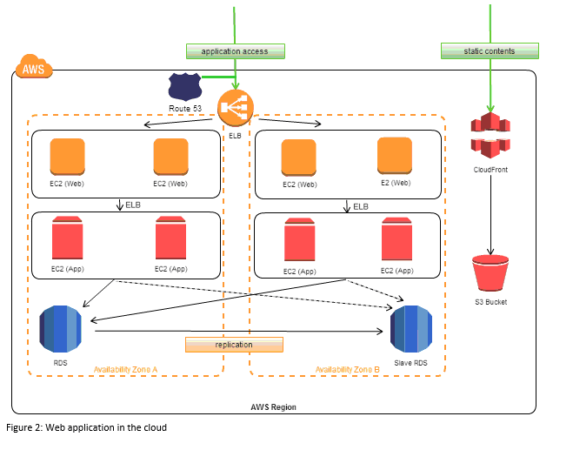

### Figure 2. Web Application in AWS Cloud

The following diagram shows example architecture for a web app. The web and application tiers run on EC2 instances in public subnets. Access to the EC2 instances over Secure Shell (SSH) is controlled by a security group, which acts as a firewall. The Auto Scaling group maintains a fleet of EC2 instances that can scale to handle the current load. This Auto Scaling group spans multiple Availability Zones to protect against the potential failure of a single Availability Zone. The load balancer distributes traffic evenly among the EC2 instances. When the Auto Scaling group launches or terminates instances based on load, the load balancer automatically adjusts accordingly. The database tier consists of DB instances in private subnets, located in multiple Availability Zones for failover protection. Access to the DB instances from the EC2 instances is controlled by a security group. Amazon Route 53 provides secure and reliable routing of your domain name to your infrastructure hosted on AWS.

##### *Amazon Elastic Compute Cloud (EC2)*

Amazon Elastic Compute Cloud (Amazon EC2) provides scalable computing capacity in the Amazon Web Services (AWS) cloud. Using Amazon EC2 eliminates your need to invest in hardware up front, so you can develop and deploy applications faster. You can use Amazon EC2 to launch as many or as few virtual servers as you need, configure security and networking, and manage storage.

##### *Amazon Relational Database Service (RDS)*

Amazon Relational Database Service (Amazon RDS) is a web service that makes it easier to set up, operate, and scale a relational database in the cloud. It provides cost-efficient, resizable capacity for an industry-standard relational database and manages common database administration tasks.

##### *Symmetric Database Encryption*

For secure exchange of digital data, resulted in large quantities of different encryption algorithms this can be classified into two groups: Symmetric encryption algorithm (with shared secret key algorithms) and Asymmetric encryption algorithm (with public key algorithms). Symmetric key algorithms are in general much faster to execute electronically than asymmetric key algorithms. The most commonly used symmetric encryption algorithm is AES. The input plain text and the cipher key are in state array fashion and hence known as a block cipher. The plaintext input are of fixed size, blocks of 128 bits and produces a block of cipher text of equal size for each plaintext block. The most commonly used symmetric encryption algorithms are the data encryption standard (DES), triple data encryption algorithm (TDEA) and advanced encryption standard (AES). In this research AES was implemented because it provides more secure algorithm than the others, and it is commonly used in records management system.

### Figure 3. Symmetric Database Encryption

Symmetric Database Encryption is one of the features that all the data that will be stored and called, by the users, from the school’s cloud database will involve a shared secret key for security purposes. This is one of the most crucial functions of the system.

##### *AES Algorithm*

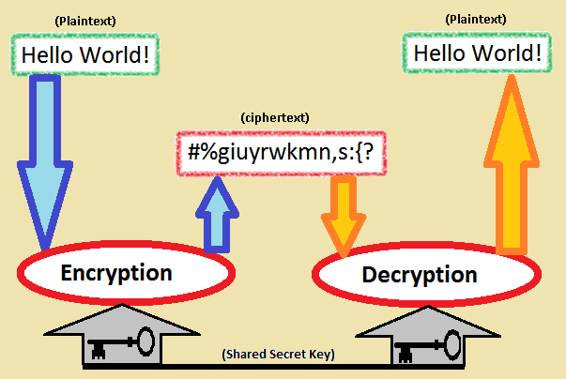The AES algorithm is a symmetric-key cipher, in which users uses a single key for encryption and decryption. The length of the plain text is fixed to be 128 bits, while the key length can be either 128,192, or 256 bits. The key length selected is of 128 bits. AES algorithm is an iterative algorithm. Every iteration can be called a round, and the total number of rounds is 10, 12, or 14, when key length is 128, 192, or 256 respectively. The 128 bit algorithm is divided into 16 bytes. These bytes are represented into 4x4 arrays called the state array, and all the different operations of the AES algorithm such as addroundkey, subbytes, shiftrows, mixcolumns and key expansion are performed on the state.

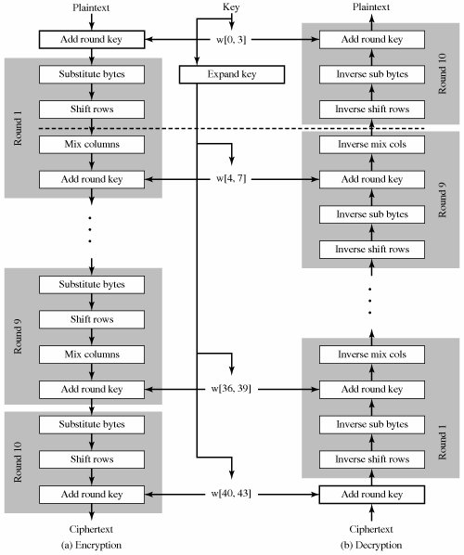

### Figure 4. Flow of AES Algorithm

The National Institute of Standards and Technology (NIST) started development of AES in 1997 when it announced the need for a successor algorithm for the Data Encryption Standard (DES), which was starting to become vulnerable to brute-force attacks.

##### *Hypertext Preprocessor (Php)*

PHP code may be embedded into HTML code, or it can be used in combination with various web template systems, web content management systems, and web frameworks.

##### *MySQL*

Is the world's most popular open source database. With its proven performance, reliability and ease-of-use, MySQL has become the leading database choice for web-based applications, used by high profile web properties including Facebook, Twitter, YouTube, Yahoo! and many more. Oracle drives MySQL innovation, delivering new capabilities to power next generation web, cloud, mobile and embedded applications.

##### *XAMPP*

XAMPP Stands for Cross-Platform (X), Apache (A), MariaDB (M), PHP (P) and Perl (P). It is a simple, lightweight Apache distribution that makes it extremely easy for developers to create a local web server for testing and deployment purposes.

# Design and Methodology

## Requirements Analysis

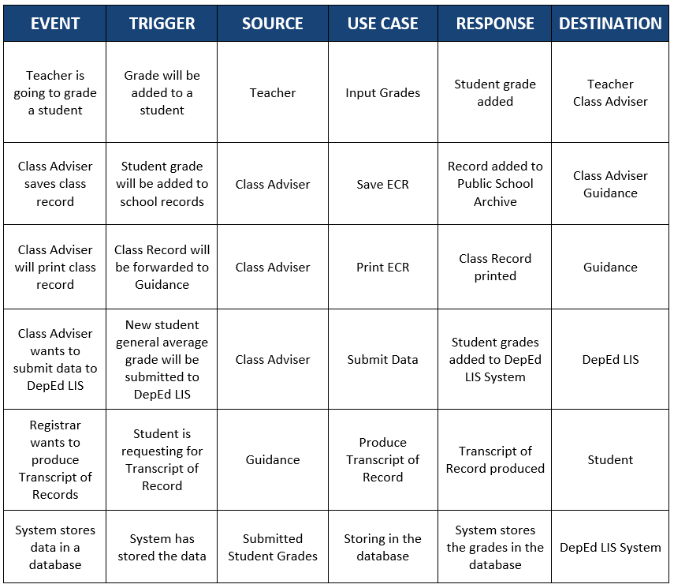

### Figure 5. Events Table

## Requirements Documentation

##### *Input Grades*

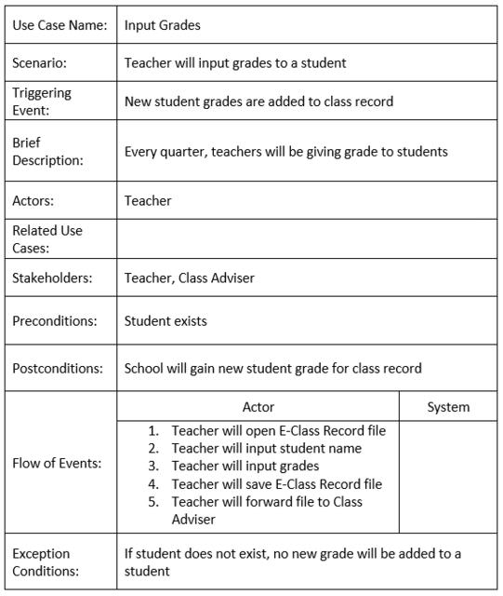

### Figure 6. Input Grades

##### *Save ECR*

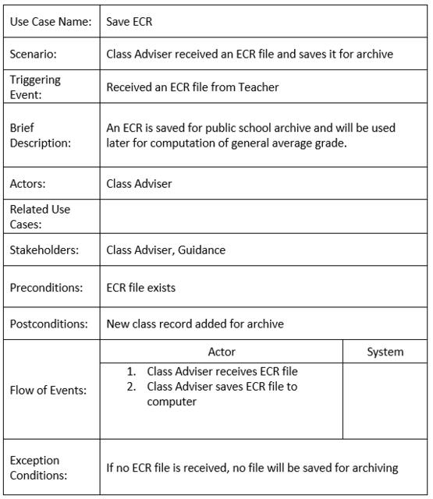

### Figure 7. Save ECR

##### *Print ECR*

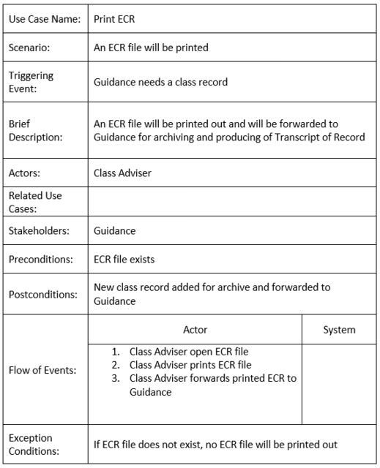

### Figure 8. Print ECR

##### *Submit Data*

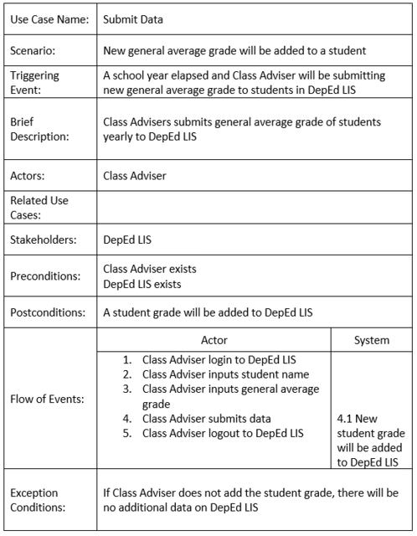

### Figure 9. Submit Data

##### *Produce Transcript of Record*

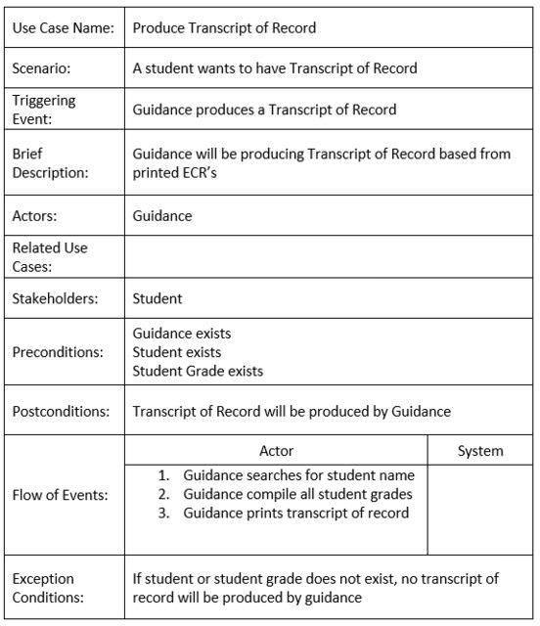

### Figure 10. Produce Transcript of Record

##### *Storing in the Database*

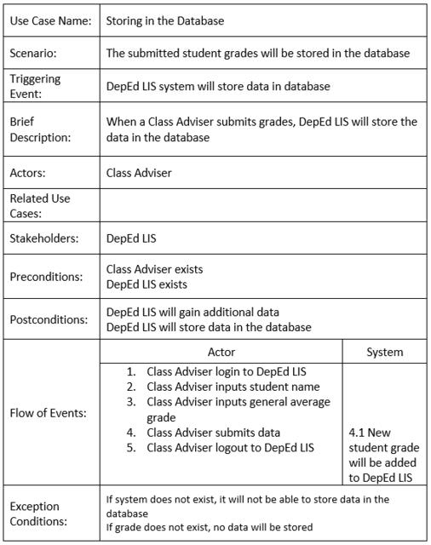

### Figure 11. Storing in the Database

## Gap Analysis/Needs Assessment

|  |  |  |  |
| --- | --- | --- | --- |
| User Requirements | Current System | Proposed Changes | Remarks/Impacts |
| An archive list of all the student’s information and subject grades with safe and secured storage | Records being printed and stored in file cabinets which takes a lot of paper and space in terms of storage | Provide a cloud based system where the school can store all records on a virtual storage with thorough encryption on every data | As compared to the current system that they use, implementing will consume less physical space. It is also a solution to the vulnerability of the manual records to decay or be destroyed. |
| To expedite the process of searching for a student record | The records of the students are currently searched manually in a huge pile of papers | Provide an archive system with a database that can arrange data in a systematic way | School personnel can now perform a range of simple to complex database queries to search for a student record |

## Design of Software, Systems, Product, and/or Process

## System Architecture

In the Presentation Tier this would allow the intended end-users to access the system

through the use of a Web Browser and it’s Graphical User Interface. This layer can access the School Application that is intended for schools to use.

The Application Tier is where the cloud computing is being carried out. These connect the interface into the Database Tier for storing and retrieving of data from the database. The AES algorithm of symmetric database encryption will be implemented and executed in this part. AES is a security mechanism to be used for submission of student grade records to the database in the cloud. The student grade record is encrypted before sending it over the network.

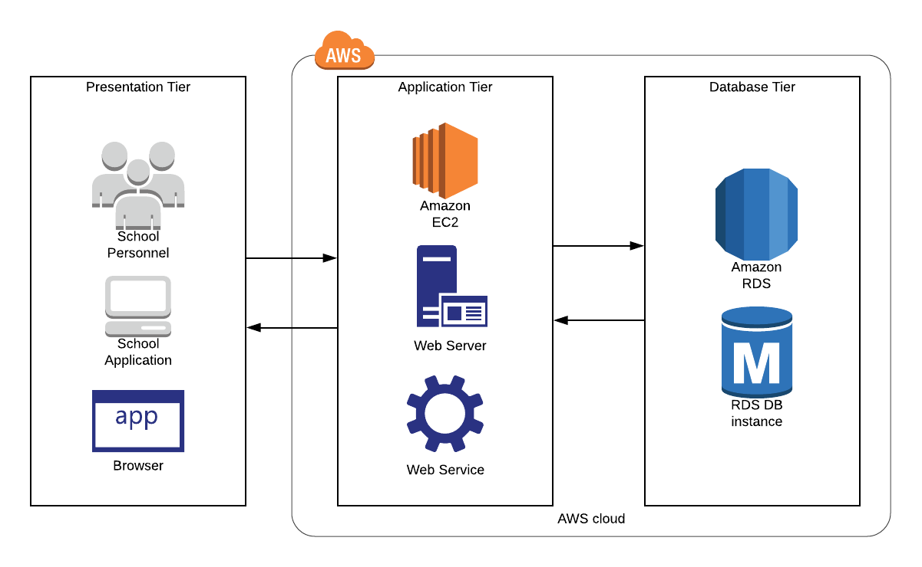 The Database Tier is where the database in cloud for the system is being handled.

### Figure 12. System Architecture

# Results and Discussion

# UML Diagrams

## Use Case Diagram

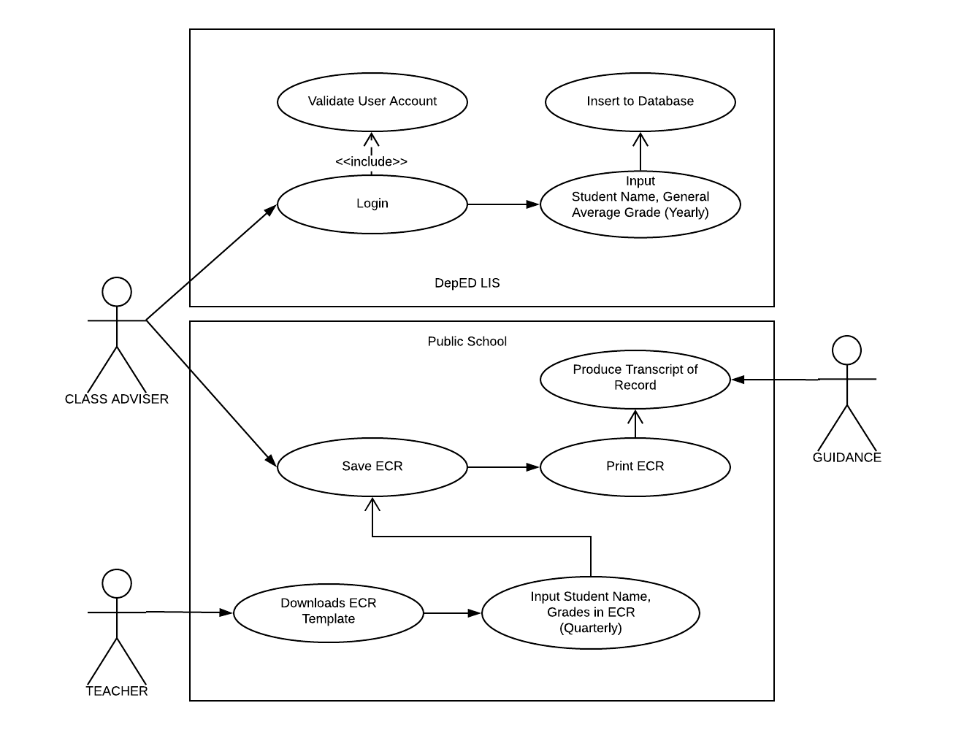

### Figure 13. Use Case Diagram

## Context Level Diagram

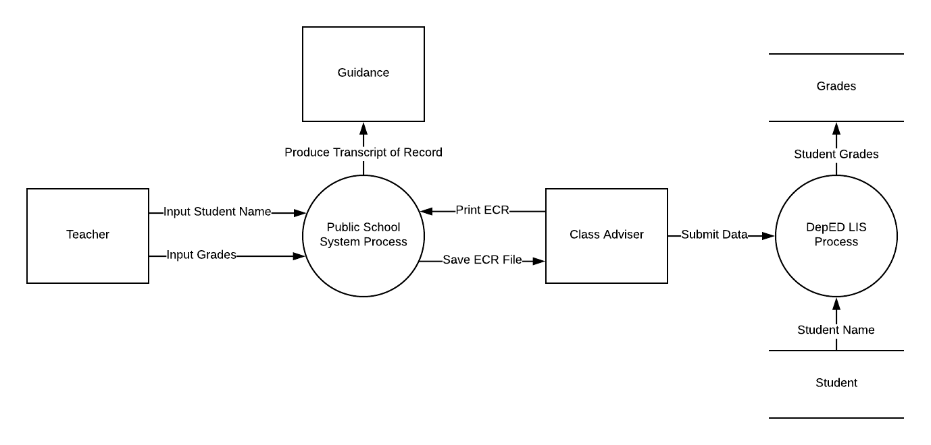

### Figure 14. Context Level Diagram

## Data Flow Diagram Level 1

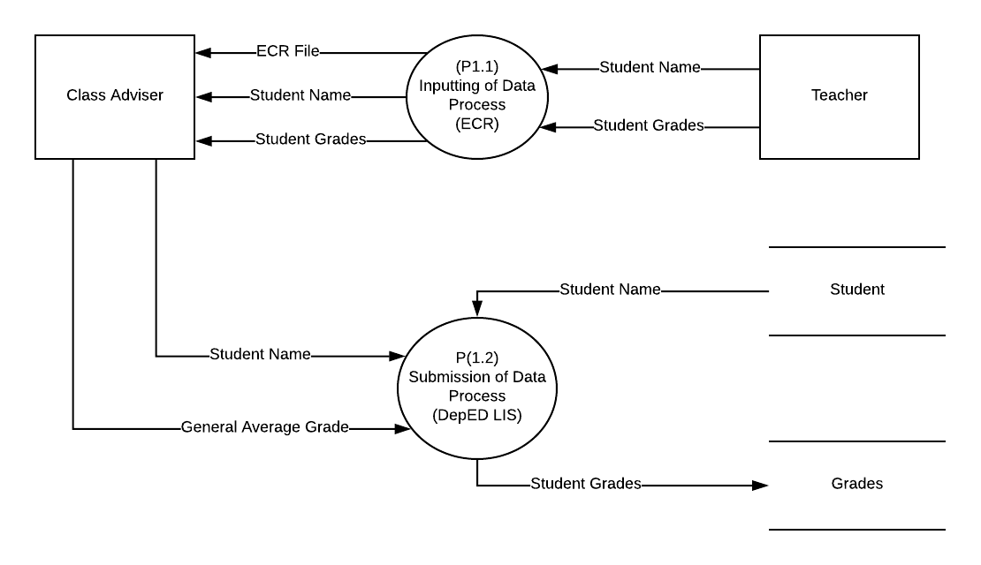

### Figure 15. Data Flow Diagram Level 1

## Data Flow Diagram Level 2

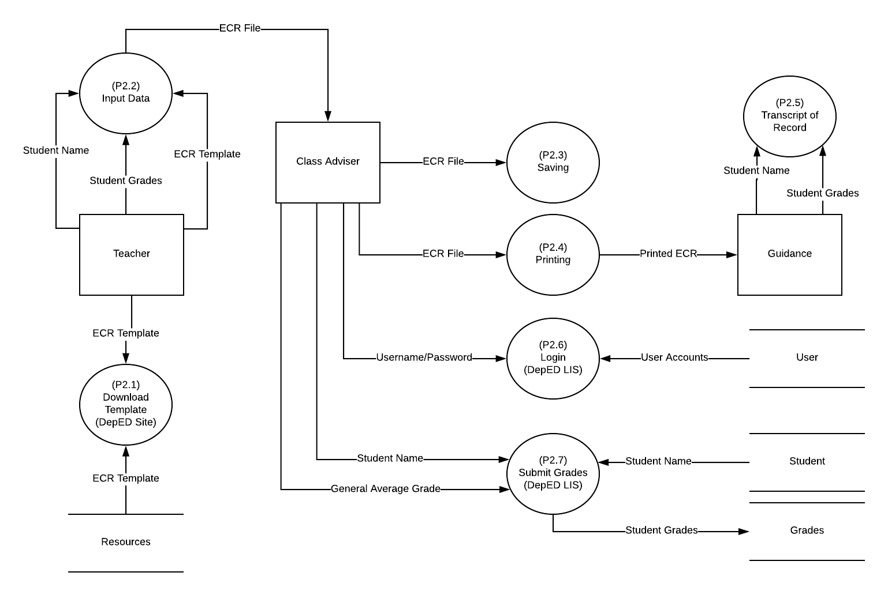

### Figure 16. Data Flow Diagram Level 2

## Entity Relationship Diagram

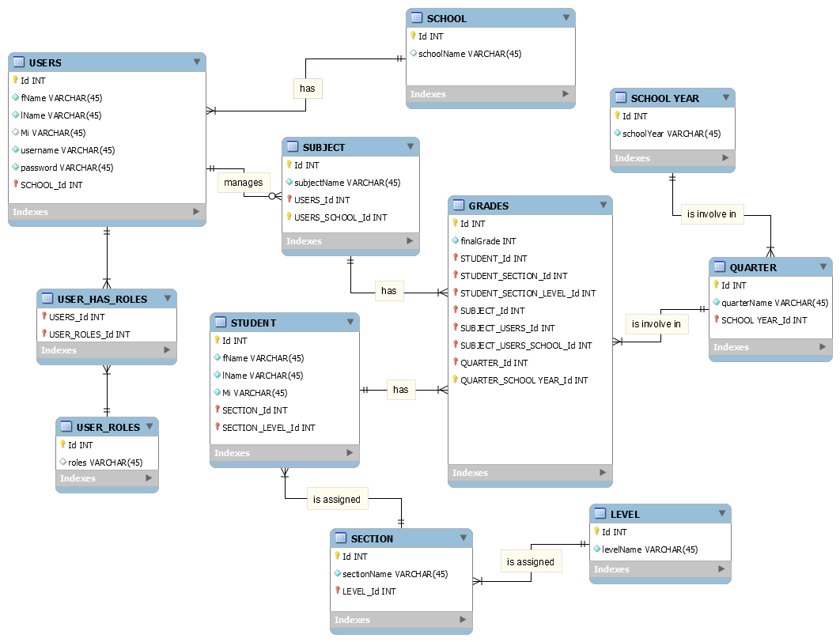

### Figure 17. Entity Relationship Diagram

## Activity Diagram

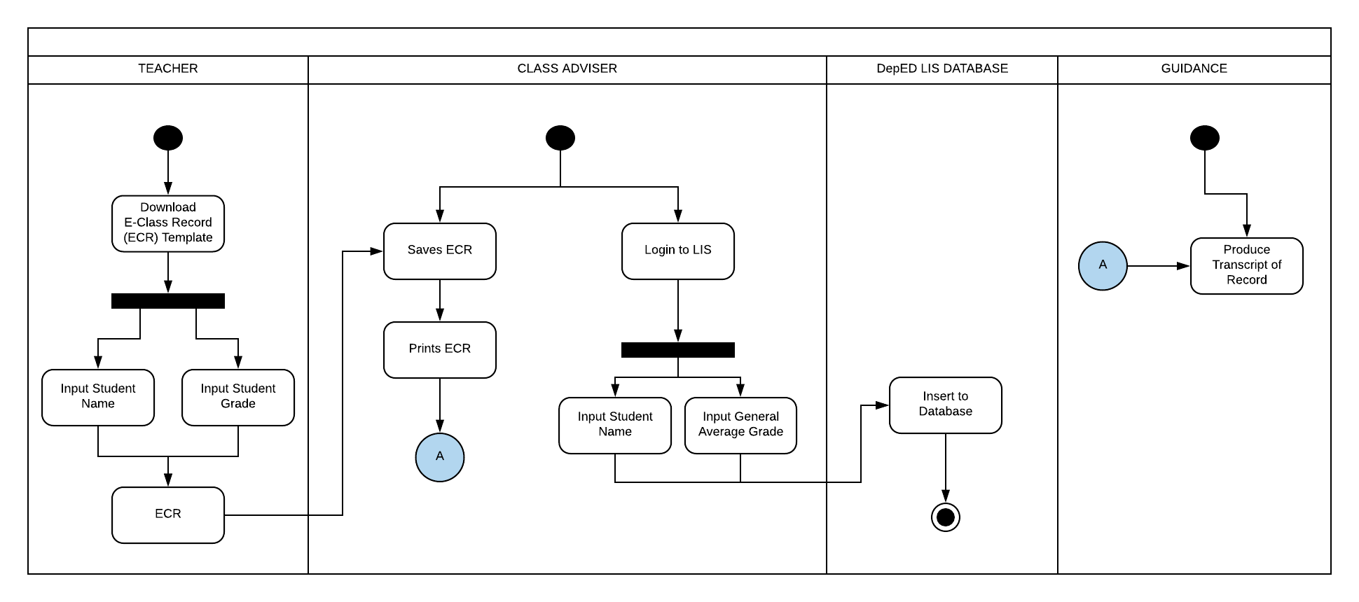

### Figure 18. Activity Diagram

## System Sequence Diagram

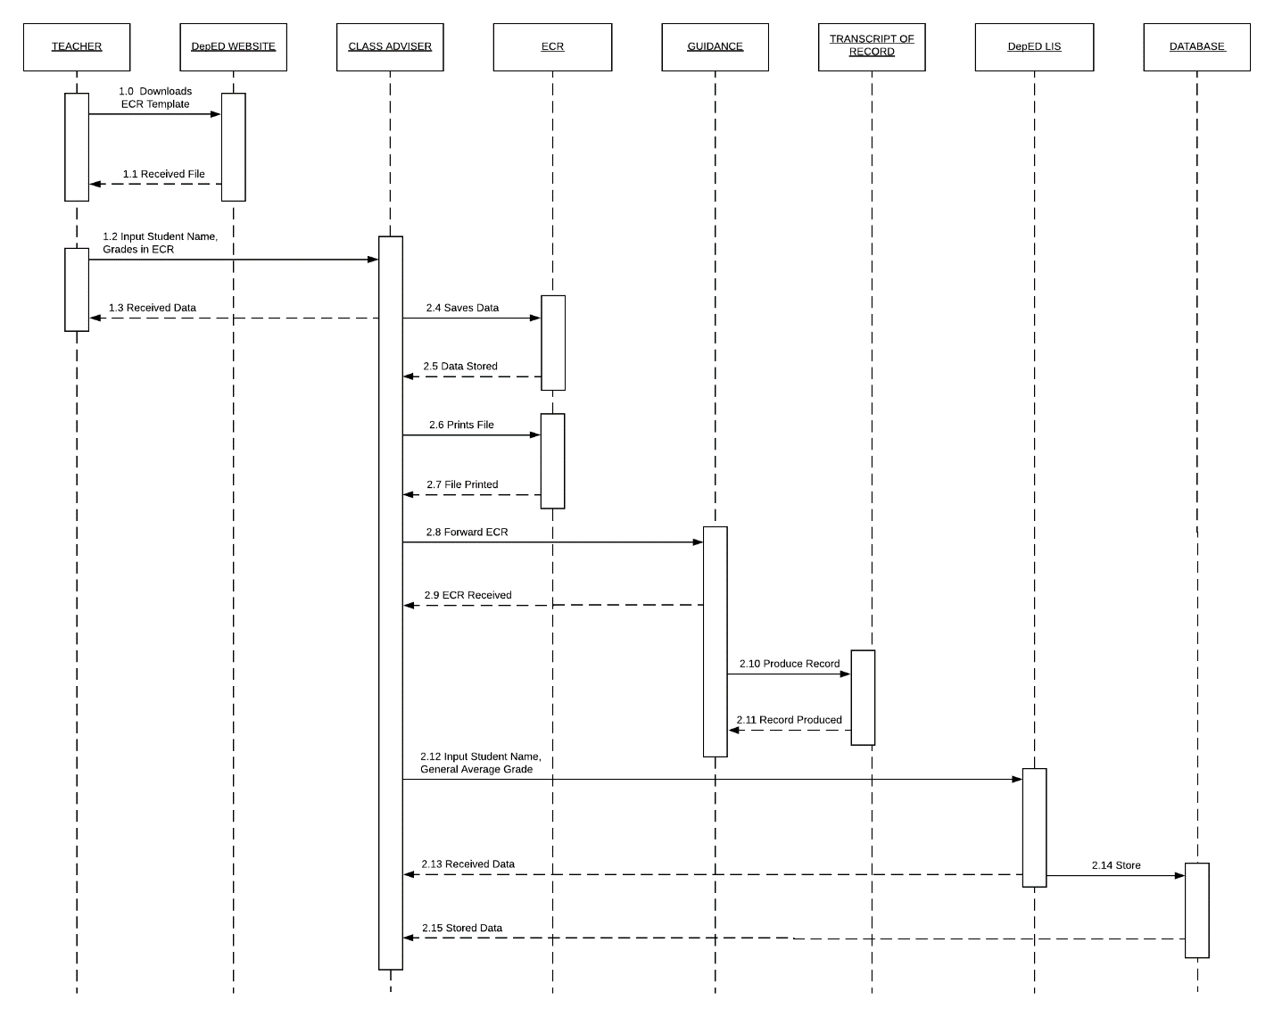

### Figure 19. System Sequence Diagram

## Object Diagram

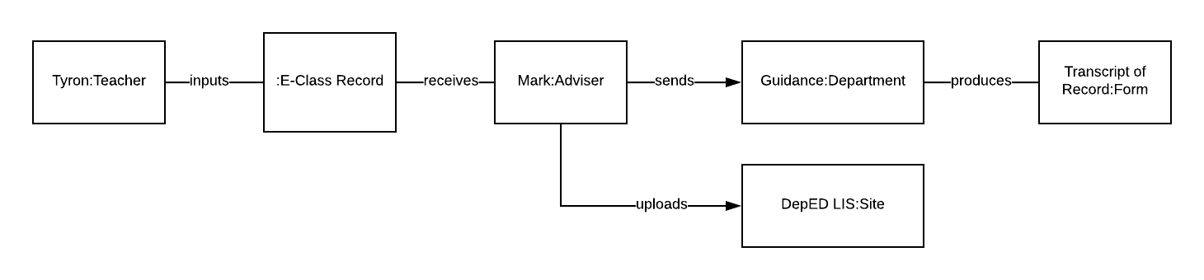

### Figure 20. Object Diagram

## Class Diagram

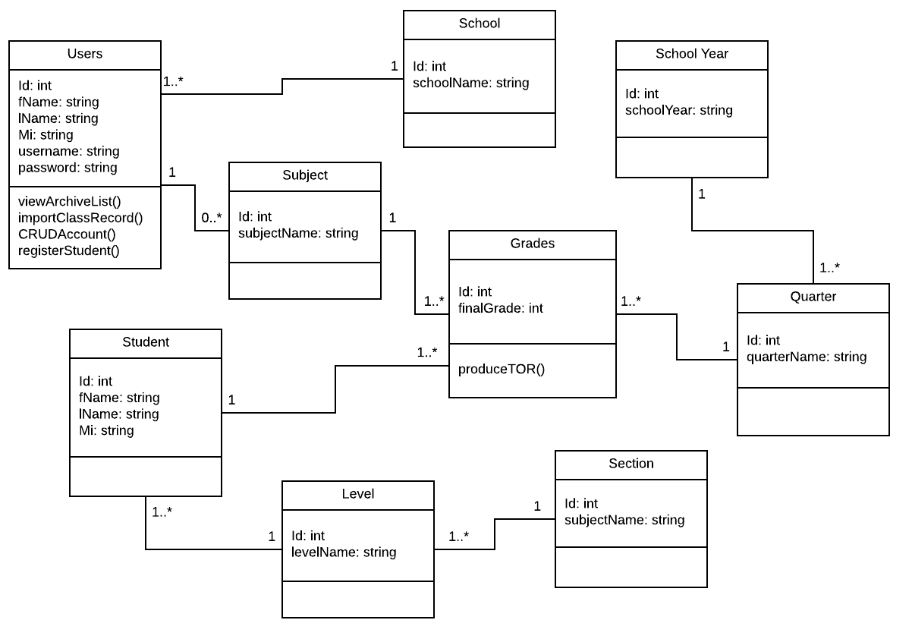

### Figure 21. Class Diagram

# Appendices

References

* Kelemen, R., & Mekovec, R. (n.d.). Document Management System. A Case Study of Verazdin Country, 1-6. Retrieved from: <https://bib.irb.hr/datoteka/345603.Kelemen-Mekovec_-_DMS_-_A_Case_Study_of_Varazdin_Counti_pp41-46s.pdf>
* K to 12 curriculum in the Philippines. (2015). What You Should Know about the New K to 12 Curriculum. Retrieved from: <http://k12philippines.com/an-overview-of-the-new-k-to-12-curriculum-in-the-philippines/>
* Zach, R. (2005). Using Spreadsheets to Keep Track of Students' Grades. Retrieved from: <https://www.ucalgary.ca/rzach/teaching/grades.html>
* Learner Information System (LIS) System Overview. (2017). 1-36. Retrieved from: <http://fape.org.ph/addons/tinymce/editor/media/articleimg/2016/DepEd%20Learner%20Information%20System%20(LIS).pdf>
* Yumi. (2017). Electronic Class Record. Retrieved from: <http://guroako.com/2017/04/23/e-classrecordelectronicclassrecord/>
* Rouse, M. (n.d.). Data Encryption Standard (DES) and Advanced Encryption Standard (AES). Retrieved from: <http://searchsecurity.techtarget.com/definition/Advanced-Encryption-Standard>