

**Housekeeping Task-sheet system**

Charles Crisostomo (*Project Manager*)

Aldrian Benedicto (*Project Analyst*)

Miggie Rodriguez (Project Developer)

Justine De Guzman (Project Developer)

Charles Baylon (Project Developer)

Manuel Sebastian S. Sanchez

*Professor*

Table of Contents

Introduction 1

Review of Related Literature/System 2

Technical Background 4

Resource Requirement 4

The Existing System 6

Company Background 6

Description of the System 6

Data Flow Diagram (Level 0) 6

Problem Areas 7

The Proposed System 8

Context Diagram 8

Data Flow Diagram (Level 0) 9

Entity Relationship Diagram 10

Data Dictionary 11

Use Case Diagram 13

Activity Diagram 14

Sequence Diagram 18

Screen Layout 20

Gap Analysis 21

# Introduction

Project Context

The group's project is Time Monitoring System that will help the housekeeping management of Taal Vista Hotel which is the chosen client, owned by SM Hotels and Conventions Corporation (SHMCC). The client's current process/system is manually writing the time that the cleaning start and the time that the cleaning ends. The team's project will improve the current process by creating a mobile application that tracks the housekeeping attendant's time in and out of the cleaning procedure. Not all rooms have the same task to accomplish, it has several types of room an example of this is a deluxe room, single, and many more. QR (Quick Response) code will be implemented in each room. Using a QR code as a security measure for information accuracy.

Purpose and Description

The purpose of this project is to provide the client with a system that will help the housekeeping management to track the time of a housekeeping attendant cleaning procedure.

Objectives

General Objectives

* To track housekeeping attendees room Time-in and Time-out

Specific Objectives

* To use QR as Security Measure for accurate recording of housekeeping attendants room time-in and time-out
* To provide management with instant real-time update on a specific housekeeping attendant
* To generate a periodic average time report on each housekeeping attendant's room cleaning accomplishments

Scope and Limitation

The proposed system of the group will be beneficial for the housekeeping management of Taal Vista Hotel in monitoring the time of the housekeeping attendance cleaning procedure. Time Monitoring System will track the housekeeping attendant's cleaning procedure which the user will scan a QR code that will get the room number and get the current time. It will also notify the housekeeping management that a housekeeping attendant is at a room cleaning. The QR code will be located at the front door of the room. The proposed system does not cover the inventory of the materials for the housekeeping and cleaning task.

## Review of Related Literature/System

**KNOWCROSS**

KNOWCROSS housekeeping coordinator creates task sheets in less than a minute and supervisor that receive the task sheet on their smartphones with traces, preferences and cleaning sequences and rooms is automatically updated in the PMS once the room are cleaned and inspected. The step by step process of the housekeeping system based on KNOWCROSS can be related to the group's proposed system because it also generate an automated task sheet and the task sheet should be received by the the cleaning staffs via smartphones and it also update the PMS after the task sheet given was done.  
*(*[*http://www.knowcross.com/know-housekeeping/*](http://www.knowcross.com/know-housekeeping/)*)*

**AMADEUS**

Amadeus is a cloud based solution that automates housekeeping daily operation, resulting in reduced check-in wait times and increased guest satisfaction. Enable reporting of guestroom deficiencies and guest requests it Allow staff to connect and manage department from anywhere, on any device.This software relate our proposed system like allowing our staff to connect and manage their department from anywhere, easily assigns their daily task and efficiently comply to hotel service management.  
*(*[*https://amadeus-hospitality.com/amadeus-service-optimization/hotsos-housekeeping*](https://amadeus-hospitality.com/amadeus-service-optimization/hotsos-housekeeping)*)*

**HOTELOGIX**

Hotelogix has Housekeeping module that works in a complete sync with the system. It lets you maintain the list of housekeeping staff without any limits. The group used this reference to help improve the current system because it is an effective task delegation and communication to the other department.

*(*[*http://www.hotelogix.com/housekeeping.php*](http://www.hotelogix.com/housekeeping.php)*)*

**HIBOX SYSTEMS**

Hibox Housekeeper is a convenient support tool for housekeeping and service personnel. The app facilitates the collaboration in all service operations, making daily tasks faster and more efficient. Running on a variety of mobile devices, reporting easy when beginning the cleaning, simply select start and when the room is cleaned then confirms it. This application is the most useful and helpful for the group’s project because their application would be a good resource to our proposed project.

*(*[*http://www.hibox.tv/Hotel-Housekeeping-System.shtml*](http://www.hibox.tv/Hotel-Housekeeping-System.shtml)*)*

**PROTEL**

Protel software has features of check and change the occupancy state, room status if it is cleaned, dirty, touched, cleaning in progress, checked. These features will help the group’s proposed system more efficient to monitor the rooms that needed to be cleaned.

*(*[*http://www.protel.net/hotel-software/addons/protel-housekeeping/*](http://www.protel.net/hotel-software/addons/protel-housekeeping/)*)*

# Technical Background

**Programming Language**

* **PHP**

PHP(recursive acronym for PHP: Hypertext Preprocessor) is a widely utilized open source scripting language that is particularly suited for web development and can be installed into HTML.

* **Java**

Java is the innovation of decision for building applications utilizing structured codes that can be executed on cell phones and this is what the group will mainly use for developing the mobile application that will serve as the interface between the user and the system.

* **SQL**

SQL (Structured Query Language) is a systematized programming language utilized for managing relational databases and performing different operations on the information given. SQL incorporate altering database tables that will help us add, delete, and update the data from our proposed system.

### Resource Requirement

**Hardware Requirements**

* **Android Device**

A handheld device that will be utilized by the housekeeping supervisor during his or her room inspection procedures.

* + **Computer**

A device that acknowledges data and controls it for some outcome based on the program or set of instructions on how the information is to be handled.

* + **Server**

A server is to share data as well as to share resources and disperse work across multiple platforms.

**Software Requirements**

* + **Android Studio**

Built based on JetBrains' IntelliJ IDEA software and designed specifically for Android application development.

* + **Yii**

Yii is an open source, object-oriented, component-based MVC PHP web application framework.

* + **Firebase**

Firebase is a mobile and web application development platform. It is linked as an assistant to android studio which is also a database.

# The Existing System

## Company Background

As early as 1956, Tagaytay was flocked tourists. Taal Vista Lodge, later to become Taal Vista Hotel, one of the top destination for travellers that enjoyed the breath-taking view of Taal Lake. SM Investment's Henry Sy used to be a regular buyer of the lodge. He is now the owner of the former Taal Vista Lodge, now Taal Vista Hotel. In 2002, Taal Vista Hotel was rebuilt in the style of the unique lodge. Facilities and several services were later constructed for business and relaxation purposes. The hotel revived its doors in 2004, and is still to this day a beloved and historical landmark in the city of Tagaytay.

## Description of the System

Housekeeping system manually creates a checklist of task that will be given to a housekeeping operative. The housekeeping manager assigns the housekeeping supervisor, checklist will be created by the supervisor and will assign a housekeeping operative. When a housekeeping operative finished the task, the checklist has a time-in and time-out section which must be signed and input the name. For the housekeeping supervisor to call out a housekeeping operative a handheld transceiver radio is provided to the housekeeping operative and housekeeping supervisor.

## Data Flow Diagram (Level 0)

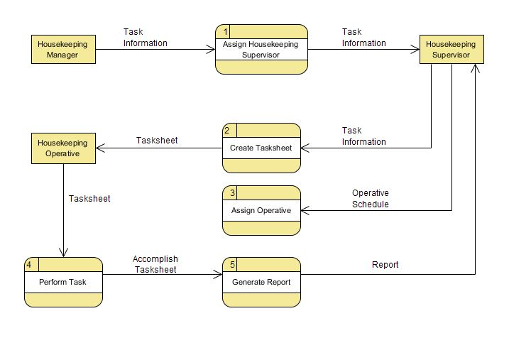

## Problem Areas

* The current system consumes a lot of paper.
* The creation of task-sheet consumes a lot of time.
* The record of housekeeping operative on starting and finishing the task is not consistent.

# The Proposed System

## Context Diagram

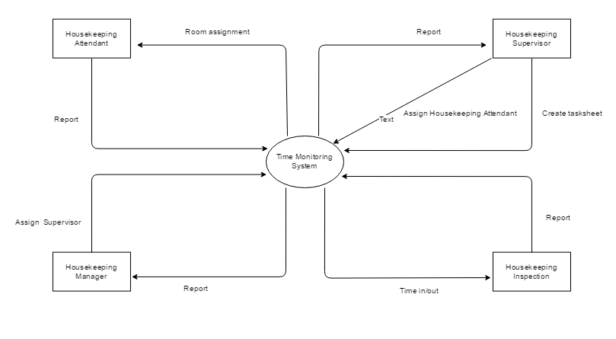

* The Housekeeping Manager Assigns Housekeeping Supervisor.
* The Housekeeping Supervisor assigns a Housekeeping attendant.
* The Housekeeping attendant receives Task sheet and reports to the Housekeeping Supervisor.
* The Housekeeping Supervisor receives report and generate the final report to be forwarded to the Housekeeping Manager.

## Data Flow Diagram (Level 0)

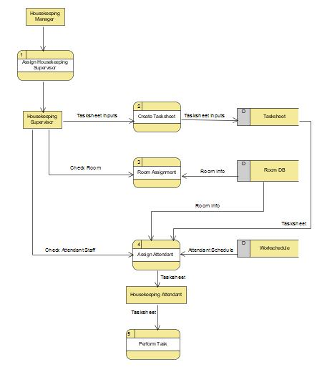

## GRvYAno.png Entity Relationship Diagram

### Data Dictionary

|  |  |  |  |  |  |  |  |
| --- | --- | --- | --- | --- | --- | --- | --- |
| **POSITION** | | | | | | | |
| ATTRIBUTE NAME | **CONTENTS** | **TYPE** | **FORMAT** | **RANGE** | **REQUIRED** | **PK OR FK** | **FK REFERENCE TABLE** |
| ID | Position ID | INTEGER | 999999 | 10000-999999 | Y | PK |  |
| pos_des | Position Description | VARCHAR(45) | Xxxxxxxx |  |  |  |  |

|  |  |  |  |  |  |  |  |
| --- | --- | --- | --- | --- | --- | --- | --- |
| **DEPARTMENT** | | | | | | | |
| ATTRIBUTE NAME | **CONTENTS** | **TYPE** | **FORMAT** | **RANGE** | **REQUIRED** | **PK OR FK** | **FK REFERENCE TABLE** |
| ID | Department ID | INTEGER | 999999 | 10000-999999 | Y | PK |  |
| dept_name | Department Name | VARCHAR(45) | Xxxxxxxx |  |  |  |  |

|  |  |  |  |  |  |  |  |
| --- | --- | --- | --- | --- | --- | --- | --- |
| **EMPLOYEE** | | | | | | | |
| ATTRIBUTE NAME | **CONTENTS** | **TYPE** | **FORMAT** | **RANGE** | **REQUIRED** | **PK OR FK** | **FK REFERENCE TABLE** |
| ID | Employee ID | INTEGER | 999999 | 10000-999999 | Y | PK |  |
| emp_no | Employee Number | VARCHAR(45) | Xxxxxxxx |  |  |  |  |
| emp_lname | Employee last name | VARCHAR(45) | Xxxxxxxx |  |  |  |  |
| emp_fname | Employee first name | VARCHAR(45) | Xxxxxxxx |  |  |  |  |
| emp_mname | Employee middle name | VARCHAR(45) | Xxxxxxxx |  |  |  |  |
| department_dept_no | Department number | INTEGER | 999999 | 10000-999999 | Y | FK | department |
| position_idposition | Position ID | INTEGER | 999999 | 10000-999999 | Y | FK | position |
| task_list_id | Tasklist ID | INTEGER | 999999 | 10000-999999 | Y | FK | Task_list |
| workschedule id | Workschedule ID | INTEGER | 999999 | 10000-999999 | Y | FK | workschedule |

|  |  |  |  |  |  |  |  |
| --- | --- | --- | --- | --- | --- | --- | --- |
| **WORKSCHEDULE** | | | | | | | |
| ATTRIBUTE NAME | **CONTENTS** | **TYPE** | **FORMAT** | **RANGE** | **REQUIRED** | **PK OR FK** | **FK REFERENCE TABLE** |
| ID | workschedule ID | INTEGER | 999999 | 10000-999999 | Y | PK |  |
| shift_name | Shift name | VARCHAR(45) | Xxxxxxxx |  | Y |  |  |
| shift_start_time | Shift starting time | TIME(5) | hh:mm |  | Y |  |  |
| shift_end_time | Shift end time | TIME(5) | hh:mm |  | Y |  |  |

|  |  |  |  |  |  |  |  |
| --- | --- | --- | --- | --- | --- | --- | --- |
| **ROOM** | | | | | | | |
| ATTRIBUTE NAME | **CONTENTS** | **TYPE** | **FORMAT** | **RANGE** | **REQUIRED** | **PK OR FK** | **FK REFERENCE TABLE** |
| ID | Room ID | INTEGER | 999999 | 10000-999999 | Y | PK |  |
| room_no | Room Number | INTEGER | 999999 | 10000-999999 | Y |  |  |
| room_type_id | Room type ID | INTEGER | 999999 | 10000-999999 | Y | FK | Room_type |

|  |  |  |  |  |  |  |  |
| --- | --- | --- | --- | --- | --- | --- | --- |
| **ROOM TYPE** | | | | | | | |
| ATTRIBUTE NAME | **CONTENTS** | **TYPE** | **FORMAT** | **RANGE** | **REQUIRED** | **PK OR FK** | **FK REFERENCE TABLE** |
| ID | Room ID | INTEGER | 999999 | 10000-999999 | Y | PK |  |
| room_type | Room Type | VARCHAR(45) | Xxxxxxxx |  | Y |  |  |
| room_description | Room Description | VARCHAR(45) | Xxxxxxxx |  |  |  |  |

|  |  |  |  |  |  |  |  |
| --- | --- | --- | --- | --- | --- | --- | --- |
| **ROOM HAS EMPLOYEE** | | | | | | | |
| ATTRIBUTE NAME | **CONTENTS** | **TYPE** | **FORMAT** | **RANGE** | **REQUIRED** | **PK OR FK** | **FK REFERENCE TABLE** |
| ID | Room has employee | INTEGER | 999999 | 10000-999999 | Y | PK |  |
| Staff | Staff | INTEGER | 999999 | 10000-999999 | Y | FK | employee |
| room_id | Room ID | INTEGER | 999999 | 10000-999999 |  | FK | room |
| Manager | Manager | INTEGER | 999999 | 10000-999999 |  | FK | employee |
| task_list_id | Tasklist ID | INTEGER | 999999 | 10000-999999 |  | FK | Task_list |
| hkeeping_timein | Housekeeping Time-in | TIMESTAMP(5) | hh:mm |  | Y |  |  |
| hkeeping_timeout | Housekeeping Time -Out | TIMESTAMP(5) | hh:mm |  | Y |  |  |
| clean_timein | Cleaning Time-in | TIMESTAMP(5) | hh:mm |  | Y |  |  |
| clean_timeout | Cleaning Time-out | TIMESTAMP(5) | hh:mm |  | Y |  |  |

|  |  |  |  |  |  |  |  |
| --- | --- | --- | --- | --- | --- | --- | --- |
| **TASK LIST** | | | | | | | |
| ATTRIBUTE NAME | **CONTENTS** | **TYPE** | **FORMAT** | **RANGE** | **REQUIRED** | **PK or FK** | **FK REFERENCE TABLE** |
| ID | Task List ID | INTEGER | 999999 | 10000-999999 | Y | PK |  |
| task_type | Task type | VARCHAR(45) | Xxxxxxxx |  | Y |  |  |
| task_sheet_template_temp_no | Task sheet template ID | INTEGER | 999999 | 10000-999999 | Y | FK | Task_sheet_template |

|  |  |  |  |  |  |  |  |
| --- | --- | --- | --- | --- | --- | --- | --- |
| **TASK SHEET TEMPLATE** | | | | | | | |
| ATTRIBUTE NAME | **CONTENTS** | **TYPE** | **FORMAT** | **RANGE** | **REQUIRED** | **PK OR FK** | **FK REFERENCE TABLE** |
| ID | Template ID | INTEGER | 999999 | 10000-999999 | Y | PK |  |

# Use Case Diagram

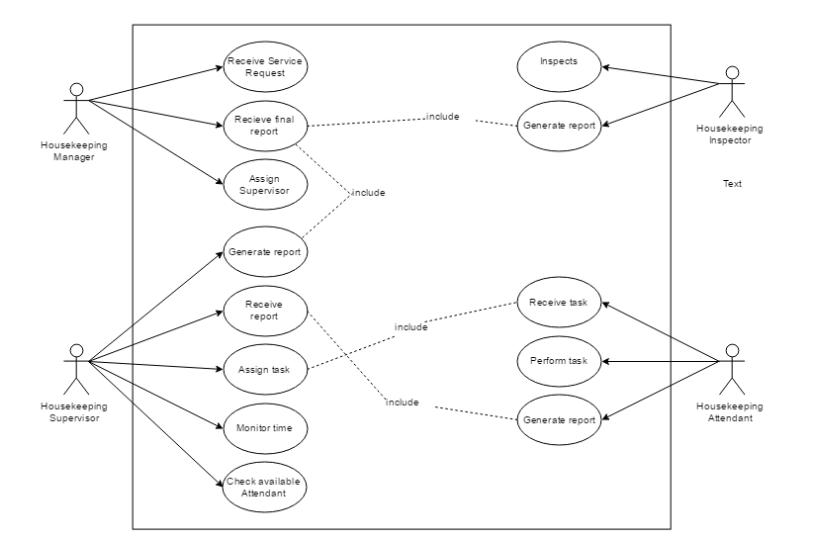

## 

## Activity Diagram

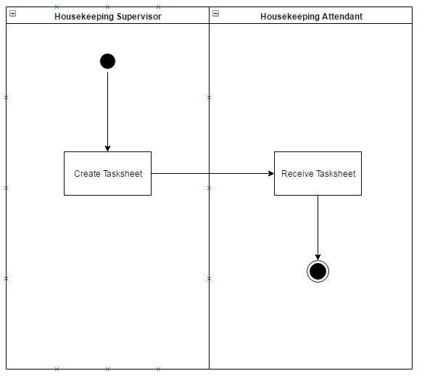

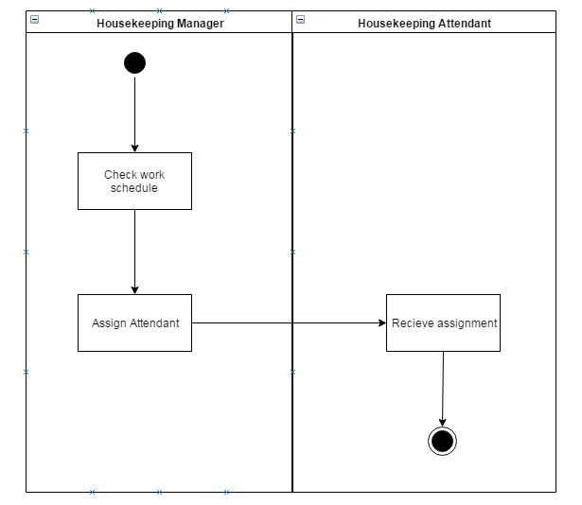

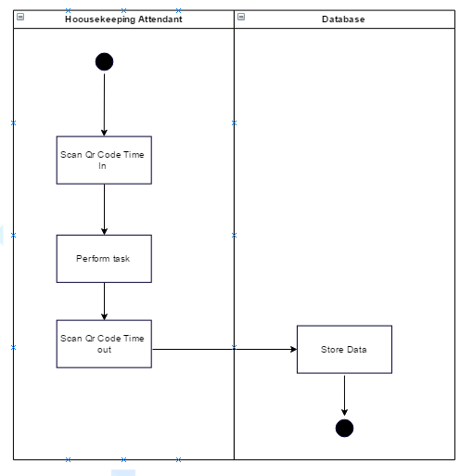

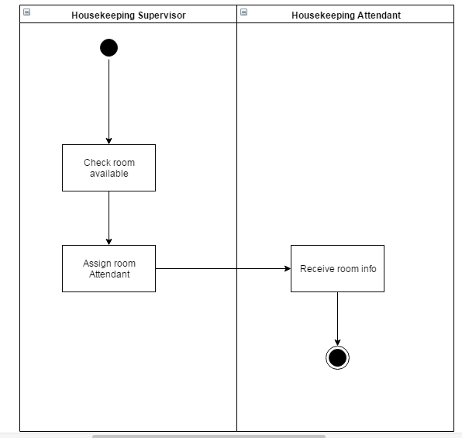

## Sequence Diagram

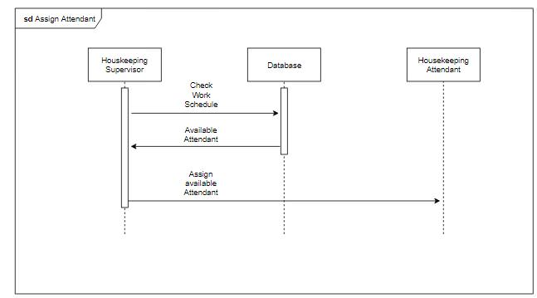

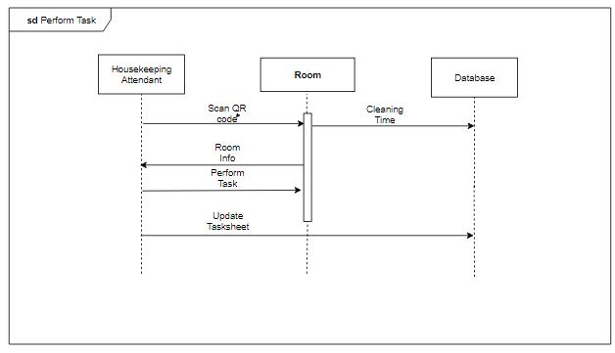

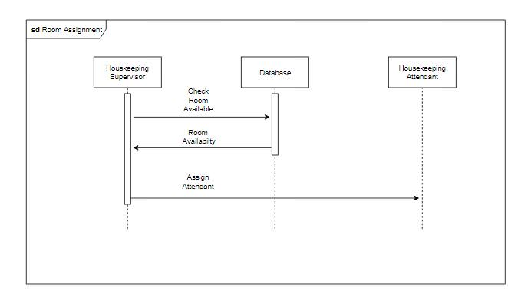

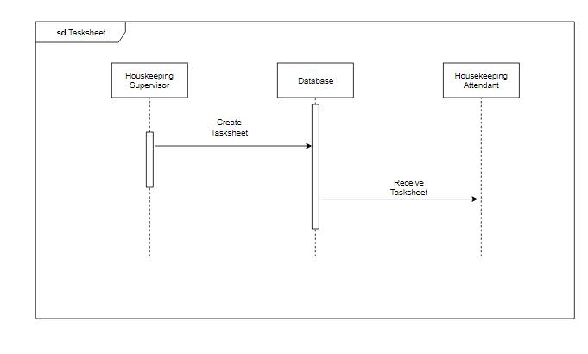

# Screen Layout

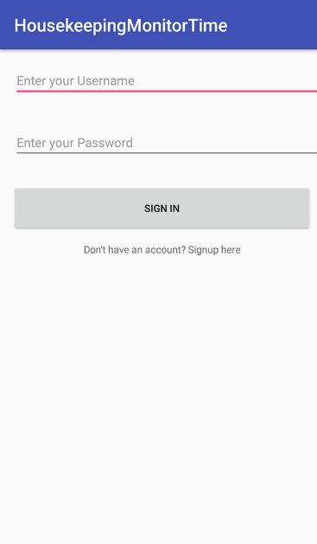

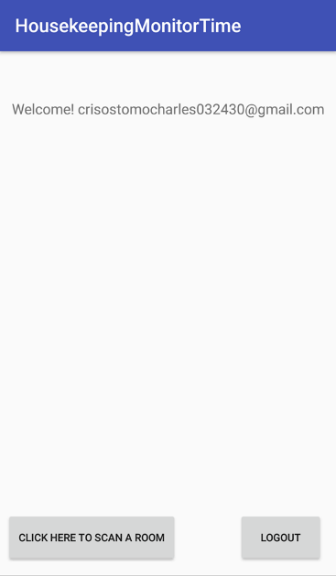

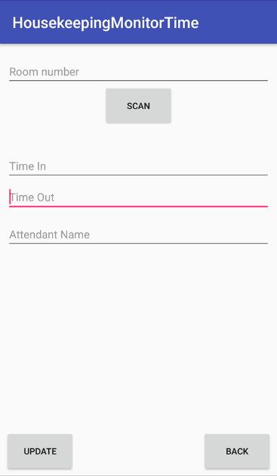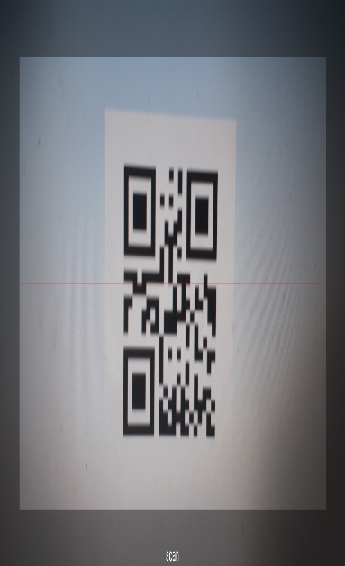

# Gap Analysis

|  |  |  |
| --- | --- | --- |
| User Requirements | Current System | Proposed Changes |
| 1. Daily routine of cleaning must be fast and efficient. | The housekeeping operative have task sheet that is formulated on a paper. | The group will develop a mobile application that will allow the housekeeping operative to do their task more efficient and have a real-time update. |
| 1. Every member of the housekeeping operative must update housekeeping supervisors on the time they started and time they finished the task. | The housekeeping operative writes down the time they started and the time they finished with their signature. | The group will create a app that has a QR code which allows the housekeeping operative to report on the housekeeping supervisor by just scanning. |
| 1. Inventory must not run out especially those consumable items. | It is recorded in excel. | The group will create an app including the management of inventories which allows the user to report and receive the stocks they have or have left. |
| 1. Every room must be kept clean always therefore housekeeping operative must not have any limits. | Sort the operative based on the position or floors to manage the division of work. | The task-sheet that will be generated by the housekeeping supervisor will also have a work schedule. |
| 1. Operative must know what rooms are under maintenance or being upgraded. | There will be a segment that allows all operative to know if the room is not available so that they will not release or be booked on the selected period. | The app has a feature that will know if the room is under maintenance and cannot be booked. |