

Inventory Management System for Hirac Tiles Center Using Analytics

Project Documentation Submitted

To the Faculty of School of

Computing and Information Technologies

Of

Asia Pacific College

In Partial Fulfillment of the Requirements for the subject

Introduction to Systems Design and Development

By

Hidalgo, Ray Miguel

*rshidalgo@student.apc.edu.ph*

Huliganga, Vincent Junior

*vchuliganga@student.apc.edu.ph*

Lu, Antonio Miguel

*amlu@student.apc.edu.ph*

Ms. Rhea-Luz Valbuena

*Sysadd1 Instructor*

November 7, 2017

Table of Contents

Organization/ Institution Detals 3

Organizational Details 3

Project Context 5

Purpose and Description 5

SWOT Analysis 7

Objectives 8

Gap Analysis 8

Scope and Limitations 9

Review of Related Literature 9

Demand Forecasting: Concept, Significance, Objectives, and Factors 9

How Inventory System Software Help Reduce Cost 9

Similar Systems 10

Technical Background 11

Business Analytics 11

Forecasting 11

Visual Basic .NET 11

Database 12

PHP: Hypertext Preprocessor (PHP) 12

Hyper Text Markup Language (HTML) 12

Design and Methodology 13

Event Table 13

Context Diagram 14

Level 0 Diagram 15

Functional Decomposition Diagram 16

Use Case Diagram 17

17

Full Use Case Description 18

Entity Relationship Diagram 24

Activity Diagram 25

Sequence Diagram 27

Object Diagram 28

Class Diagram 29

Bibliography 30

# Organization/ Institution Detals

Company Name: Hirac Tiles Center

Contact Person: Mrs. HaideCabico

Contact Details: 118 Dona Soledad Ave. Brgy. Don Bosco Paranaque City

Tel. #: (02)805 05 15

(0995)874 0374

(0947)9305294

## Organizational Details

Nature of the Company

Hirac Tiles Center carried an extensive array of the latest building and finishing materials from China and local markets. It has been the corporation goal to offer consumers not only with quality products, but also, with utmost customer satisfaction. Hirac Tiles Center will have revolutionized the construction supply industry as it committed itself to providing convenient shopping and excellent services such as complete variety of products, proper parking spaces, friendly sales representative, delivery services, interior design consultation, and many more.

Company Background/History

Hirac Tiles Center is part of 7 Kings Home Builders Corporation affiliated with RACAL CERAMICS AND BARGAIN CENTER INC., the number one (1) Tile and Ceramics retailers in the Philippines at affordable price., also with STONE TREASURES INTERNATIONAL TRADING CORP., the company that introduced variety of classic designs of Granite Slab Stone, Glass Lavatory and other products.

Company Mission & Vision

Mission

To be the top “ONE STOP SHOP” for high quality homebuilding and construction materials, home furnishing and a complete line of hardware items and accessories of LUZON.

Vision

To build a long-term business relationship with our customers and clients by providing high standard merchandise that is maintained through constant product innovations.

School of Computing and Information Technologies

Asia Pacific College

3 Humabon Place,

Magallanes Village., Makati City,

July 30, 2017

Mrs. Haide Cabico

Hirac Tiles Center

Dona Soledad Ave., Paranaque

Re: Inventory Management System Proposal

Dear Ma’am/Sir:

As a part of the course, Introduction to Analysis and Design, we are encouraged to propose an Information System Plan for an actual client to prepare us for projects that we will eventually work on.

Hence, we would like to explore the possibility of working with your organization to use our analytical skills and give solution, such as the Information System, in which would be necessary for the business operations within the company.

Our goal is to develop an inventory management system that would be a benefit for your company. To do so, we would like to ask some questions about your company this coming Tuesday August 1,2017. We would also want to have an approval of using gadgets to record the interview so that the group could review the conversation and have accurate data to create this system.

Rest assured that all information gathered will treated with utmost confidentiality.

We would be glad to work with your organization and hope to get a positive reply from you soon.

Respectfully Yours,

Ray Miguel Hidalgo

BSCS-CN

Vincent Junior Huliganga

BSCS-SS

Antonio Miguel Lu

BSCS-SS

Noted by: Rhea Luz Valbuena

# Project Context

This project proposal aims to improve Hirac Tiles Center’s inventory management through developing a system that will automate the required processes. Through the project proposal, the team expects to provide efficiency and flexibility to the client’s business Hirac is currently using a paper-based system of inventory management, where employee manually updates the inventory records. As a result, their method of inventory management causes outdated inventory information, and sometimes, duplication of purchase orders.

The team would be providing a cloud-based inventory management system for Hirac Tiles Center. This system will help the company count their stocks and reduce time used for manually counting available inventory. The proposed system will:

1. Be implemented as a perpetual system, which means it the system is up-to-date all the time whenever there is a transaction have been generated.
2. Allow the client to monitor, track, control inventory levels.
3. Provide security of inventory information. With this, store management will easily detect if their inventory is compromised.
4. Display all valid inventory data such as quantity of the product, the suppliers, delivery date, etc.
5. Generate reorder point notification, and sends an order request to the supplier.
6. Generate various inventory and sales reports using analytics to identify and predict products on demand and other information that can be used for better decision making of the client’s company.

# Purpose and Description

The current inventory system in place includes the procurement of items when there is none left, which initiates an order to the warehouse with a one-day lead time. There exists three possibilities for the Hirac Tiles Center when a customer order occurs. Figure 1 shows the operation if the item is on-hand in the store.

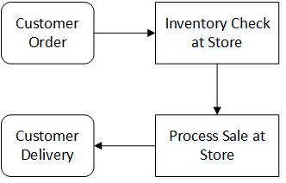

Figure 1. Process Flow for transaction with item on-hand.

If the item is readily available, then the process is simple. An inventory check is performed and if the order is less than the on-hand inventory then proceed to sale and delivery. On the other hand, if the order exceeds on hand inventory then the process shown in Figures 2 or 3 occurs.

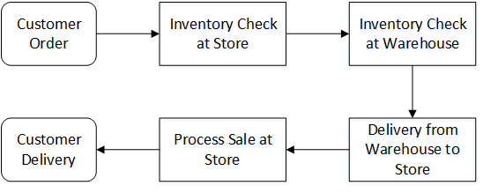

Figure 2. Process Flow for transaction with order exceeding on-hand inventory with stock in warehouse.

Two events may happen shown in Figure 2 is in the event that order exceeds on-hand inventory and an order can be placed in the warehouse. This means an additional 1-day lead time is added to the process is the customer is willing to wait. Figure 3 shows the least desirable process flow and the event of which this study is trying to reduce in occurrences, if not entirely, omit.

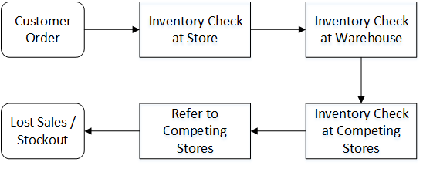

Figure 3. Process Flow that leads to stockout.

As seen in Figure 3, if an order cannot be placed in the warehouse then Hirac Tiles Center is forced to inquire to their competing stores, and purchase the item with a markup, leaving them with a smaller profit margin. The management has already expressed that they want to omit this practice but values their customers highly since they are still in the growth phase of their business. This incurs an additional Php 100.00 for the pickup of the items from the competing store and the additional cost from buying outside.

# SWOT Analysis

Strengths

Modern affordable tiles

Distributor of Caida Tiles

Quality Products and Service

Competitively low prices

Active Marketing Modules

Weakness

Delays on retrieving inventory data

Overstock and stock outs of some items

Opportunities

Wide Range of products

One-stop shop for Home Builders

Affordable Bath and tile packages

Threats

Insurance Coverage Limitation

Competitor has a substitute Product

Competitors competes aggressively with marketing activities

SWOT

# Objectives

The main objective of this project is to create an Inventory Management System. The proposed system will lessen the 10% gap of mis-product that the company is having issues with and increase the gain while lessening the cost caused by the issue. By this, the team would want to make this system automated to further enhance the purchase and track the inventory system so that the company may benefit from all of their products and would be convenient for the company to use.

# Gap Analysis

|  |  |  |  |  |  |
| --- | --- | --- | --- | --- | --- |
| Objective | Current State | Future State | Gap Identification | Gap Description | Factors |
| To decrease paper based processes. | Manual loging of sales invoices | Real-time and automated processing | Yes | There is more than 75% difference from the aim | there is no system at all |
| To develop online inventory system | the stockmen need to go to the stockroom to check stocks | the system would provide an online module for inventory | yes | there is more than 70% difference from the aim | the staff got use to the manual process |
| to develop a system for ordering | the store need to have stock outs first before ordering from warehouse | the system will provide an online processing from the current inventory and suggest what to order | yes | there is 60% -80% difference from the aim | the staff got used to the manual way of ordering |

# Scope and Limitations

For this project proposal, the team would only focus on the operations of Hirac Tiles Center Bicutan. The proposed system will only be used by the store. The company has a computer and all warehouse has one, so the team plans on creating a cloud-based system. For educational purposes, the system would be only focusing for the inventory system that would track and manage the system whenever there is a purchase.

# Review of Related Literature

## Demand Forecasting: Concept, Significance, Objectives, and Factors

According to the article, Evan J. Douglas stated that “Demand estimation (forecasting) may be defined as a process of finding values for demand in future periods.” According to Cundiff and Stiff, “Demand forecasting is an estimate of sales during a specified future period based on the proposed marketing plan and a set of particular uncontrollable and competitive forces.” With demand forecasting, it enables businesses to have better decisions when it comes to production planning such as purchasing materials, managing funds, and pricing a product. Demand forecasting also helps businesses to clarify their objectives. Once a business reviews the demand forecast, they can correct their previous objectives, so that it will reduce risks of recession. Demand forecasting also provide assistance when it comes to budgeting, employment and production management, decision making, and performance evaluation of the company. Demand forecasting may also vary, as it has many factors that affects its behavior, such as types & price of the products, competition level of technology, and economic viewpoint.

As mentioned, demand forecasting is one of the main feature of the team’s proposed system. With the implementation of demand forecasting in the proposed system, the client’s business will have better understanding of the behavior of demand in the industry, which will result to improved inventory management, safety stock management, and budgeting.

## How Inventory System Software Help Reduce Cost

According to the article, having an inventory management is one of the most challenging elements in running a small business. Without this, businesses can expect hidden costs, such as excess inventory and imported products, that can be the root cause of the business’ budget. With this, the article discusses the effects of investing on an inventory system in a business. Inventory systems lessen excess work and error. It provides accurate information throughout the inventory’s life cycle. Inventory systems provides effective control. It has accurate tracking of the inventory levels, which can help avoid shortage and costly overstock. It can also be implemented within other devices such as mobile devices. With Inventory systems, businesses can identify priorities that needs to be resolved, which results to preventing mismanagement of cash flow. And finally, Inventory systems provide accurate order and shipment information that lessen errors. According to an article from Entrepreneur, “companies can increase their profitability 20 to 50 percent or more through careful inventory management”. One of the objectives of the proposed project is to provide the client better control in their inventory. This includes tracking and managing their inventory levels. This article shows the relevance of having an inventory management system, even in small businesses. It proves that investing in an inventory management system can help reduce hidden costs that most businesses don’t notice.

## Similar Systems

TradeGecko – Inventory Management System

TradeGecko’s Inventory Management System is perfect for brand owners that are into selling wholesale or direct to consumer eCommerce business. This lets small business owners manage inventory, order, and customers from one place. It allows owners take orders, sell more, and work smarter. With this, owners can now focus on growing their own eCommerce or whole sale distribution. It features functions such as Inventory Control, Optimization, purchasing, backordering, and many more. The difference of the team’s proposed system is that it will be implemented as a cloud-based system, which will offer more scalability and accessibility for the client.

Finale Inventory

Finale Inventory is a cloud-based inventory management system that is easy to use for business owners and adopt to what the business needs. It can be accessed through a web browser or mobile device from anywhere, which will give accessibility to employees in different places while showing exact and accurate view of inventory information. Finale supports barcoding, Quickbooks, serial numbers, custom reports, multi-channel e-commerce, ShipStation, and a broad range of features for warehouse management. Although it’s the same as the team’s proposed system, as it is cloud based, it lacks one of the main features, which is demand forecasting.

With these existing systems, this will serve as basis for the team’s proposed system, as well as a support for the feasibility of the team’s proposed system and study.

# Technical Background

## Business Analytics

According to techtarget.com, Business Analytics (BA) is the practice of iterative, methodical exploration of an organization’s data, with an emphasis on statistical analysis. Business analytics is used by companies, committed to data-driven decision making. Business Analytics is used to gather data and formulate insights that will help business decisions and can be used automate and optimize business processes

Since the team is dealing with a problem within the client business, the team wants to integrate business analytics to the proposed system as the basis its features, which is demand forecasting. With Business Analytics, the team will require data from the business, and apply Predictive Analytics, which is a type of BA that analyzes trend data or historical data to assess the likelihood of future outcomes. After analyzing the data, the proposed system will generate reports that will serve as a helping tool to assists the client’s business to make better business decisions.

## Forecasting

## 

Forecasting is the process of analyzing historical data to determine a specific demand that may happen in the future. Businesses use forecasting to predict things such as stocks and sales demand depending on the historical data obtained, customer behavior (through surveys), time, specific events (e.g. Holidays). These greatly affects the outcome of the forecasting. Yet, the output of the forecast is not used in the first place, hence, the business observes and compare the forecasted result and the actual result. After that, the business will finally formulate a better strategy based on the comparison of results for better decision making.

There are two types of forecasting techniques which company analysts use to suit the data they have, and forecast demand. Qualitative forecasting is a technique where an analyst uses surveys to formulate forecasting output, which can be the basis of the analysts educated guess. Quantitative forecasting is a technique used by analysts.

## Visual Basic .NET

Visual Basic .Net is an object-oriented programming language developed my Microsoft. According to Wikipedia, it is a multi-paradigm, object-oriented programming language, implemented on the .NET Framework. .NET Framework is a software network developed by Microsoft, which offers a list of class library and offers language interoperability, which means that two different programming languages will be able to interact natively. To use Visual Basic .NET, it is required to have Microsoft’s integrated development environment (IDE), which is Visual Studio.

Visual Basic .NET is an ideal programming language for the development of the proposed system, since it made for beginner, which means that the syntax and terms won’t be as hard to be manipulate. With this, the team can import custom designs, to further improve the interface of the proposed system

## Database

A database is an assembly of information that is organized according to its type. With this, users can easily access, manage, and update their information. Databases are formatted by rows and columns, typically integrated in tables, schemas, queries, reports, views, and other objects. When handling big data, it is often suggested to integrate a database, since it will help present information in a more organized way.

For the proposed project, a database is required, since the team will be handling a lot of the data coming from the client’s business. Integrating a database in the system means that the system will be able to store and organize data properly and efficiently. This will give store employees easy access to product information such as product code, date delivered, quantity, description, etc.

## PHP: Hypertext Preprocessor (PHP)

According to php developers, PHP :Hypertext Preprocessor (PHP) is a widely used open source scripting language that is especially suited for web development and can be embedded into HTML. PHP scripting is used in 3 areas. Server side scripting, Command line scripting and desktop application scripting. These can collect form data, generate dynamic page content, and create/receive cookies. In addition, PHP can be used in every operating systems, including Linux. This means that you have the freedom to choose which operating system and web server. With PHP, the user is also not limited with the HTML output.

## Hyper Text Markup Language (HTML)

According to php developers, PHP: Hypertext Preprocessor (PHP) is a widely used open source scripting language that is especially suited for web development and can be embedded into HTML. PHP scripting is used in 3 areas. Server side scripting, Command line scripting and desktop application scripting. These can collect form data, generate dynamic page content, and create/receive cookies. In addition, PHP can be used in every operating systems, including Linux. This means that you have the freedom to choose which operating system and web server. With PHP, the user is also not limited with the HTML output.

# Design and Methodology

## Event Table

## Context Diagram

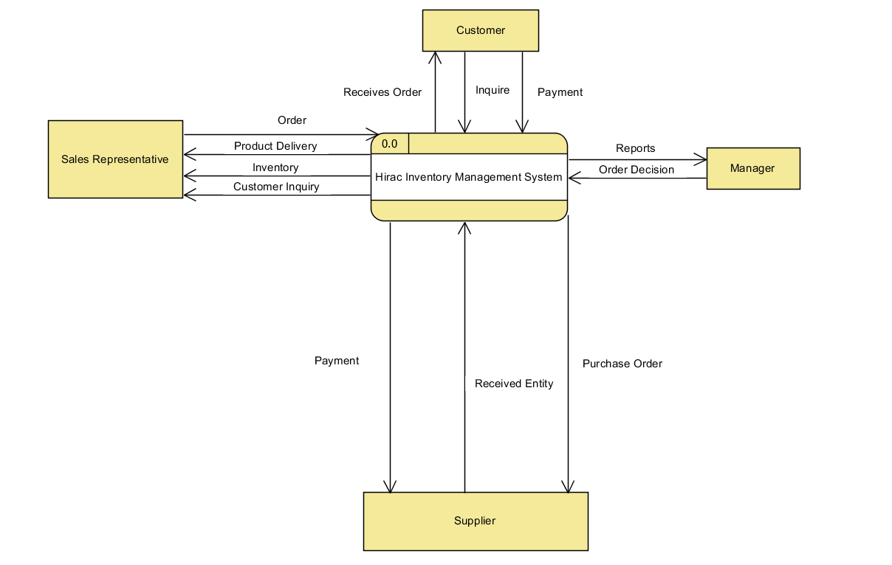

## Level 0 Diagram

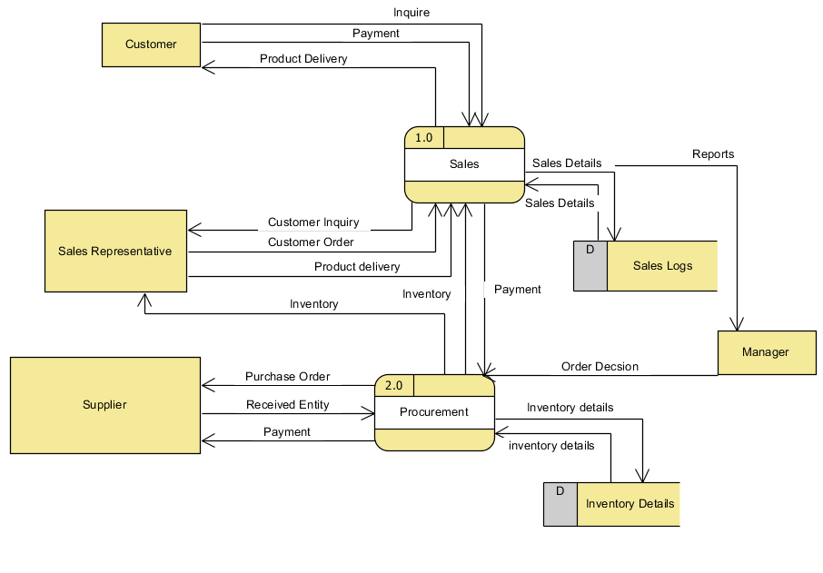

## Functional Decomposition Diagram

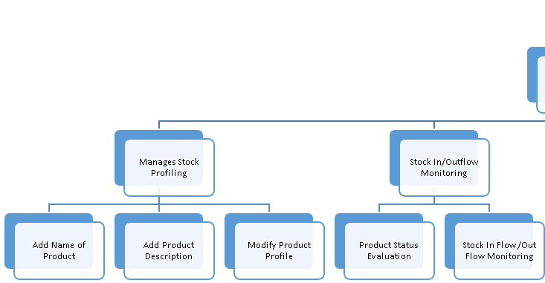

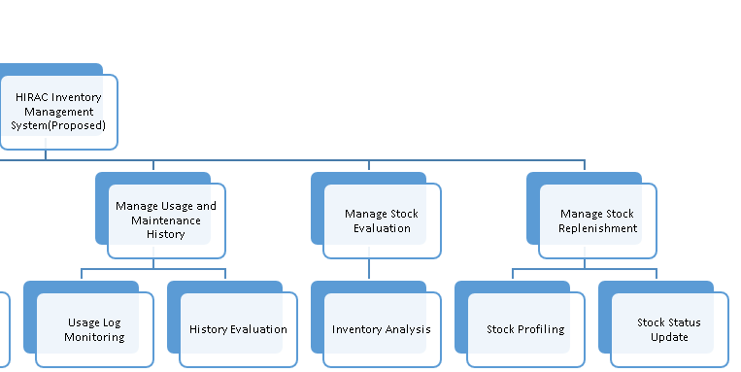

## Use Case Diagram

## 

## Full Use Case Description

|  |  |  |
| --- | --- | --- |
| Use Case Name: | **Look up Item availability** | |
| Scenario: | **Customer inquires Sales Representative for item availability** | |
| Triggering Event: | **Item availability inquiry** | |
| Brief Description: | **Customer inquires Sales Representative for Item availability. Sales Representative then uses system to check item availability** | |
| Actors: | **Customer & Sales Representative** | |
| Related Use Case: | **Calculate total amount, Print official receipt** | |
| Stakeholders: | **System** | |
| Preconditions: | **The item being search must exist within the business & the system’s database.** | |
| Postconditions: | **The system must display the information of the searched item.** | |
| Flow of Activities: | Actor | System |
| 1. **Customer inquires Sales Representative for item availability** 2. **Sales Representative looks up Item in the system** 3. **Sales Representative prompt Customer about item availability** | * 1. **System searches for item**   2. **System display search results** |
| Exception Conditions: | **3.1 If the searched item is not available, the system will prompt the Sales Representative the user.** | |

|  |  |  |
| --- | --- | --- |
| Use Case Name: | **Calculate total amount/price** | |
| Scenario: | **Sales Representative processes customer order** | |
| Triggering Event: | **Process customer order** | |
| Brief Description: | **After customer finalizes the order, the Sales Representative processes the customer order. The system will calculate total amount to payed by the customer.** | |
| Actors: | **Sales Representative** | |
| Related Use Case: | **Look up item availability, Update inventory records, Print official receipt** | |
| Stakeholders: | **System** | |
| Preconditions: | **The item listed in the customer’s order must exist within the business & the system’s database.** | |
| Postconditions: | **Based on the items listed in the customer’s order, the system must calculate the total amount to be payed, with the corresponding price of each item listed.** | |
| Flow of Activities: | Actor | System |
| 1. **Sales Representative processes customer order** | * 1. **System searches for the items listed in the order**   2. **System calculates the total amount to be payed**   3. **System displays total amount** |
| Exception Conditions: |  | |

|  |  |  |
| --- | --- | --- |
| Use Case Name: | **Update Inventory records** | |
| Scenario: | **System deducts items listed in the Customer’s order and updates the inventory records** | |
| Triggering Event: | **Deducted item** | |
| Brief Description: | **After the system calculates the total amount to payed, it updates the inventory records by deducting the item listed in the customer’s order.** | |
| Actors: |  | |
| Related Use Case: | **Calculate total amount, Print official receipt** | |
| Stakeholders: | **System** | |
| Preconditions: | **The item listed in the customer’s order must exist within the business & the system’s database.** | |
| Postconditions: | **The system must deduct the item from the database and update the inventory records.** | |
| Flow of Activities: | Actor | System |
|  | * 1. **System deducts item from its inventory records**   2. **System updates inventory records and save it.** |
| Exception Conditions: |  | |

|  |  |  |
| --- | --- | --- |
| Use Case Name: | **Print official receipt** | |
| Scenario: | **Sales Representative receives payment** | |
| Triggering Event: | **Payment received** | |
| Brief Description: | **The customer gives the payment, and Sales Representative verify the payment. The system prints official receipt, which is given to the customer.** | |
| Actors: | **Customer, Sales Representative** | |
| Related Use Case: | **Look up item availability, Calculate total amount, Update Inventory records** | |
| Stakeholders: | **Customer** | |
| Preconditions: | **The Customer must pay the exact amount calculated by the system** | |
| Postconditions: | **The System must print out the official receipt of the transaction.** | |
| Flow of Activities: | Actor | System |
| 1. **Customer gives payment** 2. **Sales Representative verifies payment** | **2.1 System prints official receipt of the transaction** |
| Exception Conditions: |  | |

|  |  |  |
| --- | --- | --- |
| Use Case Name: | **Display stock status** | |
| Scenario: | **Manager inquire stock status** | |
| Triggering Event: | **Stock status inquiry** | |
| Brief Description: | **The Manager inquires for stock status. The system displays the stock status for each item in the inventory records** | |
| Actors: | **Manager,** | |
| Related Use Case: |  | |
| Stakeholders: | **Manager** | |
| Preconditions: | **The Customer must pay the exact amount calculated by the system** | |
| Postconditions: | **The System must display the stock status of the inventory** | |
| Flow of Activities: | Actor | System |
| 1. **Manager inquires for stock status** | * 1. **System receive inquiry request for stock status**   2. **System displays current stock status for each item** |
| Exception Conditions: |  | |

|  |  |  |
| --- | --- | --- |
| Use Case Name: | **Generate reorder notification** | |
| Scenario: | **Stock reaches minimum quantity** | |
| Triggering Event: | **Stock minimum quantity** | |
| Brief Description: | **When the stock reaches minimum quantity, the system generates a reorder notification to the Manager.** | |
| Actors: | **Manager, System** | |
| Related Use Case: | **Send order request** | |
| Stakeholders: | **System, Manager** | |
| Preconditions: | **An item must reach the minimum quantity threshold set by the manager.** | |
| Postconditions: | **The System must generate a reorder notification.** | |
| Flow of Activities: | Actor | System |
| 1. **Item reaches minimum quantity** 2. **Manager receives reorder notification** | * 1. **System generates a reorder notification**   2. **System sends notification to the Manager** |
| Exception Conditions: |  | |

|  |  |  |
| --- | --- | --- |
| Use Case Name: | **Send order request** | |
| Scenario: | **System prompts Manager if it will send order request to its supplier** | |
| Triggering Event: | **Prompt to send order request** | |
| Brief Description: | **After the system sends reorder notification to manager, it will now prompt if the he/she wants to send an order request to the Supplier.** | |
| Actors: | **Manager, System** | |
| Related Use Case: | **Generate reorder notification** | |
| Stakeholders: | **Supplier, Manager, System** | |
| Preconditions: | **The system must generate a reorder notification first, before prompting the manager to send order request.** | |
| Postconditions: | **The System must prompt the Manager first, before sending an order request to the supplier.** | |
| Flow of Activities: | Actor | System |
| 1. **System prompts the manager to send order request to the Supplier** 2. **Manager confirms to send order request** | **2.1 System sends order request to the Supplier** |
| Exception Conditions: | **If the manager does not confirm to send order request, the system will not send it to the Supplier** | |

|  |  |  |
| --- | --- | --- |
| Use Case Name: | **Add to inventory records** | |
| Scenario: | **Supplier delivers purchased goods** | |
| Triggering Event: | **Delivery of purchased goods** | |
| Brief Description: | **After the system sends an order request to the Supplier, the goods are procured, and the system adds it in the inventory records** | |
| Actors: | **Supplier** | |
| Related Use Case: | **Send order request** | |
| Stakeholders: | **Supplier, System** | |
| Preconditions: | **Supplier must receive order request before delivery of goods** | |
| Postconditions: | **The System must add the delivered goods to the inventory records** | |
| Flow of Activities: | Actor | System |
| 1. **Supplier receives order request** 2. **Supplier delivers goods** 3. **Manager gives payment** | **3.1 System adds goods to the inventory records** |
| Exception Conditions: |  | |

## Entity Relationship Diagram

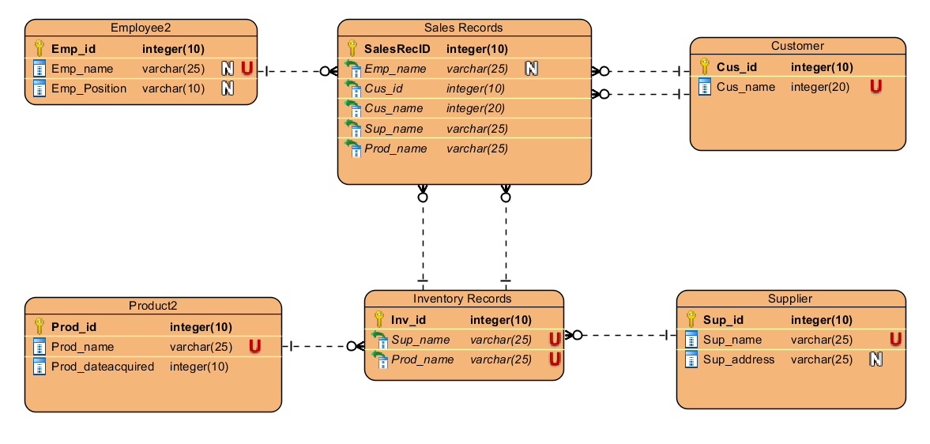

## Activity Diagram

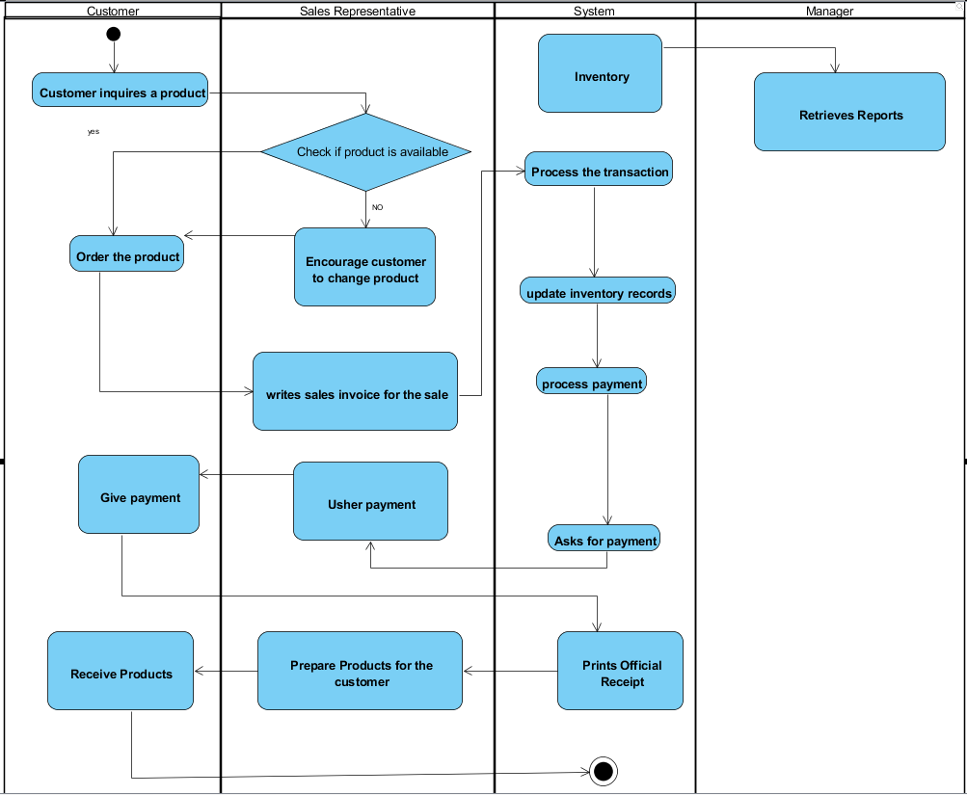

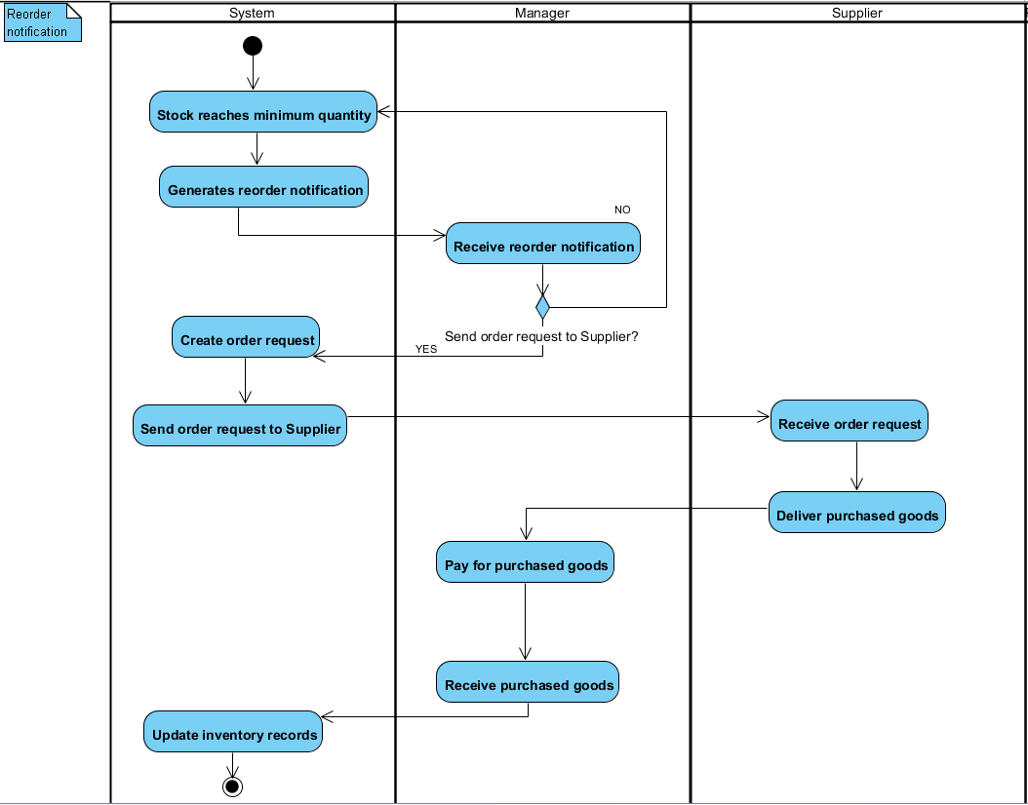

## Sequence Diagram

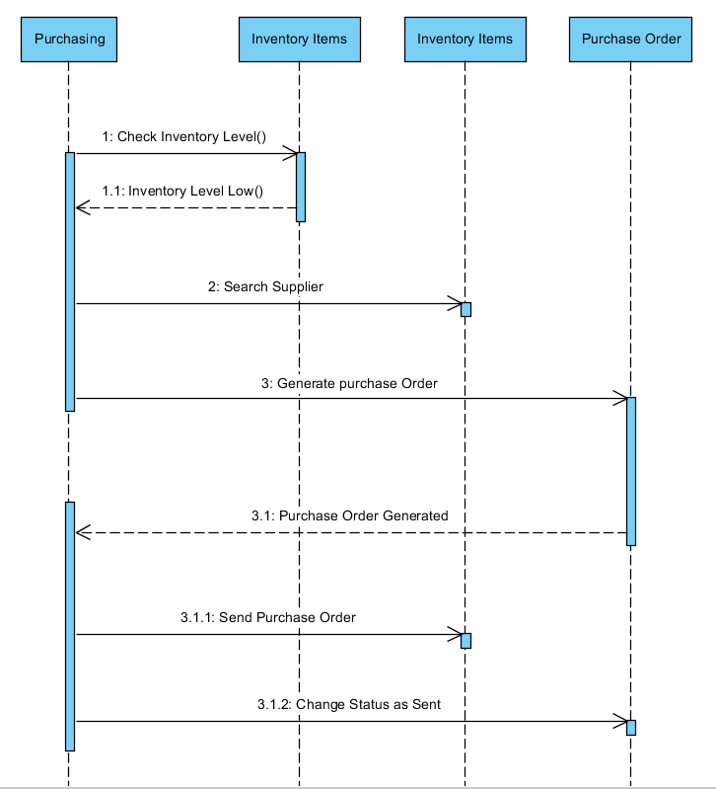

## Object Diagram

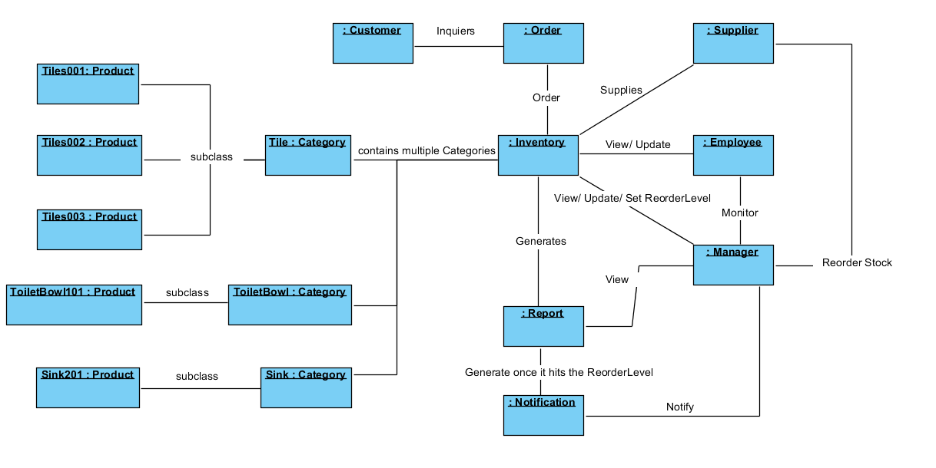

## Class Diagram

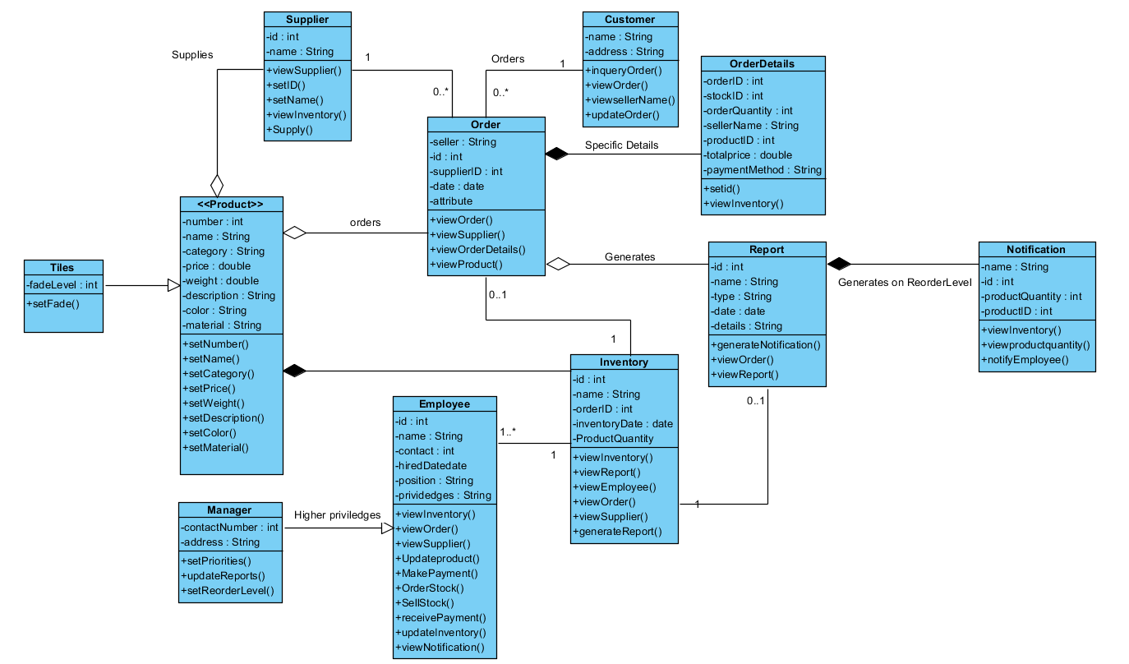

# Bibliography

* Demand Forecasting: Concept, Significance, Objectives and Factors. (2015, August 11). Retrieved September 21, 2017, from http://www.economicsdiscussion.net/demand-forecasting/demand-forecasting-concept-significance-objectives-and-factors/355
* 3 Reasons Why You Need Automated Inventory Management and ... (n.d.). Retrieved September 21, 2017, from https://www.bing.com/cr?IG=B5ED325487E94642A43BC523F6949151&CID=3A6BFBFCC08A6F170E3EF0F8C18C6E1B&rd=1&h=gi9ovQWY1l62ZXC2SYYO-Dxj1XRivxFZWMlKiJZMd1s&v=1&r=https%3a%2f%2fwww.stitchlabs.com%2fblog%2f3-reasons-why-you-need-automated-inventory-reporting%2f&p=DevEx,5064.1
* Tolhurst, C. (2013, July 17). How Inventory System Software Can Help Reduce Costs. Retrieved September 21, 2017, from http://www.business.org/software/inventory/how-inventory-system-software-can-help-reduce-costs/
* Techniques of Demand Forecasting (Survey and Statistical Methods). (2015, August 11). Retrieved September 21, 2017, from http://www.economicsdiscussion.net/demand-forecasting/techniques-of-demand-forecasting-survey-and-statistical-methods/3611
* T. (n.d.). TradeGecko - Inventory management system. Retrieved September 21, 2017, from https://www.tradegecko.com/product-tour/inventory-management-system
* Cloud Inventory ManagementFor Your Growing Business. (n.d.). Retrieved September 21, 2017, from http://www.finaleinventory.com/
* Visual Basic .NET. (2017, September 19). Retrieved September 21, 2017, from https://en.wikipedia.org/wiki/Visual_Basic_.NET
* (n.d.). Retrieved September 21, 2017, from https://msdn.microsoft.com/en-us/library/aa903378(v=vs.71).aspx
* Database. (2017, September 20). Retrieved September 21, 2017, from https://en.wikipedia.org/wiki/Database
* What is business analytics (BA)? - Definition from WhatIs.com. (n.d.). Retrieved September 21, 2017, from http://searchbusinessanalytics.techtarget.com/definition/business-analytics-BA
* What is Marketing Analytics. (n.d.). Retrieved September 21, 2017, from https://www.sas.com/en_ph/insights/marketing/marketing-analytics.html
* Staff, I. (2015, June 05). Forecasting. Retrieved September 21, 2017, from http://www.investopedia.com/terms/f/forecasting.asp
* Introduction to HTML. (n.d.). Retrieved September 21, 2017, from https://developer.mozilla.org/en-US/docs/Learn/HTML/Introduction_to_HTML