**Software Requirements Specification**

**PNP Camp Crame reservation facility office**

**Quezon City**

**Team Members:**

Jericho Ramit M. Marvin

Rollie P. Altea Jr.

Mark Ferdinand Almuete

Kathleen G. Seagan

**Date**

February 8, 2017

Table of Contents

Table of Contents 2

1. Introduction3

1.1 Purpose3

1.2 Document Conventions3

1.3 Intended Audience and Reading Suggestions3

1.4 Scope3

2. Overall Description 4

2.1 Product Perspective4

2.2 Product Functions5

2.3 User Classes and Characteristics6

2.4 Operating Environment6

2.5 Design and Implementation Constraints7

2.6 User Documentation7

2.7 Assumptions and Dependencies7

3. External Interface Requirements8

3.1 User Interfaces8

3.2 Hardware Interfaces8

3.3 Software Interfaces8

3.4 Communications Interfaces8

4. System Features8

4.1 System Feature 18

4.2 System Feature 2 (and so on).8

5. Other Nonfunctional Requirements8

5.1 Performance Requirements8

5.2 Safety Requirements.8

5.3 Security Requirements8

5.4 Software Quality Attributes8

5.5 Business Rules9

6. Other Requirements9

**1. Introduction**

**1.1 Purpose**

The purpose of Software Requirement Specification (SRS) is to deliver a detailed explanation of the system requirements, user specifications, and functionalities to implement the PNP Camp Crame Facility Reservation System. In this way, the team and the client will have a clear understanding about the project objectives.

**1.2 Document Conventions**

The team uses a simple format in creating this SRS. Bold font style was used on highlighted topics, while the rest of document was transcribed using the standard font, New Times Roman.

**Acronym and Abbreviations:**

* SRS: Software Requirement Specification

**1.3 Intended Audience and Reading Suggestions**

The target readers of the SRS document are the following entities:

System Developers – pertains to the developers of this project. This may serve as their guide and reference as it records all pertinent information about the system.

Documenter – this may serve as their guide in creating user manual, flow charts and other documents that are necessary for this project.

Testers – they may use this document as their reference in testing the system.

Users – pertains to the user of this system. This document may serve as their guide in navigating the system to fully understand the flow of the process.

**1.4 Scope**

The PNP Camp Crame Facility Reservation System aims to expedite the process of reserving a certain facility and provide a simplified yet user-friendly approach for both existing and potential customers. The system will show up-to-date availability of the facility and will handle cancellation, booking and modification. This will give PNP facility customers the ability to reserve a facility anytime and anywhere. It will also minimize the workload of the facility management staffs, as all data will be automated and centralized.

**2. Overall Description**

**2.1 Product Perspective**

The PNP Camp Crame Facility Reservation System is an online reservation system that aims to improve the existing manual process in reserving facilities at the PNP Camp Crame Facility Reservation Office. This will enable its users to manage their reservation conveniently, as the process will be done online.

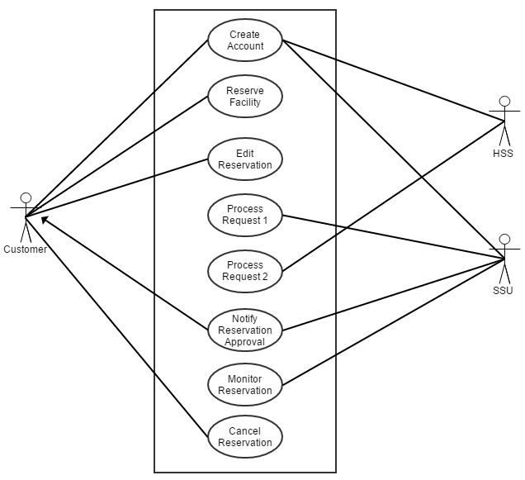

**2.2 Product Functions**

The PNP Camp Crame Facility Reservation System is developed to provide faster and reliable way of reserving a certain facility at the PNP Camp Crame. The target users of this system are the following:

1. Customers
2. HSS
3. SSU

Each user must have an account to be able to access the system.

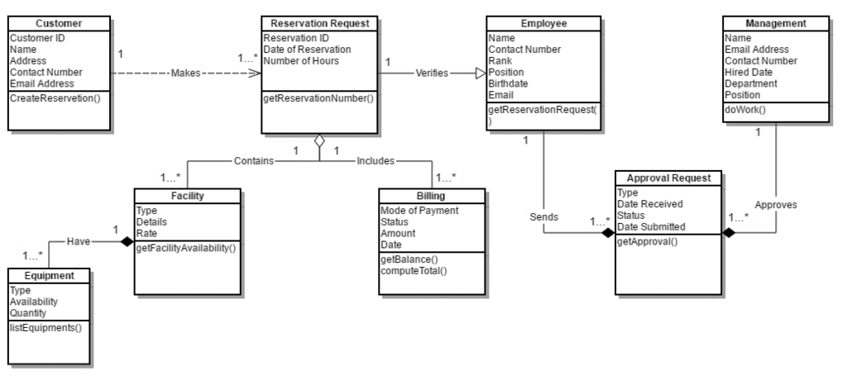

**2.3 User Classes and Characteristics**

There are three users expected to utilize the PNP Camp Crame Facility Reservation System. Below are the target users and their respective activities.

|  |  |
| --- | --- |
| USER | Activities |
| Customer | *Creates an account *Views availability *Reserves a facility * Monitors the status of the reservation. *Cancels a reservation |
| SSU | *Creates an account *Views availability * Edits facility availability *Reviews reservation |
| HSS | *Creates an account *Views availability *Reviews reservation * Approves/Declines reservation request |

**2.4 Operating Environment**

OE_1: The PNP Camp Crame Facility Reservation System should be working with any web browsers. It is recommended but not necessary to use the latest version of the web browser for faster and reliable operation.

OE_2: The PNP Camp Crame Facility Reservation System is developed to run on Windows, iOS, Linux.

OE_3: The PNP Camp Crame Facility Reservation System can be accessed by SSU and HSS. Registered customers will be given an access to the system with certain restrictions.

OE_4: Minimum hardware requirements: Dual Core 1.6GHz of faster. RAM: 1 gigabyte (GB) (32-bit) or 2 GB (64-bit).

**2.5 Design and Implementation Constraints**

Although the system is an upgraded method compared to current process of reserving a certain facility at the PNP Camp Crame, it is necessary for the system developers of this project to observe the guidelines provided by the clients.

* The system design must meet the standards provided by the client.
* System functionalities will be developed upon the approval of the client.
* The system uses PhpmyAdmin MySQL for the database.
* The system uses Yii2 (advance template) and Admin LTE (theme in backend) to build the system.

**2.6 User Documentation**

<List the user documentation components (such as user manuals, on-line help, and tutorials) that will be delivered along with the software. Identify any known user documentation delivery formats or standards.>

Software Requirements Specification for <Project> Page 3

**2.7 Assumptions and Dependencies**

The PNP Camp Crame Facility Reservation System is best to navigate through PCs and Laptops. This maywork on mobile phones that have advance features i.e. IOS 8 and above, IOS Marshmallow and etc.

**3. External Interface Requirements**

3.1 User Interfaces

**4. System Features**

**5. Other Nonfunctional Requirements**

**5.1 Performance Requirements**

-       The system should work on Should work on IE Mozilla Firefox Google chrome

-       The application should be flexible for future enhancements.

- Multiple connections to the system at the same time should not slow down the application to a large degree.

**5.2 Safety Requirements**

Customers will only be allowed to access certain features. The system will secure all outletsof each transaction that includes any confidential customer information. The system will automatically log out users after a certain period of inactivity.

**5.4 Software Quality Attributes**

**5.4.1 Security**

All users are required to have an account to be able to access The PNP Camp Crame Facility Reservation System. Users will be granted access to certain functionalities depending on their role.

**5.4.2 Reliability**

The system shall be a web-based application and has to be run from a web server.

**5.4.3 Scalability**

The online reservation system is designed to accommodate large number of users. Once the system implemented, it is expected to attract more customers since the process will become faster and more convenient.

**5.4.4 Availability**

Since this is an online system, reservation can be made anytime and anywhere.

**5.4.5 Responsiveness**

The performance shall depend upon hardware components of the users.

**5.5 Business Rules**

The use of The PNP Camp Crame Facility Reservation System should make way to a better, faster and reliable process of reserving a facility without neglecting the rules and regulations of the client. System designs and functionalities should meet the requirements of the client

**6. Other Requirements**

The team will require a facility reservation form sample from the PNP Camp Crame Facility Reservation Office. Sample request letter and approval letter should also be obtained from the client for reference purposes.