PhilCom Projects Monitoring System

Project Documentation Submitted
To the Faculty of School of
Computer Science and Information Technology
Of
Asia Pacific College

In Partial Fulfillment of the Requirements for the subject
Applied Projects 2 or Software Development

By

Ferrer, Christine Joy A.
Montalban, Adrianne J.
Andes, Mark Anthony S.

Table of Contents

Page no

PhilCom Projects Monitoring System 1
I.Narrative 3
A. Executive Summary 3
B. Introduction 3
1. Client Profile 3
2. Client’s Mission and Objectives 4
3. Project Objectives 4
4. Purpose of the Project 4
5. Rationale of the Project 5
a. The Current Process Flow 5
b. User Information Needs 5
c. How the Information is being processed 5
C. Systems Features and Functions 6
1. Software Environment 6
a. Programming Languages 6
b. Specific Software 6
c. Web Server Application 6
d. Operating System 6
e. Other Software 6
2. Hardware Environment 6
3. Networking and Security 6
a. Security 6
b. Server 6
4. Application System Modules 7
a. 7
b. 7
c. 7
d. 7
II.System Diagrams and Screenshots 7
A. Data Flow Diagrams 7
1. Context Level Data Flow Diagram 7
2. Level 0 Data Flow Diagram 8
B. UML Diagrams 8
C. Entity – Relationship Diagram 8
D. Data Dictionary 8
E. Screenshots 8
F. Lessons Learn 8
III. Appendices 8

Narrative

Executive Summary

PhilCom (Philippine Global Communications, Inc.) is a professional institution that is highly respected, profitable, and globally renowned among communication leaders. They are an institution empowered to deliver total business solutions through unparalleled communications services led by proactive and highly competent individuals who are quality-driven, exceptionally innovative and strongly committed to their stakeholders. Asia Pacific College students who are taking up Software Development offer them a new effective way to monitor their projects called PhilCom Projects Monitoring System (PPMS).
The PPMS is for viewing, editing, monitoring and reporting functions in the system. It contains list views of the project’s information, logs and weekly status reports. Regular employees and clients will be able to view the projects, status and the person-in-charge, but will have no permission to edit. The PIC can edit but are limited to certain fields. While, the PM department managers have the ability to view and edit all fields in the table. Status reports can be saved as excel and pdf documents for weekly reporting to the clients.

Introduction

Client Profile

Philippine Global Communications, Inc. (PhilCom) celebrates its 84th year in the industry by reaffirming its commitment to deliver innovative and cost-effective products and services to its customers. This is the core of PhilCom's management strategy. Since its inception in 1924, PhilCom has demonstrated the dynamism needed to respond to the constantly changing market place. PhilCom is known for having introduced a wealth of firsts in Philippine Telecommunications Industry.

Client’s Mission and Objectives

MISSION

PhilCom is a professional institution that is highly respected, profitable, and globally renowned among communication leaders.

VISION

We are an institution empowered to deliver total business solutions through unparalleled communications services led by proactive and highly competent individuals who are:

- Quality-driven
- Exceptionally Innovative and
- Strongly committed to their stakeholders.

Project Objectives

- Innovate and cost-effective services to clients
- Provide efficient way of monitoring and recording projects
- Manage and organize projects in one database
- Promote the system for the company to implement
- Impart less trouble in sending emails to the field to monitor each project.
- Increase productivity in terms of processing
- Improve their work quality.

Purpose of the Project

The system is for:
- Adding Project
- Automatically generates Project ID
- List view of all projects
- Add/Edit/Delete employees
- Date/Time automatic adjustment
- Automatic project status adjustment
- Project and Employee Logs
- Weekly Status reports

Rationale of the Project

The Current Process Flow
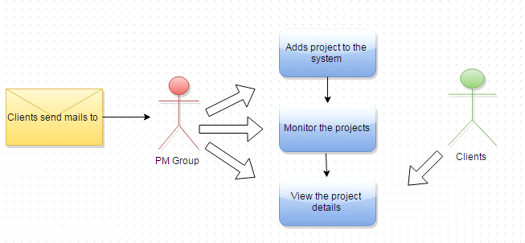

User Information Needs

- Project Code
- Account
- Project Name
- Site Name
- Person-in-Charge
- Milestone
- Contractor
- Percentage Remarks

How the Information is being processed

Systems Features and Functions

Software Environment

Programming Languages
- PHP
- HTML
- CSS
- JavaScript

Specific Software
- Xampp
- Yii 2.0 Framework
- MySql Workbench

Web Server Application
- Xampp

Operating System
- Windows
- Linux

Other Software
None

Hardware Environment
- Computer
- Laptop
- Mobile

Networking and Security

Security
- Preventing SQL Injection

Server

Application System Modules

System Diagrams and Screenshots

Data Flow Diagrams

Context Level Data Flow Diagram
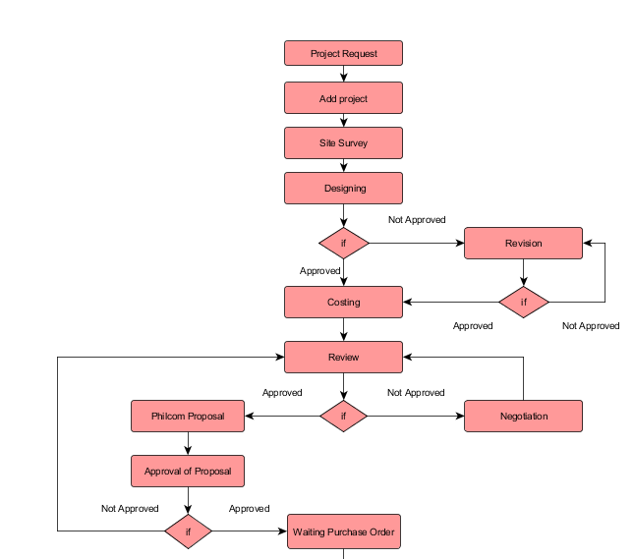

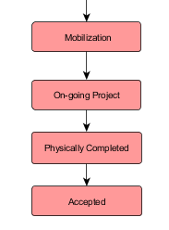

Level 0 Data Flow Diagram

UML Diagrams

Entity – Relationship Diagram
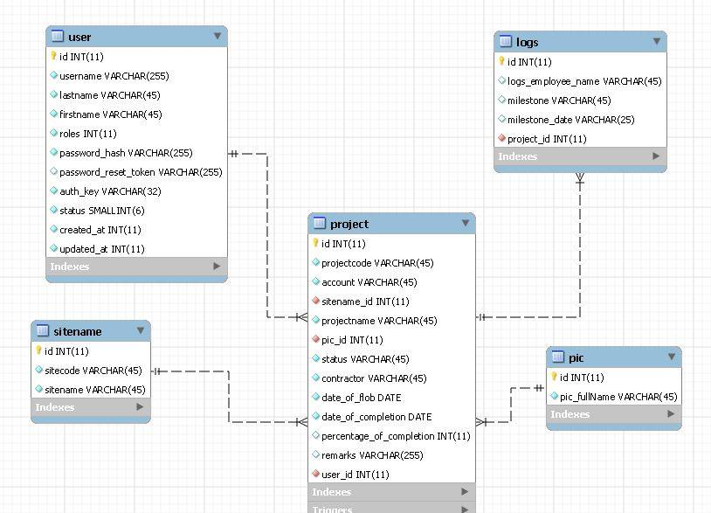

Data Dictionary

Screenshots

Lessons Learn

Appendices

- SRS
- Gantt chart
- Test Cases

- Activity list

Work Breakdown Structure
1.0 Initiation
1.1 Identify Project Team
1.2 Identify Stakeholder
1.3 Develop Project Charter
1.4 Project Kick-Off Meeting
1.5 Gather Information
2.0 Planning
2.1 Define Initial Requirements
2.2 Define System Requirements
2.3 Discuss Roles and Responsibilities
2.4 Create Preliminary Scope Statement
2.5 Schedule Task
2.5.1 Create Work Breakdown Structure
2.5.2 Prepare Gantt Chart
2.5.3 Develop Risk and Contingency Plan
3.0 Executing
3.1 Implementation of Scheduled Tasks
3.2.System Design
3.3 Procure Hardware/Software
3.4 Coding of the System
4.0 Monitoring and Controlling
4.1 Testing the System
4.2 Project Progress Reports
4.2.1 Issue Reports
4.2.2 Milestone Reports
5.0 Closing
5.1 Final Project Documentation
5.2 Final Project Presentation
5.3 Lesson Learned

- Admin/user manual

