**I. Introduction**

**1.1 Background of the Problem**

In Asia Pacific College (APC), there are various subjects offered. The school provides 12 or more terms that consists of various subjects. The units of the subjects depend on its weight and relevance to the student’s course. Those subjects are modifiable depending on different reasons. The process of modifying subjects is called a pre-registration. The system of pre-registration is currently manual, resulting to exerting more effort and consuming more time.

Advisers are professors assigned to approve pre-registration requests of students. In order to approve the requests, they sign the filled-up pre-registration form then updates the online assessment form. There are policies that the advisers follow to correctly update the students’ assessment form like there is maximum number of units for each student. But, since advisers and students are humans, exceptions can be made due to case-to-case basis. Another effect of being human is human errors. They tend to cause delay because of meticulous advising and prone to wrong decisions due to insufficient knowledge about the policies and biases. With those errors, more problems arise like congestion in terms of environment, where the office of the adviser becomes crowded because of large groups pre-registering at the same time and because of insufficient knowledge, the process delays and congestion in terms of workload, where jobs overload and more papers are used. More use of paper means increase in the expenses of the school, which is also considered to be a problem.

Automating nearly everything is getting popular nowadays, from queuing systems to making a cup of coffee, it’s about time that the pre-registration of APC gets automated. Automating the pre-registration process of APC would bring advantages to the APC Community.

**1.2 Statement of the Problem**

How can the current system of pre-registration be improved to better serve the students of APC?

**1.3 Objectives**

* To understand the flow of the current pre-registration process
* To look for sample algorithms that may serve as a basis for working on the project
* To improve the current pre-registration process
* To provide convenience to students and advisers
* To integrate the online pre-registration database to FLAVIO database
* To lessen the processing time of pre-registration by five percent (5%)
* To lessen the costs of papers by twenty percent (20%) due to the manual pre-registration

**1.4 Significance**

The FLAVIO Pre-registration can contribute to the APC community. It can help improve the current process of the school’s pre-registration system. The aspects looked into are the convenience of the students, the full potential of the school's online services and simplified tasks for the current manual process of the system.

**1.5 Scope and Limitations**

The online pre-registration project will be conducted inside Asia Pacific College, but the FLAVIO website can also be accessed outside. In order to access the website, authentication is required which are username and password for security purposes. The database of the online pre-registration and FLAVIO database will be integrated to have consistent and parallel information to avoid confusion in data.

Crashing of the website may be looked into by the group since it may be because of errors in the code and overloading of the website can be handled by the ITRO staff because they have access in the servers where the databases are located.

Also, the time it takes for the Program Directors to approve the requests depends on their availability, hence it is not counted as part of the processing time of the online pre-registration.

**II. Related Literature**

FLAVIO Pre-Registration System Project focuses on helping our school’s online services by adding the pre-registration function. The project has been planned not only for innovation purposes but also to assist the students of APC on handling their subjects. This would be a big help especially for those students who are having a hard time adding or dropping subjects to organize their schedule and units. after researching, the system that is similar to the project is the Online Hotel Reservation by Mr. CJ Palomo. The system is used for easier booking of room in the fastest way. Like the online pre-registration project, the system has features like Login Form, Registration Form, Booking, and Reservation Transaction. These features will be similar to what we will do on our project. Some functions that the online pre-registration will have are Registration Form, Subjects to be added, and Subjects to be dropped. (Retrieved on February 19, 2016 from http://www.sourcecodester.com/node/10082)

The decision of pursuing the FLAVIO Pre-Registration was made because of the feasibility and the maintenance will be easier to conduct as it is focused on database management and web programming. These services will be efficient by making the pre-registration process easier to use.

La Consolacion College, located in Laguna, previously had a manual enrollment system. Because of Mr. G. Pantino as Project Manager, Mr. J. Catalan as Software Lead, Ms. R. Lorezo as Quality Assurance Manager, Ms. J. Romero and Mr. J. Castillo as Junior Programmers, the online enrollment system was created. The objectives are to reduce the time consumed by enrolling, reduce the workload done by students and the registrar and to implement an organized record of the student’s enrollment transactions. The users that will benefit from the online system are La Consolacion’s students, professors and the school registrar. The data dictionary contains the entities, attributes, content, data type, format, a primary key and a foreign key. That information can guide the developers in creating the system’s database. Entity Relationship Diagram, Use Cases, Event Table, Activity Diagram and Data Flow Diagram are also created. (Retrieved on February 19, 2016 from http://projects2.apc.edu.ph/wiki/index.php/La_Consolacion_College_School_System)

The goals of La Consolacion College Enrollment System and FLAVIO Pre-Registration System Project are the same. The two systems goals are to reduce the time consumed by the process and to reduce the workload of the students and the registrar. The only difference of the systems is that La Consolacion College Enrollment System is for students to enroll in a set of classes while on the other hand, FLAVIO Pre-Registration System is for students to modify the subjects, depending on the reasons. La Consolacion College Enrollment System will be a good basis for the development of the FLAVIO Pre-Registration System.

Another project, GG Salon Scheduling System by Arjenelle Acabado and Jessa Jaramillo, students of Asia Pacific College, used databases and scheduling techniques similar to what we had in mind doing our project. They also had objectives similar to ours. They also aimed to improve on the current system of their client. Their goal was to also make the current system efficient and convenient for the users.(Retrieved on February 19, 2016 from http://projects2.apc.edu.ph/wiki/index.php/GG_Salon_Scheduling_System_-_Arjenelle_Acabado,_Jessa_Jaramillo)

**References:**

Acabado, A., & Jaramillo, J. (2013). GG Salon Scheduling System. Retrieved on February 19, 2016 from http://projects2.apc.edu.ph/wiki/index.php/GG_Salon_Scheduling_System_-_Arjenelle_Acabado,_Jessa_Jaramillo

Palomo, C.J. Hotel Reservation System. (2016). Retrieved on February 19, 2016 from http://www.sourcecodester.com/node/10082

Pantino, G., Catalan, J., Lorezo, R., Romero, J. & Castillo, J. (2011). La Consolacion College School System. Retrieved on February 19, 2016 from <http://projects2.apc.edu.ph/wiki/index.php/La_Consolacion_College_School_System>

**ERD**

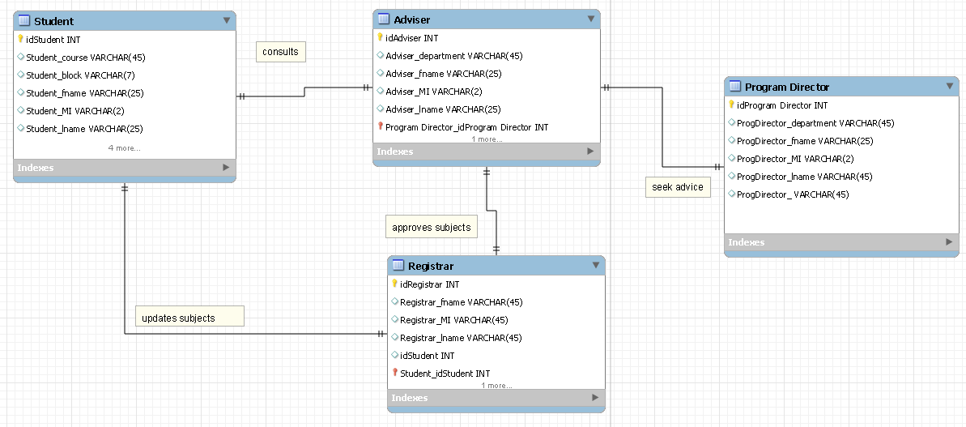

**Diagram 0 - Current Pre-Registration System in APC**

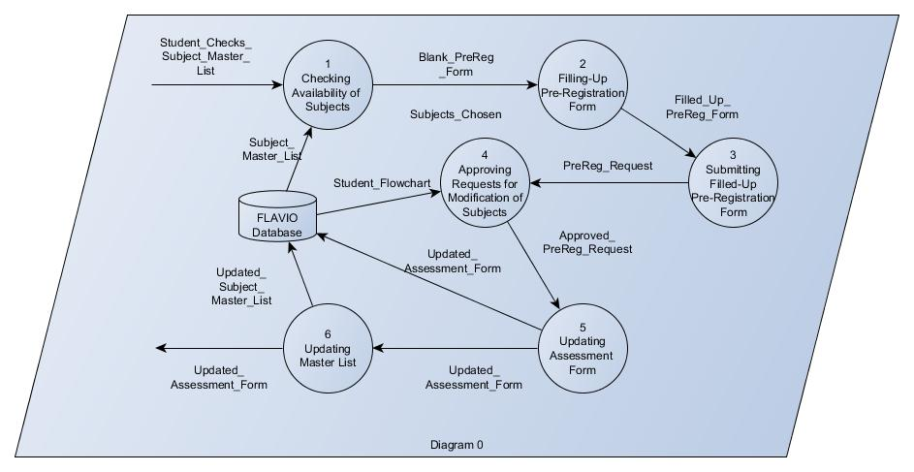

**Diagram 1 - Checking Availability of Subjects**

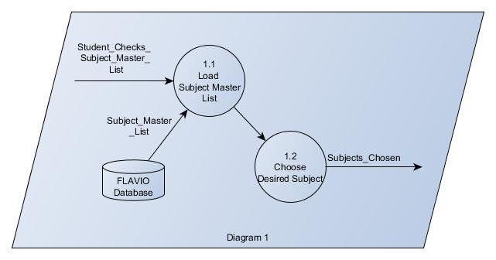

**Diagram 2 - Filling-up Pre-Registration Form**

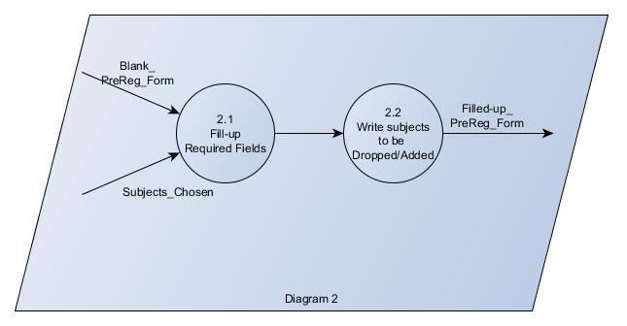

**Diagram 3 - Submitting Filled-up Pre-Registration Form**

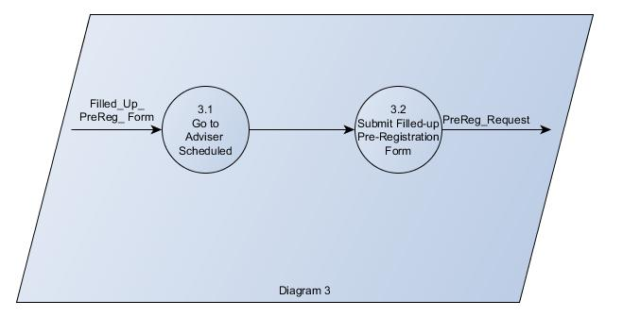

**Diagram 4 - Approving Requests for Modification of Subjects**

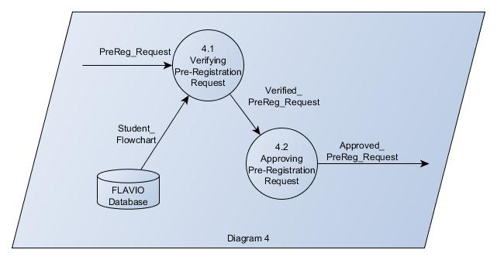

**Diagram 5 - Updating Assessment Form**

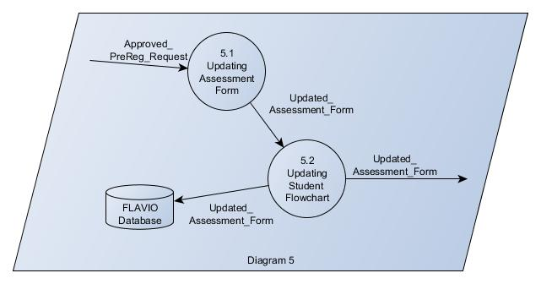

**Diagram 6 - Updating Subject Master List**

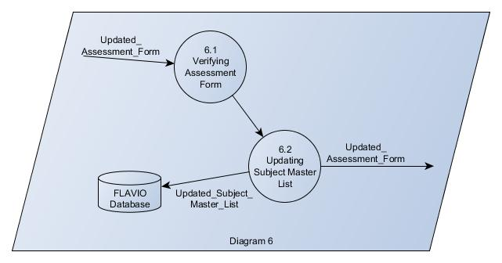

**Data Dictionary**

