Mikhaela Francesca G Pachico

SS141

CSPROJ

# phpMyAdmin

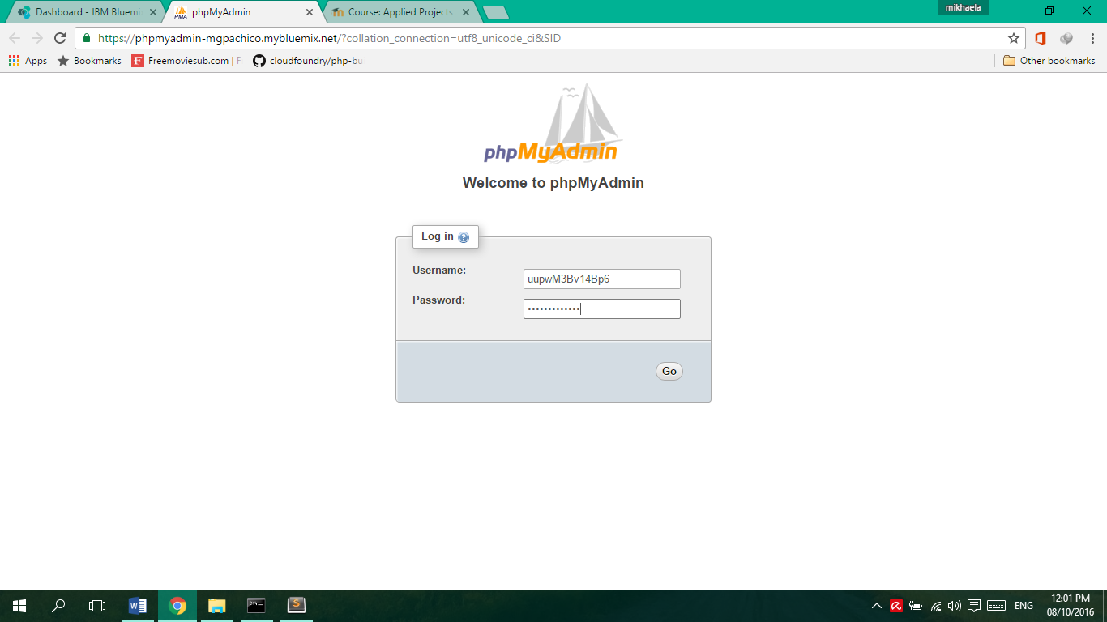<https://phpmyadmin-mgpachico.mybluemix.net/?collation_connection=utf8_unicode_ci&SID>

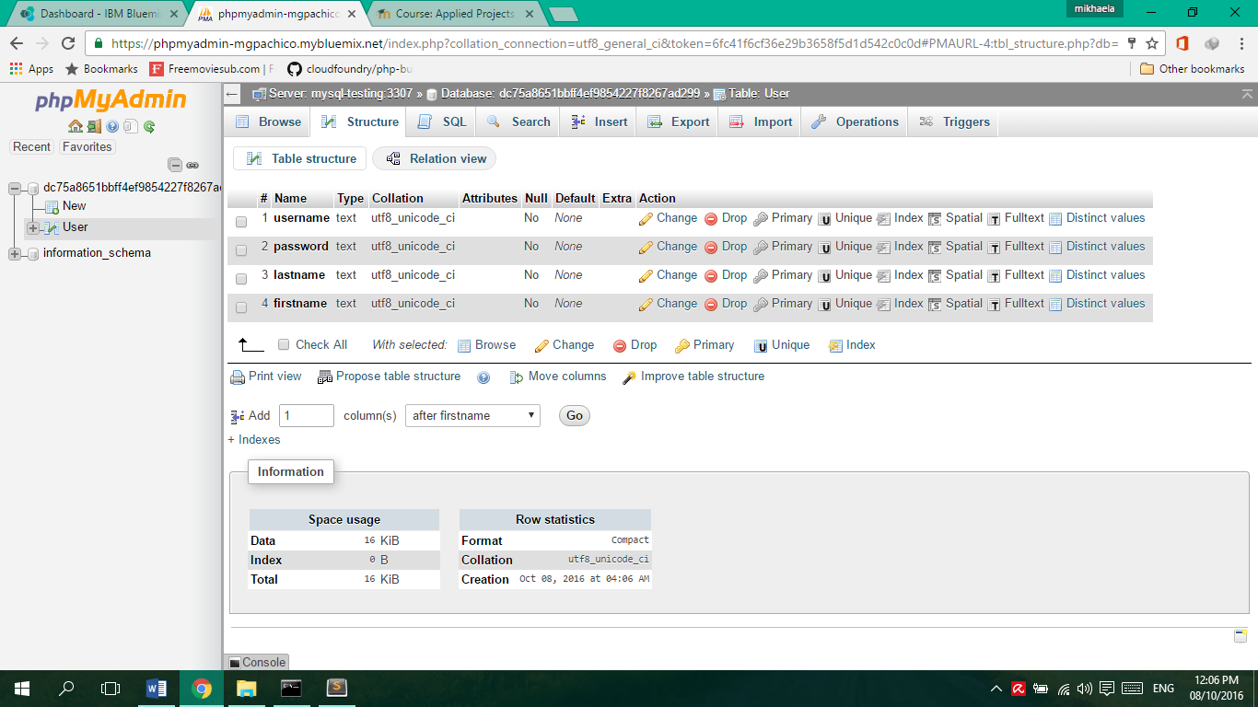

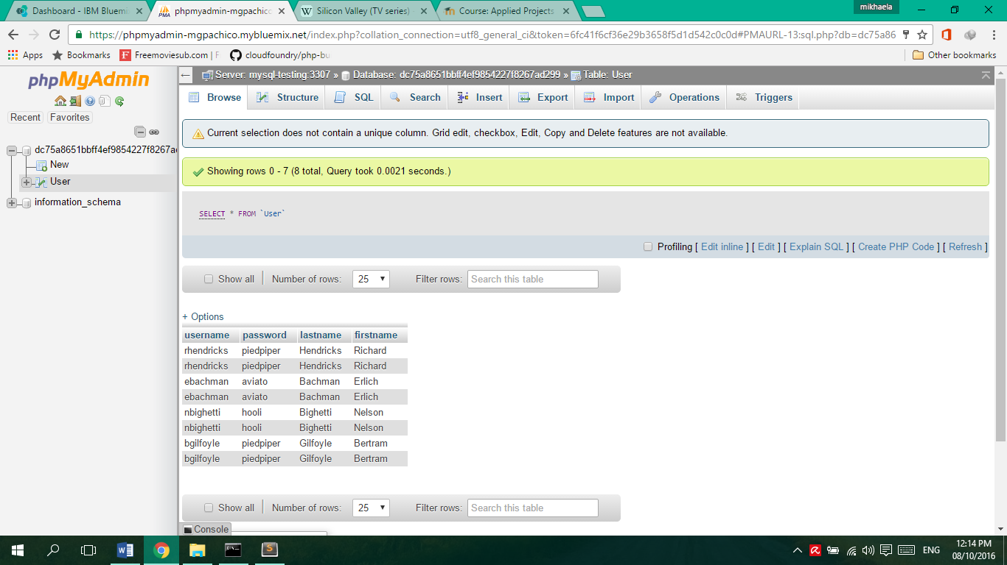

# samplephp

