What is the goal of the system?

The proposed system’s goal is to improve and make the customer service of a restaurant faster, particularly the order taking and billing process. For us to achieve our goal, we first identified the causes of delays in the restaurant’s current system of customer service. One of the causes of delays that we found was the structure and the workflow of the restaurant. The restaurant’s structure is wide and big. We think that the more steps it takes for the waiters to approach the cashier, cook and customers, the longer it takes for the order of customer to come. The customer have to wait several minutes for their order to be cooked because the waiter still needs to give the customer’s order slip to the cashier for it to be put in the POS, then to the chef for it to be cooked. Our idea is instead of the waiter bringing the order to the cook and cashier, the waiter can now serve another customer because the system will already bring the list of orders of the customer to the cook and cashier electronically. Another cause of delay is human error and manual order taking. The usual set up is that the customer will call a waiter for him to write his/her order. The waiter will write it in a piece of paper. Now, the problem here is when sometimes, the waiter/cashier/cook might lose the paper and when it happens, the order of a certain customer will not be processed. Another scenario is when the waiter wrote the wrong order of a customer, because of that the customer will wait for the order, and after minutes of waiting, he/she will find out that the order h/she said was not what he/she wanted. So they will order again and wait for several minutes, thus making the customer feel dismayed and unsatisfied. Another scenario is when the food is not available anymore and the cook didn’t tell it to the waiters. If a customer ordered for a certain food, the waiter will deliver the order slip to the cook, when the cook see’s the order, he will tell that the food is not available anymore and because of that the waiter need to go back and inform the customer and get another order from him/her. That scenario wastes several minutes. By pinpointing out the cause of delays, we think of a system that can help remove those delays so we proposed an order taking application system. The goal of this app as said earlier is to improve the billing and order taking process. The proposed system will shortened the travel time of waiters by making the workflow of the system short and by removing human errors as much as possible.

How will the system make the customer service faster?

The system will make the customer service faster by shortening the travel time of waiters by making the workflow shorter. The current set up of the restaurant is that the waiter will get the order of the customer and bring the order slip to the cashier and cook. The waiter still need to walk going to the cashier and cook before he can attend to another table to serve other customers. This is where the system comes in. the waiter will no longer need to bring the order slip to the cashier and cook. The waiter will now just enter the order of the customer to the system, once the customer inputs the orders, there will be a confirmation of the orders, and once it is entered the order will be sent to the cashier and cook, so no need for the waiter to travel, aside from that human error will not anymore be a factor because there’s no chance for the order to be wrong or lost. The waiter can now attend and serve other customers. The customer will now just have to wait for their food to arrive.

What are the available/similar technologies available?

There are some similar technologies that are existing. We can use this existing technologies as a basis on how we can build our system and we can use this to look on areas that we can enhance and improve for the System application that we are planning to do.

1. Singapore Mobile App (Big Spoon)

– This app acts as an ordering menu of the customers. With this in hand, the phone will be able to detect which restaurant is he/she in and formulate menus from the said restaurant.

http://bigspoon.sg/

2. BreadCrumb

- This flexible Ipad app provides real views of tables, catalogs the menu by a selection's name or ingredients, processes sales and delivery tickets and sends orders to the kitchen. The app also works with traditional receipt printers and cash drawers.

https://breadcrumb.com/

3. Servjoy

- This app was built especially for restaurant management purposes like guest seating, restaurant billing, order taking and priority of serve. This app also lets you customize the ingredients that you want on your food.

http://www.gofrugal.com/mobile/servjoy-kot-app.html

4. Touchbistro

- Lets the user customize the app for the restaurant. The user can make a menu for their customers to view, personalize, the design of the app on how the user wants to see it. It works just like Servjoy.

http://www.touchbistro.com/pos-solutions/restaurant-pos/

5. Chow Now

- An app that lets the customer order from the restaurant. It lets the customer view the menu outside the restaurant. The customer can use the app if he wants something from the restaurant and he/she can also choose the ingredients he want for a certain food. The customer can pick up the food or let it be delivered to him/her.

https://www.chownow.com/

How minutes can it saved?

By eliminating certain delays like order taking errors, staff incompetence and the time spent by servers running back and forth from the customer, cashier and cook, the estimated amount of time that can be saved by the system is 7-10 minutes. 7-10 minutes is a huge amount of time in business. Not just for business but for those people whose hungry or in a hurry to eat. This is just an estimated amount of time by comparing the timing diagram of the current order taking system of our client’s restaurant and the timing diagram of our proposed system.

Current Workflow of the Restaurant

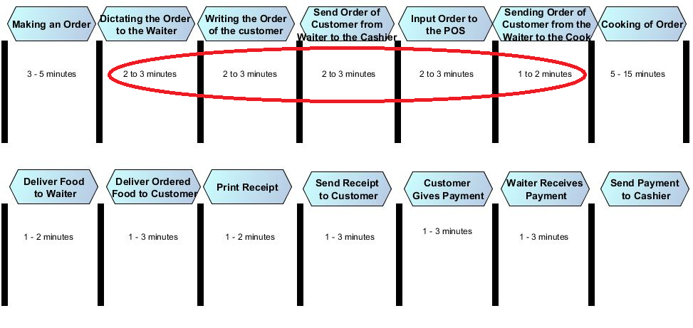

Workflow of the proposed system for the restaurant

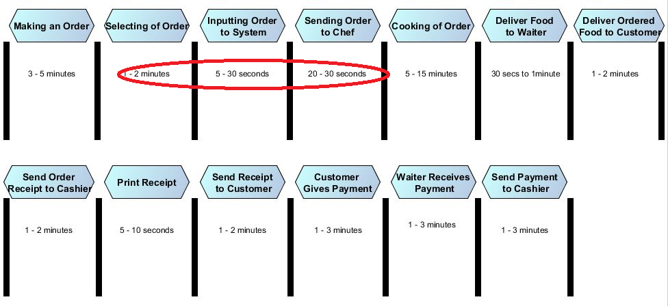

How efficient can the proposed system be?

The current order taking system of the restaurant takes about 17 to 36 minutes before the food can be delivered to the customer based on its timing diagram, and with the system that we are proposing it can be reduced to 10 to 26 minutes. The reduced waiting time will have a lot of positive effects.

* It will delight the customer, making them feel more satisfied
* Chance that these customers will come back again will increase
* The restaurant can entertain more customers
* Leads to more sales and income

Another scenario is sometimes, customers don’t eat on a restaurant when they see that it is too crowded and busy, where a lot of customers are waiting. The customers then will look for another restaurant where there are few people,where waiters can serve and accommodate them.

How much is the proposed system?

The proposed system will be around 12000 php to 17000 php. The package will include three tablets that approximately costs 5000 php. The 2000 php will be spent to other materials that we need for coding.