# Improving Internet Connection in APC

Project Documentation Submitted

To the Faculty of School of

Computer Science and Information Technology

Of

Asia Pacific College

In Partial Fulfillment of the Requirements for the subject

System Analysis Design 1 and Sytem Analysis Design 2

By

Paulo Capuz

Jefferson Gonzales

Genesis Diocampo

Table of Contents

Improving Internet Connection in APC 1

Abstract 3

List of Figures, List of Tables, List of Notations 3

I. Introduction 10

**1.1** **Background of the Problem** 10

**1.2** **Statement of the Problem** 10

**1.3** **Objectives** 10

General Objectives 10

Specific Objectives 10

**1.4** **Significance** 11

II. Scope and Limitations 11

III. Related Literature 11

**Bandwidth management in universities in Zimbabwe: Towards a responsible user base through effective policy implementation** 11

**Bandwidth Management and Quality of Service** 11

**A Control Approach to Bandwidth Management in Networked Control Systems** 12

IV. Theoretical Background 12

V. Proposed Solution to the Problem 12

# Abstract

This research was conducted to know how APC can improve internet connection. The researchers gathered information from school personnel regarding the current network structure, current user policies and a review of what seems to be the problem or what is currently happening in the network. The researchers sought for solutions by consulting networking experts to determine what could be done best and the results show that the use of VLANs, bandwidth management software, web cache, web filtering based on the user policy. We recommend utilizing a bandwidth manager software/firewall, because it is capable of doing most of the solutions proposed, we also recommend to better implement the current user policy.

# List of Figures, List of Tables, List of Notations

**Activity Diagram**

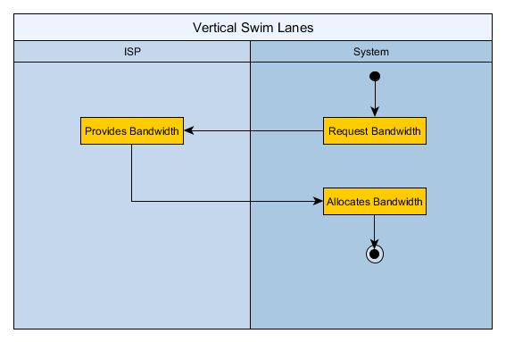

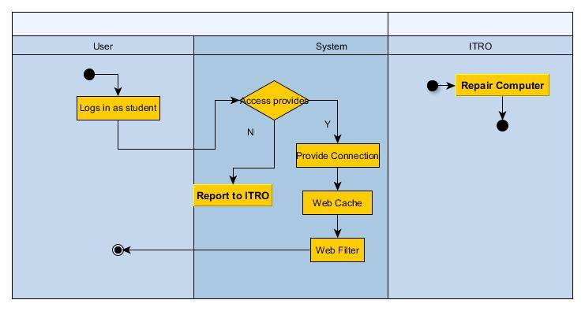

**Class Diagram**

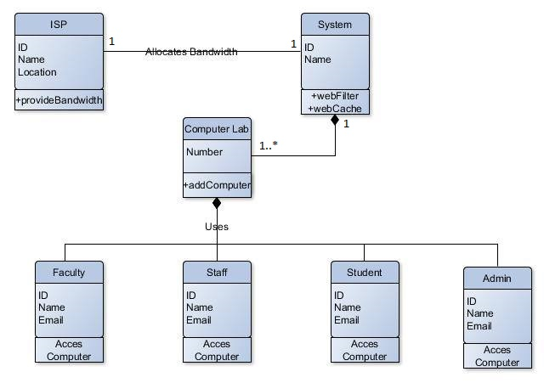

**Communication Diagram**

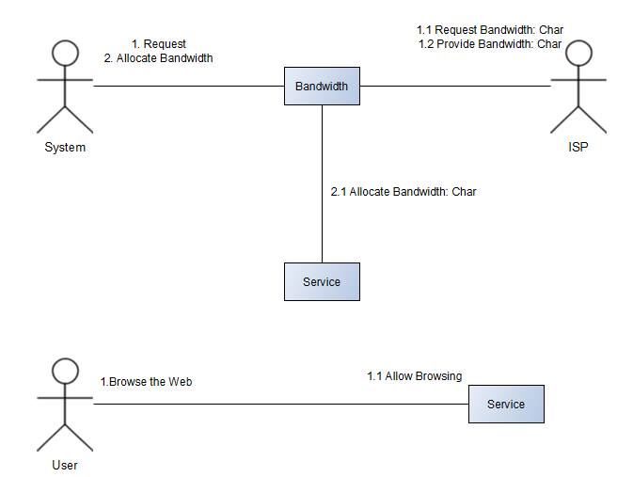

**State Diagram**

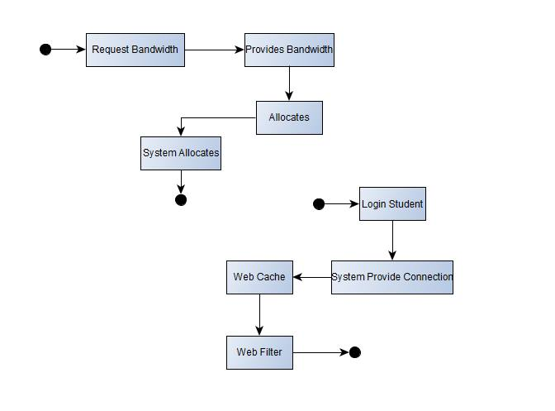**Timing Diagram**

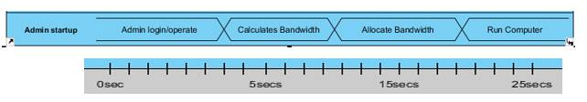

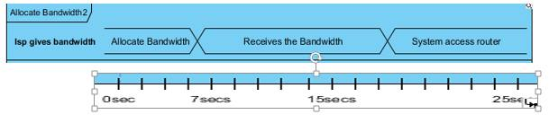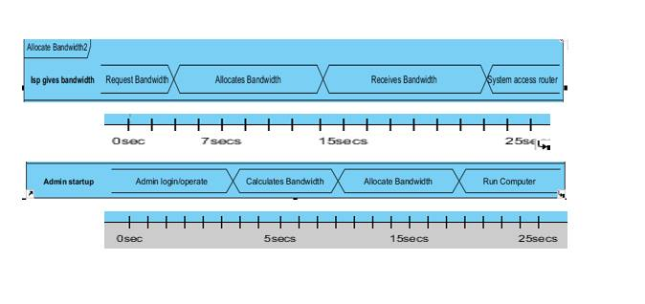**Use Case Diagram**

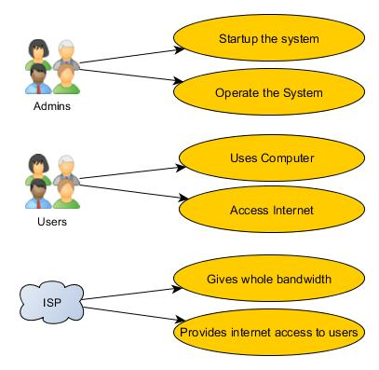

**Object Diagram**

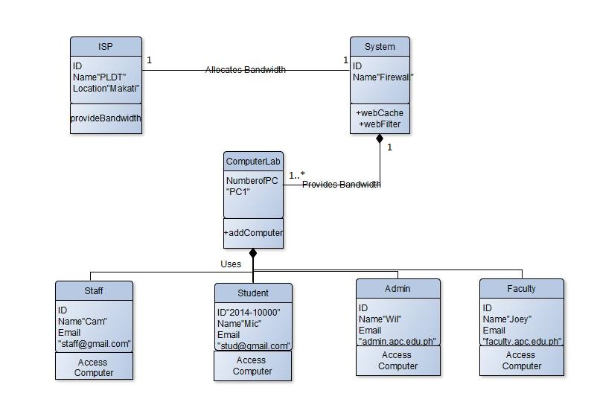

**Sequence Diagram**

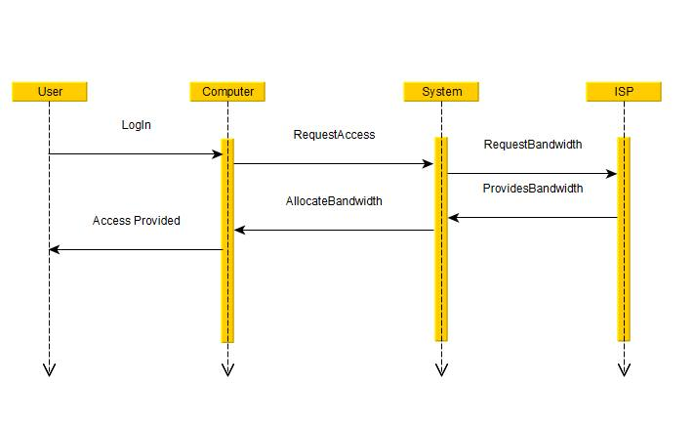

**Event Table**

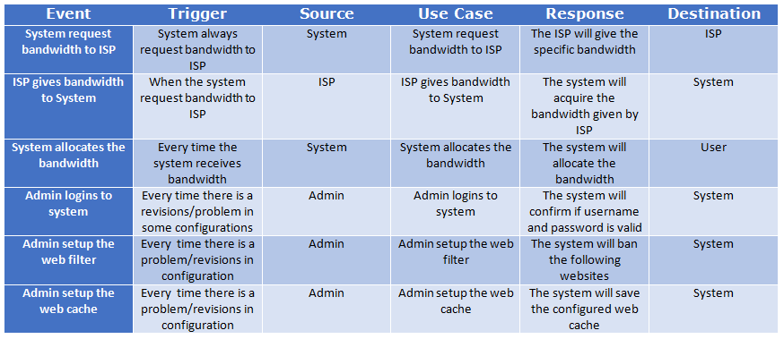

# Introduction

## **Background of the Problem**

The researchers’ problem concerns the slow internet connection speed in APC. Most students would say that the internet connection speed is so poor that it sometimes affects their classes. The researchers claim that this is caused by a poor bandwidth management, Lacking Network Design and Policies are not implemented properly.

For Bandwidth Management we tested speed test of different computer from a different LAB, we tested one computer in room 304 between the time of 7:30AM – 9:30AM with a speed of 42kb/s, another computer in room 502 at 9:30AM – 11:30AM has 58kb/s, one computer in room 314 at 1:30PM – 3:30 PM has 39kb/s, this proves that there is no bandwidth management in the network of APC.

Second, ineffective design for broadcast domain, for example if one computer searches one site like google.com, it will send a broadcast and the switch will forward it to every ports and all the switches will get a copy of broadcast packet that reduce the available bandwidth of network links for normal traffic because the broadcast traffic is forwarded to all the ports in a switch. Last, Policies are not implemented properly.

## **Statement of the Problem**

How can we improve the internet connection in APC in terms of connection stability?

## **Objectives**

### General Objectives

* To improve APC’s internet connection stability.

### Specific Objectives

* To enforce user policy through web filtering.
* To improve the connection by implementing VLAN.
* To improve quality of service by implementing bandwidth management.

## **Significance**

It is well known that throughout the whole APC building, the internet connection speed in the computer laboratories is very limited. It does not reliably load the webpages required for the classes and it sometimes prevents classes from taking online quizzes. This can be very problematic to both students and professors. This project’s significance is that the output will benefit the students and professors who will be using computer laboratories in Asia Pacific College.

# Scope and Limitations

The researcher’s project seeks to improve the service of internet connection here in APC. The target will be one computer laboratory for testing but the result itself is not limited to one laboratory but applicable to all laboratories. With APC’s total of 60mb/s bandwidth, the team will be targeting only computers wired to the main network and computers owned by APC only. The operational hours will be from 7:30 AM – 9:30 PM.

# Related Literature

## **Bandwidth management in universities in Zimbabwe: Towards a responsible user base through effective policy implementation**

According to the study "The authors recommend that using Quality of Service (QoS) and Bandwidth management will enable network administrators to control network traffic flow so that appropriate users and applications get priority during the allocation of network resources.". It means that they want to address a software that can control the bandwidth of their network by not extending the bandwidth that their ISP give also known as the bandwidth management tool. And also they want to monitor the network traffic so out of it they can now manage or control the bandwidth.

## **Bandwidth Management and Quality of Service**

The internet is growing rapidly as a tool of information medium. As the demand continue to increase, it is obvious that internet traffic increases with it. The internet is now filled with different types of users with different types of needs; casual users who are likely going to pay for less bandwidth to be able to access the web and their email, and the users who are willing to pay for higher bandwidth to be able to use multi-media applications and other software that require high consumption of bandwidth.

## **A Control Approach to Bandwidth Management in Networked Control Systems**

TCP cannot determine an error loss event in terms of network highly on wired networks so the TCP Westwood congestion control algorithm is proposed. It is a fuzzy controller that can enhance wired networks that have high error rate. Note that this is already a proposed project. The proposed TCP Fuzzy is tested on OMNET++ IDE based on the reference below and they confirm that the fuzzy controller gives better performance than the standard TCP in wired networks when error rate increase.

# Theoretical Background

* Fault Tolerance - the ability of a system to respond gracefully to an unexpected hardware or software failure. There are many levels of fault tolerance, the lowest being the ability to continue operation in the event of a power failure.
* Scalability - Scalability is a characteristic of a system, model or function that describes its capability to cope and perform under an increased or expanding workload. A system that scales well will be able to maintain or even increase its level of performance or efficiency when tested by larger operational demands.
* QoS - Quality of service (QoS) is the overall performance of a telephony or computer network, particularly the performance seen by the users of the network. To quantitatively measure quality of service, several related aspects of the network service are often considered, such as error rates, bit rate, throughput, transmission delay, availability, jitter, etc.

# Proposed Solution to the Problem

With the information gathered from different IT professors and school personnel, we have proposed the following solutions:

* Virtual Local Area Network (VLAN) – The team has gathered details regarding the broadcast domain of APC as explained in the background of the problem. The current broadcast domain layout will let a computer send a broadcast and the switch will forward it to all the ports causing bandwidth traffic.
* Bandwidth throttling – to provide quality of service (QoS) in the network. Assuring computer network connections equal bandwidth. Resulting to stable download and upload speed among computer units.
* Web Filtering based on User Policy – based on our related literature, we have seen that user access policy is also related in bandwidth consumption. Therefore, bandwidth traffic is still affected by unnecessary web activities. We will base the user access policy from the student handbook.

1. **Conclusions and Recommendations**

Lack of appropriate bandwidth management and poor network design is preventing the productive use of the Internet at APC. Which results to low quality output of academic activities. Managing bandwidth to provide quality of service for APC network is important to maintain academic activities in the computer laboratories.

To improve the stability of connection, VLAN must be implemented with the network switches of APC. This will allow the network to have broadcast control for every switch since by segmenting a large LAN to a smaller VLAN we can reduce broadcast traffic; as each broadcast will be sent within the relevant VLAN only.

Utilizing “PFsense”, a software where we can create a VLAN for each switch in the network, set a bandwidth control or limit and apply web filtering based on the user policy. With this we will be able to meet our objective which is to improve internet connection stability.

**References:**

[http://www.investopedia.com/terms/s/scalability.asp](http://l.facebook.com/l.php?u=http%3A%2F%2Fwww.investopedia.com%2Fterms%2Fs%2Fscalability.asp&h=lAQGFpyJp)

[http://www.webopedia.com/TERM/F/fault_tolerance.html](http://l.facebook.com/l.php?u=http%3A%2F%2Fwww.webopedia.com%2FTERM%2FF%2Ffault_tolerance.html&h=lAQGFpyJp)

<https://en.wikipedia.org/wiki/Quality_of_service>

<http://citeseerx.ist.psu.edu/viewdoc/download?doi=10.1.1.63.4586&rep=rep1&type=pdf>

<http://citeseerx.ist.psu.edu/viewdoc/download?doi=10.1.1.684.2516&rep=rep1&type=pdf>

<http://files.eric.ed.gov/fulltext/EJ1084130.pdf>